ARTIFICIAL INTELLIGENCE PROJECT

Tic-Tac-Toe Game
Using Minimax Algorithm
An AI-Powered Game with Python & Tkinter

TEAM MEMBERS
Sherif Wael | 241000304
Obai Ashraf | 241001181
Youssef Walid | 241001097
Youssef Elnady | 241001144

Faculty of Computers & Artificial Intelligence | Academic Year 2025–2026

1. Project Idea Description
This project is an AI-powered Tic Tac Toe game developed using Python and the Tkinter library for the graphical user interface (GUI). The game allows a human player to compete against a computer-controlled AI bot.
The main objective of the project is to implement Artificial Intelligence concepts, especially the Minimax algorithm, in a simple and interactive game environment.
The game supports three difficulty levels:
- Easy: The bot chooses random moves.
- Medium: The bot uses a combination of 30% random moves and 70% Minimax strategy.
- Hard: The bot uses the full Minimax algorithm to always select the optimal move.

The project also includes:
- Interactive GUI
- Automatic win/draw detection
- Score tracking system
- Restart game functionality
- Dynamic player/computer symbol assignment
- AI thinking delay simulation

The Minimax algorithm enables the AI to predict future game states and choose the best possible move, making the Hard difficulty highly challenging.

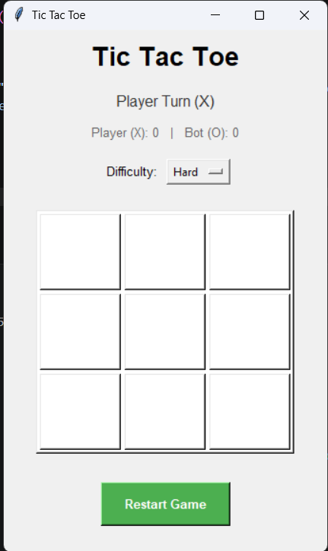
Figure: Tic-Tac-Toe Game Interface

2. Literature Review
Artificial Intelligence is widely used in game development to simulate intelligent decision-making behavior. One of the most common educational examples in AI is the Tic Tac Toe game because it demonstrates search algorithms and game theory concepts in a simple environment.
The Minimax algorithm is a classical AI algorithm used in two-player games. It works by recursively exploring all possible future moves and evaluating the best move for the AI while minimizing the player’s chances of winning.
Python is one of the most popular programming languages for AI applications because of its simplicity and powerful libraries. Tkinter is commonly used to build desktop GUI applications in Python.
Several online and desktop Tic Tac Toe games implement AI-based opponents, but this project focuses on educational implementation and algorithm visualization.

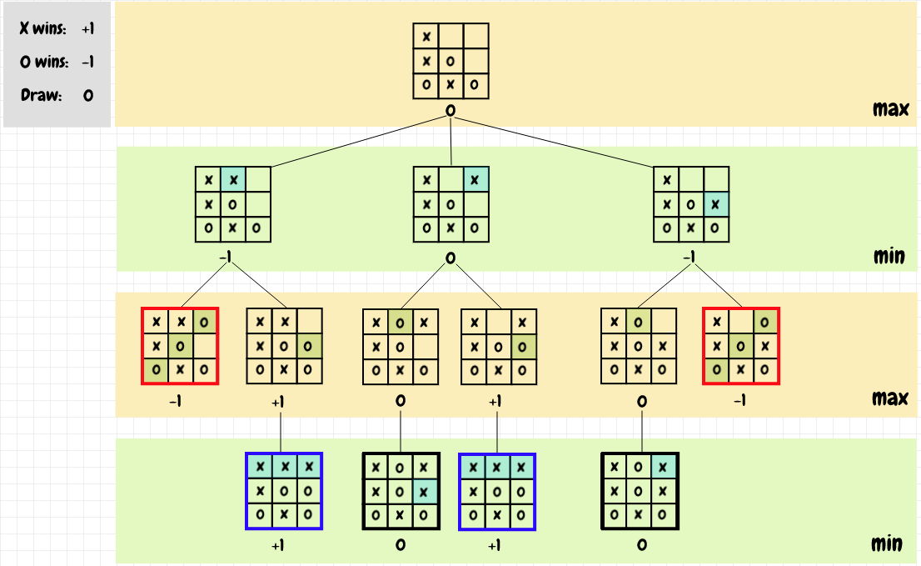
Figure: Game Overview — Main Game Window

3. Main Functionalities
The project provides several core functionalities:
- Human vs AI gameplay
- Three AI difficulty levels
- Smart decision-making using Minimax
- Graphical User Interface using Tkinter
- Real-time win and draw detection
- Restart game button
- Score tracking system
- AI move delay simulation for realism

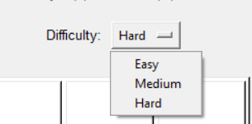
Figure: Difficulty Selection Menu

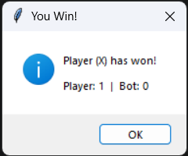  Figure: Player Wins Screen | 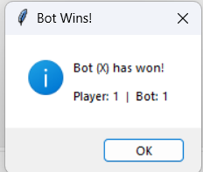  Figure: Bot Wins Screen

4. Similar Applications in the Market
Many Tic Tac Toe applications are available online and on mobile devices. Some popular examples include:
- Google Tic Tac Toe
- Connect Four
- Web-based AI game simulators
5. Input and Output Format
Inputs:
The system receives the following inputs:
- Mouse clicks on game board cells
- Difficulty level selection
- Restart game button actions
Outputs:
The system displays:
- Updated game board
- AI moves
- Current game status
- Winner messages
- Draw messages
- Updated scores
6. Details of the Algorithm & Results of Experiments
Minimax Algorithm
The Hard difficulty level uses the Minimax algorithm to determine the optimal move. The algorithm works as follows:
- Generate all possible moves
- Simulate future board states
- Evaluate outcomes recursively
- Select the move with the highest score

Evaluation Scores
Result | Score
AI Win | +1
Player Win | −1
Draw | 0

Difficulty Modes
Easy Mode
- The AI chooses random moves only.
Medium Mode
- 70% Minimax strategy
- 30% random moves
Hard Mode
- Full Minimax implementation
- AI becomes nearly unbeatable

Note: The experiments showed that the Hard mode consistently prevents the player from winning because the Minimax algorithm evaluates all possible future outcomes.
7. Conclusion
This project successfully demonstrated the implementation of Artificial Intelligence concepts through the development of a Tic Tac Toe game using Python and the Minimax algorithm. The game provides an interactive graphical interface and multiple difficulty levels to improve the user experience.
The Minimax algorithm enabled the AI bot to make intelligent decisions and perform optimal moves, especially in Hard mode where the AI becomes very difficult to defeat. The project also helped in understanding important AI topics such as game trees, recursive algorithms, decision-making, and search strategies.
In addition, the project improved programming skills in Python, GUI development using Tkinter, and problem-solving techniques. Overall, the project achieved its objectives by combining Artificial Intelligence concepts with practical software development in a simple and educational game application.

