Project Name
Advanced Multi-User Banking & Financial Management System
Introduction
What is this project?
This project is a simple digital wallet app that works on a computer screen (like a terminal). It lets users:
- Open a bank account
- Log in safely
- Deposit money and withdraw money (in Pakistani Rupees)
- Send money to friends
- Check and track daily spending
Why did we build it this way?
We built this app mainly for learning purposes.
In real banking apps, everything must be very safe and accurate. Even a small mistake can cause big problems. So, in this project, we intentionally added some hidden bugs and weaknesses in the system.
The goal was not to make a perfect app, but to learn how real developers find and fix problems.
How did we test it?
After building the app, we acted like software testers and checked it in three ways:
- Manual Testing:
We tried wrong inputs like negative amounts or sending more money than available to see if the app handles mistakes.
- Automated Testing:
We wrote small test scripts to automatically check if the system rules (like balance checks) are working correctly.
- Security Scanning (SonarQube & Snyk):
We used tools that scan code to find problems like bad coding practices, logic errors, and security risks (for example, unsafe password storage).
What is the final goal?
The goal of this project is to show how real software is improved step by step.
We started with a simple and imperfect program, then:
- Found bugs and errors
- Detected security issues
- Fixed problems
- Improved the code quality
- Stored the final version safely on GitHub
In the end, it shows how a rough, unsafe app can be turned into a more secure and reliable banking system through proper testing and improvement.
Repository Link: https://github.com/Obaid017/SQE_Semester_Project
Phase 2: Manual Testing Specification Document
Test Case ID | Description | Operation | Input | Actual Result | Expected Result | Status
TC- 01 | Verify user login capability with completely valid database credentials. | Customer Login Execution | Username: obaid  Password: 0123! | Access granted seamlessly; system routes directly to user main dashboard screen. | Access must be granted securely; system routes to user workspace panel dashboard. | PASS
TC- 02 | Verify authentication routine rejects an incorrect account password. | Customer Login Execution | Username: obaid  Password: Wrong999 | Access denied with message console stating: "Authorization Refused: Incorrect password." | Access must be safely denied; system increments failed tracking count parameter. | PASS
TC-03 | Verify cash withdrawal operates correctly within active account capital. | Account Withdrawal | Withdrawal Amount: 1,000 PKR | Account balance drops down to 4,000.00 PKR; displays success status. | Balance must update to 4,000.00 PKR; transaction logs into memory. | PASS
TC-04 | Verify system blocks withdrawal transactions that drop below the minimum limit. | Account Withdrawal | Withdrawal Amount: 300 PKR | Application rejects process; prints: "Process Failed: Minimum withdrawal limit is PKR 500.0" | Process must stop immediately; blocks balance modifications from executing. | PASS
TC-05 | Verify system blocks deposit transactions that fall below the minimum threshold. | Account Deposit | Deposit Amount: 50 PKR | Application rejects process; prints: "Process Failed: Minimum deposit limit is PKR 100.0" | Process must stop immediately; flags minimum limit transaction error. | PASS
TC-06 | Verify input boundary validation handling for negative deposit amount entries. | Account Deposit | Deposit Amount: -50 PKR | Application handles amount as minimum limit error value instead of an invalid value. | System must capture negative values upfront and print: "Invalid Amount. Negative values not allowed." | FAIL
TC-07 | Verify safety boundary thresholds when an account attempts an overdraft transfer. | P2P Fund Transfer | Transfer Amount: 1,000 PKR  (With only 500 PKR balance) | System processes transaction anyway; sender balance drops into a negative value of -500.00 PKR. | System must intercept request before modification, block execution, and throw: "Insufficient funds." | FAIL

Test Case 06:
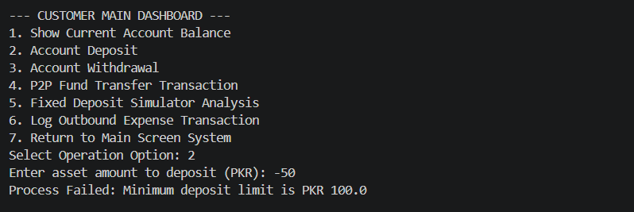
Test Case 07:
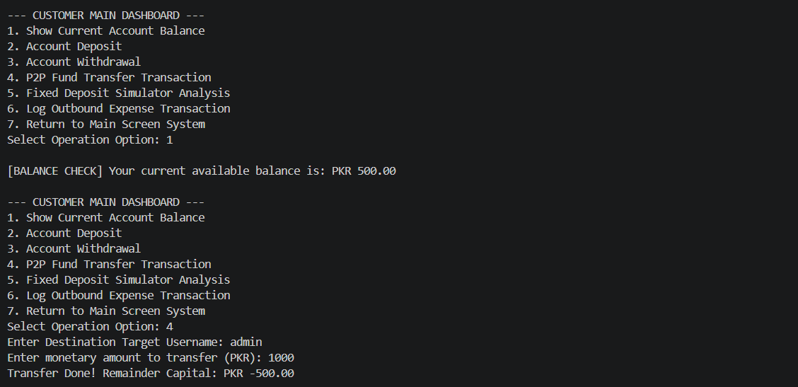

Phase 3: Bug Reporting
Bug Report 01: Negative Deposit Validation Bypass
Field | Details
Bug ID | BUG-01
Bug Name | Negative Deposit Validation Bypass
Description | The system accepts negative deposit numbers (e.g., -50) but processes them under the "Minimum Deposit" limit check instead of blocking them as an invalid negative amount.
Steps to Reproduce | 1. Run program.  2. Log into account Obaid.  3. Go to option 2 (Deposit) and input -50-
Expected Result | System should print an explicit error: "Invalid Amount. Negative values not allowed."
Actual Result | System prints minimum limit text: "Process Failed: Minimum deposit limit is PKR 100.0".
Severity | High
Status (Pass/Fail) | FAIL

Bug Report 02: Critical Inter-Account Overdraft Exploitation
Field | Details
Bug ID | BUG-02
Bug Name | Missing Sender Balance Check in P2P Transfers
Description | The transfer function does not check if the sender has enough money before moving funds, allowing accounts to drop into negative balances.
Steps to Reproduce | 1. Log into account ali (Balance: 2500 PKR).  2. Go to option 4 (Transfer).  3. Transfer 2000 PKR, then immediately try to transfer another 1000 PKR.
Expected Result | System should reject the second transfer and print: "Process Failed: Insufficient funds."
Actual Result | System processes the transfer and forces the sender's balance down to -500.00 PKR.
Severity | Critical / Blocker
Status (Pass/Fail) | FAIL

Run Testing.py
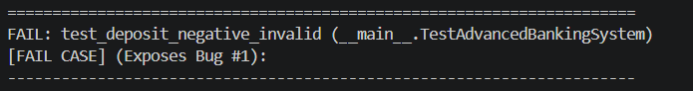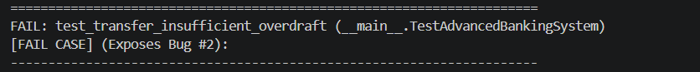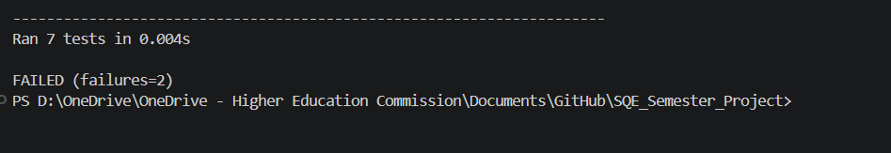

Phase 4: Code Quality Analysis
Start sonar Qube:
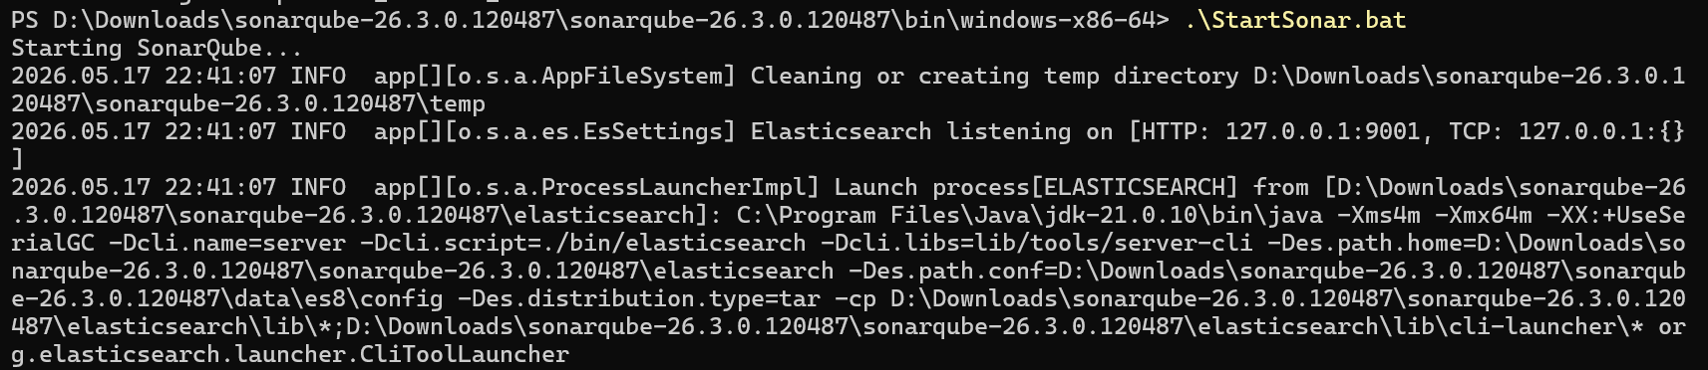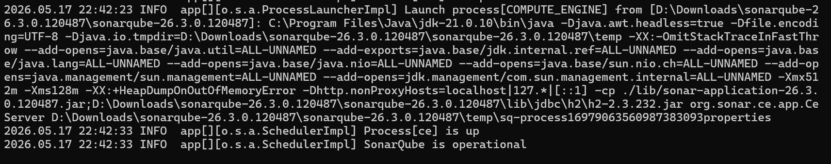
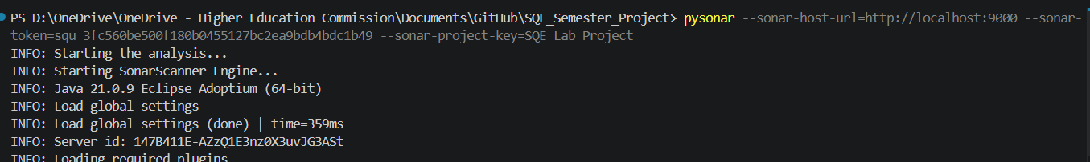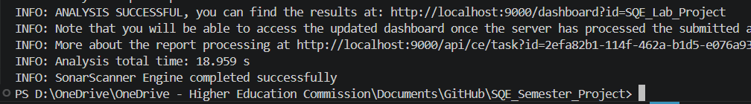

Project Overview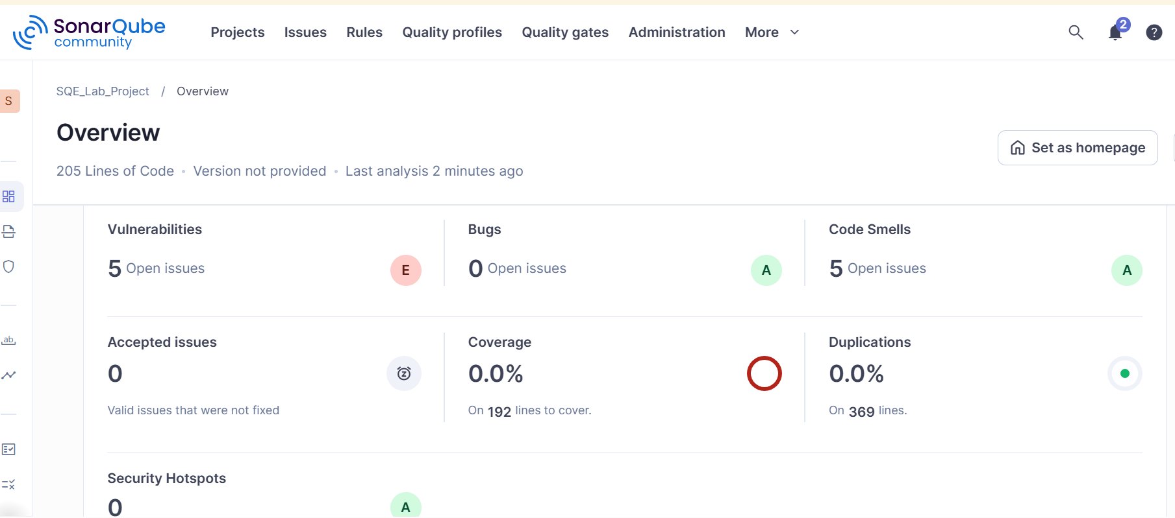
Phase 5: Security Analysis Using Snyk
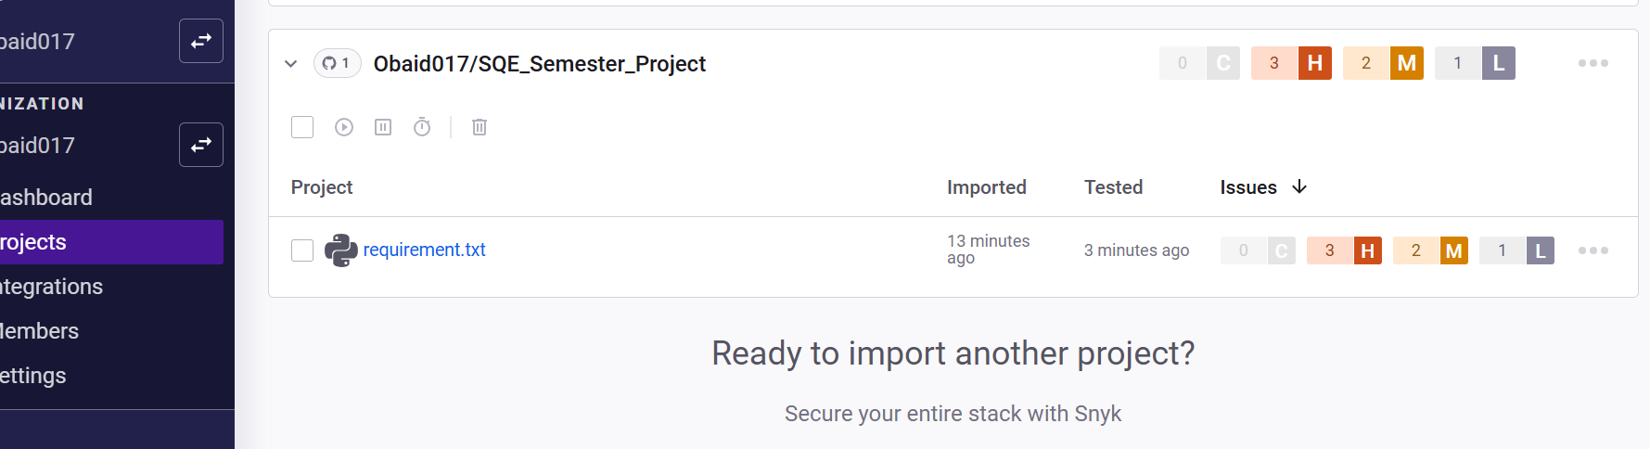
Phase 6: Version Control
