COMSATS UNIVERSITY ISLAMABAD,
ATTOCK CAMPUS.

Lab Midterm Examination
Course:
DevOps (CSC418)
Submitted to:
Mr. Muhammad Kamran
Submitted By:
OBAID ULLAH KHAN
CIIT/FA23-BSE-054/ATK
Section:
BS-SE
Date of submission:
30-October-2026
Assignment Submission Portal with Automated Testing

Overview

O.1 GitHub Repository URL
Obaid017/bse-054-assignment-portal

O.2 GitHub Page URL

Assignment Submission Portal - Demo

Task 1: Develop the Assignment Submission Portal
Requirements covered: a form for name, registration number, assignment title and submission URL; validation of required fields and the URL; saving valid submissions; displaying saved submissions.

1.1 Create the project folder and virtual environment
Terminal (PowerShell)
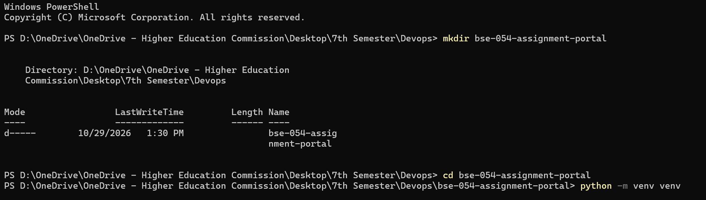
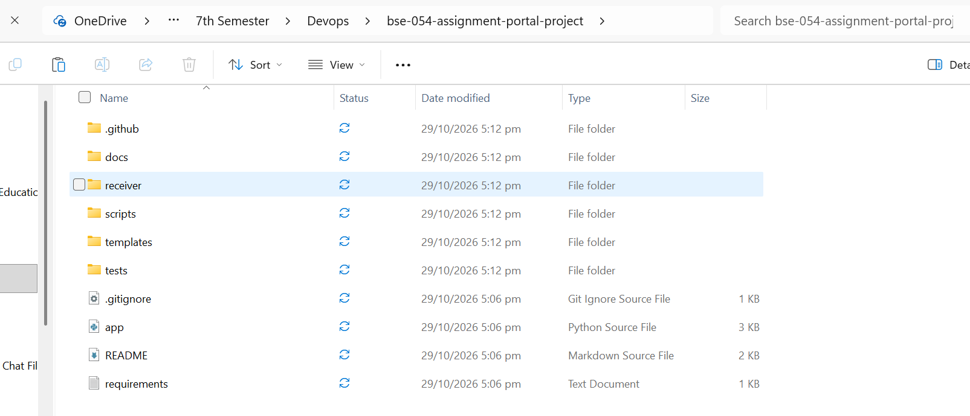

1.2 requirements.txt
requirements.txt
flask>=3.0
pytest>=8.0
Terminal
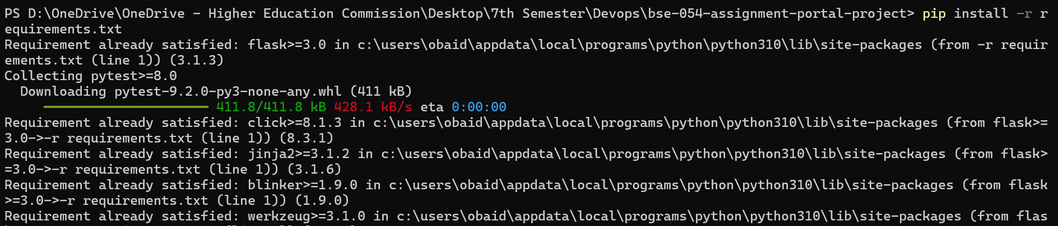

1.3 Run the application
Terminal
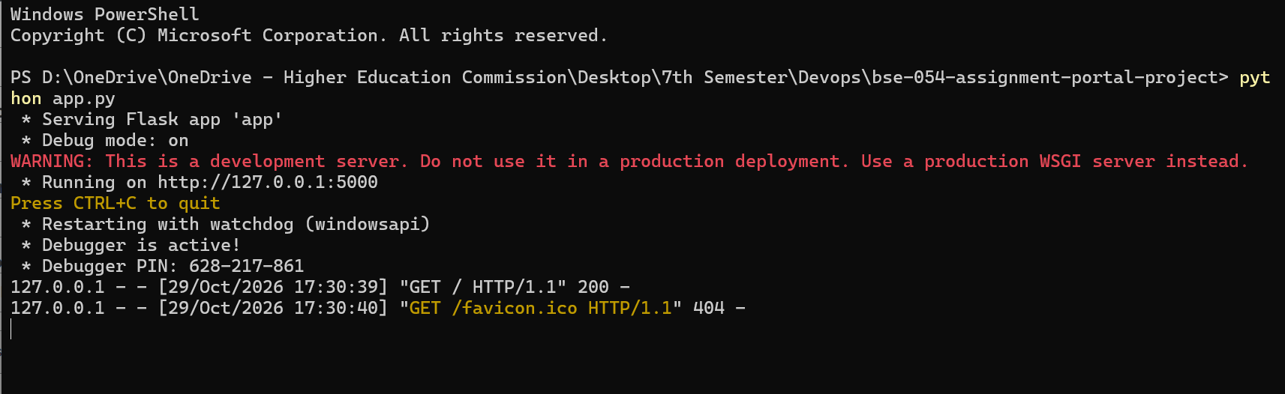Open http://localhost:5000 in the browser
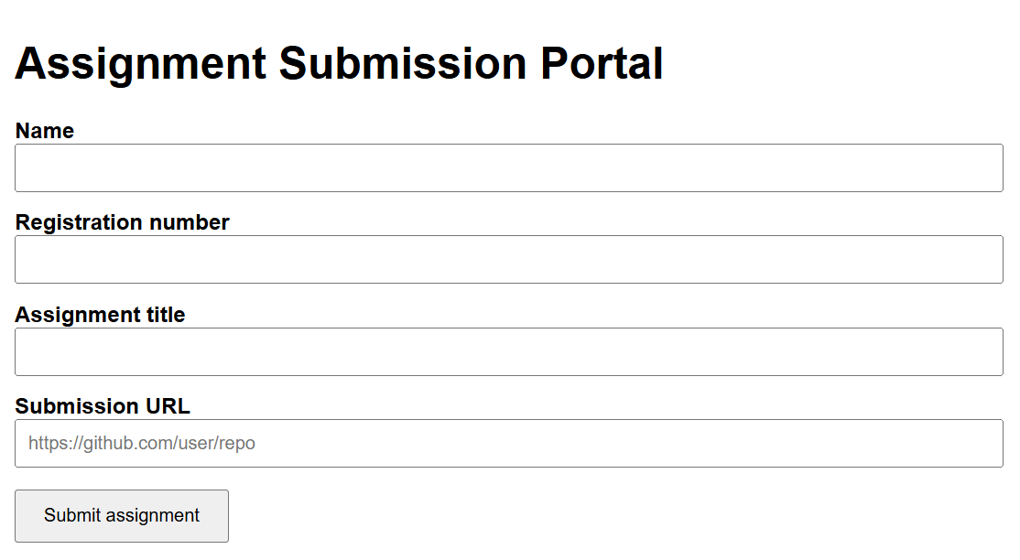

With Invalid URL
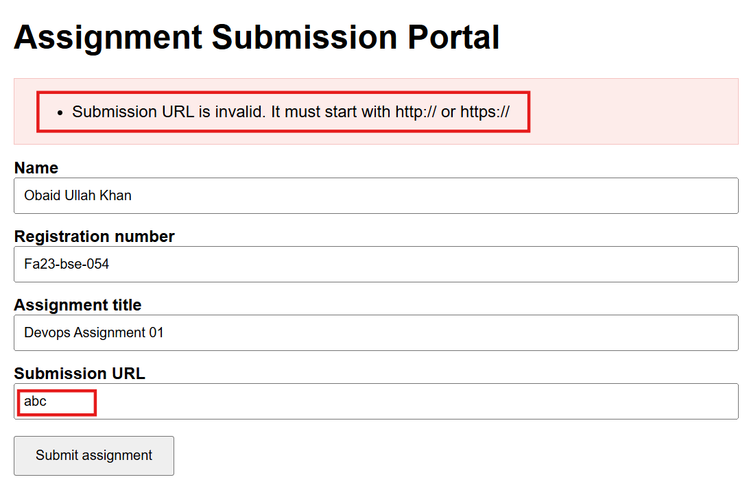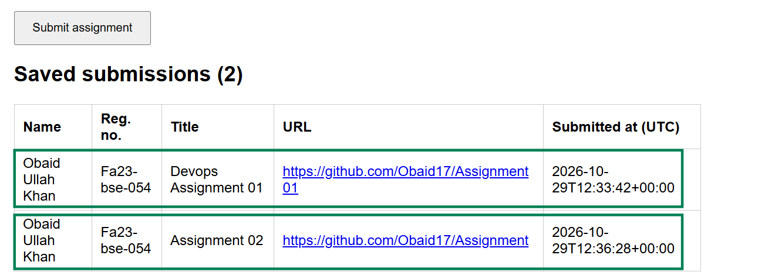

1.4 Evidence that submissions are saved
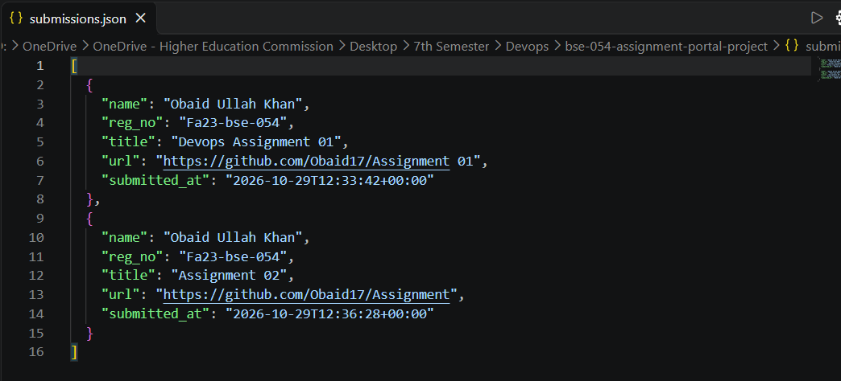
Task 2: Maintain the Project on GitHub
Requirements covered: repository containing the application, automated tests, pipeline configuration and local report receiver, with a README explaining how to run the app, run the tests and start the receiver.

2.1 Create the GitHub repository
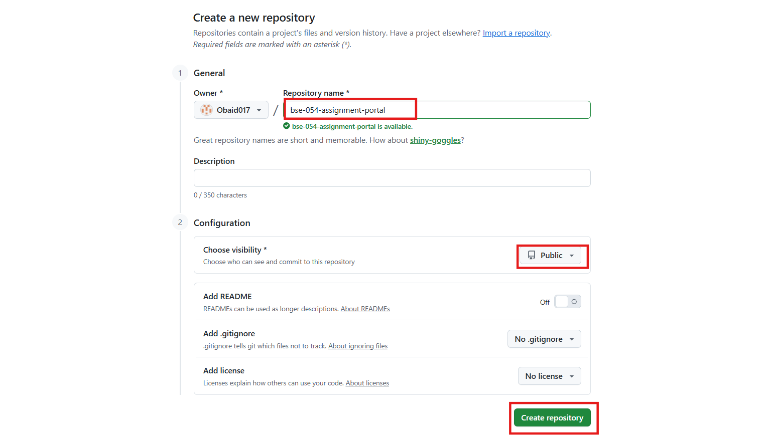

2.2 Push the project to GitHub
Terminal
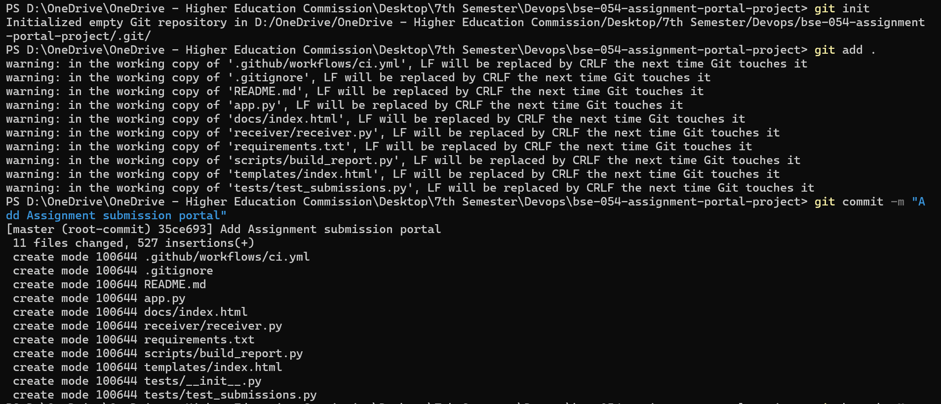
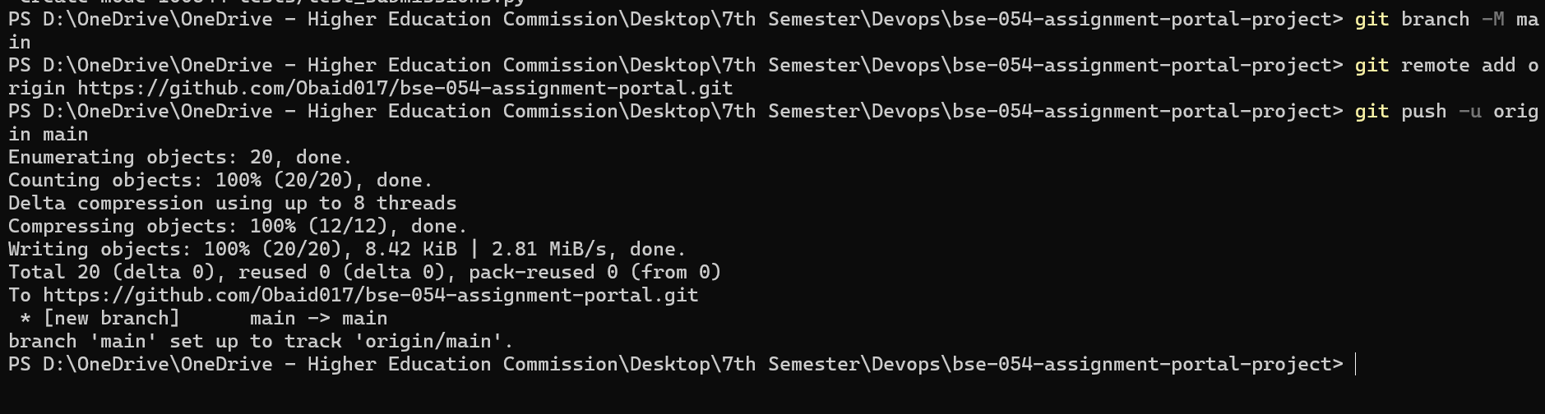

2.3 Verify the repository
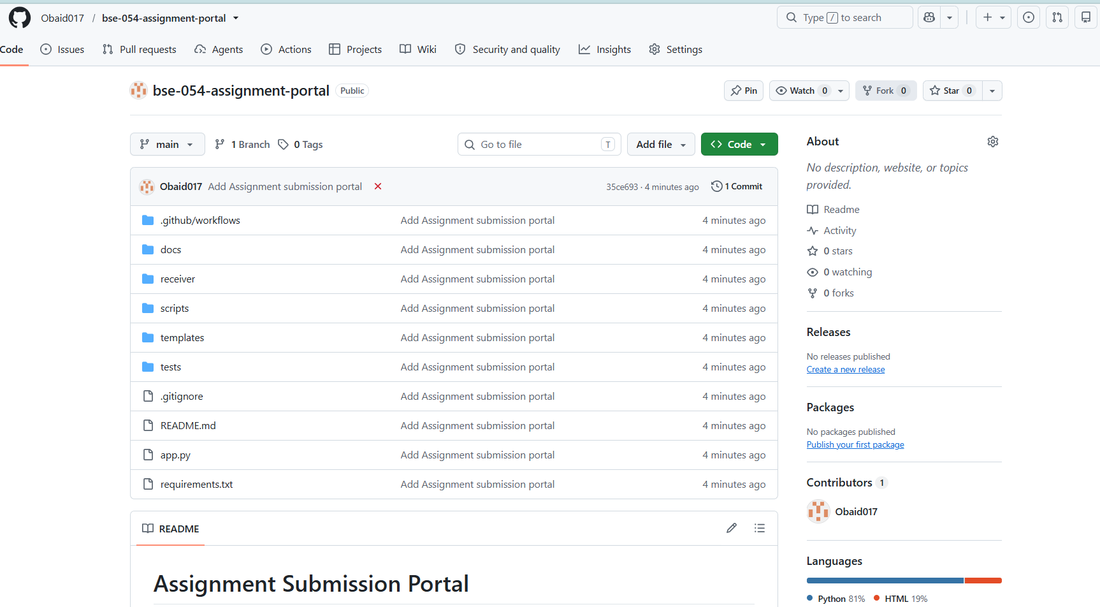
2.4 Maintain the project on GitHub (code, tests, pipeline, receiver, README)
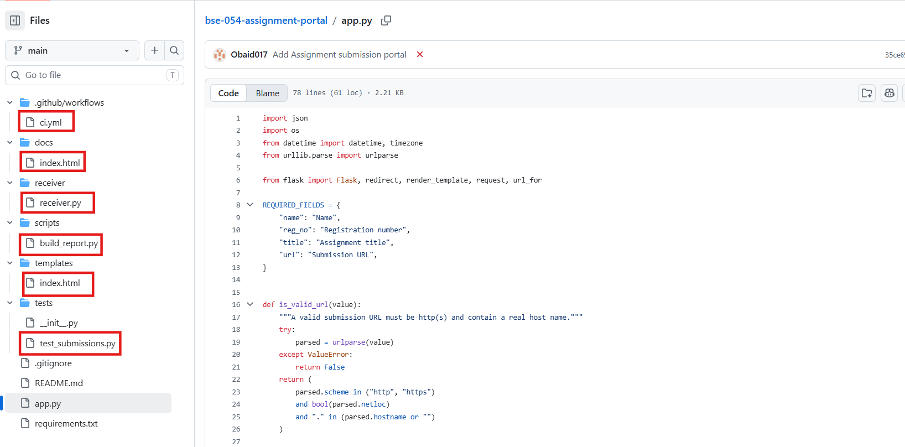

Task 3: Run Automated Tests on Every Push
Requirements covered: a CI pipeline that tests the pushed revision after every push, with at least the three required test cases, where results come from really executing the tests and a failed test fails the test stage.

3.1 Write the automated tests
The three required test cases map to three test methods. Each test posts to the portal using Flask's test client with a temporary data file, so tests never touch your real submissions.json.

Required test case | Test method | What it asserts
Complete details and valid URL | test_valid_submission_is_saved_and_listed | Saved to the file and appears in the list
Missing registration number | test_missing_registration_number_is_rejected | HTTP 400, validation message shown, nothing saved
Invalid submission URL | test_invalid_url_is_rejected_and_not_saved | HTTP 400, error shown, nothing saved

3.2 Run the tests locally
Terminal
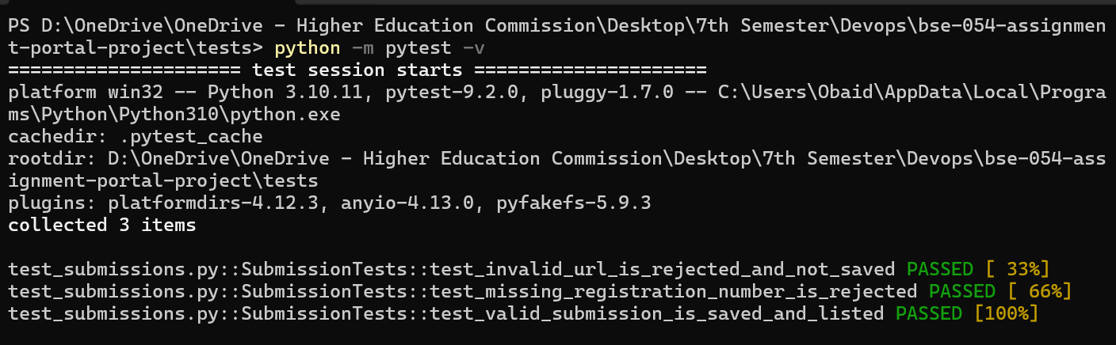

3.3 Create the CI workflow
.github/workflows/ci.yml (version 1 - tests only)
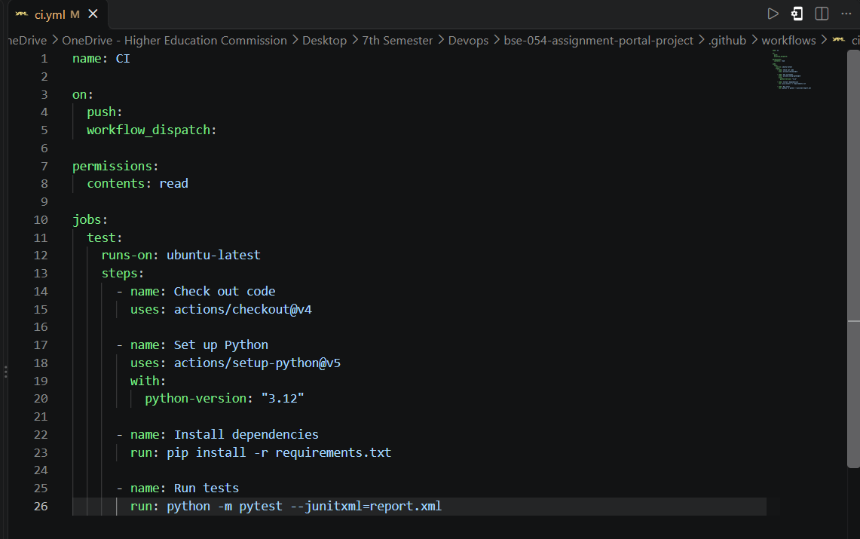

3.4 Push and verify the pipeline
Terminal
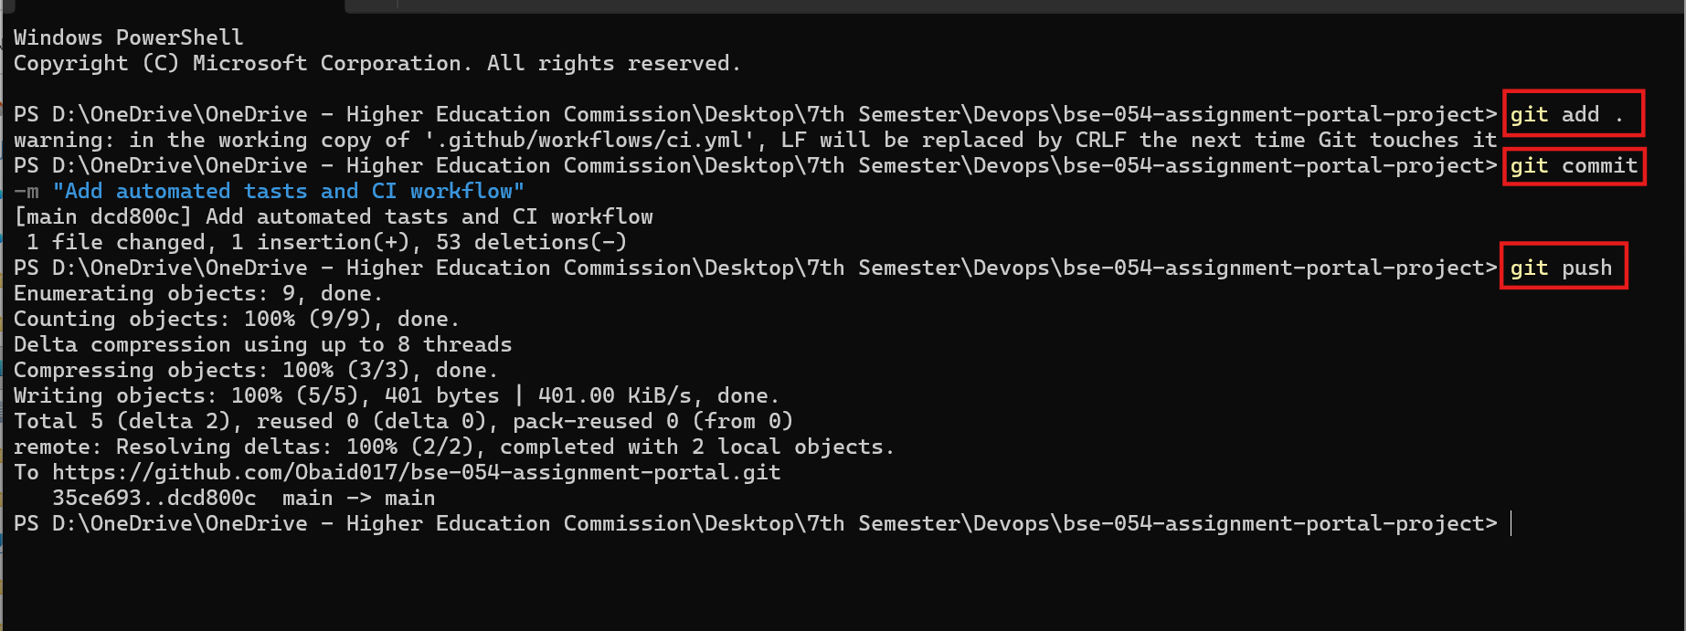
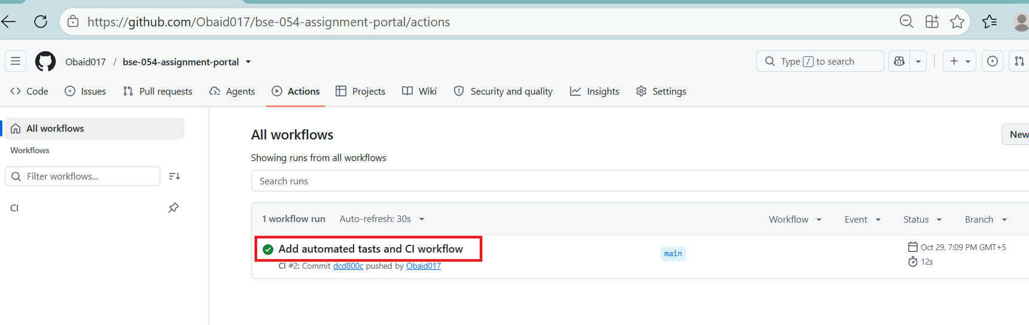

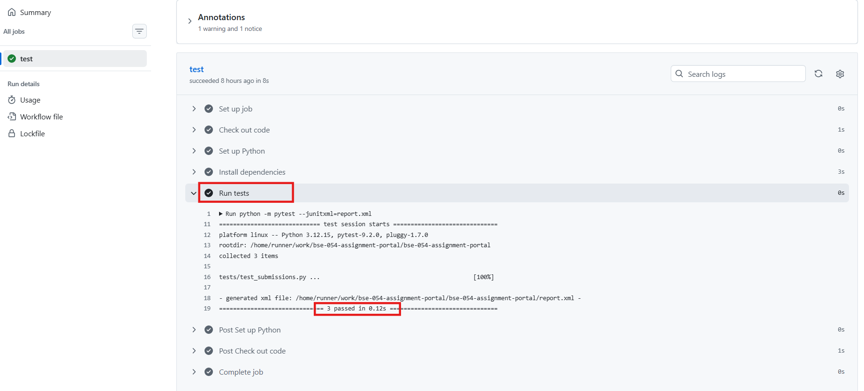Task 4: Send the Report to Localhost and Save JSON
Requirements covered: a local HTTP receiver that automatically receives the completed test report and saves it as test-report.json, with repository details and per-test results, delivered for passing and failing runs, with no manual copying.

4.1 Report format
The report contains every item the exam asks for. A failing run looks like :
Example test-report.json (failing run) 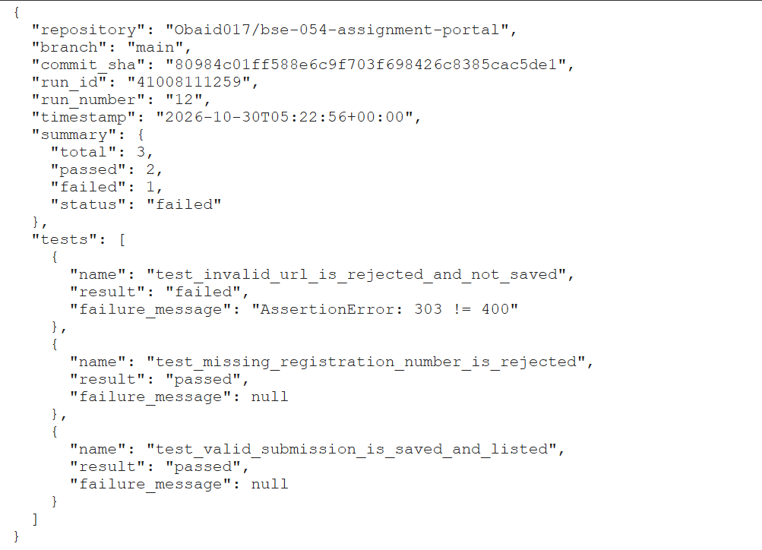

Requirement | JSON field
Repository name | repository
Branch | branch
Commit SHA | commit_sha
Pipeline run identifier | run_id (and run_number)
Execution timestamp | timestamp
Each test: name, result, failure message | tests[].name, tests[].result, tests[].failure_message
Total / passed / failed counts and overall status | summary.total, summary.passed, summary.failed, summary.status

4.2 Start the receiver
Terminal 1 (PowerShell)
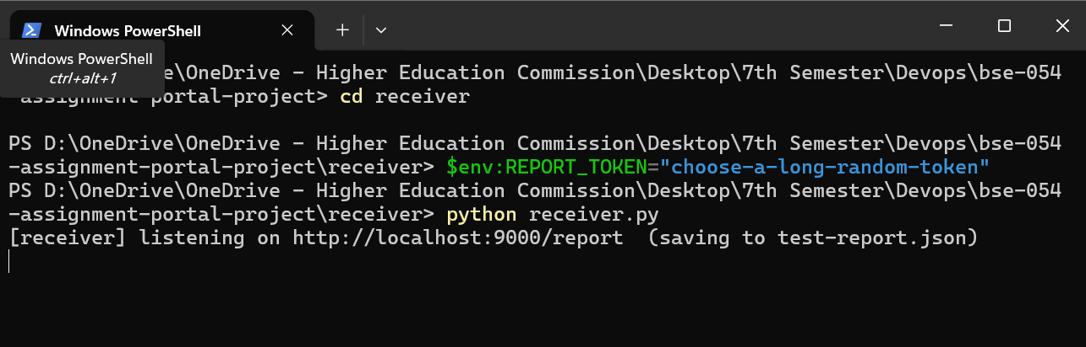

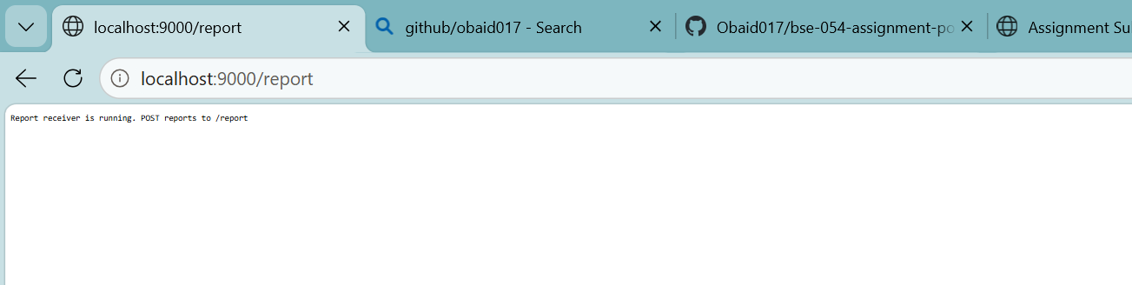
Terminal 2
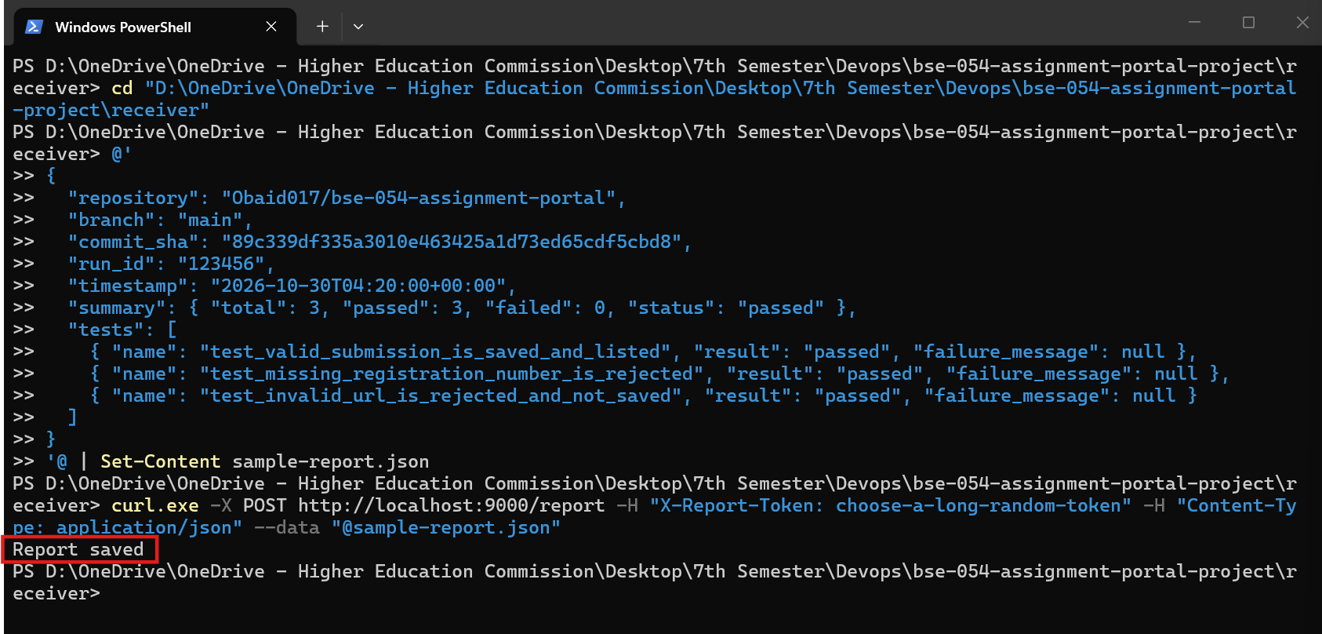

4.3 Make localhost reachable from GitHub (ngrok tunnel)
A GitHub-hosted runner cannot reach your localhost, so a tunnel gives your receiver a public HTTPS address.
- Create a free account at ngrok.com and install ngrok.
- Run: ngrok config add-authtoken <my-ngrok-token>
- In the ngrok dashboard open Domains and claim your free static domain. A static domain means the URL does not change between demos.
- Keep the receiver running, then in a new terminal run the tunnel command below.
Terminal 3 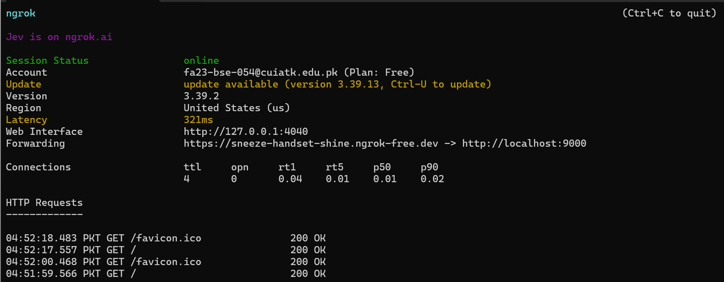

Test it
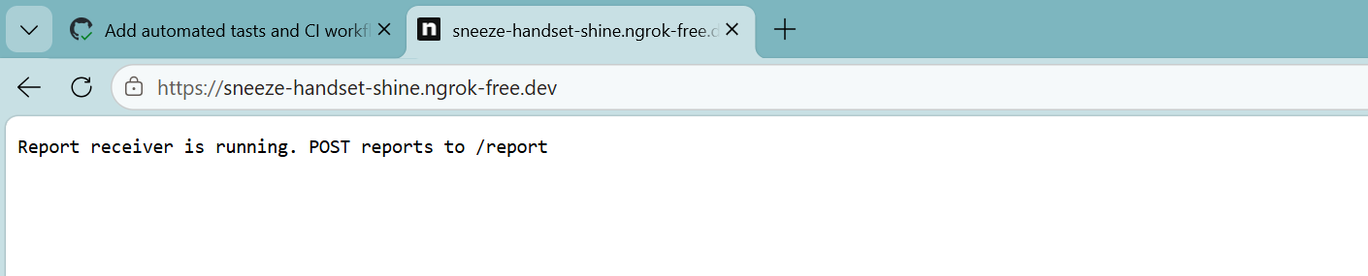

Terminal
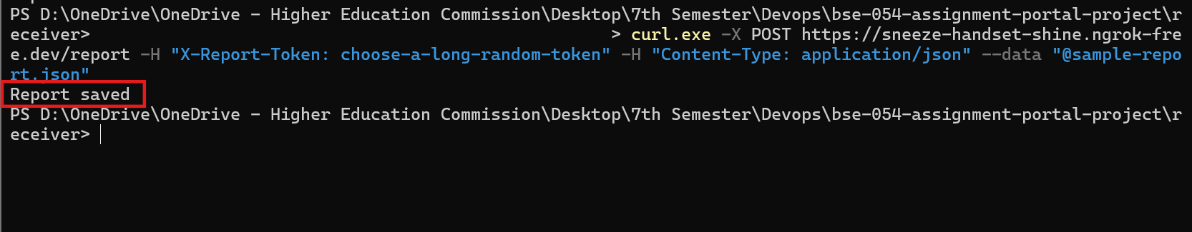

4.4 Add the repository secrets
Secret name | Value
REPORT_URL | https://name.ngrok-free.app/report
REPORT_TOKEN | The same token That set in the receiver terminal

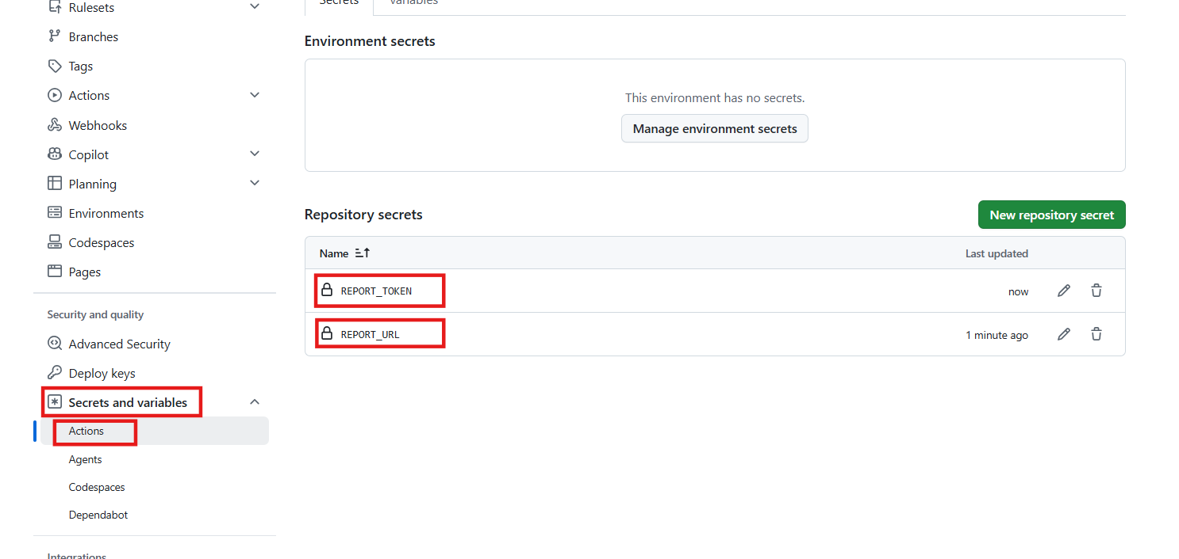

4.5 Update ci.yml - add the report steps
Add these two steps directly after the "Run tests" step in ci.yml. The line "if: always()" makes them run even when the tests fail, so failing runs also deliver a report.
Add to .github/workflows/ci.yml
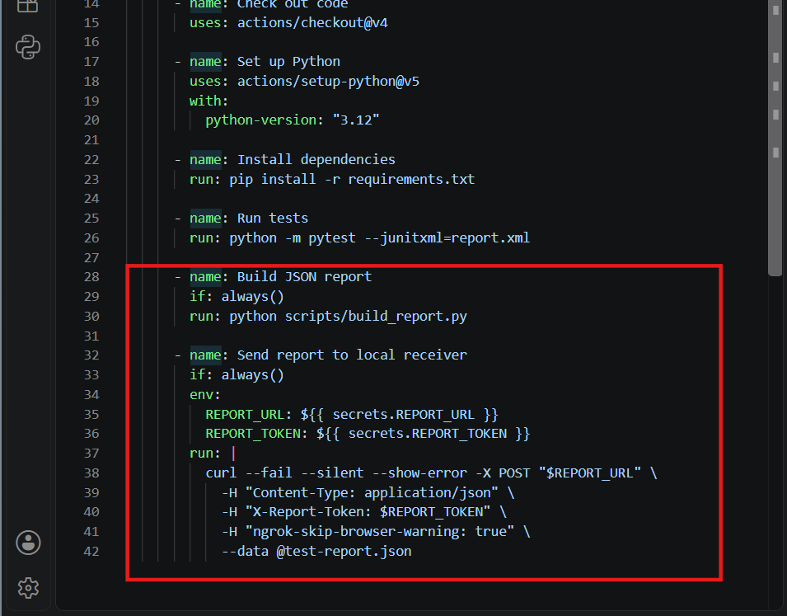

Terminal
Update Repository
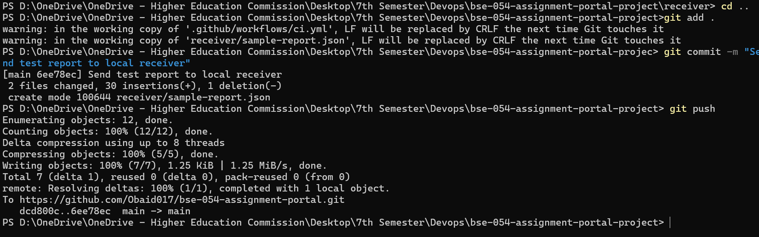

4.6 Verify the report is received automatically

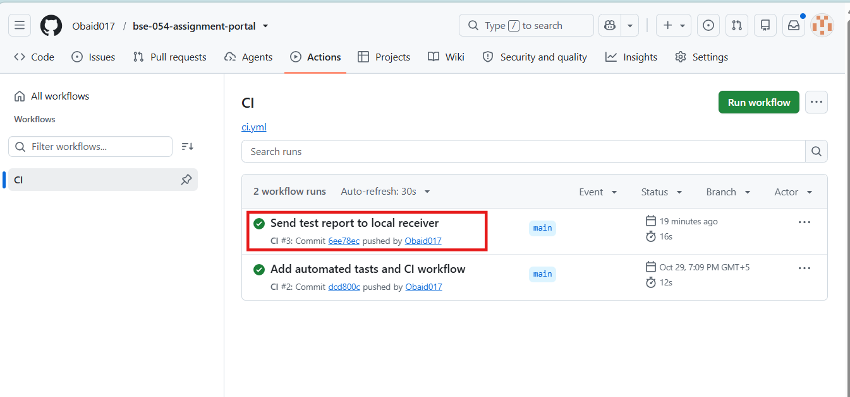

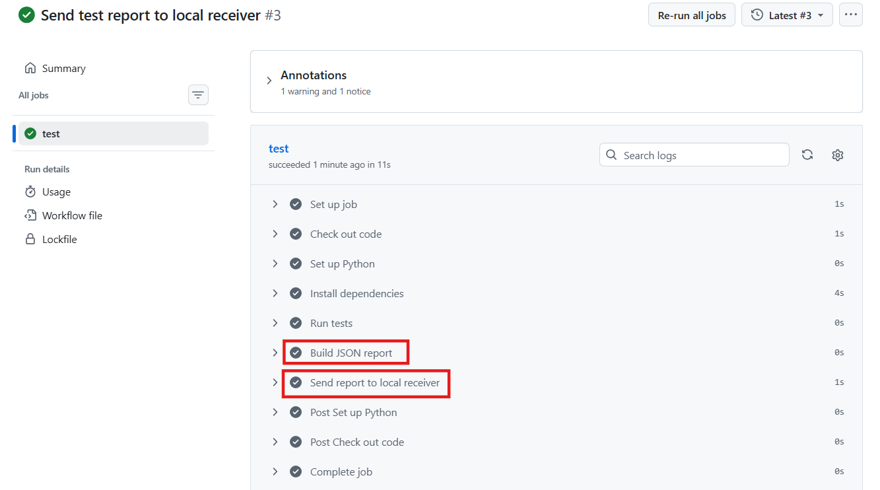
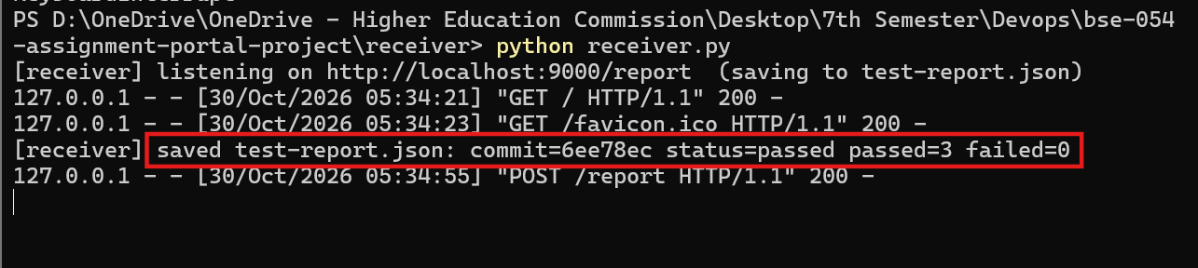

Task 5: Demonstrate the Complete Workflow

5.1 Run A - push that passes all tests
Terminal
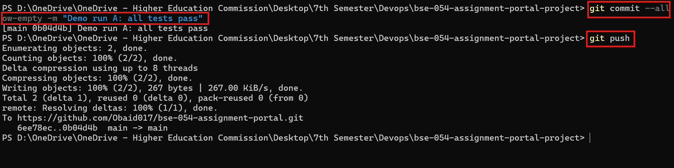
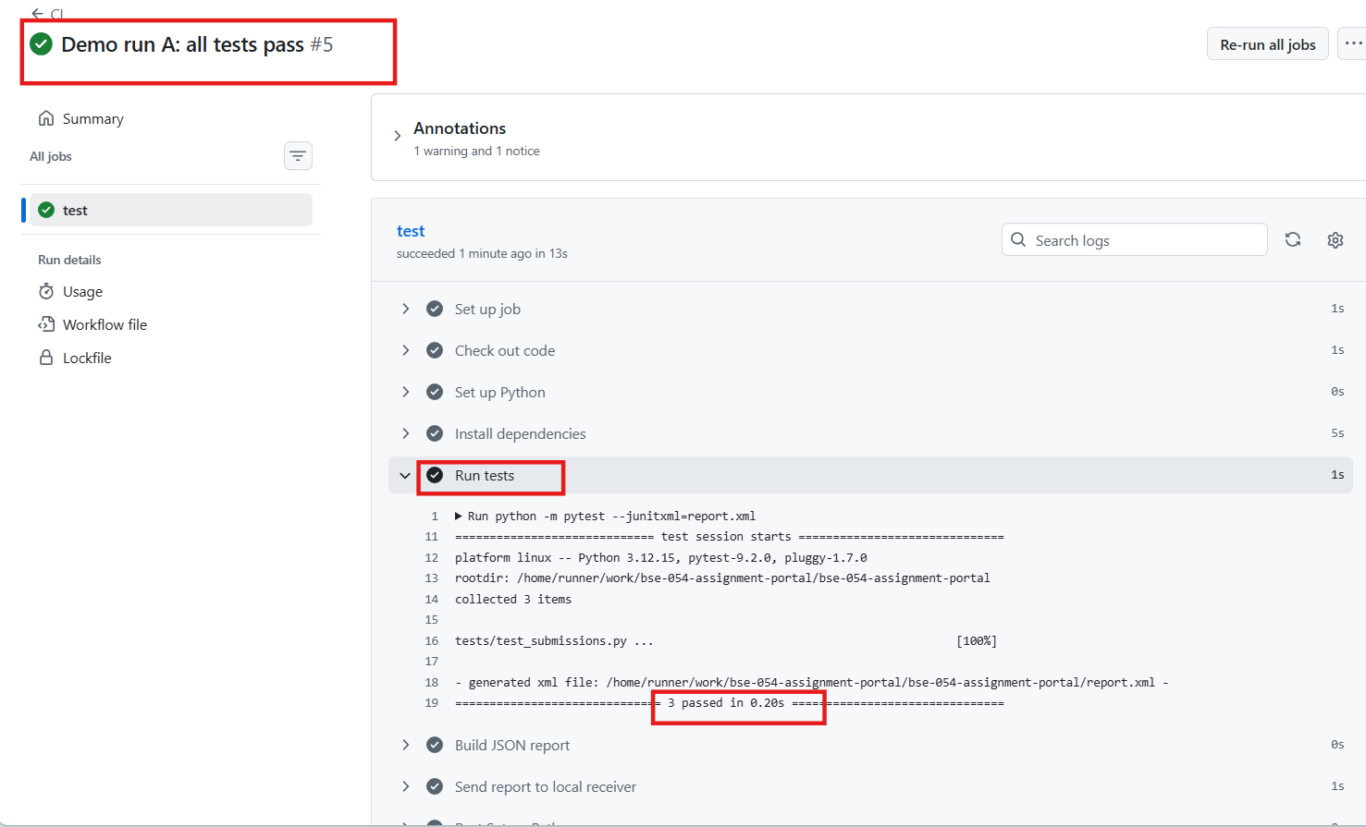
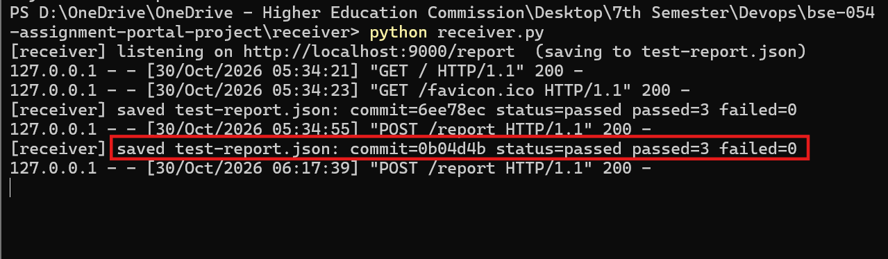

Updated report
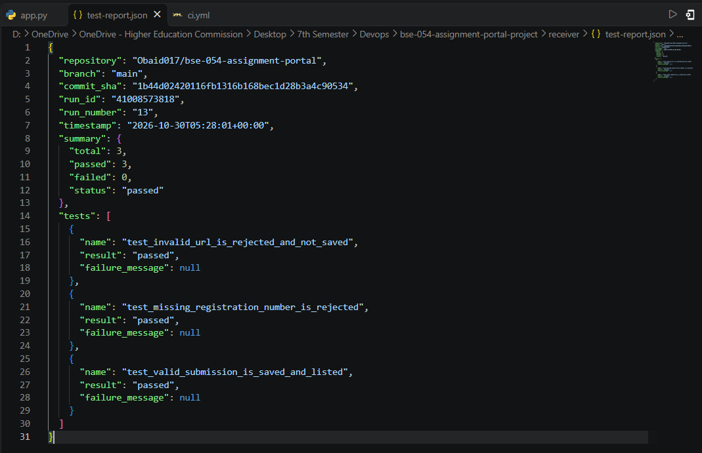

5.2 Run B - introduce a defect and push (failing run)
Open app.py and add one line at the very top of is_valid_url() so every URL is accepted:
app.py (defect)
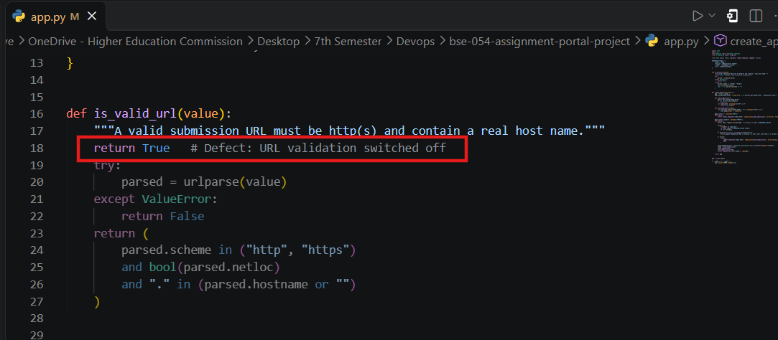

Terminal
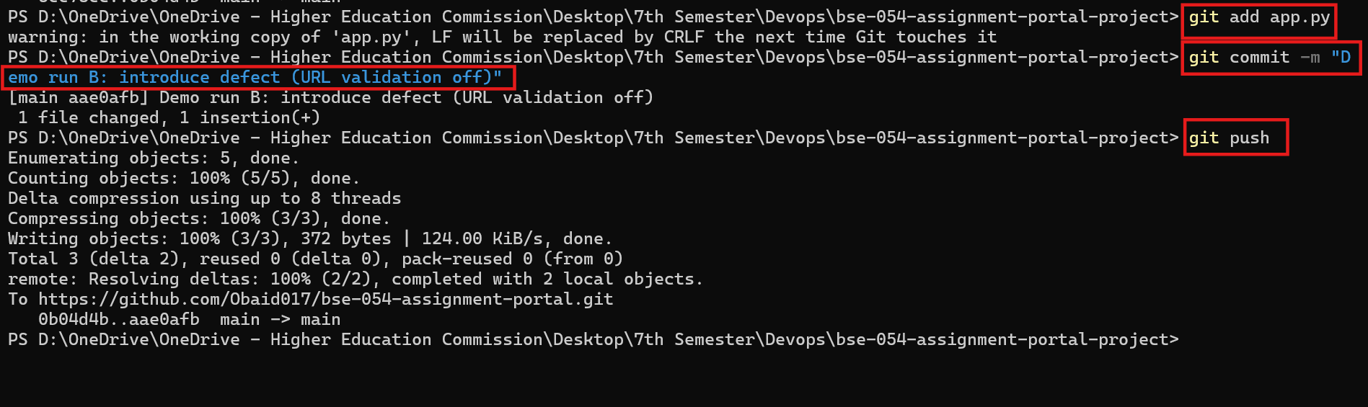
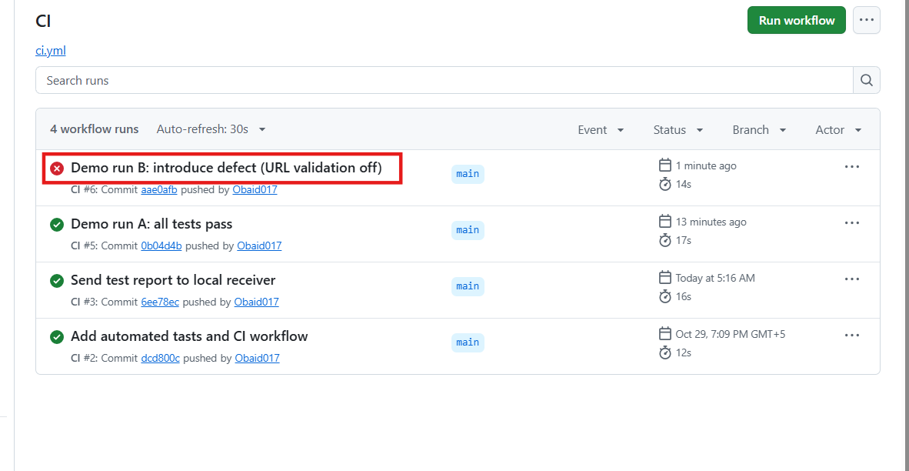
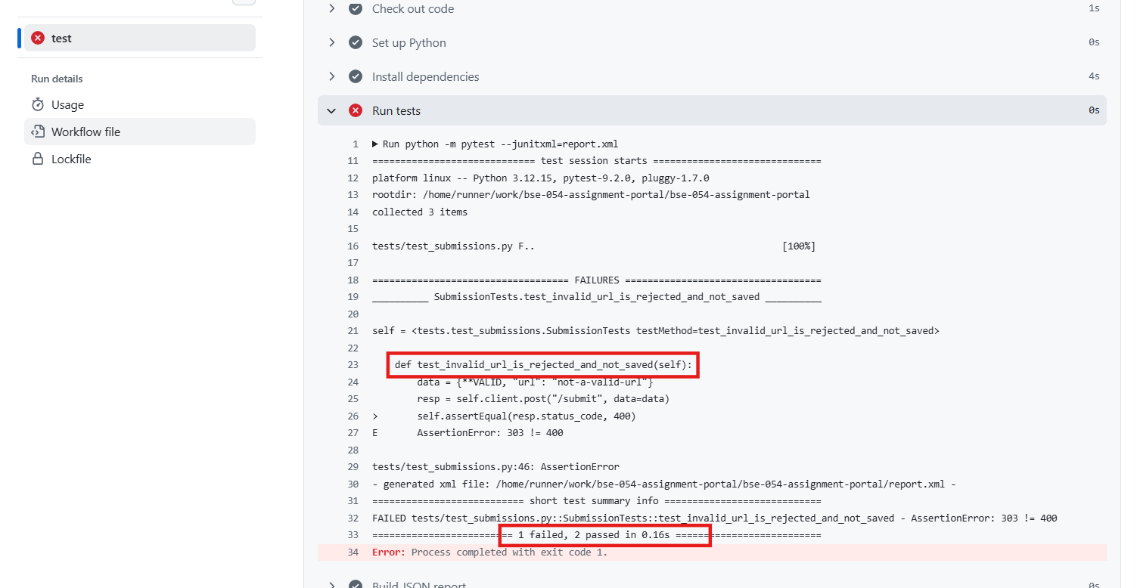
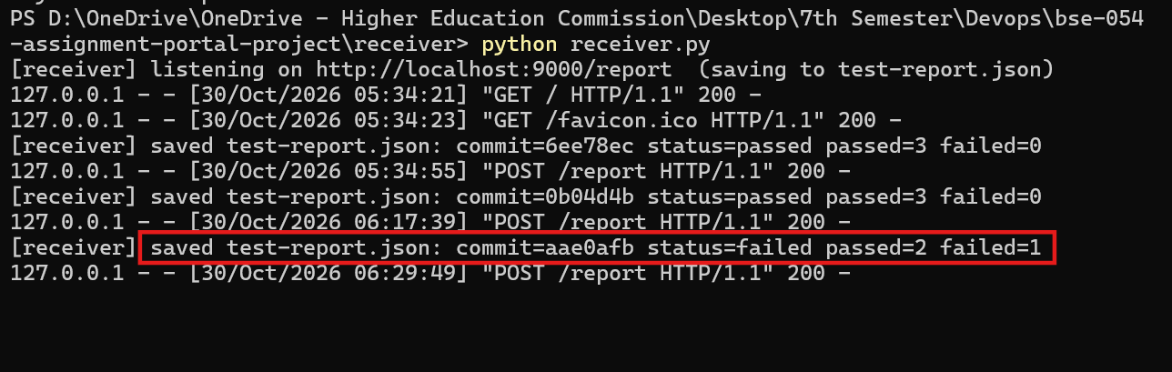

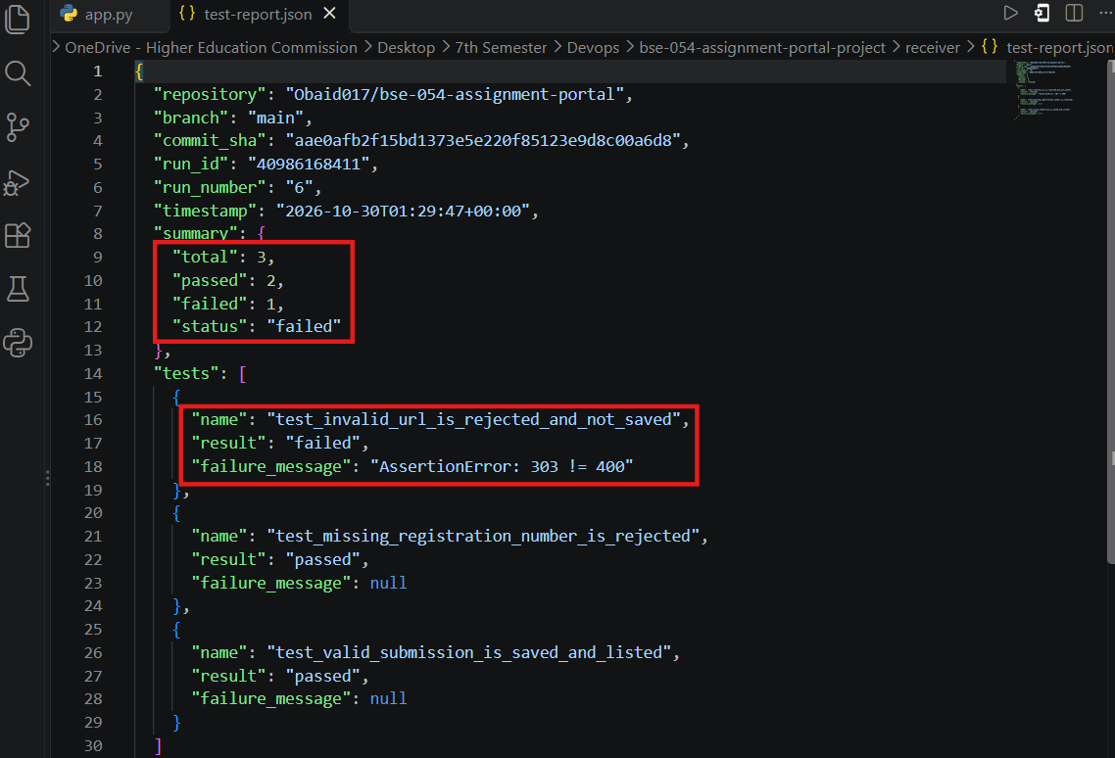5.3 Run C - fix the defect and push (passing run)
Delete the line "return True" from is_valid_url() and push again.
Terminal 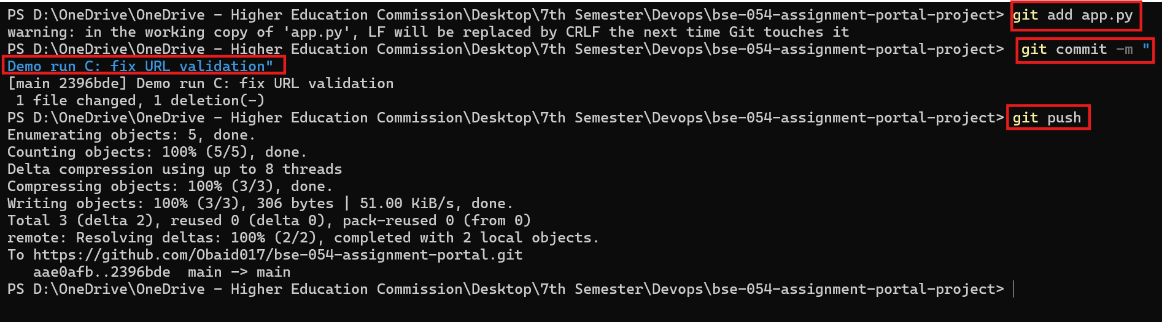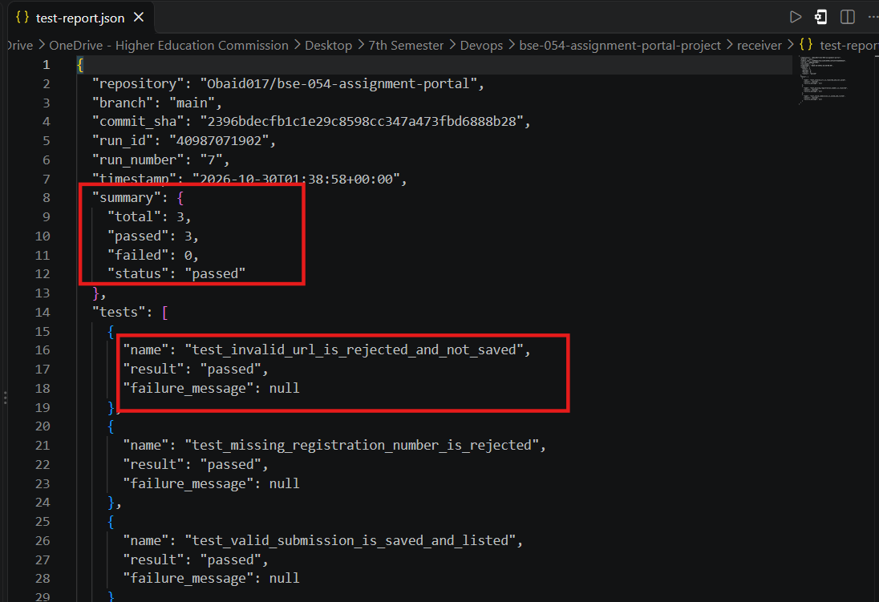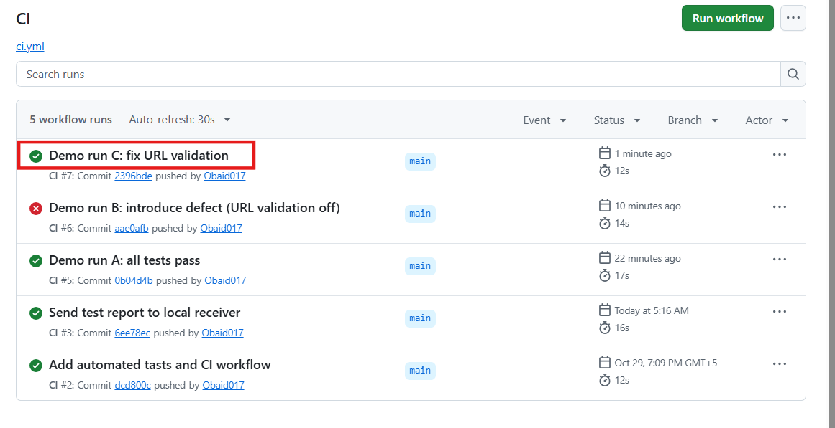

5.4 Summary of the three runs
Run | Commit SHA | Result | Passed / Failed | Run URL
A (all pass) | https://github.com/Obaid017/bse-054-assignment-portal/commit/0b04d4b6e06809078c4c0c0887de00bac4bf52e5 | Passed | 3 / 0 | Demo run A: all tests pass · Obaid017/bse-054-assignment-portal@0b04d4b
B (defect) | https://github.com/Obaid017/bse-054-assignment-portal/commit/aae0afb2f15bd1373e5e220f85123e9d8c00a6d8 | Failed | 2 / 1 | Demo run B: introduce defect (URL validation off) · Obaid017/bse-054-assignment-portal@aae0afb
C (fixed) | https://github.com/Obaid017/bse-054-assignment-portal/commit/2396bdecfb1c1e29c8598cc347a473fbd6888b28 | Passed | 3 / 0 | Demo run C: fix URL validation · Obaid017/bse-054-assignment-portal@2396bde

Bonus 1: Deployment to GitHub Pages
Requirement: after a push to main, publish a static frontend/demo to GitHub Pages only when all tests for that revision pass. A failing run must leave the previously published version unchanged.

B1.1 Enable GitHub Pages
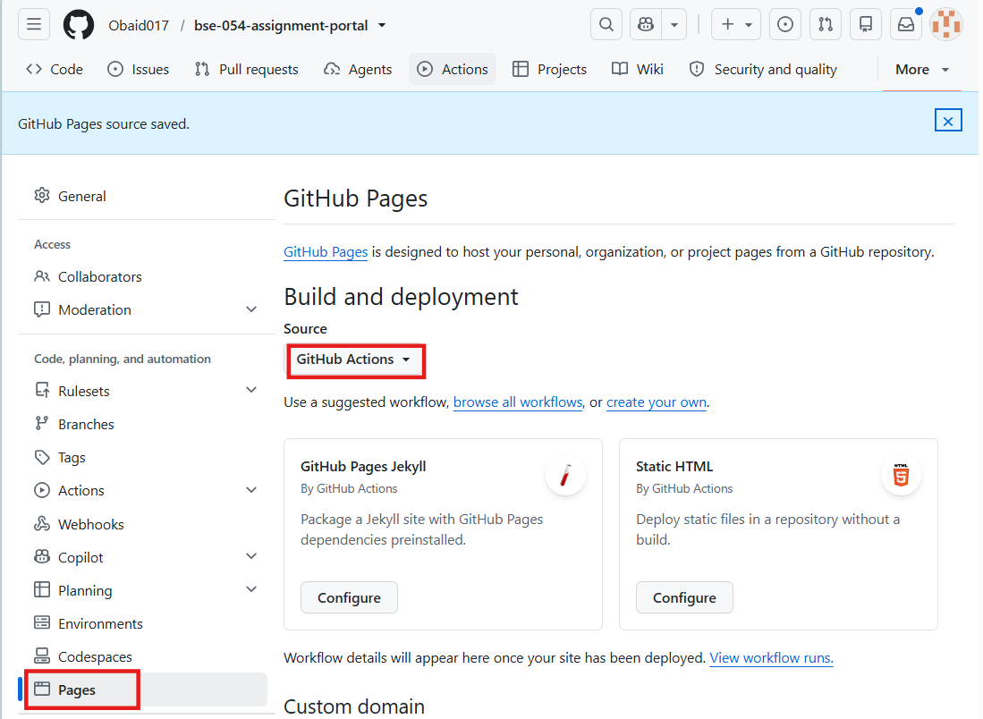

B1.2 Add the deploy job to ci.yml
Add this job at the end of ci.yml (same indentation as the "test:" job). The two lines that make it conditional are "needs: test" (the job only runs if the test job succeeded) and "if: github.ref == 'refs/heads/main'" (only on main). When a test fails the deploy job is skipped, so the last published site stays unchanged. Its own permissions block gives only this job the pages and id-token rights it needs.
Add to .github/workflows/ci.yml
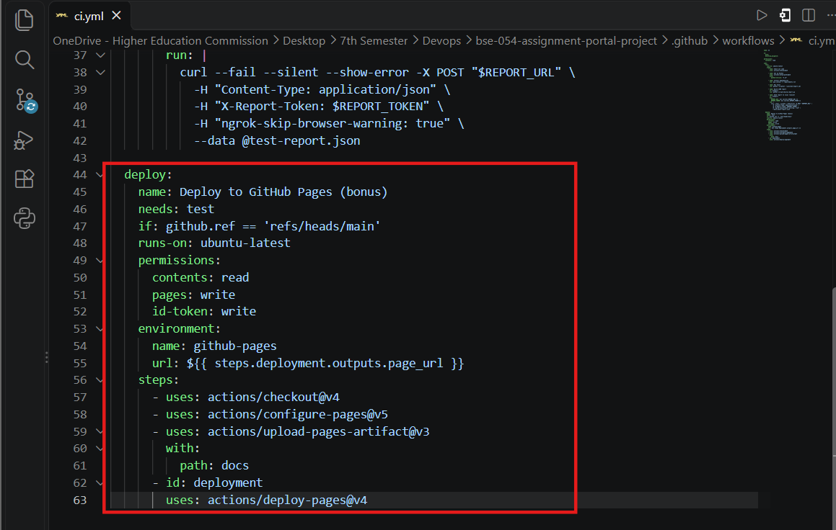
Push code on GitHub
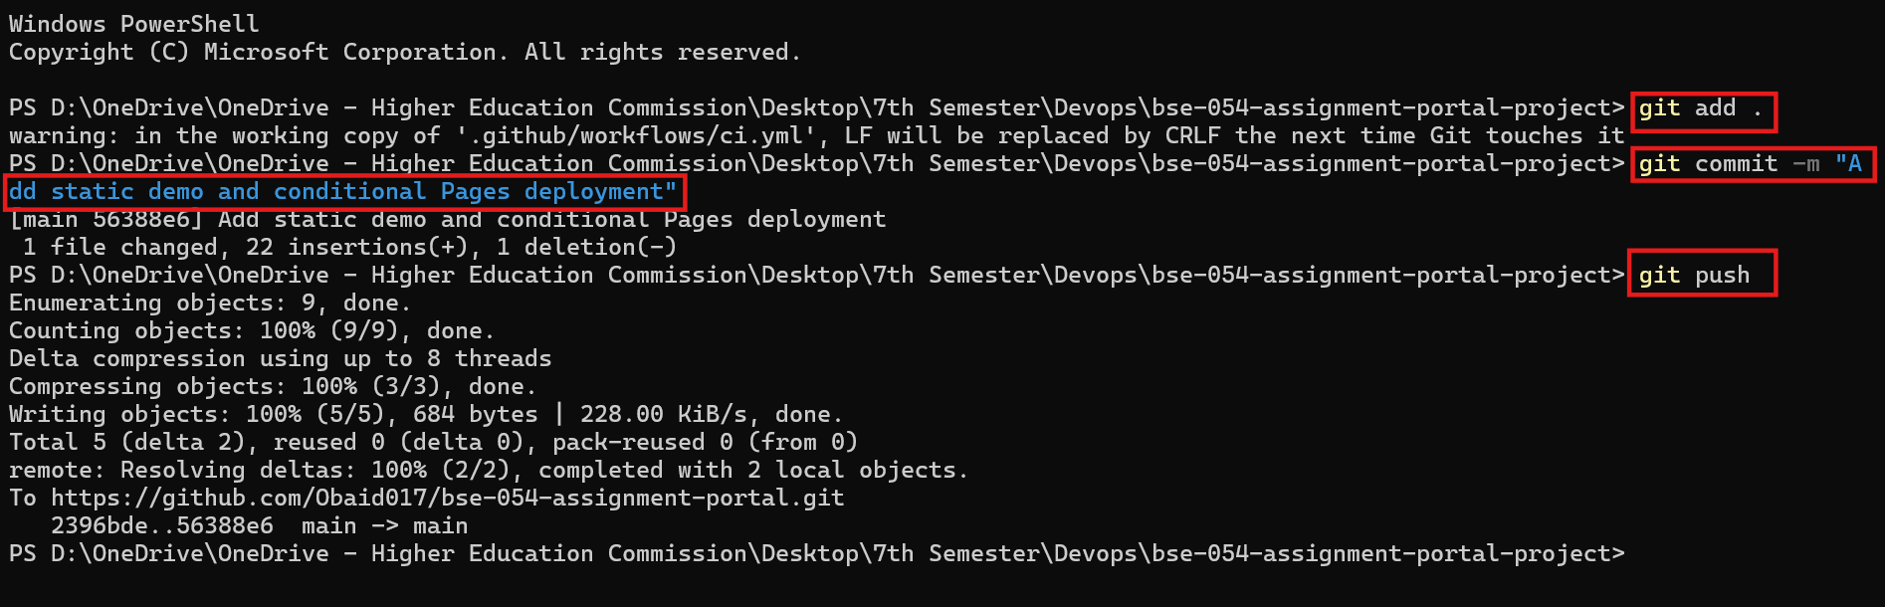

B1.3 Verify both cases

All Test cases Pass

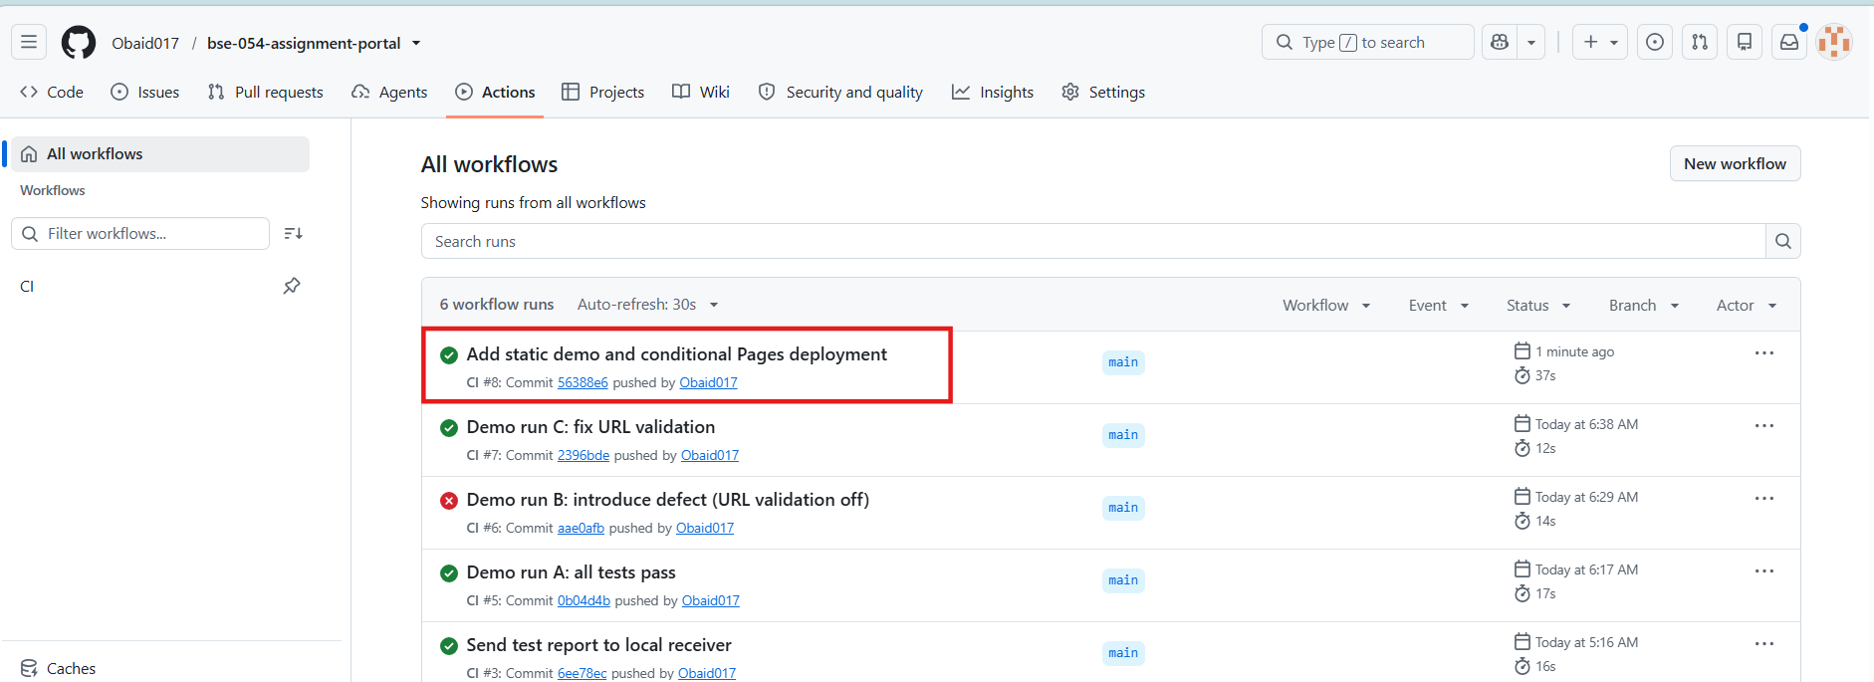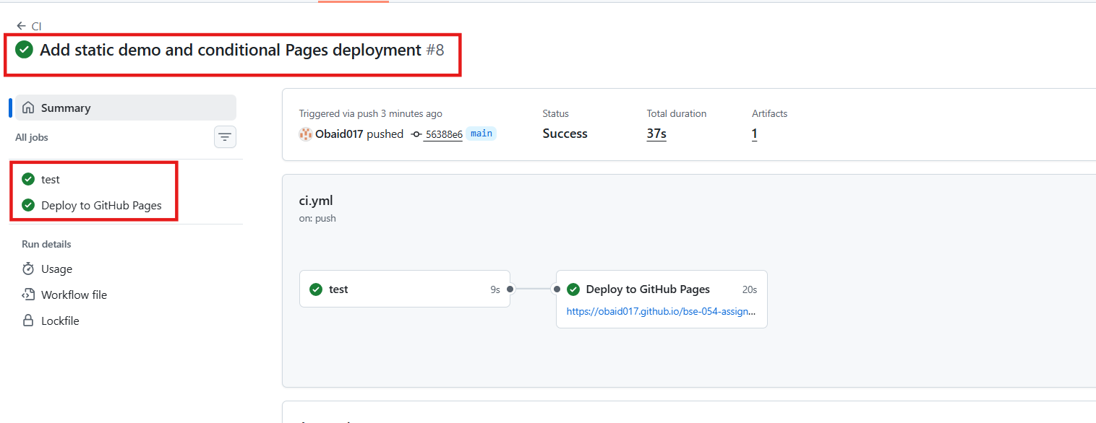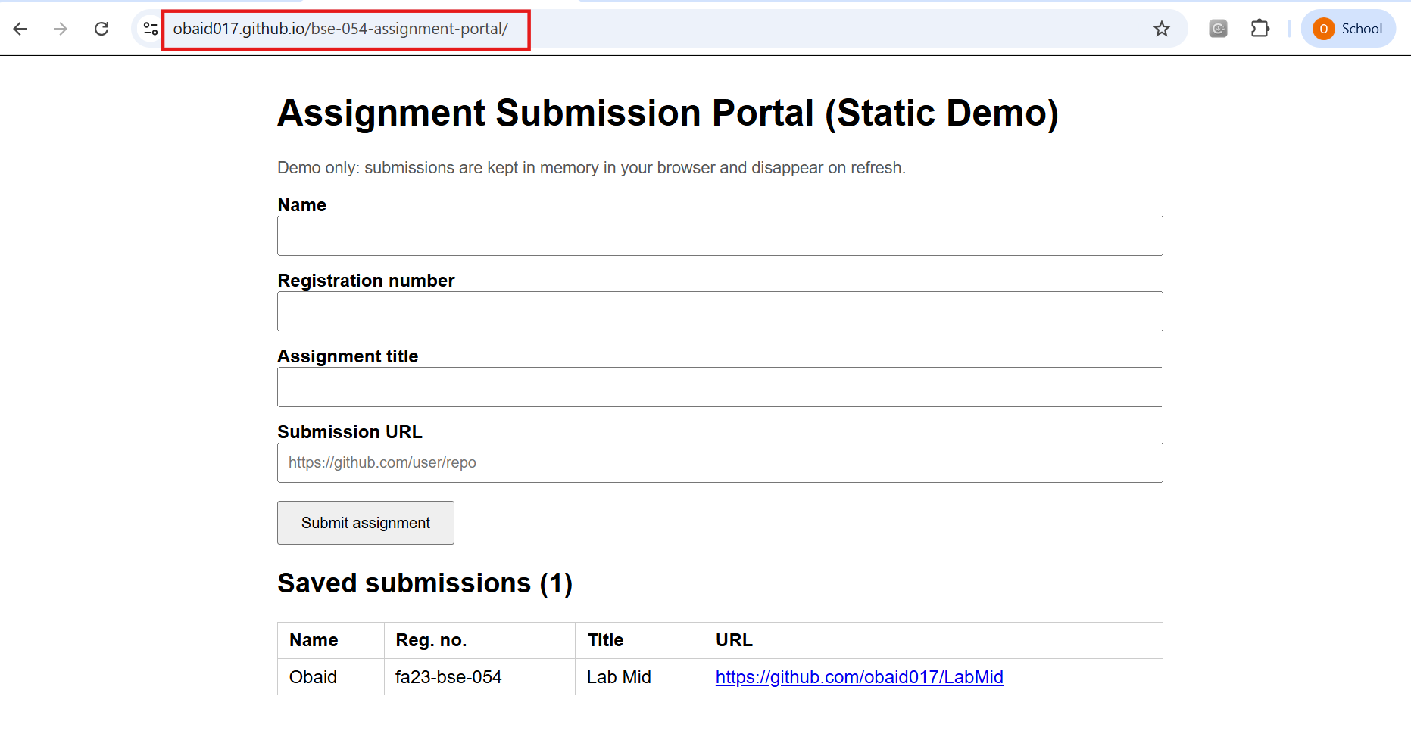

Prove a failing run does NOT deploy

App.py (Defects)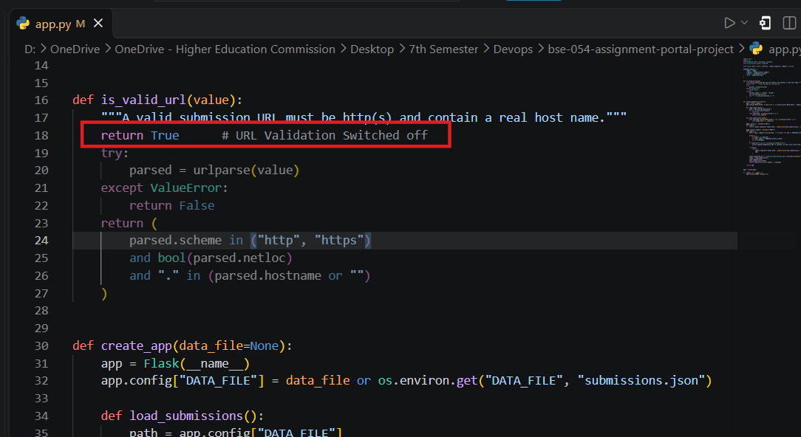Push Code On Github

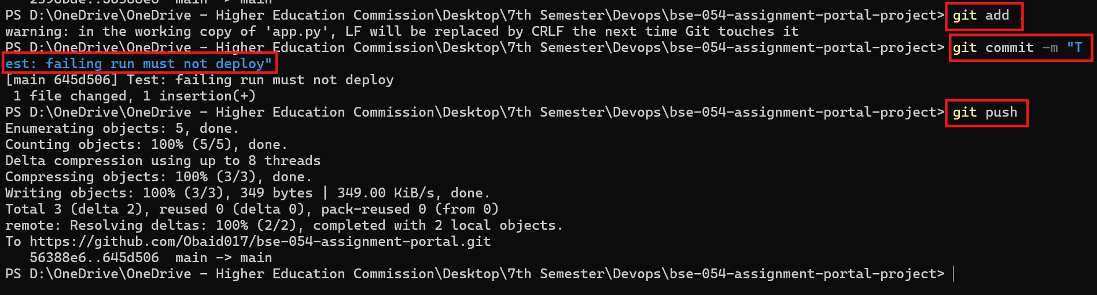Not Deploy to Github page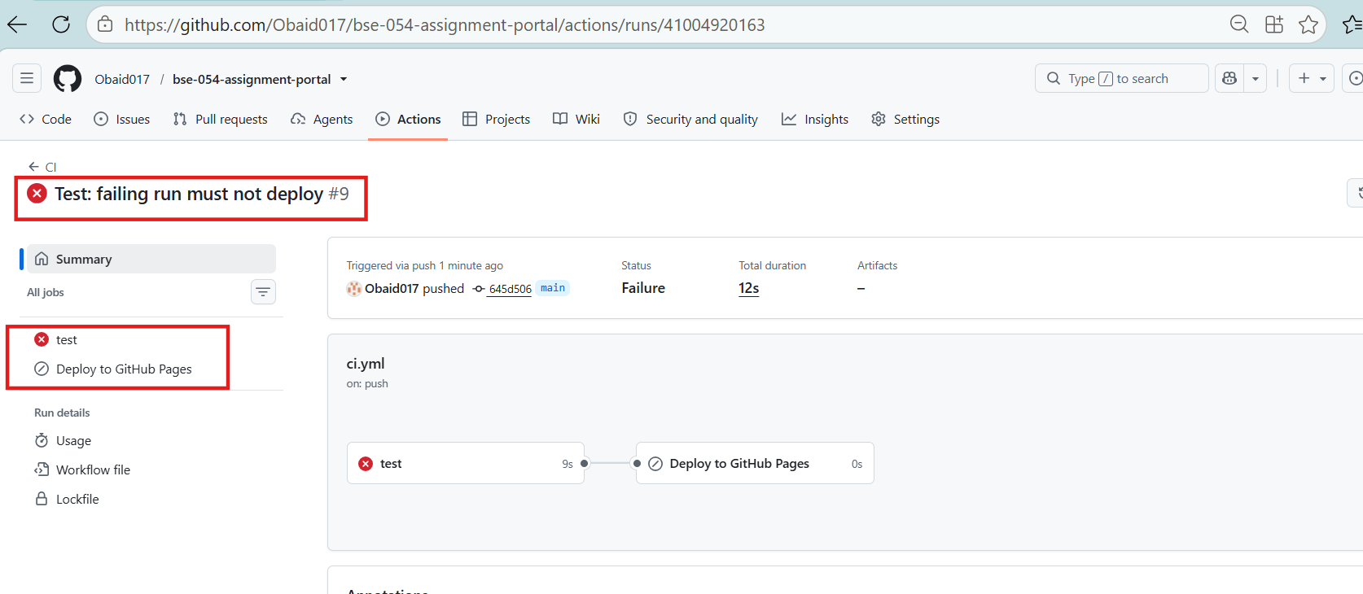

Older Version Run Successfully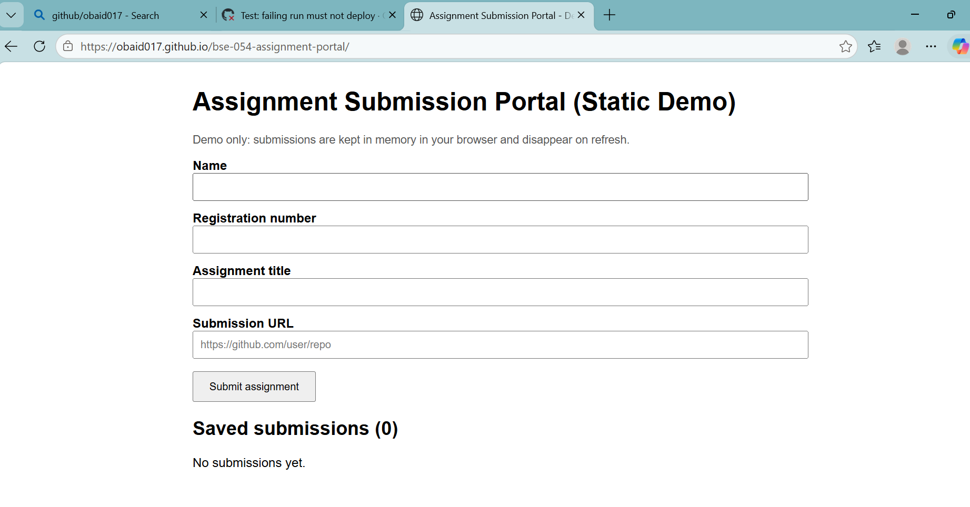

Fix it and deploy again

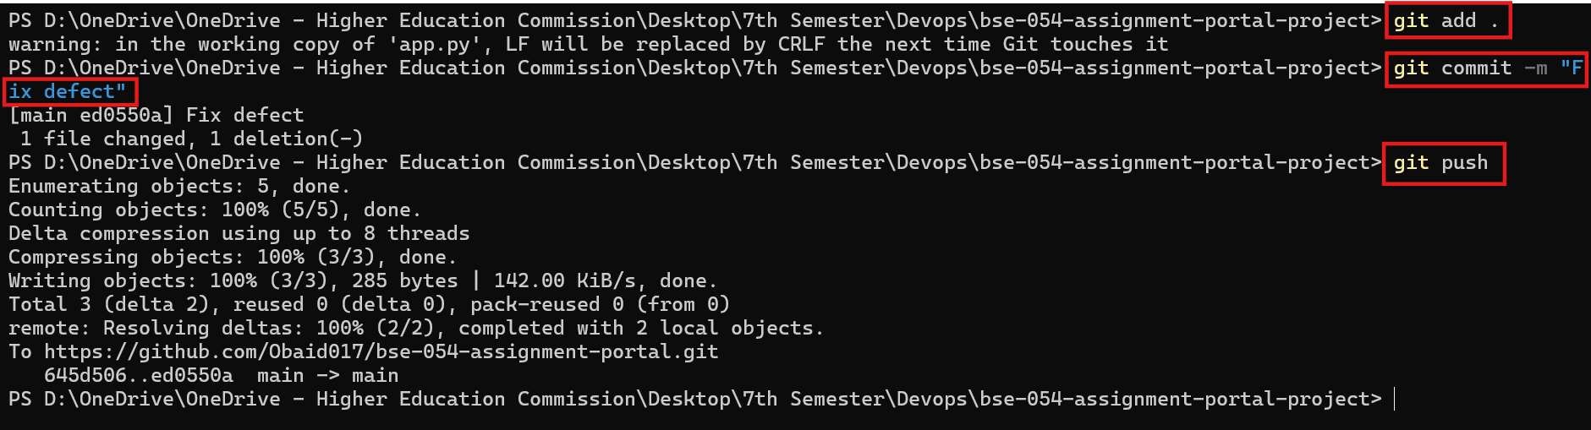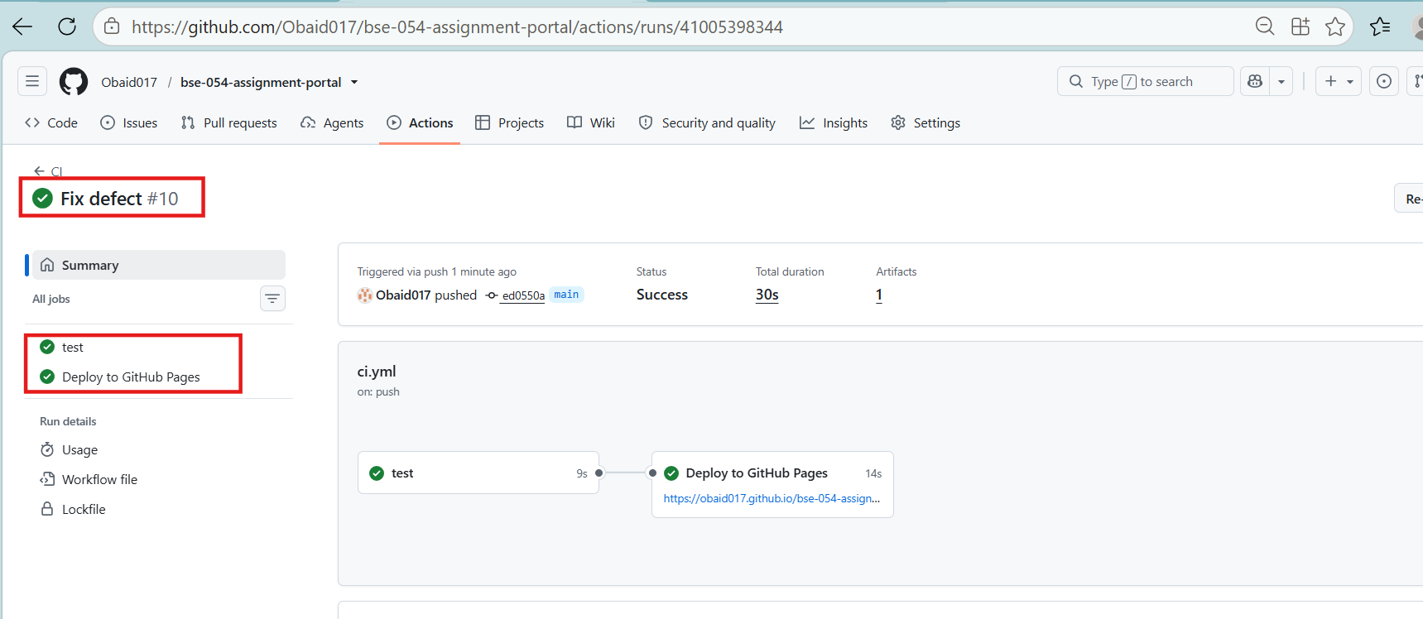

B1.4 Deployed URL
https://obaid017.github.io/bse-054-assignment-portal/

Bonus 2: Email the Test Report
Requirement: after both passing and failing runs, email the report to a configurable address with the commit identifier, overall result, test counts and individual results (or the report attached). Credentials must stay in secrets.

B2.1 Create a Gmail App Password
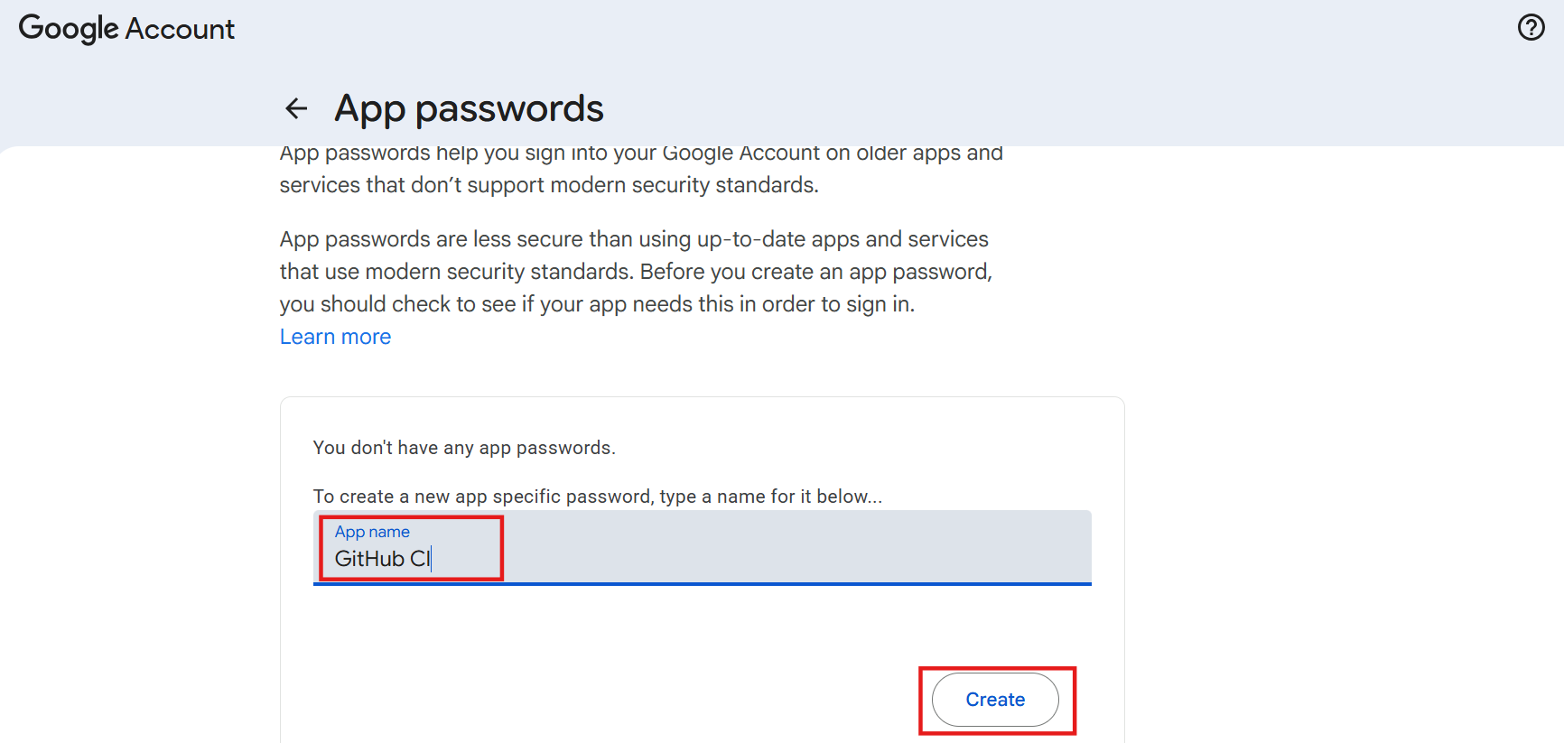

B2.2 Add the email secrets
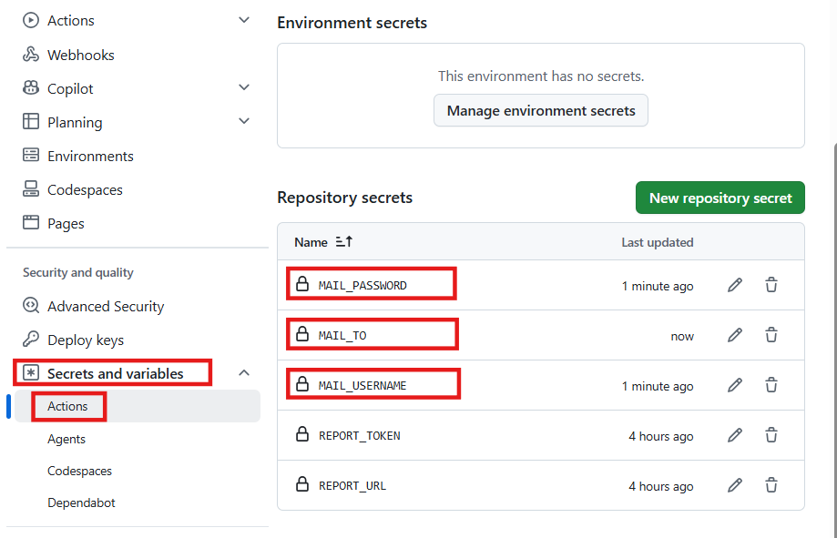

B2.3 Add the email step to ci.yml
Add this step at the end of the test job (after "Send report to local receiver"). With "if: always()" it also runs after failing tests. The email body is summary.txt (commit, result, counts and each test result) and test-report.json is attached.
Add to .github/workflows/ci.yml
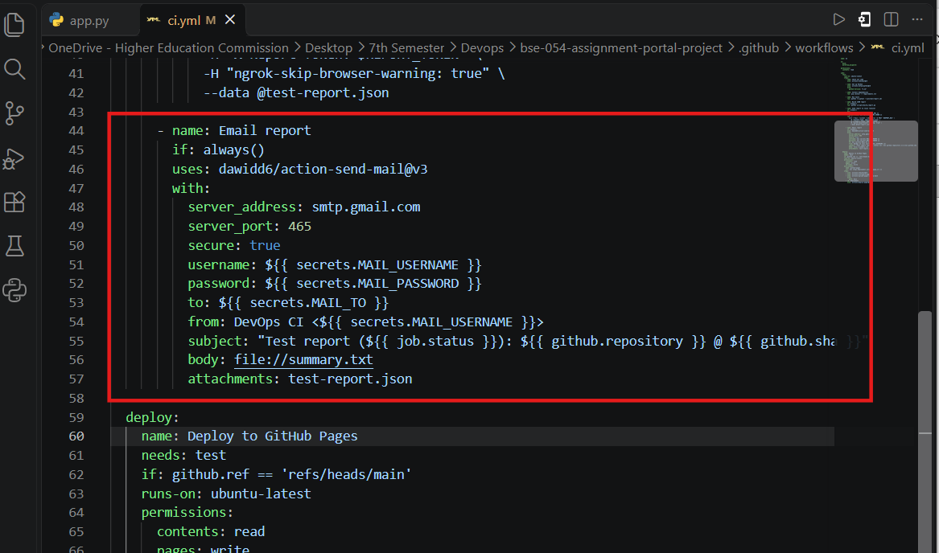
Push Code on GitHub 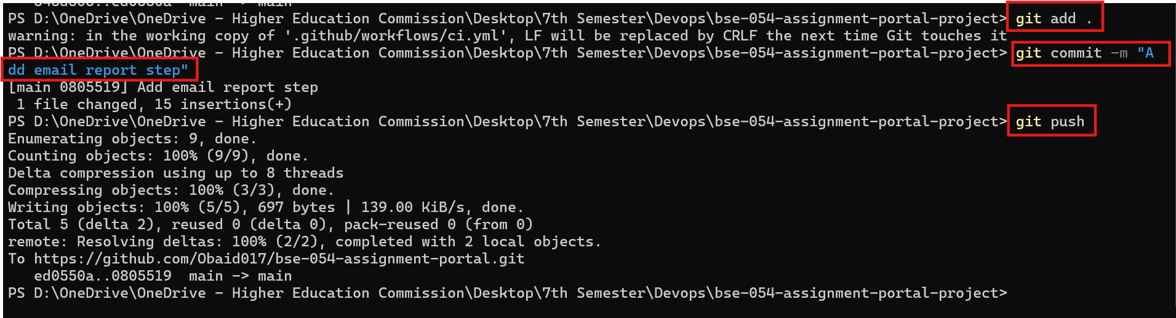

B2.4 Evidence of received emails 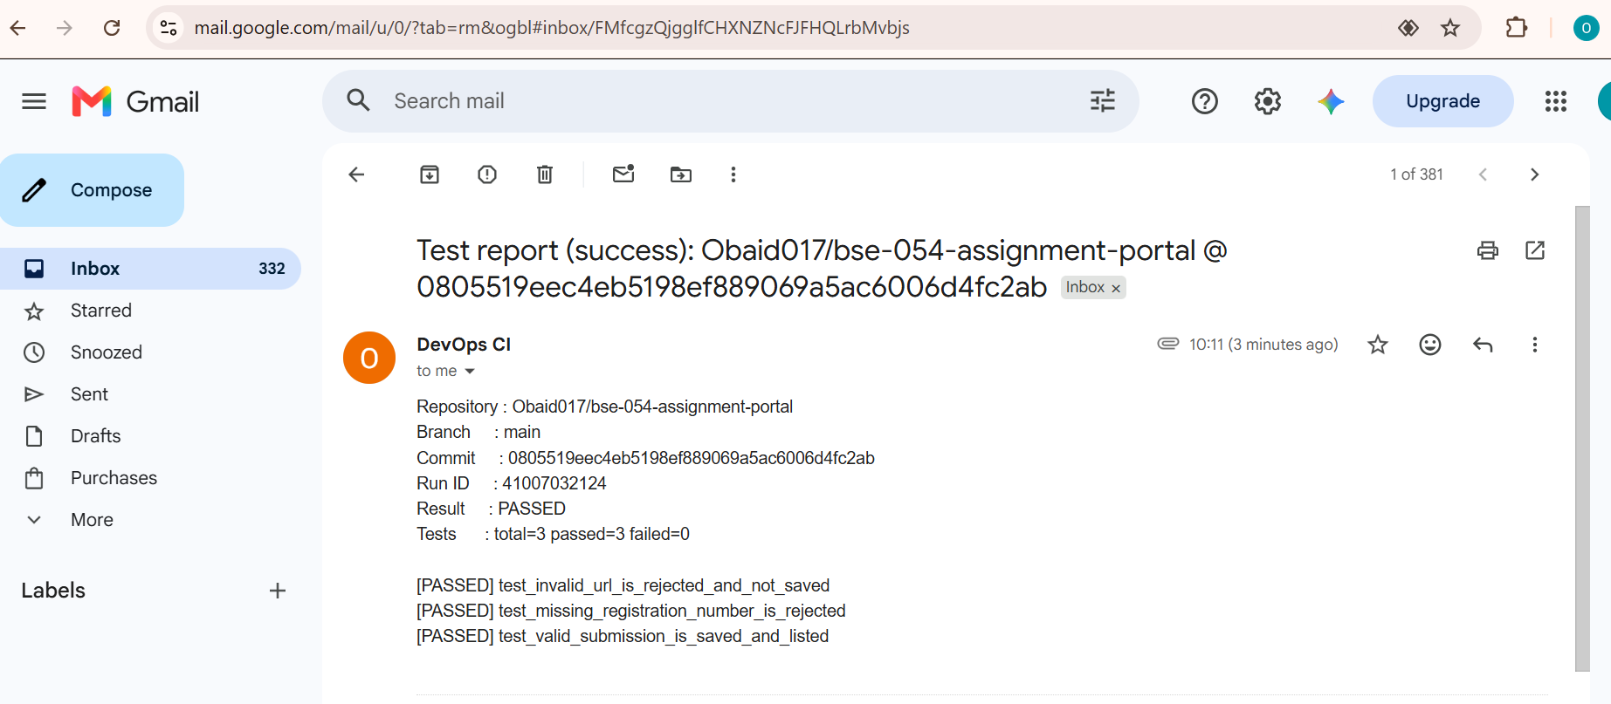 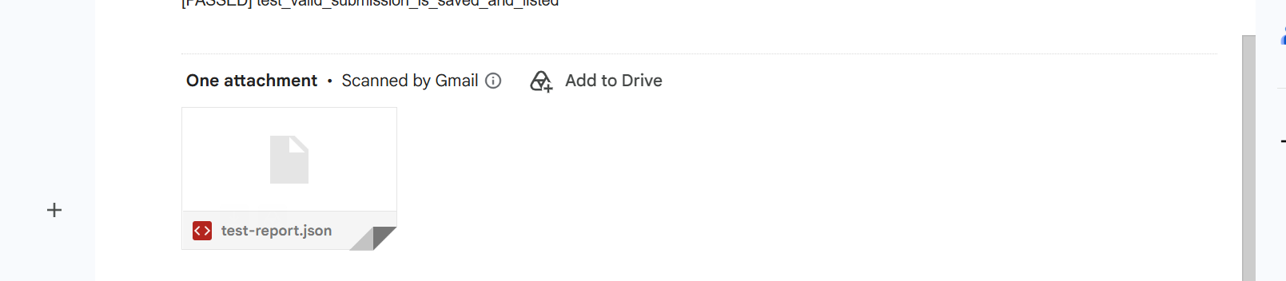

Test-report.json in mail

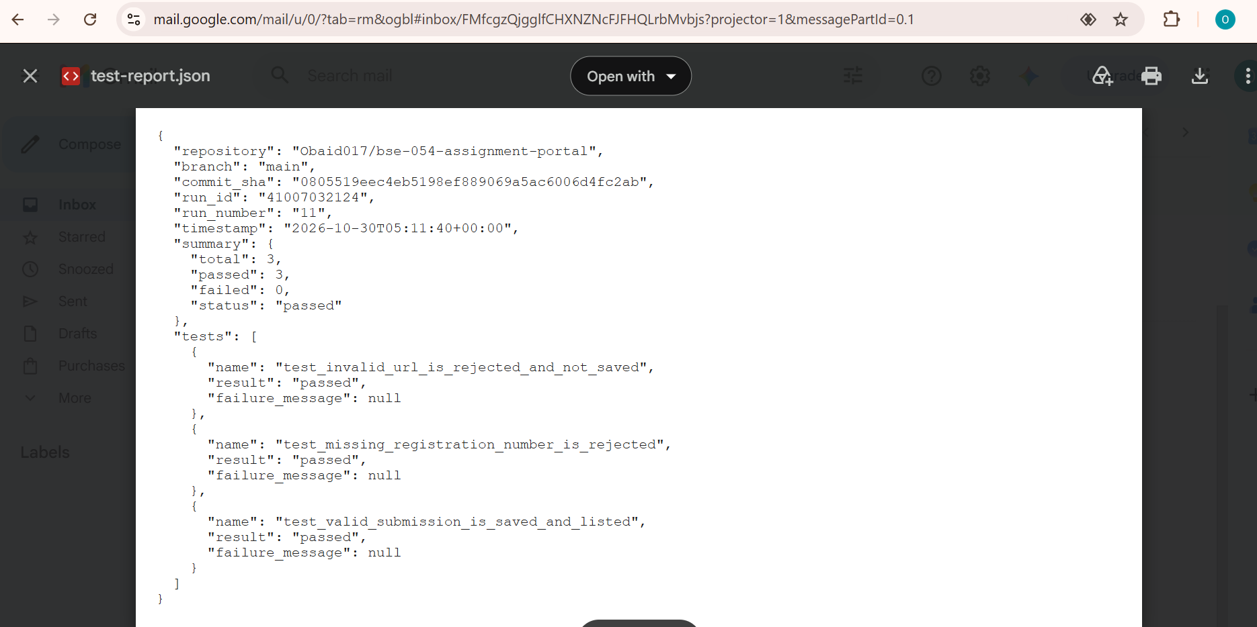

Verify Through GitHub Actions 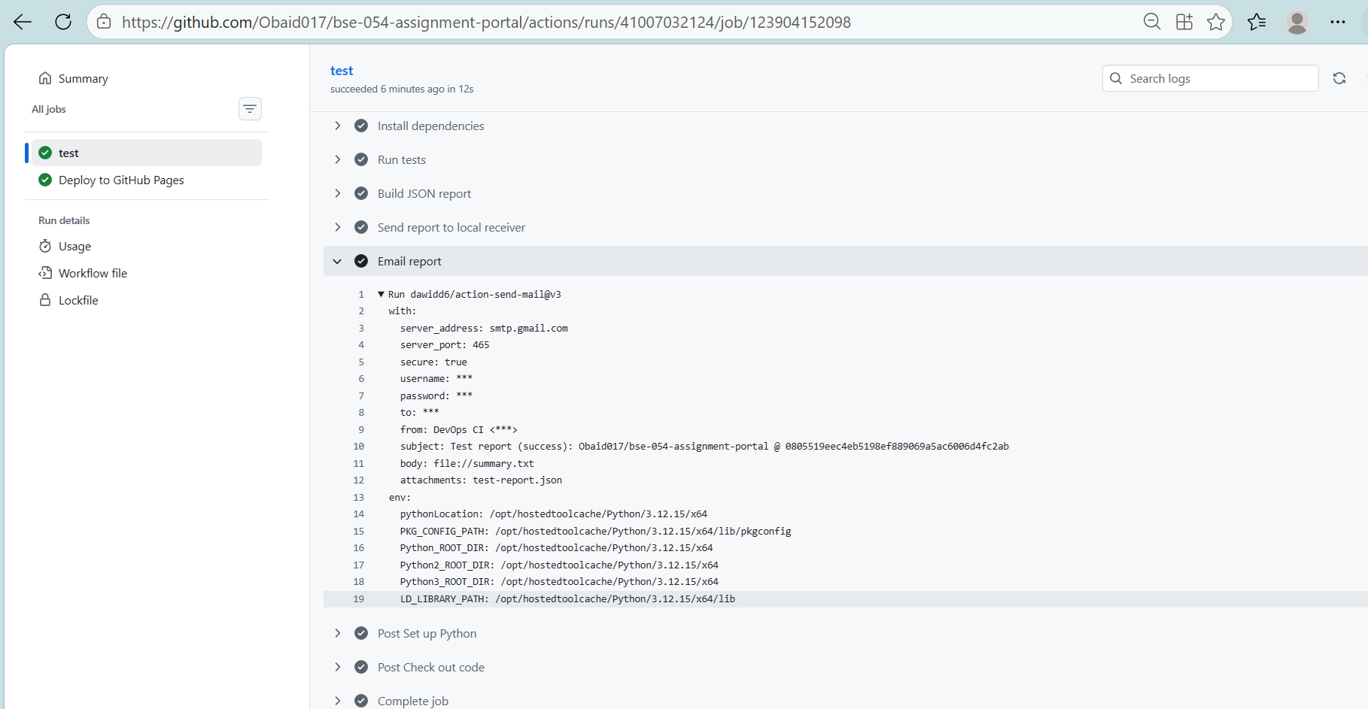

If Test Case Fail

Push Code on GitHub With Fail Test

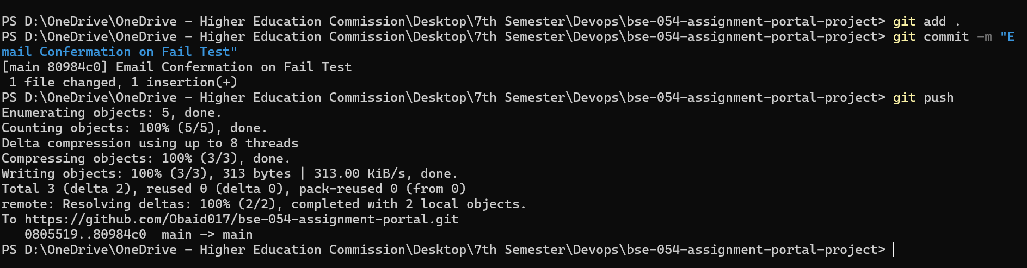

Mail Confirmation 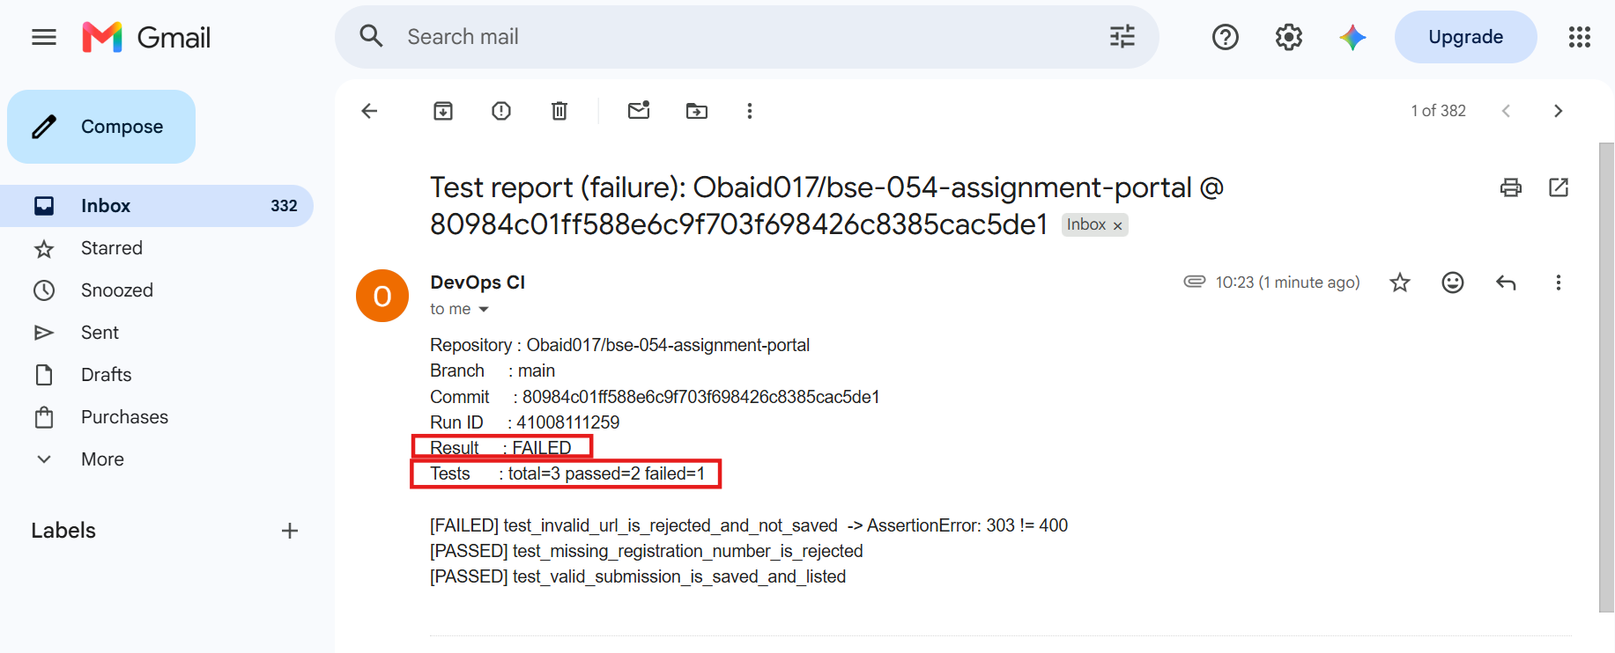

File Attach With Mail 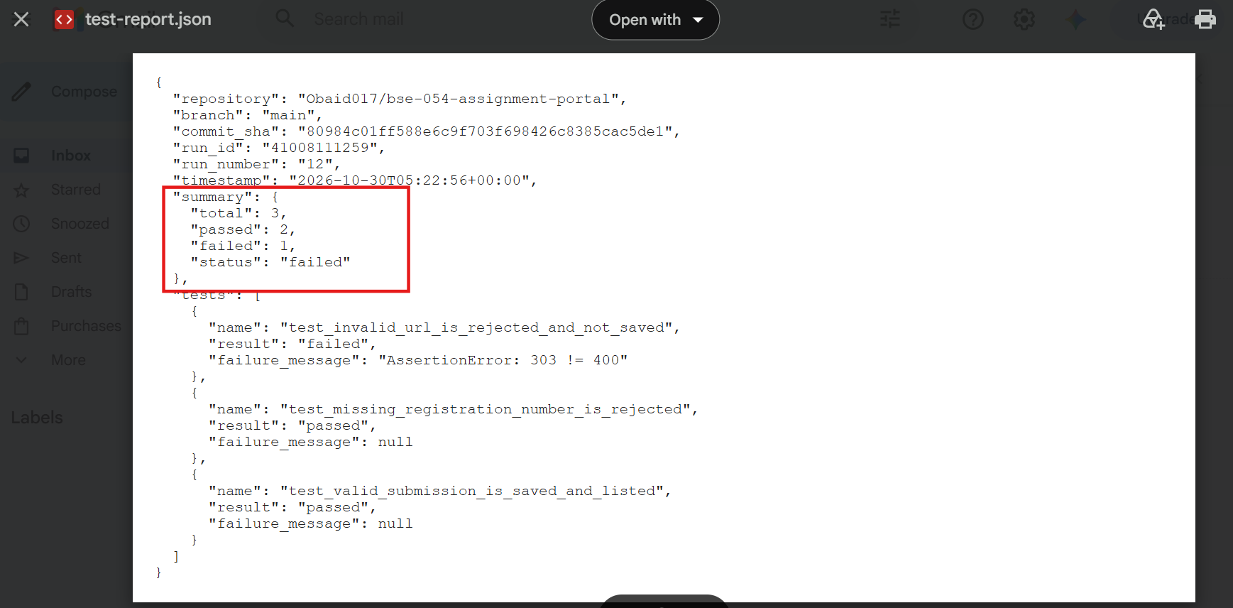

Fix it and deploy again

Push Code 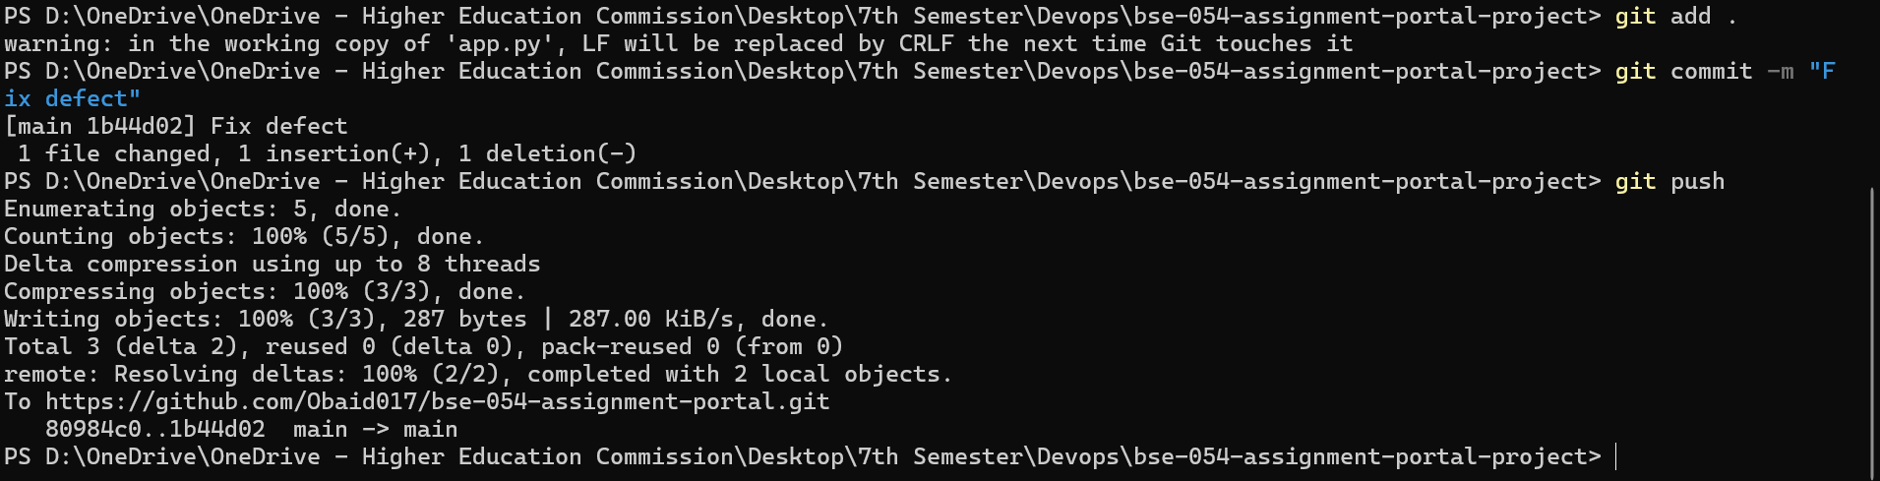

Confirmation Through GitHub Action 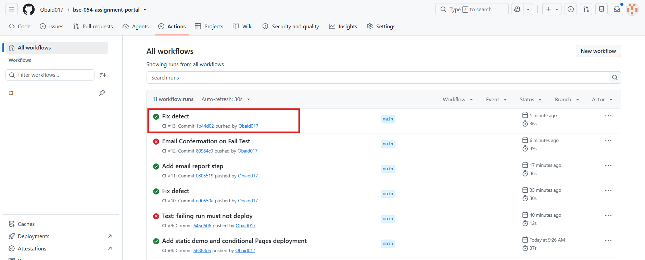

Confirmation Through Mail 