***NAME: MUHAMMAD OBAID ULLAH***

***SECTION: BSCS-1F***

***ROLL NO: 24K-0793***

**Question1**:

Open Command Prompt and navigate to the directory where you want to work.

Use the (change directory) command to move to different folders. For example, move to the

Documents folder and then back to the root directory. Take a screenshot of your Command

Prompt window showing the directory changes.

STEP 1:

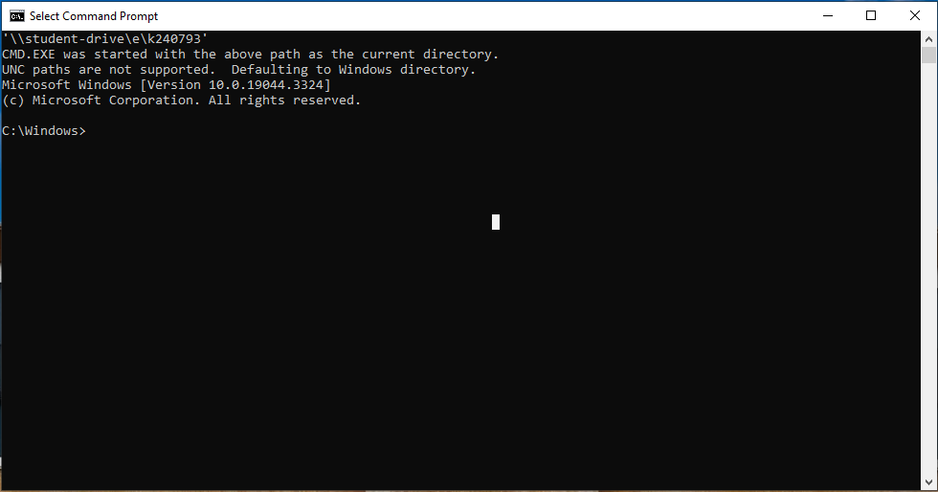

STEP 2:

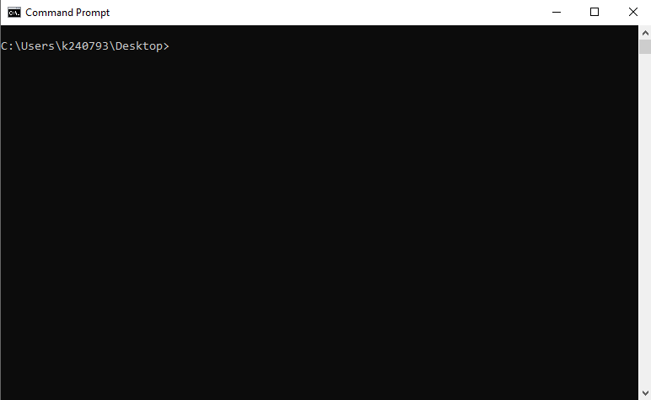

STEP 3:

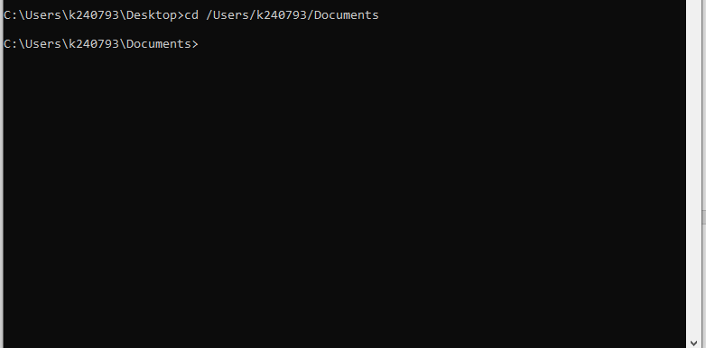

STEP 4:

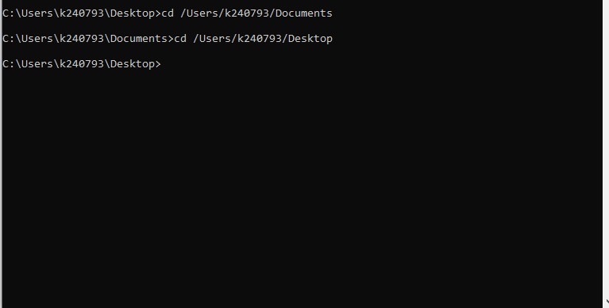

**Question2**:

Create a new folder named Lab_Task_Folder in your desktop. Inside this

folder, create two text files named file1.txt and file2.txt. Use the echo command to

add some sample text to these files. List the contents of the folder to confirm that the files

were created. Finally, delete file2.txt and take a screenshot showing the remaining files.

**STEP 1:**

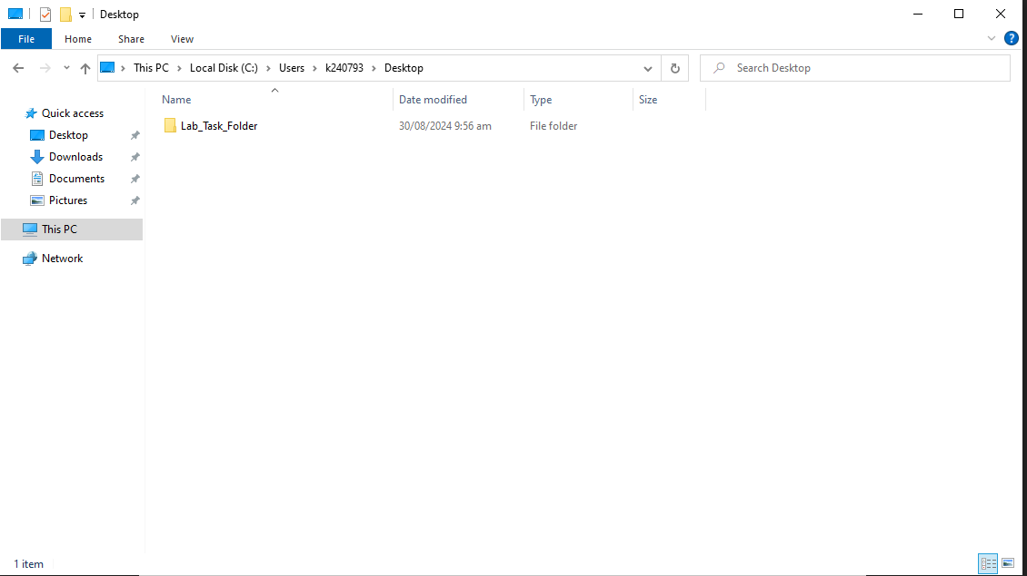

**STEP 2:**

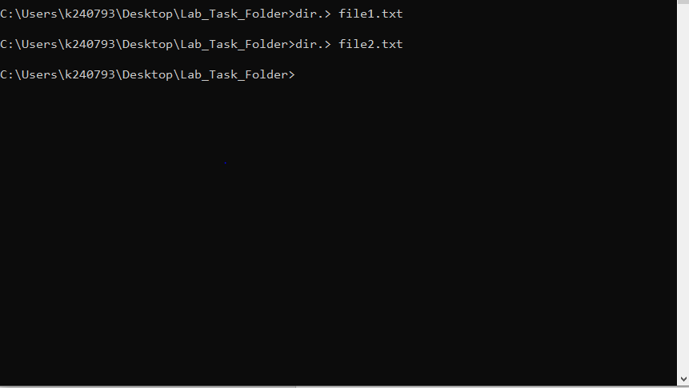

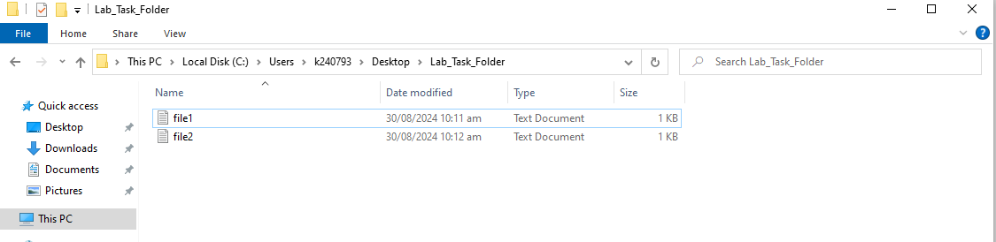

**STEP 3:**

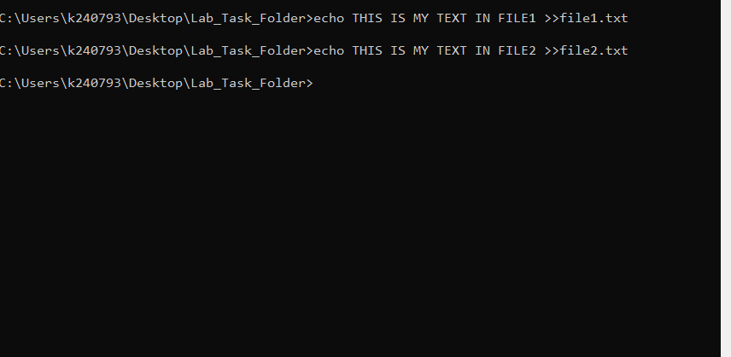

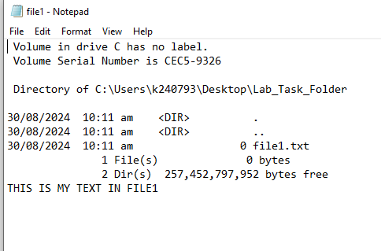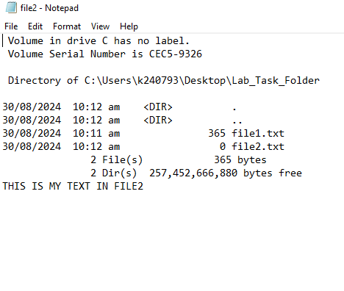

**STEP 4:**

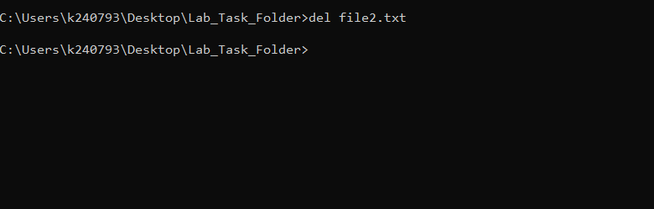

**STEP5:**

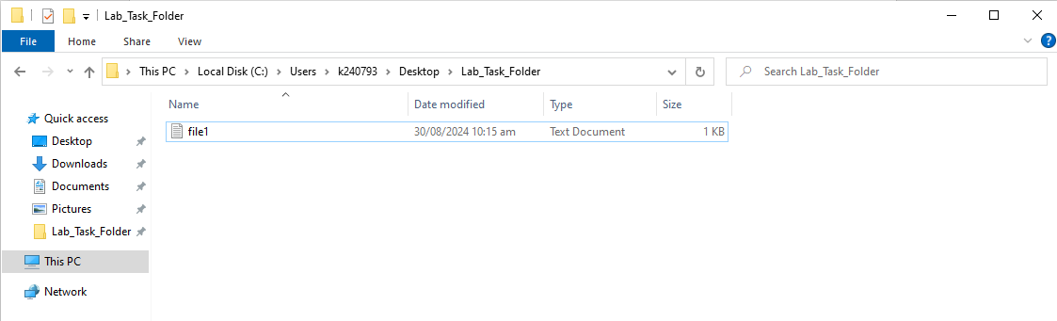

**Question3:**

Create a text file named report.txt in your user directory with the text "This is a

report." Check that the file was created by listing the contents of your user directory. Then, rename

report.txt to summary.txt and verify that the rename operation was successful by listing the

directory contents again. Take a screenshot showing the directory before and after the rename.

STEP 1:

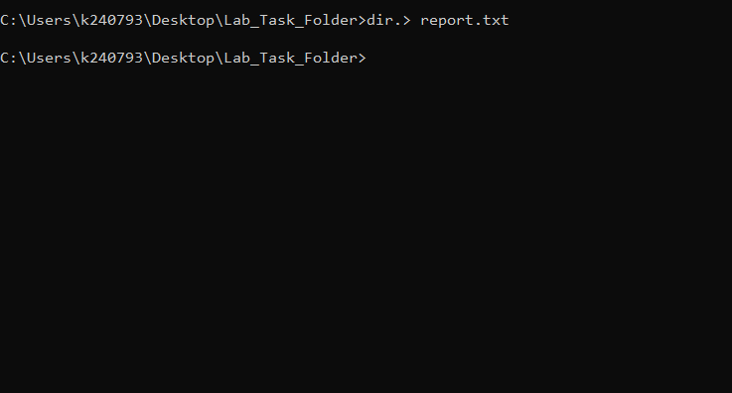

STEP 2:

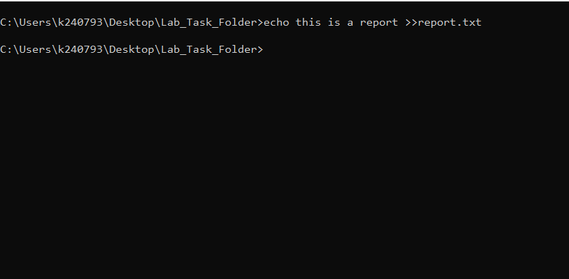

STEP 3: