NAME: MUHAMMAD OBAID ULLAH

SECTION: BSCS-1F

ROLL NO: 24K-0793

TASK_1:

Retrieve all employee id, their salaries, and hire dates from the employees table. Only display those whose salary is greater than 5000. Order the result by the hire date in descending order.

STEP 1:

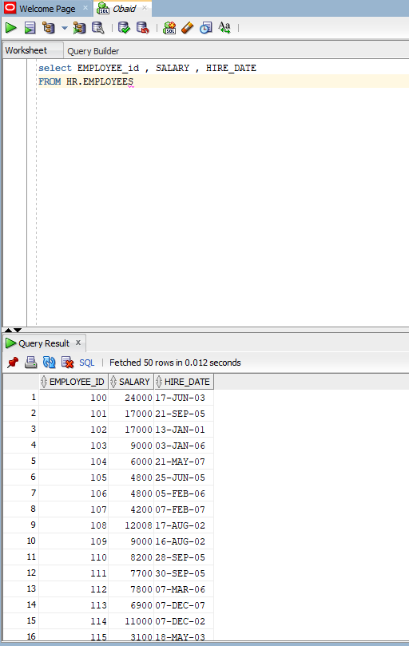

***STEP2:***

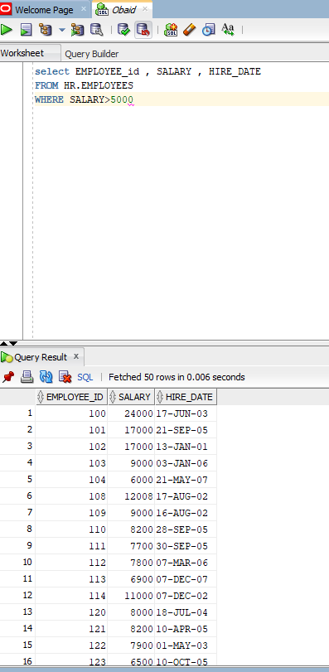

***STEP:3***

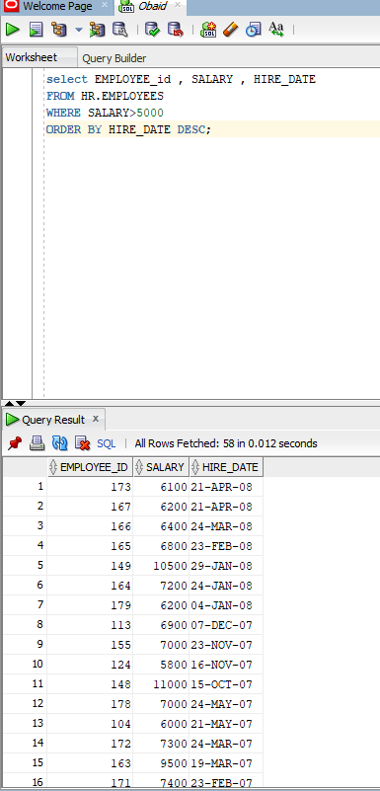

***TASK:2***

Update the salary of the employee with ID 103 to 8000.

***STEP:1***

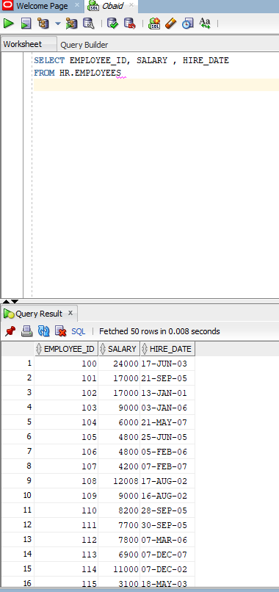

***STEP:2***

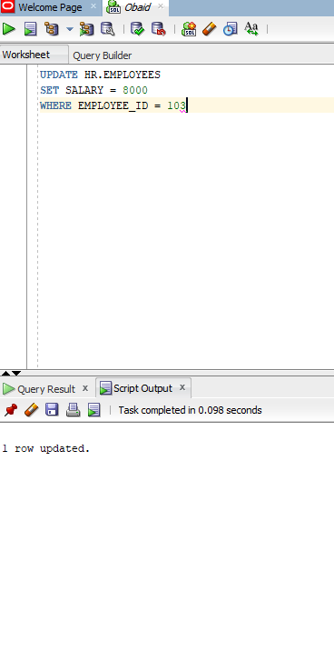

***STEP:3***

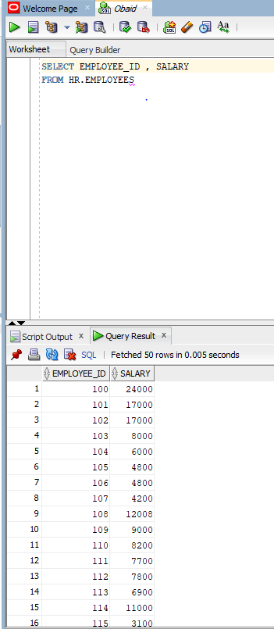

TASK3:

Remove employees from the employees table whose salary is less than 3000.

***STEP1:***

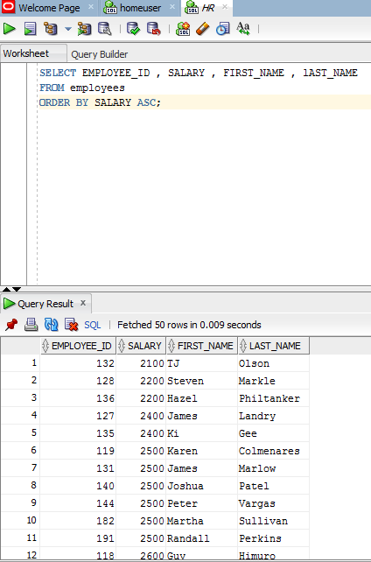

***STEP 2:***

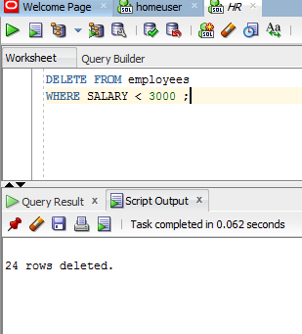

***STEP 3:***

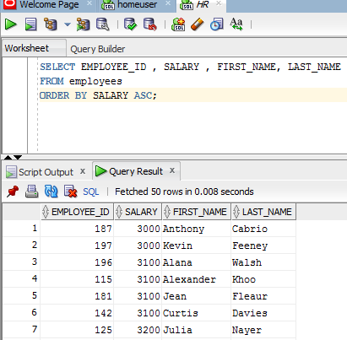

***TASK 4:***

***Display the total salary paid in each department. Group the results by department ID.***

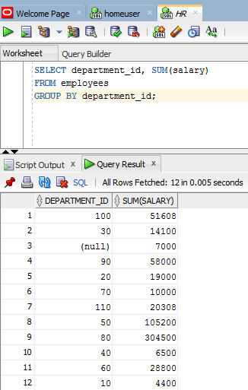

***TASK 5:***

Display department IDs and their total salary, but only for departments where the total salary exceeds 50,000.

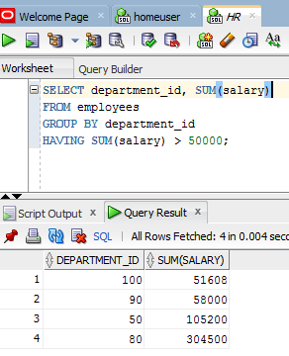

***TASK 6:***