|  |
| --- |
| **Digital Logic Design**  **(EL-1005)** |
| **LABORATORY MANUAL**  **Spring-2025** |



|  |  |  |
| --- | --- | --- |
| **LAB 08**  **Binary Decoder** | | |
|  |  |  |
| ________________________________________ | __________ | ___ |
| STUDENT NAME | ROLL NO | SEC |
|  | | |
| ______________________________________ | | |
| INSTRUCTOR SIGNATURE& DATE | | |
| **MARKS AWARDED: /10** | | |
| ___________________________________________________________________ | | |
| **NATIONAL UNIVERSITY OF COMPUTER AND EMERGING SCIENCES (NUCES), KARACHI** | | |

**Lab Session 08: Binary Decoder**

**OBJECTIVES:**

* Define basics of decoding mechanism
* Explain the working principle of 2 – 4 Decoder, 3-8-line Decoder & BCD to Seven Segment Decoder.
* Understand the usage of Seven Segment Display
* Familiarize with some important terminologies like
* Common Anode & Common Cathode Display
* Active High enable & Active Low enable devices

**APPARATUS:** Logic trainer, Logic probe

**COMPONENTS: 74LS138 (3-8-line decoder), 74LS47 (BCD to Seven Segment Decoder)**

#### **THEORY:**

Decoder is a multiple-input, multiple-output logic circuit that converts coded inputs into coded output coded outputs. The basic function of decoder is to detect the presence of a specified combination of bits (code) at its input and indicate the presence of that code by a specified output. Various kinds of decoding include n-to-2n decoding & binary-coded decimal decoding. Decoder has Enable inputs which must be on for the decoder to function.

## **2 to 4 Decoder**

Let 2 to 4 Decoder has two inputs A1 & A0 and four outputs Y3, Y2, Y1 & Y0. The **block diagram** of 2 to 4 decoder is shown in the following figure.

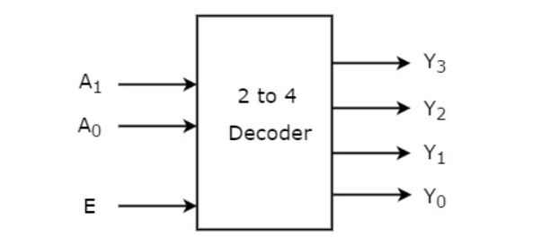

One of these four outputs will be ‘1’ for each combination of inputs when enable, E is ‘1’. The **Truth table** of 2 to 4 decoder is shown below.

Each output is having one product term. So, there are four product terms in total. We can implement these four product terms by using four AND gates having three inputs each & two inverters. The **circuit diagram** of 2 to 4 decoder is shown in the following figure.

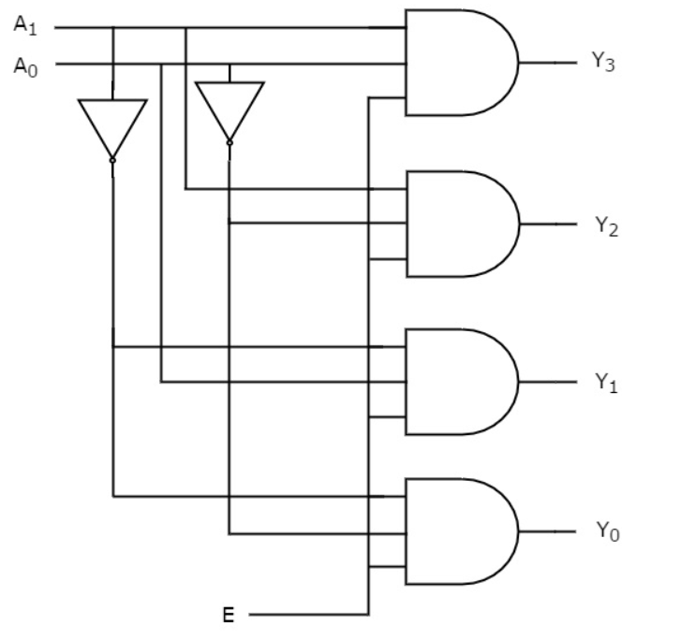

1. **Implementation of 3-8-line Decoder using IC 74LS138**

This decoder decodes one of eight lines depending on the three binary select inputs and three enable pins. It is an octal decoder capable of decoding eight possible three-bit combinations to eight separate active-Low outputs.

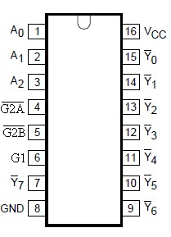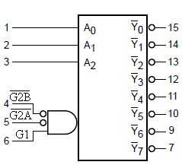

Fig 1. Pin Configuration Fig 2. Logic Symbol

A0 – A2 Input Bits

G2A**’**, G2B**’** Enable (Active LOW) Inputs

G1 Enable (Active HIGH) Inputs

Y0**’** - Y7**’** Active LOW Outputs

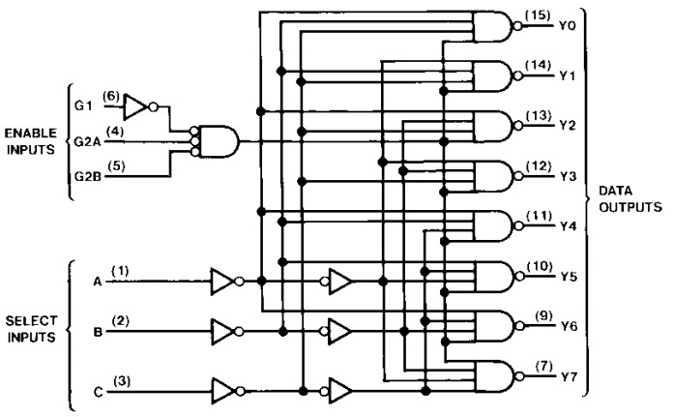

1. **Implementation of BCD to Seven Segment Decoder using IC 74LS47**

The BCD to Seven Segment Decoder accepts BCD code on its input and provides outputs to derive Seven-segment display devices to produce a decimal read-out by turning on the appropriate LED segments.

If the Seven Segment display is a common-anode display that is an active Low (Low- enable) device because it takes 0 to turn on a segment, the decoder IC to be used must also have active Low outputs. IC 74LS47 has active low outputs therefore it will require a common-anode display device for compatibility.

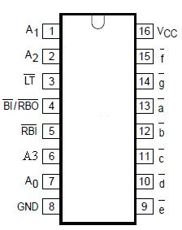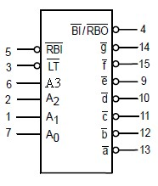

|  |
| --- |
| Fig 3. Pin Configuration Fig 4. Logic Symbol |

|  |  |
| --- | --- |
| A0 – A3 | BCD Inputs |
| RBI**’** | Ripple Blanking Input (Active LOW) |
| LT**’** | Lamp Test Input (Active LOW) |
| BI**’**/RBO**’** | Blanking Input or Ripple Blanking Output (Active LOW) |
| a**'** – g**'** | Active LOW Outputs |

# Seven –Segment Display

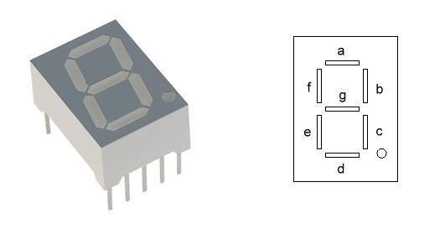

# Common Anode Display Active low inputs

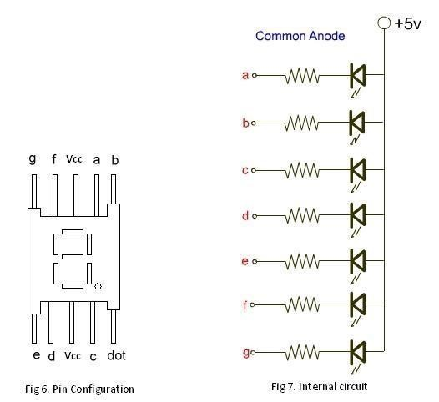

**IN-LAB TASK**

## **Exercise # 01**

**Implementation of 3-8-line Decoder using IC 74LS138**

### a. 3-8-line Decoder

|  |  |  |  |  |  |  |  |  |  |  |  |  |  |
| --- | --- | --- | --- | --- | --- | --- | --- | --- | --- | --- | --- | --- | --- |
|  | **INPUTS** | | |  |  |  | |  | **OUTPUTS** | | |  |  |
|  | **Enable** | |  | **Select** |  |
| **G1** | **G2A’** | **G2B’** | **A2** | **A1** | **A0** | **Y0’** | **Y1’** | **Y2’** | **Y3’** | **Y4’** | **Y5’** | **Y6’** | **Y7’** |
|  |  |  |  |  |  |  |  |  |  |  |  |  |  |
|  |  |  |  |  |  |  |  |  |  |  |  |  |  |
|  |  |  |  |  |  |  |  |  |  |  |  |  |  |
|  |  |  |  |  |  |  |  |  |  |  |  |  |  |
|  |  |  |  |  |  |  |  |  |  |  |  |  |  |
|  |  |  |  |  |  |  |  |  |  |  |  |  |  |
|  |  |  |  |  |  |  |  |  |  |  |  |  |  |
|  |  |  |  |  |  |  |  |  |  |  |  |  |  |

## **Exercise # 02**

**Implementation of BCD to Seven Segment Decoder using IC 74LS47**

### b. BCD to Seven Segment Decoder

|  |  |  |  |  |  |  |  |  |  |  |
| --- | --- | --- | --- | --- | --- | --- | --- | --- | --- | --- |
|  | **INPUTS** | |  |  |  | **OUTPUTS** | | |  |  |
| **A3** | **A2** | **A1** | **A0** | **a'** | **b'** | **c'** | **d'** | **e'** | **f'** | **g'** |
|  |  |  |  |  |  |  |  |  |  |  |
|  |  |  |  |  |  |  |  |  |  |  |
|  |  |  |  |  |  |  |  |  |  |  |
|  |  |  |  |  |  |  |  |  |  |  |
|  |  |  |  |  |  |  |  |  |  |  |
|  |  |  |  |  |  |  |  |  |  |  |
|  |  |  |  |  |  |  |  |  |  |  |
|  |  |  |  |  |  |  |  |  |  |  |
|  |  |  |  |  |  |  |  |  |  |  |
|  |  |  |  |  |  |  |  |  |  |  |

**POST-LAB TASK**

**Exercise #01:**

Implement a 4-16 bit decoder using the 2-4 decoder IC (Hint: for enable use the last inputs)