NAME: OBAID

ROLL NO: 24K-0793

LAB_10:

TASK_1:

TASK_2: 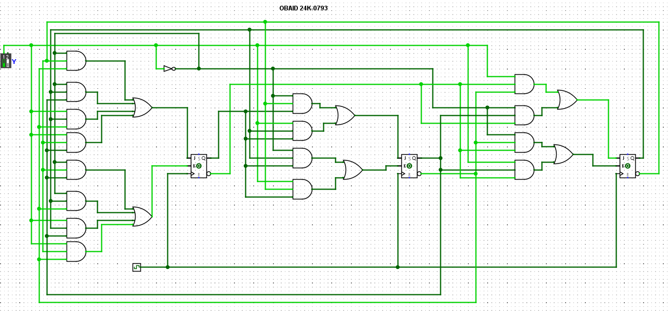

TASK_2(Truth Table):  
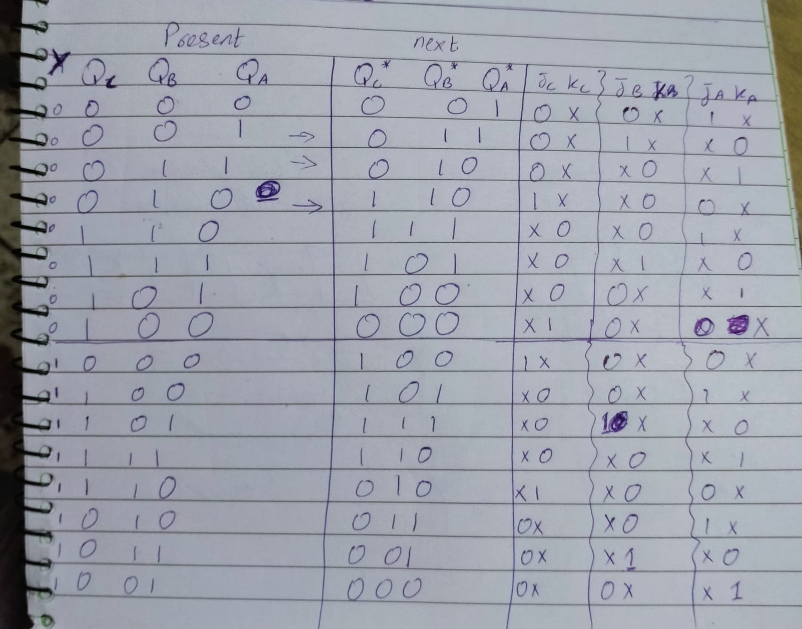

TASK_3:

