NAME: MUHAMMAD OBAID ULLAH

ROLL NO: 24K-0793

POST_LAB_TASKS_LAB_03

POST_LAB_TASK 1:

TIMING DIAGRAM:

|  |  |
| --- | --- |
| A |  |
| B |  |
| C |  |
| D |  |
| Expected Output |  |
| Actual Output |  |

SOFTWARE SCREENSHOT:



TRUTH TABLE:

|  |  |  |  |  |
| --- | --- | --- | --- | --- |
| A | B | C | D | X |
| 0 | 0 | 0 | 0 | 1 |
| 0 | 0 | 0 | 1 | 1 |
| 0 | 0 | 1 | 0 | 1 |
| 0 | 0 | 1 | 1 | 1 |
| 0 | 1 | 0 | 0 | 0 |
| 0 | 1 | 0 | 1 | 0 |
| 0 | 1 | 1 | 0 | 1 |
| 0 | 1 | 1 | 1 | 1 |
| 1 | 0 | 0 | 0 | 1 |
| 1 | 0 | 0 | 1 | 0 |
| 1 | 0 | 1 | 0 | 1 |
| 1 | 0 | 1 | 1 | 1 |
| 1 | 1 | 0 | 0 | 1 |
| 1 | 1 | 0 | 1 | 0 |
| 1 | 1 | 1 | 0 | 1 |
| 1 | 1 | 1 | 1 | 1 |

**POST_LAB_TASK_2:**

1. **A + AB = A**

Sol:

L.H.S = A + AB

L.H.S = A . ( 1 + B )

L.H.S = A . 1

L.H.S = A

L.H.S = R.H.S

CIRCIUT DIAGRAM:

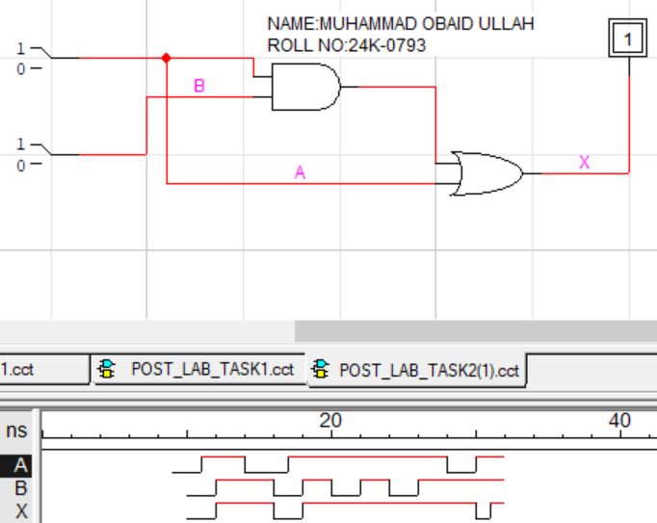

2. ( A + B )( A + C) = A + BC

Sol :

L.H.S = ( A + B )( A + C)

L.H.S = A . A + A . C + B . A + B . C

L.H.S = A + A . C + B . A + B . C

L.H.S = A . ( 1 + C + B ) + B . C

L.H.S = A ( 1 + B ) + B . C

L.H.S = A . 1 + B . C

L.H.S = A + BC

L.H.S = R.H.S

**Circuit diagram:**

1. ( A + B )( A + C) A screenshot of a computer program

   Description automatically generated
2. A + BC

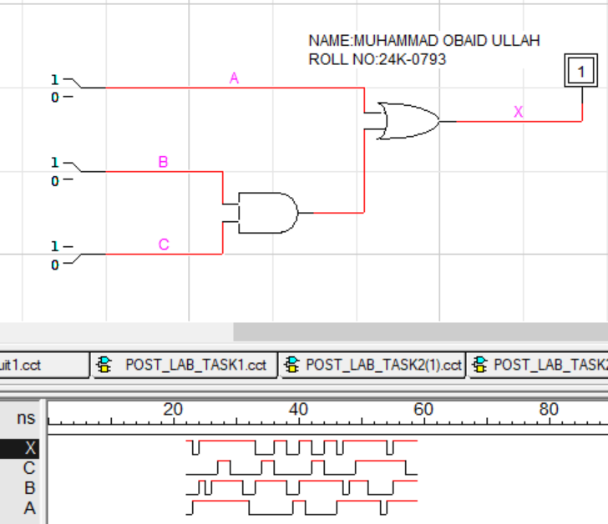

POST_LAB_TASK_3:

BOOLEAN EXPRESSION:  


Since in XOR , 𝑍=𝐴 ⨁ 𝐵=𝐴′𝐵+𝐴𝐵′

X = Z’C + ZC’

**