NAME: MUHAMMAD OBAID ULLAH

ROLL NO:24K-0793

POST_LAB_TASKS_LAB_04

TASK1:  
a):

|  |  |  |  |  |
| --- | --- | --- | --- | --- |
| AB \ CD | 00 | 01 | 11 | 10 |
| 00 | 1 | 1 | 0 | 0 |
| 01 | 1 | 1 | 1 | 0 |
| 11 | 0 | 0 | 0 | 0 |
| 10 | 0 | 1 | 0 | 0 |

MINIMIZED EQUATION:  
(A+B+C′)(A′+B′)(A′+D)

b):

|  |  |  |  |  |
| --- | --- | --- | --- | --- |
| **AB \ CD** | **00** | **01** | **11** | **10** |
| **00** | 1 | 0 | 0 | 1 |
| **01** | 1 | 1 | 0 | 1 |
| **11** | 0 | 1 | 1 | 1 |
| **10** | 1 | 0 | 1 | 1 |

MINIMIZED EQUATION:  
(A+B+D′)(B′+C′+D′)(B+C+D′)

QUESTION 2:

K_MAP:

|  |  |  |  |  |
| --- | --- | --- | --- | --- |
| AB/CD | 00 | 01 | 11 | 10 |
| 00 | 1 | 1 |  |  |
| 01 |  | 1 |  |  |
| 11 |  |  |  |  |
| 10 | 1 | 1 |  |  |

MINIMIZED EXPRESSION:

B′+A′C

Logic Works: 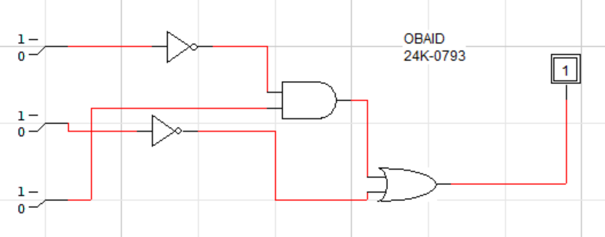

TRUTH TABLE:

|  |  |  |  |
| --- | --- | --- | --- |
| A | B | C | X |
| 0 | 0 | 0 | 1 |
| 0 | 0 | 1 | 1 |
| 0 | 1 | 0 | 0 |
| 0 | 1 | 1 | 1 |
| 1 | 0 | 0 | 1 |
| 1 | 0 | 1 | 1 |
| 1 | 1 | 0 | 0 |
| 1 | 1 | 1 | 1 |

QUESTION 3;  
K_MAP:

|  |  |  |  |  |
| --- | --- | --- | --- | --- |
| **AB \ CD** | **00** | **01** | **11** | **10** |
| **00** | 0 | 1 | 0 | 0 |
| **01** | 0 | 1 | 1 | 1 |
| **11** | 0 | 1 | 1 | 1 |
| **10** | 0 | 1 | 1 | 1 |

MINIMIZED EXPRESSION(SOP):

A′CD+A′BC+ABC+BCD+A′BCD

MINIMIZED EXPRESSION(POS):

(A+B+C)⋅(A+B+D)⋅(A+B+C′)⋅(A′+B+D′)⋅(A′+B′+C)⋅(A′+B′+D)

