**NAME: MUHAMMAD OBAID ULLAH**

**ROLL NO: 24K-0793**

**TASK_1:**

**SOURCE CODE:**

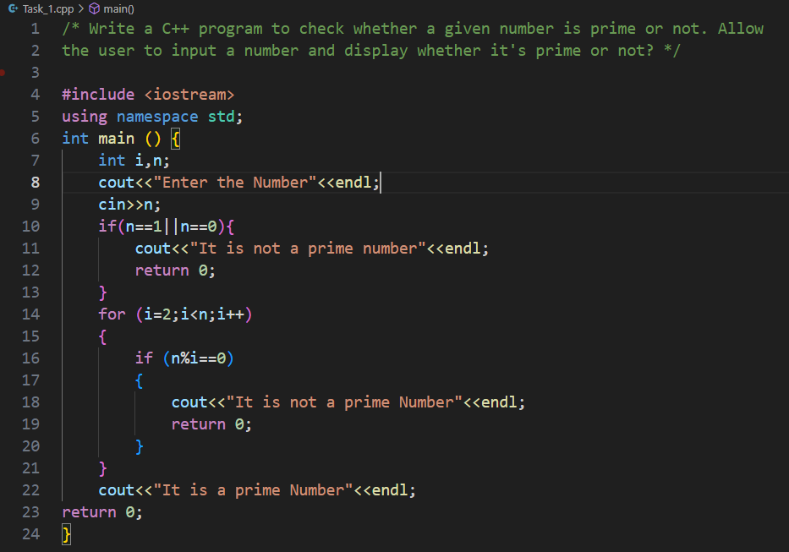

**OUTPUT:**

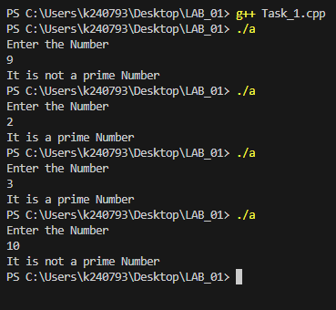

**TASK_2:**

**SOURCE CODE:**

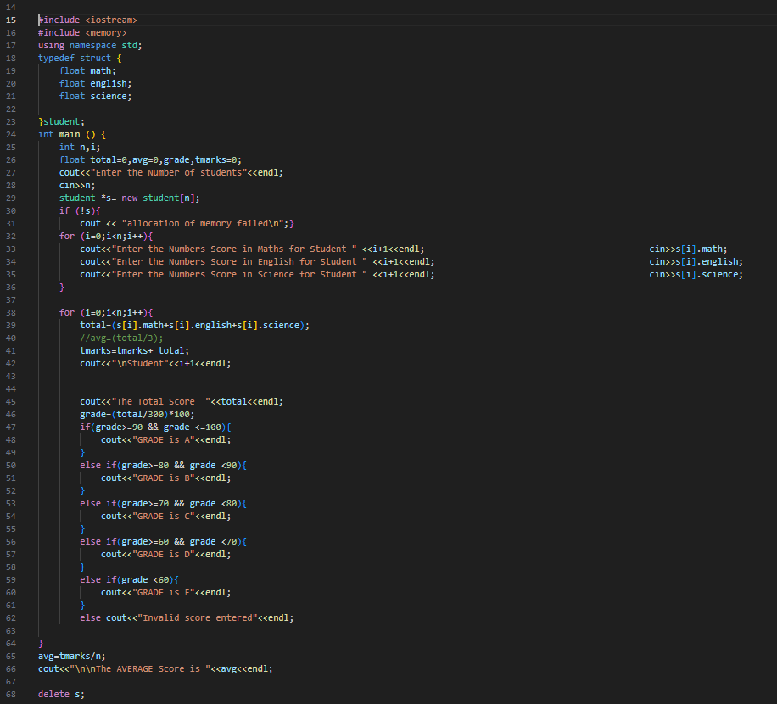

**OUTPUT:**

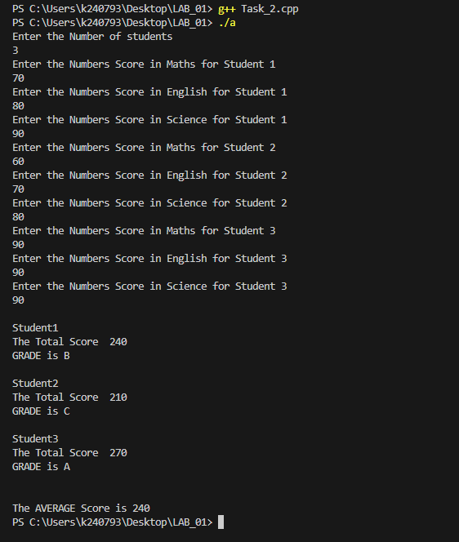

**TASK_3:**

**SOURCE CODE:**

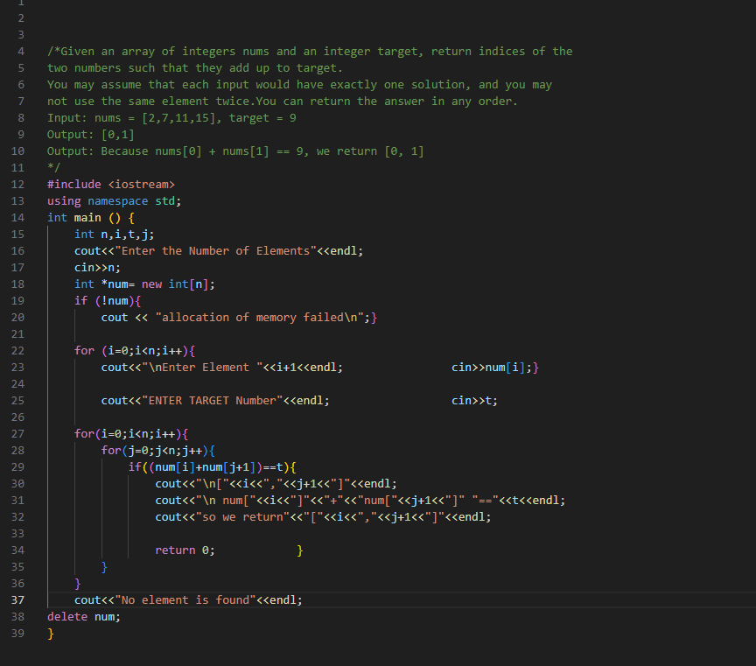

**OUTPUT:**

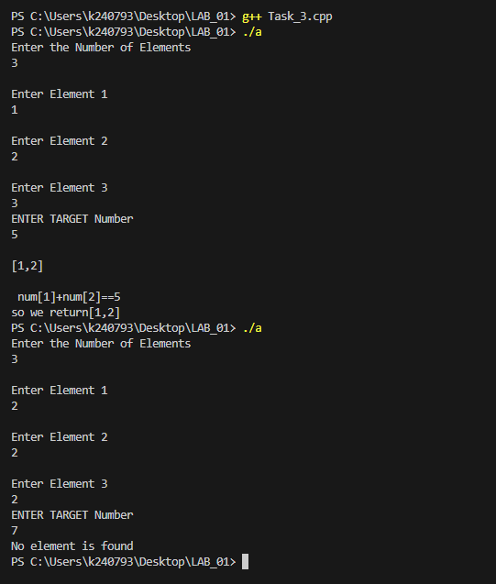

**TASK_4:**

**SOURCE CODE:**

**OUTPUT:**

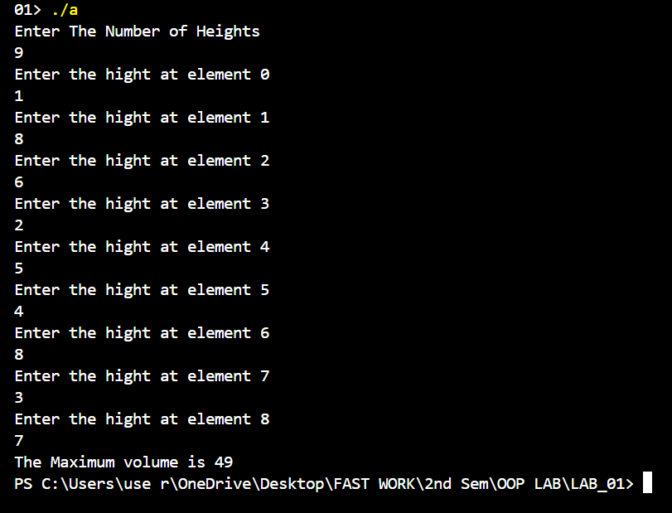

**Task_5:**

**SOURCE CODE:**

**OUTPUT:**

**ADDING AND DISPLAYING:**

**ADDING AND SEARCHING:**

