**Exploring a Simple Genetic Algorithm :**

Effect of fixed length of chromosome i-e 8 bits and varying population size on number of generations :

|  |  |
| --- | --- |
| Population Size (N) ---> user input | Number of Generations(G) ---> output |
| 4 | 3 |
| 5 | 1 |
| 6 | 2 |
| 7 | 3 |
| 8 | 3 |

Graphical Representation :

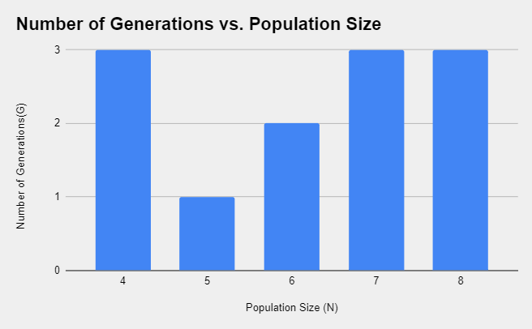

Screenshots for the above results are attached :

* **Population = 4 :**

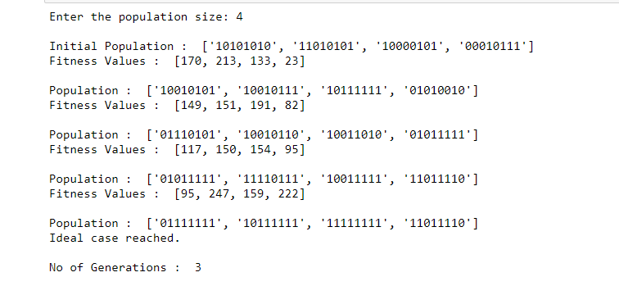

* **Population = 5 :**

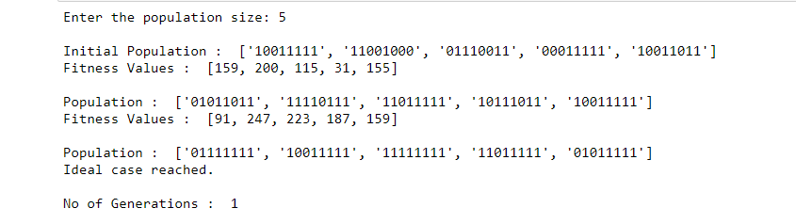

* **Population = 6 :**

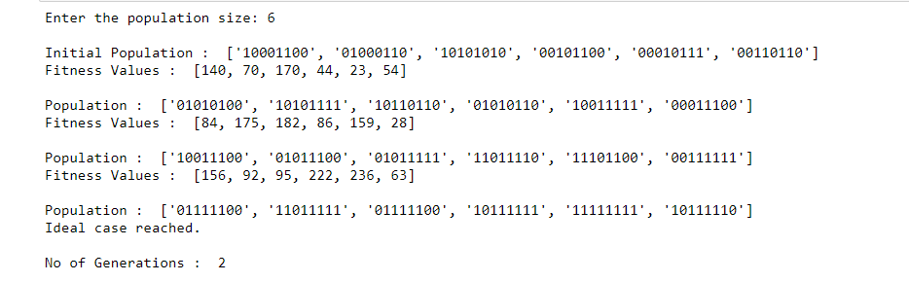

* **Population = 7 :**

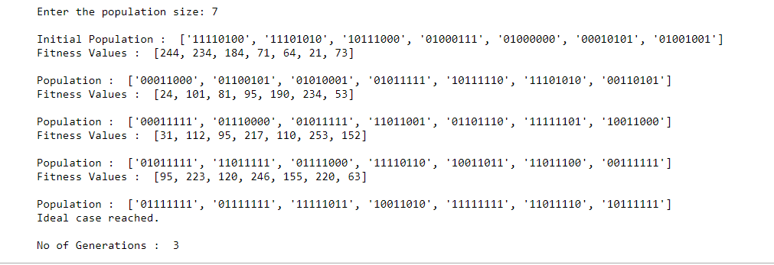

* **Population = 8 :**

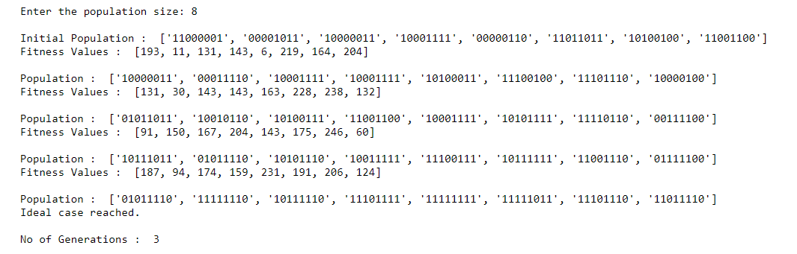

Effect of fixed population size and varying length of chromosomes on number of generations :

|  |  |  |
| --- | --- | --- |
| Population Size (N) | Length of Chromosome (L) | Number of Generations (G) |
| N = 4 | 8 | 2 |
| 9 | 4 |
| 10 | 5 |
| N =5 | 8 | 6 |
| 9 | 2 |
| 10 | 3 |

* here the length of chromosome is in bits .

Graphical Representation :

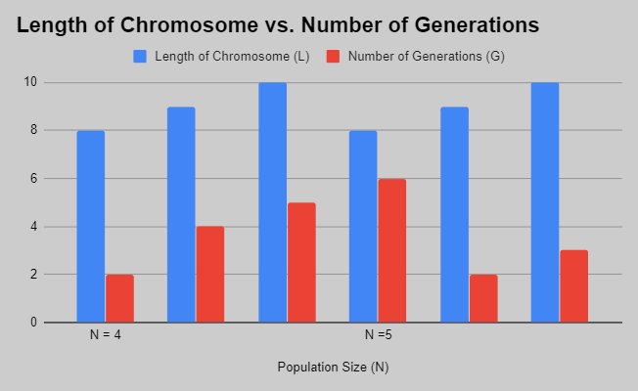

Screenshots for the above results are attached :

* **Population Size : 4 , Length of chromosome : 8**

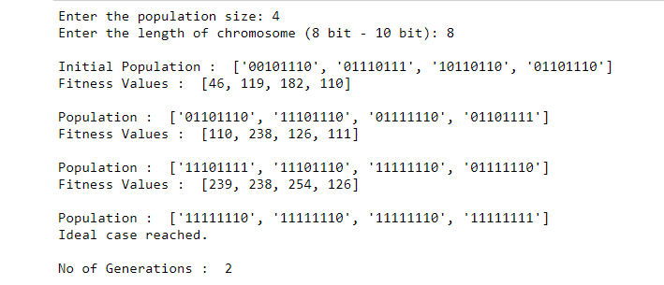

* **Population Size : 4 , Length of chromosome : 9**

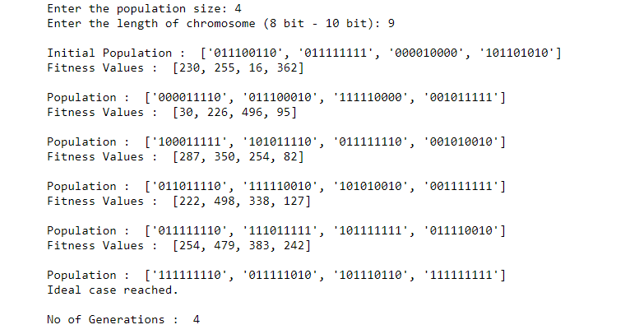

* **Population Size : 4 , Length of chromosome : 10**

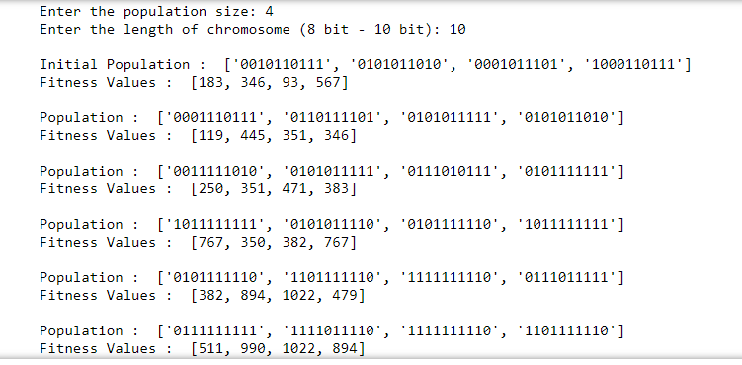

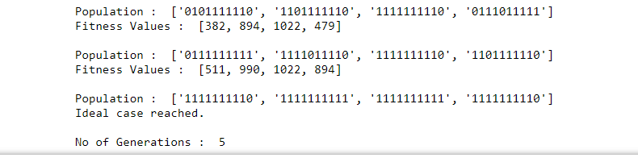

* **Population Size : 5 , Length of chromosome : 8**

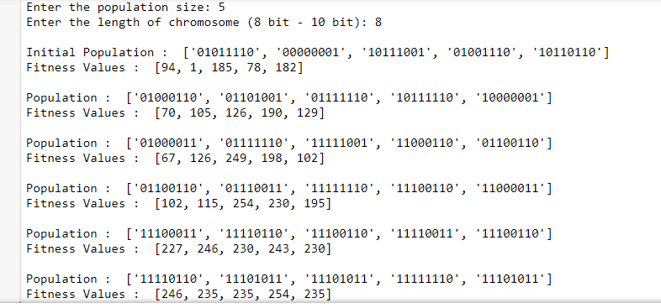

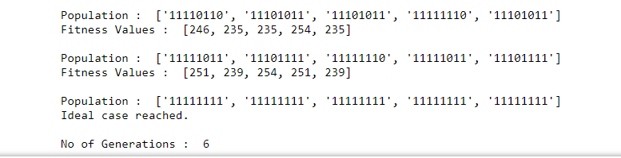

* **Population Size : 5 , Length of chromosome : 9**

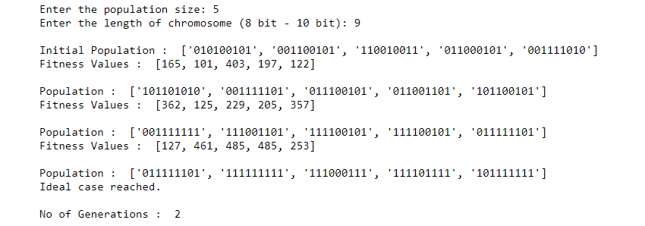

* **Population Size : 5 , Length of chromosome : 10**

