# London Musical Ticket System

## Introduction

The purpose of this project is to develop a Musical Ticket System using the knowledge and understanding of the Java programming language that has been developed along with this course.

The London Musical Ticket System is a Java Swing-based GUI project and it includes a number of GUI components such as JLabel, JTextField, JButton, JComboBox and JTable etc to name a few. In addition to these native GUI components, the GUI also incorporates capabilities to load external files (.CSV file for this project) using JFileChooser component and also writes .txt files. Additionally, the project also incorporates a working model of JavaDB (Derby) integration to save data into database table and also to fetch data from the tables.

The general flow or idea for the London Musical Ticket System is to allow users to easily make reservations for their favourite shows. These shows has their own day of month, time slots, run-time information, age-limit etc. After picking their favourite shows with other information such as date, time slot etc, the users also gets a receipts (in form of .txt) to confirm their bookings and also to have a proof about their reservations.

The London Musical Ticket System was developed by keeping in mind the ticket systems employed worldwide and many real ticketing systems were taken into consideration to design this ticket system. The GUI of London Musical Ticket System is very user-friendly. The GUI was focused around an idea which was to prevent user from typing more and more information. In London Musical Ticket System, only a handful textfields are added so that user will not have a burden to write more and more information to make their reservations. Instead a number of information is added in form of dropdowns (JCombobox) which gets filled automatically from the information provided to the system on run time.

## Design and Development

The London Musical Ticket System was designed solely using Java programming language. The software stack includes NetBeans IDE (version 21) and JDK-21 is used for the Java development. For database, the GUI is integrated with Derby (version 10.17) which is a network-based JavaDB designed specifically for Java applications.

The GUI was designed using NetBeans IDE’s GUI components. The components are carefully placed keeping in mind the idea of a user-friendly environment and also about the real ticket systems employed worldwide. For (almost) every of the GUI component, a callback is also added so that relevant business logic can be handled when a GUI component triggers an action.

When application starts, a blank GUI is displayed to the user with a number of buttons. The buttons are self explanatory and user should not find any difficulty in understanding the reason for that specific button. In addition to buttons, a number of other GUI components such as Combobox, Table, TextFields and labels are also added in the GUI. On first run, since the GUI is blank and does not contains any information related to London Musical shows, a number of dropdows (comboboxes) and buttons are also disabled. The reason behind it is to prevent incorrect data transactions since there is no viable data in the GUI at the moment.

Below screenshot represents how the actual GUI looks like on first run:

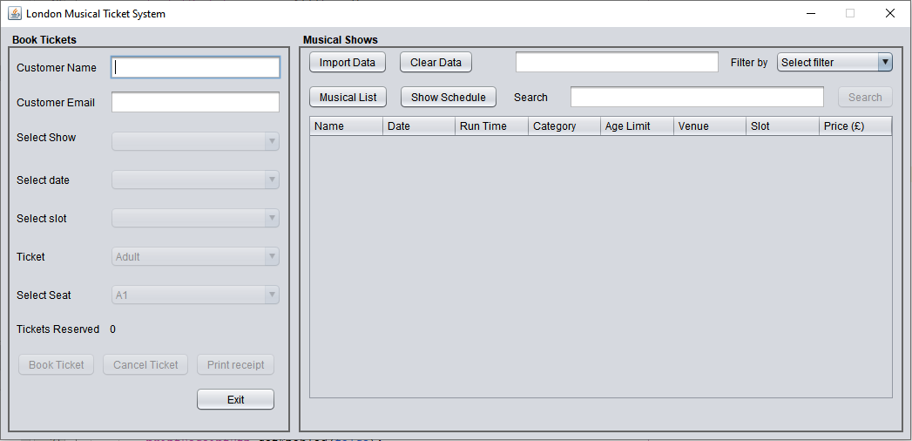

As mentioned above and as it can also be seen from the above screenshot, the GUI is blank and number of GUI components are disabled.

Now user can either import data (using Import Data button) or can see existing data (using either Musical List or Show Schedules buttons). When GUI is filled with relevant data of London Musical shows, the GUI looks a little different as shown in below screenshot.

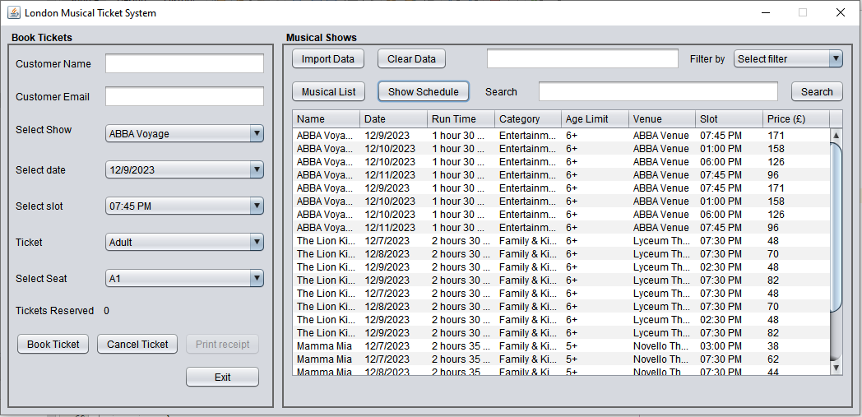

The above screenshot represents that as soon as the London Musical Ticket System is provided with relevant data, every GUI component becomes enable except the Print receipt button. The reason behind Print Receipt button being disabled at the moment is because there is no ticket reservations made till now.

After making couple of tickets reservations, the GUI is updated and it looks like in below screenshot:

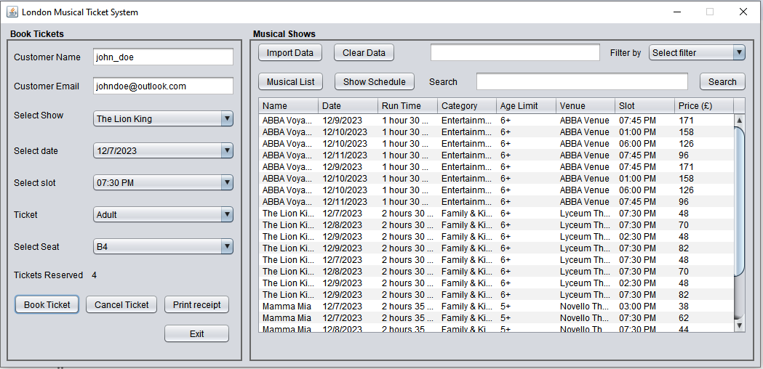

In the above screenshot, it is being displayed that a user **John Doe** has reserved four tickets. It can be seen that Print Receipt buttons is now enabled and user can now print the receipt to get the bill and total amount of his/her reservations along with reservation details.

When user click on Print Receipt button, the Musical Ticket System writes a text file (having .txt extension) containing all details about the reservations the user just made. Below is the example receipt file (in .txt format) of the reservations that we just made earlier.



The user can simply print this reservation file for record. It can be observed that the London Musical Ticket System is designed by taking in interest about the real world scenarios that it can be seen that receipt filename pattern is not a simple pattern. The pattern contains, along with customer name, also a timestamp. The reason behind adding timestamp is that it can kept in system for records to avoid any fraudulent activity. Not only to avoid frauds, it also allows same customer to make multiple reservations and all of the reservations will be kept in different receipts (as text files) and will not override previous receipt files.

## Testing and Faults