**Title: Project Report,**

**Academic Registration System**

1. Introduction:

This project aims to develop a website that simplifies the process of registering for the Lebanese University’s Faculty of Sciences courses. The report outlines the project's goals, objectives, methodologies, implementation details, and outcomes.

2. Project Goals:

The primary goal is to enhance the course registration experience for university students. The specific objectives include:

* Creating a user-friendly home page providing information about the university.
* Implementing a registration system that requires user sign-up and approval from the admin.
* Allowing approved users to log in and register for courses, view grades, and manage profile information.
* Enforcing course registration constraints, such as prerequisites, to prevent unauthorized registrations.
* Empowering the admin to review and manage student registrations, including accepting, editing, or rejecting course selections.
* Allowing the admin to make student accounts and give them grades through importing Excel files.
* Facilitating communication between the admin and students regarding course registrations and grades.
* Allowing the admin to upgrade a user’s status to admin and see the list of current admins.

3. Methodology:

The Agile methodology was followed for this project, implying that iterative development was used. Frequent feedback and continuous improvement were prioritized throughout the development lifecycle.

4. Implementation Details:

The website's features and functionalities include:

* Home Page: Provides information about the university and the website developers, including the faculty’s programs, campus facilities, and social media and the developers’ motives, and names.
* User Sign-up: Requires prospective users to be registered with the university before signing up for website access.
* Admin Approval: The admin reviews sign-up requests and decides whether to accept or reject them.
* Account Creation: The admin can create the accounts for the students by importing an Excel file containing the students’ information.
* User Login: Approved users can log in to the system to access personalized features.
* Course Registration: Logged-in students can register for courses, where the website will enforce constraints such as prerequisites.
* Grade Checking: Students can view their grades for completed courses.
* Profile Management: Students can edit and update their profile information.
* Admin Actions: The admin can review and manage student registrations, including acceptance, editing, or rejection. Plus, add more admins and keep track of them.
* Grade Editing: The admin has the ability to edit student grades as necessary. He can also import an Excel file containing the grades of students for a certain course which automatically sets the grades of the students.

5. Technology Stack:

* The website is primarily built using PHP for backend, with HTML, CSS, and JavaScript utilized for front-end development.
* Extra Frameworks: Bootstrap, JQuery, and AJAX.
* The MySQL database is employed for data storage and retrieval, and the server used was the XAMPP Apache Server.

6.Documents:

* Database ER Diagram:

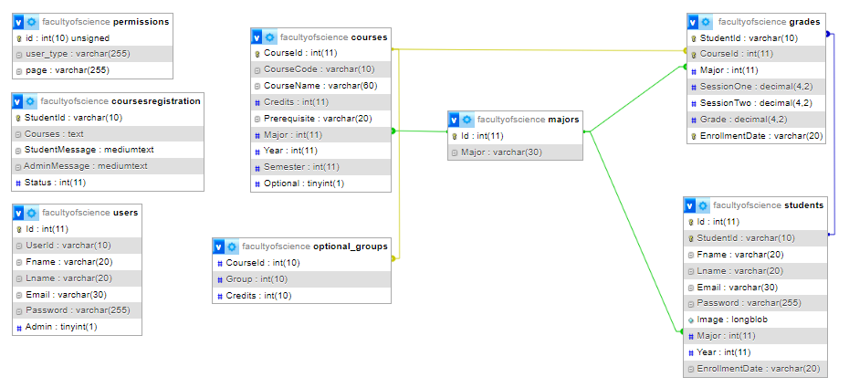

* Use Case Diagram:

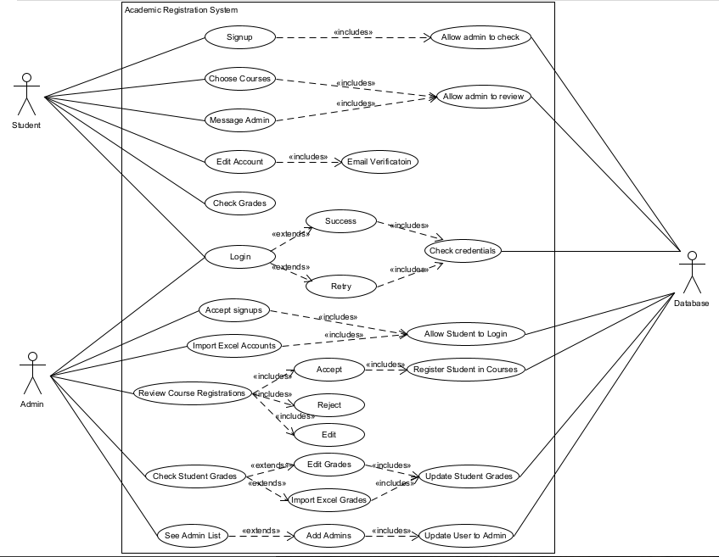

* Sequence Diagram:

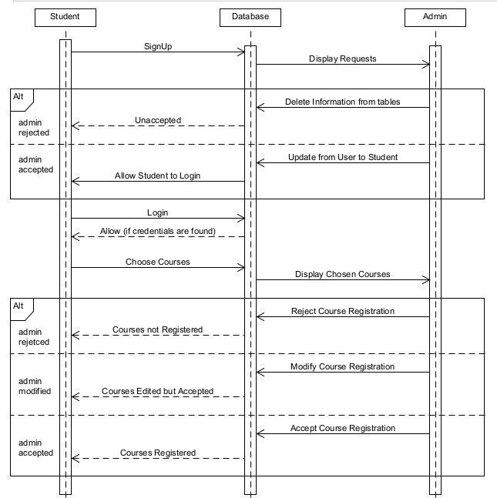

7. Results and Outcomes:

The implemented website successfully achieved the project's goals, resulting in several positive outcomes, including:

* Simplified Course Registration: The website streamlined the course registration process, making it more convenient and user-friendly.
* Enhanced Communication: The admin-student interaction improved through the website, facilitating efficient communication regarding course registrations and grades.
* Improved Accuracy: Course registration constraints, such as prerequisites, prevented unauthorized registrations and ensured students select appropriate courses.
* Efficient Approval Process: The admin's role in approving or rejecting student registrations was made more efficient, saving time and effort.
* Enhanced User Experience: The intuitive interface, personalized features, and easy navigation enhanced the overall user experience for students and admin.

8. Conclusion:

In conclusion, the development of the academic registration website successfully met the project goal of simplifying the registration process for students. The implementation of user-centric features, adherence to constraints, and efficient communication channels contributed to an improved registration experience. Future enhancements may include advanced analytics for course planning, course descriptions so students can learn what the courses teach directly from the website and incorporating additional administrative features.

References:

* The PHP manual: <https://www.php.net/manual/en/>