*3815ICT – Software Engineering*

*Minesweeper*

*Milestone 1 – Reflection on GUI*

Student: Zak Barker

Student#: S5085150

Subject: 3815ICT Software Engineering

Email: Zak.Barker@Griffithuni.edu.au

**Customization**

The original GUI for minesweeper is reasonably bland with a grey metallic art style to complement the premise of minesweeper. This thematic style is highly customisable and one implementation for the GUI of this implementation is to utilise a coastal/ocean theme based around sweeping for crabs in the ocean. In terms of reflection, this is a basic conceptual idea which made implementation a little bit more personalised. As such, investment of thought and time was a little bit easier as the concept of minesweeper seemed slightly less bland. From a user’s standpoint, it could be a welcome variation from the standard minesweeper and the use of colour and themes may keep that user interested for one more game.

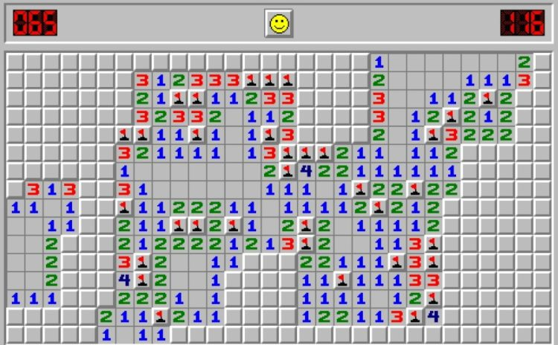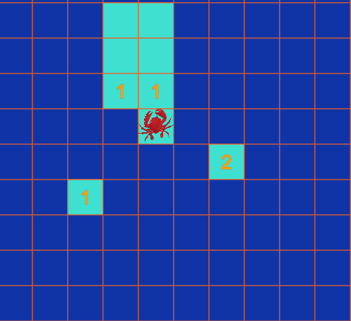

Figure 1 – Mines vs Crabs

As for the technicalities such as buttons and functionality of GUI, it is important to stick to conventions for these implementations. That is because from a usability standpoint, it is simpler for a user to deal with something they are familiar with. Ahead are a few images of the final product with various GUI elements.

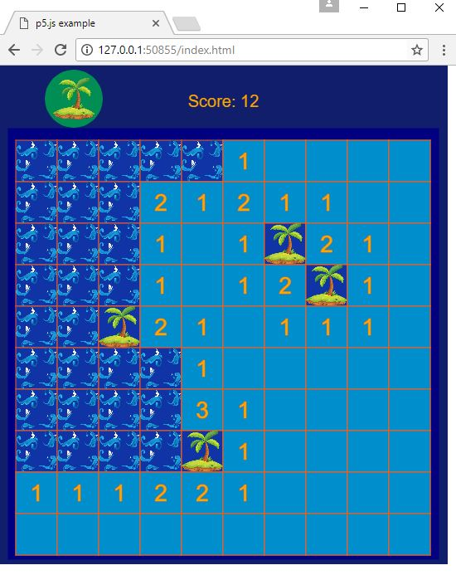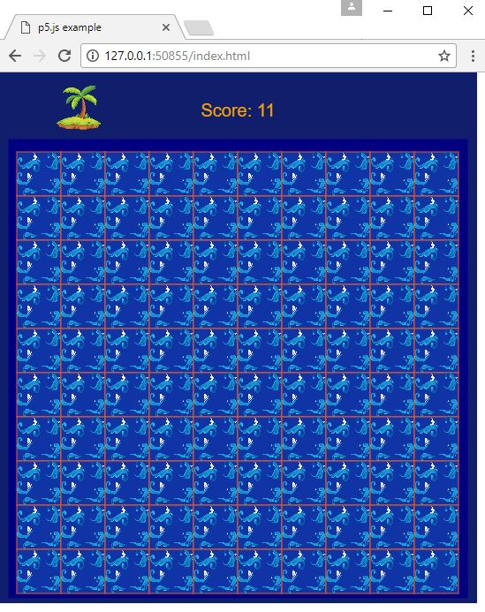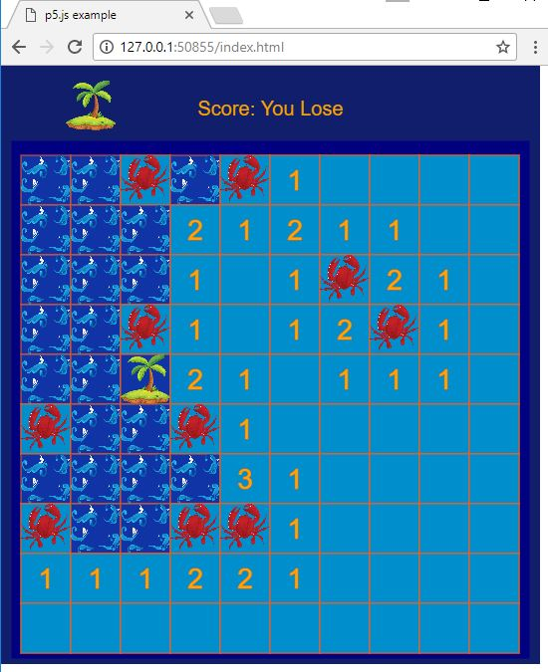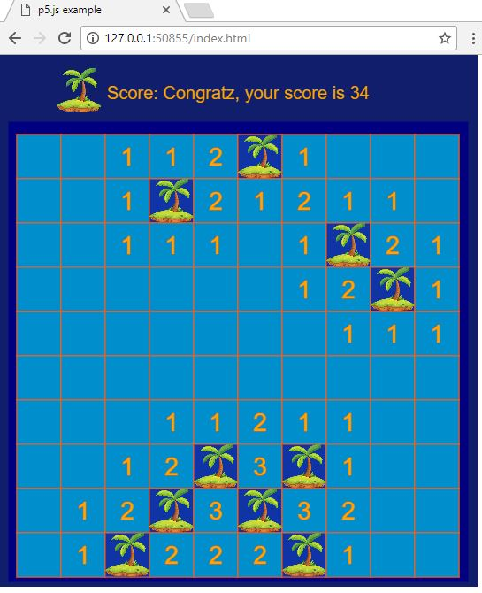

Figure 2 – Complete Prototype

Links to a video of the prototype functioning will be provided. The first link shows a case of a complete game resulting in a win and the second video shows multiple instances of a loss. Complete functionality of the prototype has been demonstrated in this video.

Link to Case Win - [https://youtu.be/Yr-KP5kNcNg](https://protect-au.mimecast.com/s/D9XKCMwvOEhJ9opWuwZ9DX?domain=youtu.be)

Link to Case Loss - [https://youtu.be/q2jnY3kXPMU](https://protect-au.mimecast.com/s/sc3NCNLwQEi69nYXS4BFlJ?domain=youtu.be)