3815ICT-Software Engineering Workshop 6

**Activity 1**

Study the short entry in Wikipedia for the “Client-Server Model” en.wikipedia.org/wiki/Client-server_model

**Response 1**

The client-server model is used to separate the responsibilities of delivering a web service between two separate entities being the client and server. The client acts as the front end and includes the user interface. This client has the job of displaying information to the user and receiving input, the client’s responsibility is not to process this data. The client will send requests to the server along with data and relies on the server to process that data and respond to the request. This is the server’s responsibility. The server is also known as the back end and handles all of the behind the scenes work in order to keep the client light and dynamic. Server may also interface with a database or various APIs.

**Activity 2**

Implement a Java client and a single-response Java server by following the tutorial by Rick Proctor titled “Sockets: Basic Client-Server Programming in Java” ( edn.embarcadero.com/article/31995 ). This is not meant to be a comprehensive introduction to computer networking, but should be explanatory enough. The exercise is illustrative that in a client-server architecture there are at least two programs, one (or many) client(s) and one (or many) server(s). Our recommendation is that you build this using an IDE like NetBeans (netbeans.org). You can build both (client and server) under the same project. Edit the project properties to configure two run configurations, so you can work and compile both at the same time when working on a single computer (the exercise by Rick Proctor works all on a single computer identified as the localhost). See Figure 1 for the setting of a configuration for the SingleSocketServer.

**Response 2**

I had a little bit of trouble implementing this on the school computers as they do not have java. Aside from this, the Ros Kinetic environment does not have the netbeans software. To complete the project, I needed to use the computers with netbeans to create and compile my files. I then needed to zip them up and send them back to myself. I was then able to go into the Ros Kinetic environment which has java installed. I unzipped the file in the virtual machine and ran the commands on the command line. This was a success and this was the result.

Client Side

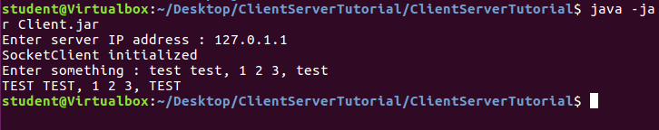

Server Side

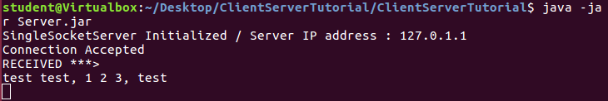

**Activity 3**

Experiment with the code of the previous activity, For example, run the client alone without the server running. In fact, we recommend that you build the client with the option Clean and Build Main project. This will build a jar file for the client that you can run from a terminal window with java -jar ClientServerTutorial/dist/ClientServerTutorial.jar Experiment commenting code out. See what error you get (what do the catch blocks return). Not that when you run this example, the server waits for about 10 seconds before it issues a response, so you can observe the time stamp when the client issues the request and when the server sends its reply.

**Response 3**

I ran the client side without activating the server. The client was prompted for a server IP but since there was no IP nor active serve, the client request threw an exception. There was nothing for the client to connect to.

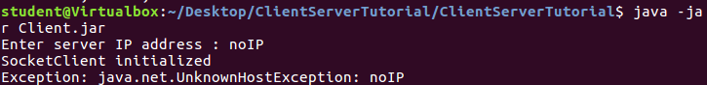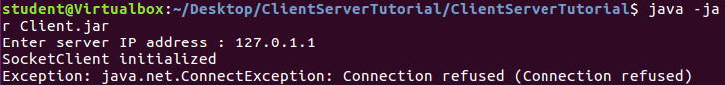

**Activity 4**

We have modified the example above to create a client and a server that can communicate across two computers. We have also modified the example so the server does provide some service to the client. Check the code supplied with this workshop. Identify the differences with the exercise above. You should inspect the code and also test the programs. We have packaged as a NetBeans project already. What is the service provided by the server? Use the code provided and expand the multi-threaded server that answers to several clients simultaneously to provide the same service but now accept multiple connections.

**Response 4**

The service provided by the server is fairly simple. The server accepts string input from the client and returns that same string in all upper-case characters.

I connected multiple clients to the server and attempted to run, they worked fine, however, the server delayed its response until all clients had queried it.

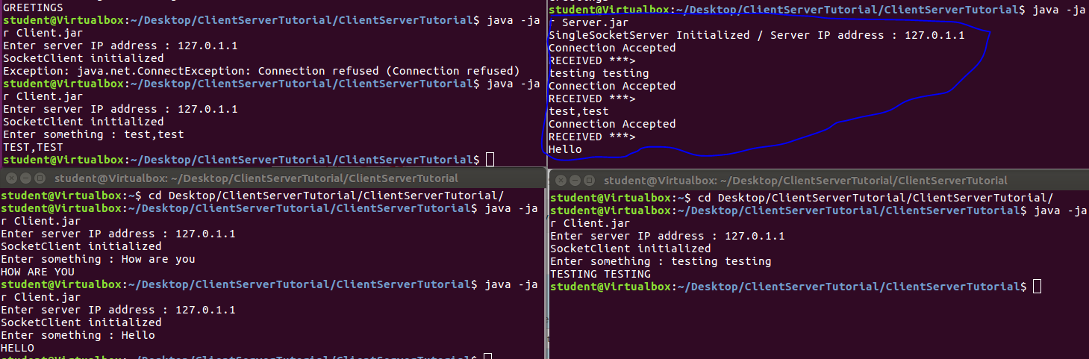

**Activity 5**

Read “Alexa, are you listening?” by Mark Barnes (labs.mwrinfosecurity.com/blog/alexaare-you-listening). Write a 300 word essay about whether this is a software engineering issue, a computer engineering issue or both.

**Response 5**

This issue with Alexa doesn’t just come down to either software engineering or computer engineering. There are issues with both. There is a fault within the physical design of the Amazon Echo which allows for someone to abuse the internal software frameworks. It does not appear to be tappable remotely, this would suggest a fault in the software engineering. As for the physical intrusion into the device, a design issue could be the fault. Once the user has accessed the physical infrastructure of the Echo, they are able to access the kernel and further access to the software within the system. It can be said that this hardware issue is exacerbated by the fact that the software is also vulnerable to attack. The person hacking the system is supposedly able to do so without leaving a trace. This is a huge oversight in the design of both Software Engineers and Computer Engineers and leads to privacy issues which puts the consumer at risk. It is inevitable that hackers will attempt to break the programming and physical restrictions on any device for personal gain or for simple sport and they are exceptionally skilled. It is the responsibility of both Software and Computer Engineers to ensure that their software provides adequate protection for the consumer and in the case of Amazon Echo, it is a failure of both.

**Activity 6**

Write 15 lines of a reflective report on the previous activities. Analyse and evaluate the match of the activities to the learning objectives proposed in this workshop/laboratory.

**Response 6**

To be fair, reading a lot of articles about a subject is not a very engaging way for me to learn personally and usually a lot of the information goes over my head. In terms of the first learning objective, I need to see something in action if I am able to grasp the concept. I learnt very little reading the documents provided as a lot of the information went over my head. When it came to actually implementing something and watching the roles of Client and Server play out in front of me, things began to click more. In that respect, the first 2 learning goals were achieved. In terms of a multi-threaded structure, I did notice that using the original program, the server would not respond to each client until it had received all queries. I suppose that a multi-threaded server would be able to emit information on demand while hosting multiple servers. The final learning objective was to discuss the security vulnerabilities of the Echo. ‘Is google listening?’ has been a meme for a while now and to see that Amazon Echo has these security issues is absolutely no surprise. The learning object has been reached and basically the idea that if something can be exploited – it likely will – has come over me. The activities fulfilled the learning objectives just fine.