**ISTE252 Week 5 - Lab**

**Cordova Plugins**

Modify the Device Orientation app so that you have a start and top button.

The $ symbol represents your prompt, all cordova, and dos or unix commands will follow the $, on your device your prompt may be longer, but it will most likely end in a $ symbol. So, let’s get started by typing in the following commands to create the cordova app and then change into that app’s directory:

**$cordova create StartStop com.example.startstop StartStop**

**$cd StartStop**

*Now, add the platforms* you will use (you can do this all on one line by separating each platform with a space, and remember windows and iOS don’t play well together):

**$cordova platform add android**

**$cordova platform add ios**

**$cordova platform add browser**

**$cordova platform add windows**

*Now add the plugins*

**$cordova plugin add cordova-plugin-console**

**$cordova plugin add cordova-plugin-dialogs**

**$cordova plugin add cordova-plugin-device-motion**

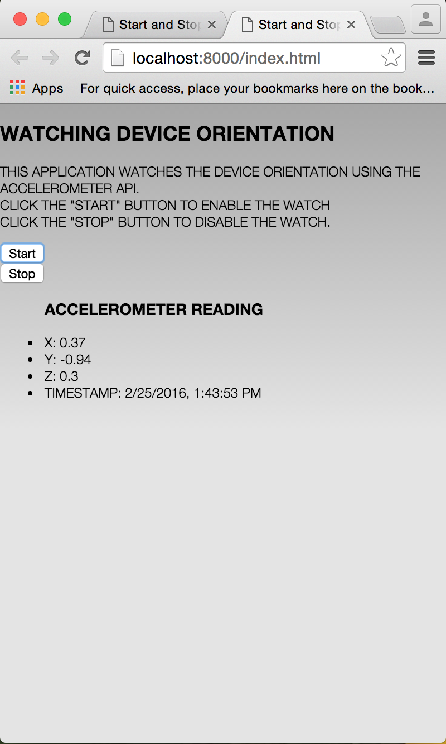

*Get the code:*

1. Download the file called StartStop-www.zip” from MyCourses.
2. Unzip the file and use a file manager (Finder, or Window’s Explorer) to navigate to its www folder.
3. Next, open another window in your file manager and navigate to the StartStop www folder.
4. Replace all the contents of the Project’s www folder with all of the files your www folder from the unzipped ‘StartStop -www.zip” folder.

In the terminal window, navigate to the StartStop folder and issue the following commands:

**$cordova prepare**

**$cordova emulate browser**

The output should look something like this 🡪 🡪 🡪

To run on your device:

**$cordova run -device**

**TODO**: Change the frequency from ½ second to 2 seconds

and fix the style, change the icon