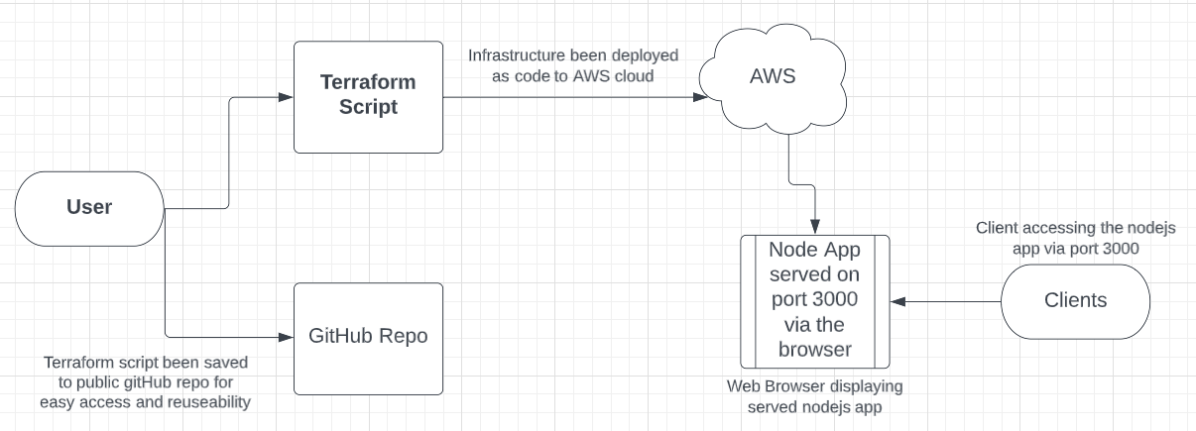**DESIGN:**

**Description:**

The above diagram depicts the deployment of the Nodejs application hosted on GitHub as specified in this link; <https://github.com/nodejs/examples/tree/main/servers/express/api-with-express-and-handlebars>

The “user” as stated in the diagram, is responsible for writing the terraform script.

In the terraform script, the user defined the infrastructures as code. The terraform script contains the following infrastructures;

* VPC
* Subnet
* Route Table
* Key Pairs
* Security Group
* Internet Gateway
* EC2 instance
* Elastic IP
* User Data

This terraform script is heavily automated since I have used the concept of “user_data” in the process.

The script is being deployed as code to the AWS Cloud

The terraform script is being saved to the public repository on GitHub. See below link to the terraform script; <https://github.com/frankisinfotech/terraform.git>

The nodejs application is being served on the client’s browser via port 3000.

See below the displayed application;

