NAME:
OBAZEE-SUNDAY ABIEMWENSE SAMSON

MATRIC NUMBER:
230591114

DEPARTMENT:
COMPUTER SCIENCE

STREAM:
STREAM 1

COURSE:
CSC 394

DESCRIPTION OF THE DATABASE PROJECT
The project — The NPA ICT Help Desk Data Portal & Management System is a database-driven software platform developed to digitize, record, monitor, and streamline internal IT support operations at the Nigerian Ports Authority (NPA) - ICT Department, where I undertook my Students Industrial Work Experience Scheme (SIWES).

Problem Statement
Before the implementation of this database software, internal technical issues—including terminal switch downtime, printer spool faults, and operating system errors were manually recorded on physical paper requisition slips and log books.
- Loss of Incident Records: Physical paper slips were frequently misplaced, coffee-stained, or filed erroneously, causing loss of critical records.
- Zero Real-Time Tracking: Department heads and IT supervisors had no centralized visibility into whether a reported issue was pending, actively undergoing troubleshooting, or resolved.
- Delayed Turnaround Times: Technicians received complaints informally via phone or hallway conversations, resulting in unassigned tasks and delayed resolution times.
- Inability to Audit Service Quality: Without a centralized database, evaluating department satisfaction levels or compiling monthly audit metrics for executive management was practically impossible.

The Solution
The NPA ICT Help Desk Data Portal modernizes and transforms this workflow into an integrated, real-time database management ecosystem:
- 1. Digital Client Requisition: Staff across all NPA port departments can lodge technical support requests digitally with room extension, officer designation, and detailed issue descriptions.
- 2. Centralized Cloud Relational Database: All requests are immediately synchronized into an AlwaysData-hosted MySQL cloud database with automatic timestamps and unique ticket IDs.
- 3. Administrative Data Portal: Technicians and supervisors log in with an administrative passkey to inspect, filter by date, paginate, update ticket statuses (Pending, In Progress, Resolved), purge obsolete entries, and export formatted CSV reports.

2. PROJECT DEPENDENCIES AND REQUIREMENTS
The database project was constructed using modern, scalable cross-platform and cloud technologies: FLUTTER / DART for the administrative dashboard, PHP (Hypertext Preprocessor) for backend REST API services, and MySQL 8.0 for cloud relational database management.

Software & Tool Requirements
- 1. Integrated Development Environment (IDE): Visual Studio Code with Flutter, Dart, and PHP extension packs for code editing, linting, and debugging.
- 2. Flutter & Dart SDK: Version 3.13.0 or higher with Dart SDK 3.x for building high-performance, responsive UI widgets.
- 3. Backend Server Runtime: PHP Version 8.0+ configured with MySQLi and JSON modules to handle CORS-compliant RESTful requests.
- 4. Cloud Database: MySQL 8.0 Relational Database Management System hosted securely on AlwaysData Cloud infrastructure.
- 5. Web Browser: Google Chrome (Recommended) or Microsoft Edge for dashboard interaction.
- 6. Version Control: Git for source code version control and GitHub synchronization.

Hardware Specifications
- • Operating System: A laptop running Windows 10 or Windows 11 (64-bit) (also compatible with macOS and Linux).
- • Processor: Intel Core i3 minimum (Intel Core i5 or Core i7 recommended).
- • Memory (RAM): 4 GB RAM minimum (8 GB to 16 GB recommended for smooth compilation and multitasking).
- • Storage: At least 500 GB internal storage (SSD recommended) with at least 10 GB free space for development SDKs.
- • Network: Broadband internet connectivity for continuous cloud database synchronization.

3. INSTALLATION AND SETUP PROCESS

Option 1: Direct Online Assessment (Live Cloud Access)
The NPA ICT Help Desk Data Portal is deployed live on cloud infrastructure and can be accessed directly from any web browser without any local setup or installation:
- Live Portal Link:
https://npa-helpdesk-requestform.alwaysdata.net
- Access Password:
samson
- How to Access:
  - Click the live link above to launch the portal in your browser (Google Chrome or Microsoft Edge recommended).
  - Type the password samson in the access password field.
  - Click "Access Portal" to open the live dashboard.
  - From the dashboard, you can view live requests from the database, filter by date, change ticket statuses (Pending, In Progress, Resolved), or click "Export CSV" to download an instant audit report.

Option 2: Follow these step-by-step instructions to set up, configure, and execute the project locally:
Step 1: Clone or Copy Source Code
Clone the repository from GitHub to your local development machine:
bash
git clone https://github.com/ObazeeSamson/npa-help-request-desk.git
cd help_desk_data_portal
Step 2: Open Source Code in Visual Studio Code
Launch the project directory in VS Code:
bash
code .
Step 3: Install Flutter Dependencies
Run the Flutter package manager to fetch all required libraries (including google_fonts, http) defined in pubspec.yaml:
bash
flutter pub get
Step 4: Verify API & Cloud Database Connection
The Flutter web application communicates directly with the live AlwaysData cloud backend via lib/constants.dart, which routes all REST API requests to the cloud server:
dart
// lib/constants.dart (Frontend API Endpoint Configuration)
class AppConstants {
AppConstants._();
/// Root URL for all Help Desk REST API endpoints (AlwaysData server)
static const String apiBase =
'https://npa-helpdesk-requestform.alwaysdata.net/help_desk_request';
}
On the AlwaysData server, db_connect.php handles incoming API requests and connects securely to the MySQL cloud database:
php
<?php
declare(strict_types=1);
// AlwaysData MySQL credentials
$host = "mysql-npa-helpdesk-requestform.alwaysdata.net";
$username = "npa-helpdesk-requestform_samson";
$password = "Kyrieirving@11";
$database = "npa-helpdesk-requestform_database";
$conn = new mysqli($host, $username, $password, $database);
$conn->set_charset("utf8mb4");
if ($conn->connect_error) {
http_response_code(500);
die(json_encode([
'status' => 'error',
'message' => 'Database connection failed: ' . $conn->connect_error,
]));
}
?>
Step 5: Launch the Application
Compile and launch the Flutter web application on Google Chrome:
bash
flutter run -d chrome --web-port 5000
Step 6: Access the Project in Your Browser
Open your web browser and navigate to: http://localhost:5000. Enter the administrative master password (samson) to unlock the portal dashboard.

4. DATABASE SCHEMA DESIGN
The core database schema is organized around the help_requests table in the cloud MySQL database (hosted on AlwaysData and administered via phpMyAdmin):
sql
CREATE TABLE IF NOT EXISTS help_requests (
id INT AUTO_INCREMENT PRIMARY KEY,
requesting_department VARCHAR(150) NOT NULL,
room_extension VARCHAR(50) NOT NULL,
requesting_officer VARCHAR(150) NOT NULL,
requester_designation VARCHAR(150) NOT NULL,
complaint_description TEXT NOT NULL,
action_taken TEXT NULL,
diagnosed_by VARCHAR(150) DEFAULT 'Unassigned',
technician_designation VARCHAR(100) NULL,
date_time_out DATE NULL,
satisfaction_level VARCHAR(50) NULL,
comment TEXT NULL,
status ENUM('pending', 'in_progress', 'resolved', 'closed') DEFAULT 'pending',
created_at TIMESTAMP DEFAULT CURRENT_TIMESTAMP
) ENGINE=InnoDB DEFAULT CHARSET=utf8mb4 COLLATE=utf8mb4_unicode_ci;

5. FUNCTIONS PRESENT IN THE PROJECT
As the administrator / ICT officer, the project enables you to:
- 1. Administrative Authentication: Secure authentication gate protecting confidential incident logs.
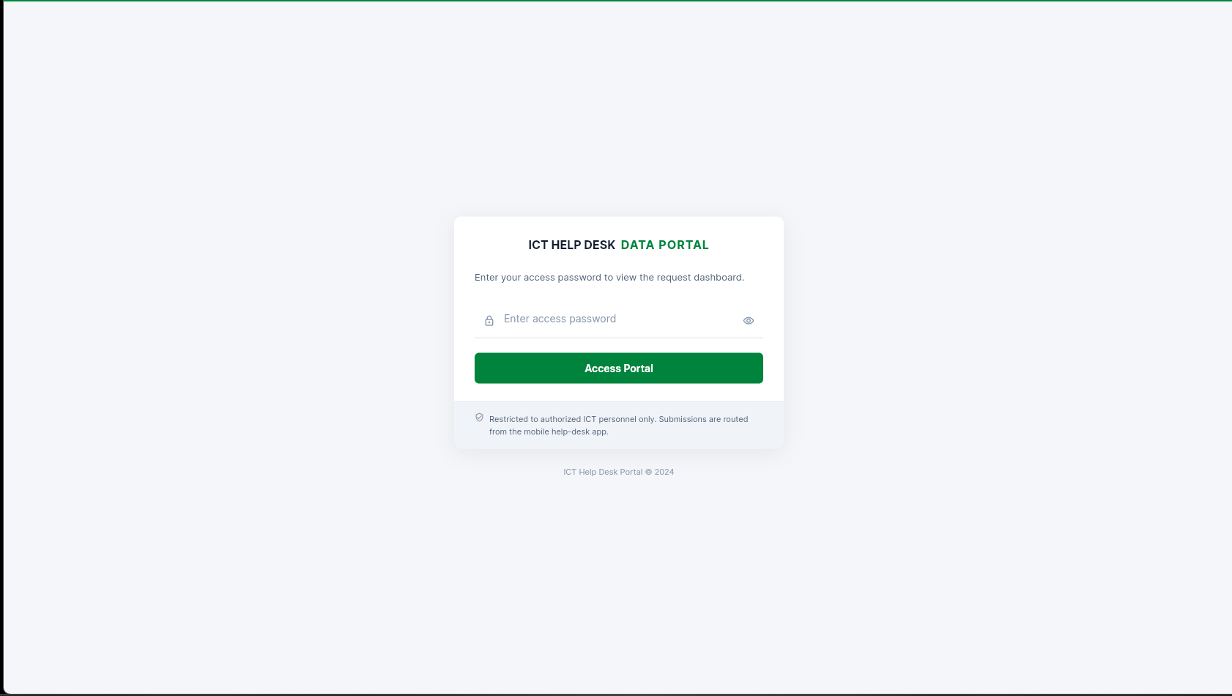

- 2. Retrieve All Records: View all logged tickets in a responsive, styled tabular data grid.

- 4. Date Range Filtering: Dynamically isolate tickets created between specific start and end dates.
- 5. Pagination Controls: Seamlessly browse large datasets via 8-record-per-page slicing.
- 6. Update Ticket Status: Update ticket states from pending to in_progress or resolved in real time.
- 7. Delete Records: Permanently delete duplicate or obsolete records using prepared SQL statements.
- 8. Export CSV Audit Logs: Generate and download complete or date-filtered CSV spreadsheets.

6. DETAILED CRUD FUNCTIONALITIES IN THE PROJECT
The system implements complete Create, Read, Update, and Delete (CRUD) operations alongside security and reporting capabilities.

A. ADMINISTRATIVE AUTHENTICATION GATE
To ensure data integrity and confidentiality, the portal requires administrators to authenticate before accessing tickets.
// verify_password.php (Backend Authentication)
$correctPassword = 'samson';
$password = trim($_POST['password'] ?? '');

if ($password === $correctPassword) {
echo "success";
} else {
echo "invalid";
}

B. 1: CREATE NEW PRODUCT / SUPPORT RECORD
Staff lodge support tickets containing technical complaint details. The backend prepares and executes an SQL INSERT statement:
// submit_request.php (INSERT INTO help_requests)
$stmt = $conn->prepare(
"INSERT INTO help_requests
(requesting_department, room_extension, requesting_officer, requester_designation, complaint_description, diagnosed_by, status)
VALUES (?, ?, ?, ?, ?, ?, ?)"
);
$stmt->bind_param("sssssss", $dept, $room, $officer, $designation, $complaint, $diagnosed, $status);
$stmt->execute();

C. 2: RETRIEVE ALL & CATEGORICALLY FILTERED RECORDS
The dashboard queries all logged requests and displays them in a data table featuring pagination and status badges:
// get_requests.php (SELECT FROM help_requests)
$sql = "SELECT id, status, requesting_department, room_extension, requesting_officer,
requester_designation, complaint_description, diagnosed_by, created_at
FROM help_requests
ORDER BY id DESC";
$result = $conn->query($sql);

D. 3: UPDATE THE RECORDS
When a technician works on or resolves an issue, the ticket status is updated via an inline dropdown, executing an SQL UPDATE:
// update_status.php (UPDATE help_requests SET status = ?)
$stmt = $conn->prepare("UPDATE help_requests SET status = ? WHERE id = ?");
$stmt->bind_param("si", $status, $id);
$stmt->execute();

E. 4: DELETE RECORDS
Administrators can remove test or duplicate entries with an SQL DELETE statement and confirmation dialog:
// delete_request.php (DELETE FROM help_requests WHERE id = ?)
$stmt = $conn->prepare("DELETE FROM help_requests WHERE id = ?");
$stmt->bind_param("i", $id);
$stmt->execute();

F. 5: EXPORT RECORDS (Audit CSV Reports)
Administrators can stream the database records directly to a downloaded CSV file for executive reporting:
// export_requests.php (CSV File Streaming)
header('Content-Type: text/csv; charset=utf-8');
header('Content-Disposition: attachment; filename="npa_ict_helpdesk_report.csv"');
$output = fopen('php://output', 'w');
fputcsv($output, ['ID', 'Department', 'Room/Ext', 'Officer', 'Designation', 'Complaint', 'Status', 'Date']);
// Iterate records and fputcsv($output, $row)...

7. SECURITY & BEST PRACTICES
- • Parameterized SQL Queries: Every database write and deletion strictly utilizes parameterized prepared statements ($stmt->bind_param), eliminating SQL injection vectors.
- • Transport Layer Security (HTTPS): All communication between the Flutter client and the AlwaysData backend is encrypted using TLS/HTTPS.
- • Input Validation: Input strings are trimmed and sanitized; statuses are validated against an allowed whitelist.
- • Memory Management: Controllers, listeners, and streams are systematically disposed to ensure optimal client memory efficiency.

8. CONCLUSION
The NPA ICT Help Desk Data Portal & Management System demonstrates a comprehensive, robust, and functional database software implementation for CSC 394. It successfully replaces obsolete paper logs at the Nigerian Ports Authority with an automated cloud database architecture, providing real-time operational visibility, accountability, and seamless maintenance tracking.

