|  |  |
| --- | --- |
| EX.NO:-10 | **INTRODUCTION TO PROLOG** |
| DATE: |

**AIM:**

To learn PROLOG terminologies and write basic programs.

**TERMINOLOGIES**

**1. Atomic Terms: -**

Atomic terms are usually strings made up of lower- and uppercase letters, digits, and the underscore, starting with a lowercase letter.

**Ex:**

dog

ab_c_321

**2. Variables: -**

Variables are strings of letters, digits, and the underscore, starting with a capital letter or an underscore.

**Ex:**

Dog

Apple_420

**3. Compound Terms: -**

Compound terms are made up of a PROLOG atom and a number of arguments (PROLOG terms, i.e., atoms, numbers, variables, or other compound terms) enclosed in parentheses and separated by commas.

**Ex:**

is_bigger(elephant,X)

f(g(X,_),7)

**4. Facts: -**

A fact is a predicate followed by a dot.

**Ex:**

bigger_animal(whale).

life_is_beautiful.

**5. Rules: -**

A rule consists of a head (a predicate) and a body (a sequence of predicates separated by commas).

**Ex:**

is_smaller(X,Y):-is_bigger(Y,X).

aunt(Aunt,Child):-sister(Aunt,Parent),parent(Parent,Child).

**PROGRAM:**

**SOURCE CODING:**

**KB1:**

woman(mia).

woman(jody).

woman(yolanda).

playsAirGuitar(jody).

party.

# OUTPUT:

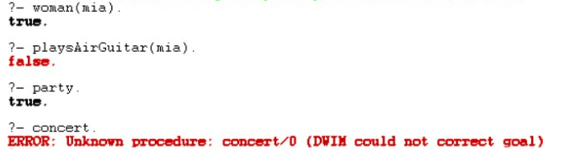

**KB2:**

happy(yolanda).

listens2music(mia).

Listens2music(yolanda):-happy(yolanda).

playsAirGuitar(mia):-listens2music(mia).

playsAirGuitar(Yolanda):-listens2music(yolanda).

# OUTPUT:

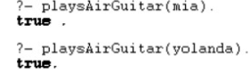

**KB3:**

likes(dan,sally).

likes(sally,dan).

likes(john,brittney).

married(X,Y) :- likes(X,Y) , likes(Y,X).

friends(X,Y) :- likes(X,Y) ; likes(Y,X).

# OUTPUT:

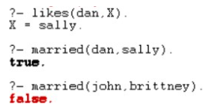

**KB4:**

food(burger).

food(sandwich).

food(pizza).

lunch(sandwich).

dinner(pizza).

meal(X):-food(X).

# OUTPUT:

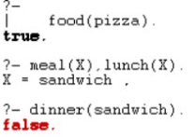

**KB5:**

owns(jack,car(bmw)).

owns(john,car(chevy)).

owns(olivia,car(civic)).

owns(jane,car(chevy)).

sedan(car(bmw)).

sedan(car(civic)).

truck(car(chevy)).

# OUTPUT:

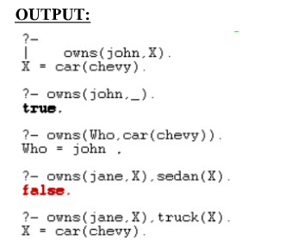

**KB6:**

Find minimum maximum of two numbers

find_max(X,Y,X):-X&gt;=Y,!.

find_max(X,Y,Y):-X&lt;Y.

find_min(X,Y,X):-X=&lt;Y,!.

find_min(X,Y,Y):-X&gt;Y.

# OUTPUT:

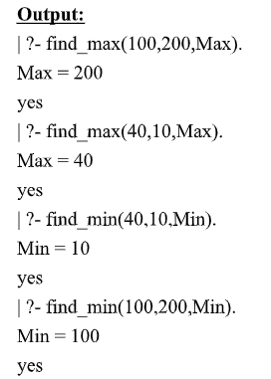

**KB7:**

Here are some simple clauses.

likes(mary,food).

likes(mary,wine).

likes(john,wine).

likes(john,mary).

**How do you add the following facts?**

1. John likes anything that Mary likes

2. John likes anyone who likes wine

3. John likes anyone who likes themselves

**% New facts and rules**

likes(john, X) :- likes(mary, X).

likes(john, Y) :- likes(Y, wine).

likes(john, Z) :- likes(Z, Z).

# OUTPUT:

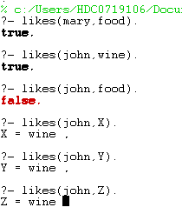

**RESULT:**

Thus to learn PROLOG terminologies has been executed successfully