Active Directory & Windows Security Administration
Evidence-based lab portfolio | Windows Server 2019 • Windows 10 • VMware Workstation
Prepared for technical portfolio and security / IAM job applications

1 | Executive overview
This lab demonstrates administration and validation of a Windows Active Directory environment with organizational-unit design, domain user and computer enumeration, restricted Finance file shares, Group Policy audit configuration, and Windows Security log review. The attached screenshots establish the observed configurations and test outcomes; they do not establish a production deployment.

2 | Environment and scope
- Domain: obed.local; domain controller / file host displayed as OBED01 (Obed01.obed.local).
- Client: CLIENT01, Windows 10 Education build 19045, VMware virtual machine; 192.168.202.101 (as recorded in supplied AD.txt).
- Server: Windows Server 2019 VM; directory administration, Group Policy, file-sharing and Event Viewer evidence.
- Finance shares: Accounts Payable and Accounts Receivable, with user-specific permission testing.

3 | Directory structure and account administration
The dsquery evidence lists organizational units for Domain Controllers, Okeukwu, Finance, Information Technology, Accounts Payable and Accounts Receivable. The user query shows named domain accounts in their departmental OUs; the computer query shows OBED01 and CLIENT01. These commands demonstrate LDAP/AD enumeration rather than proof of provisioning dates or password-policy enforcement.
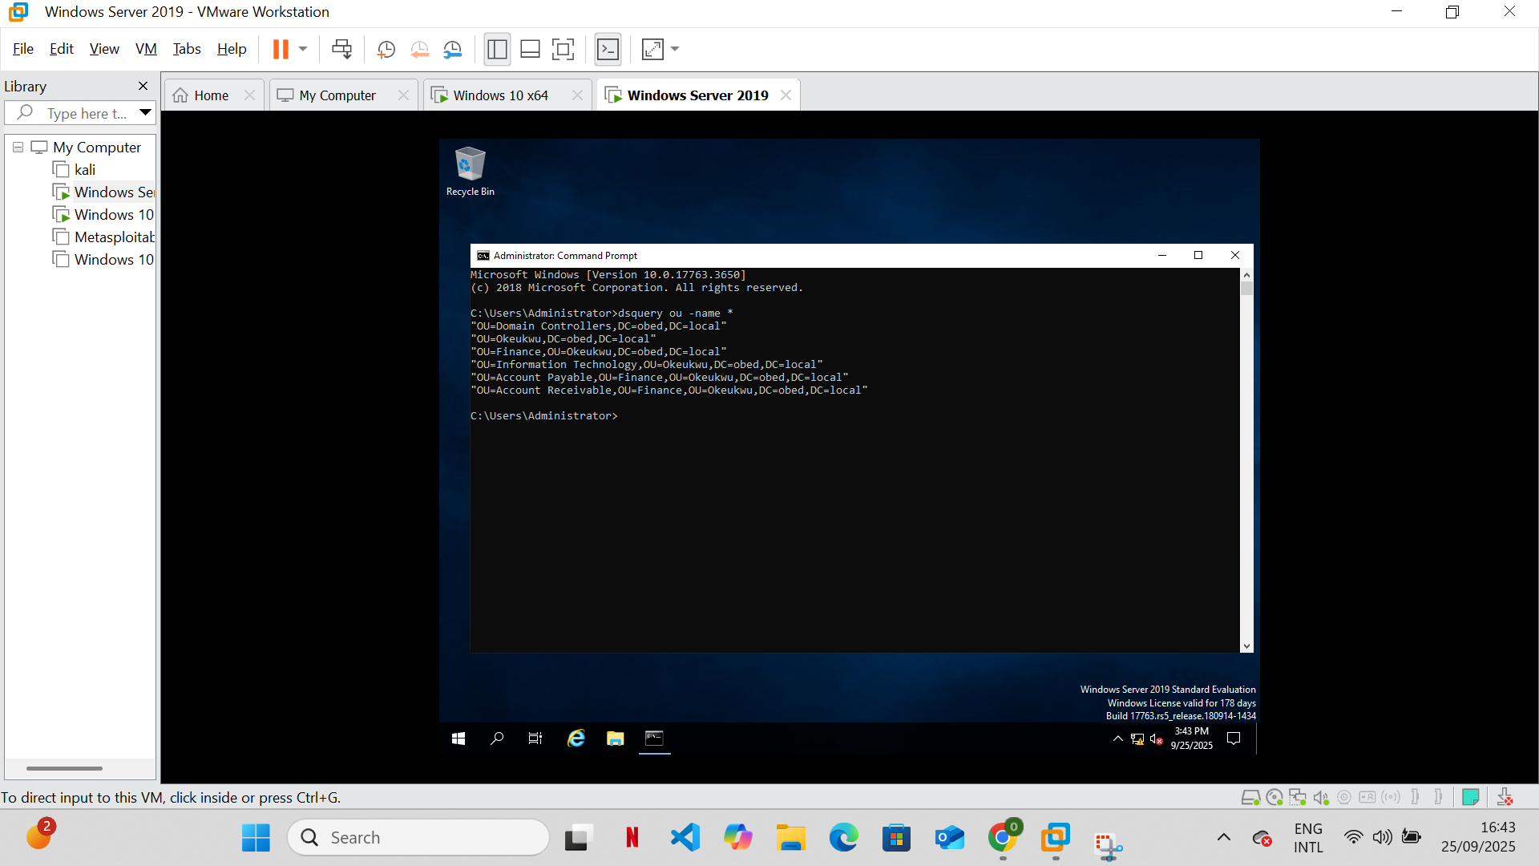
Figure 1. dsquery OU inventory in obed.local.
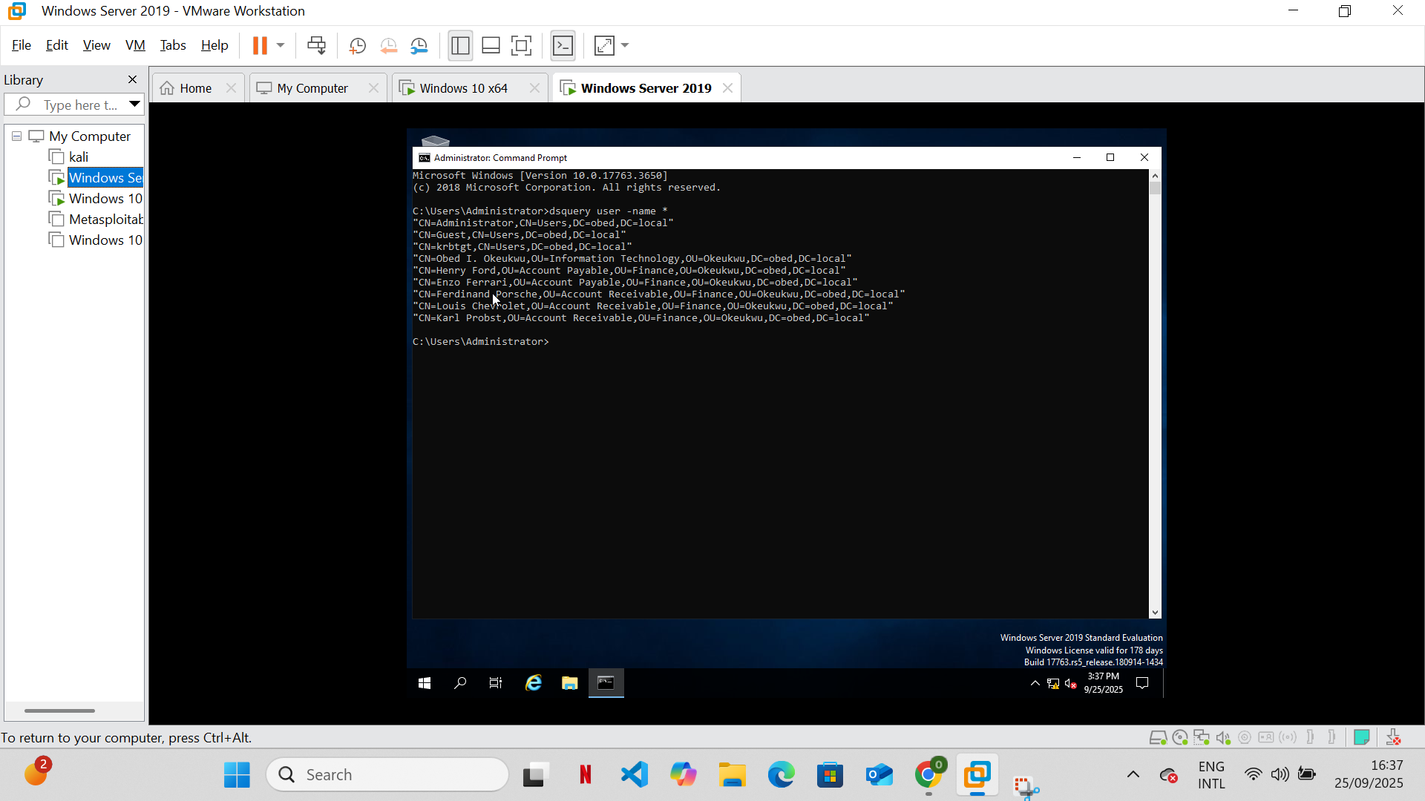
Figure 2. dsquery user inventory and distinguished names.
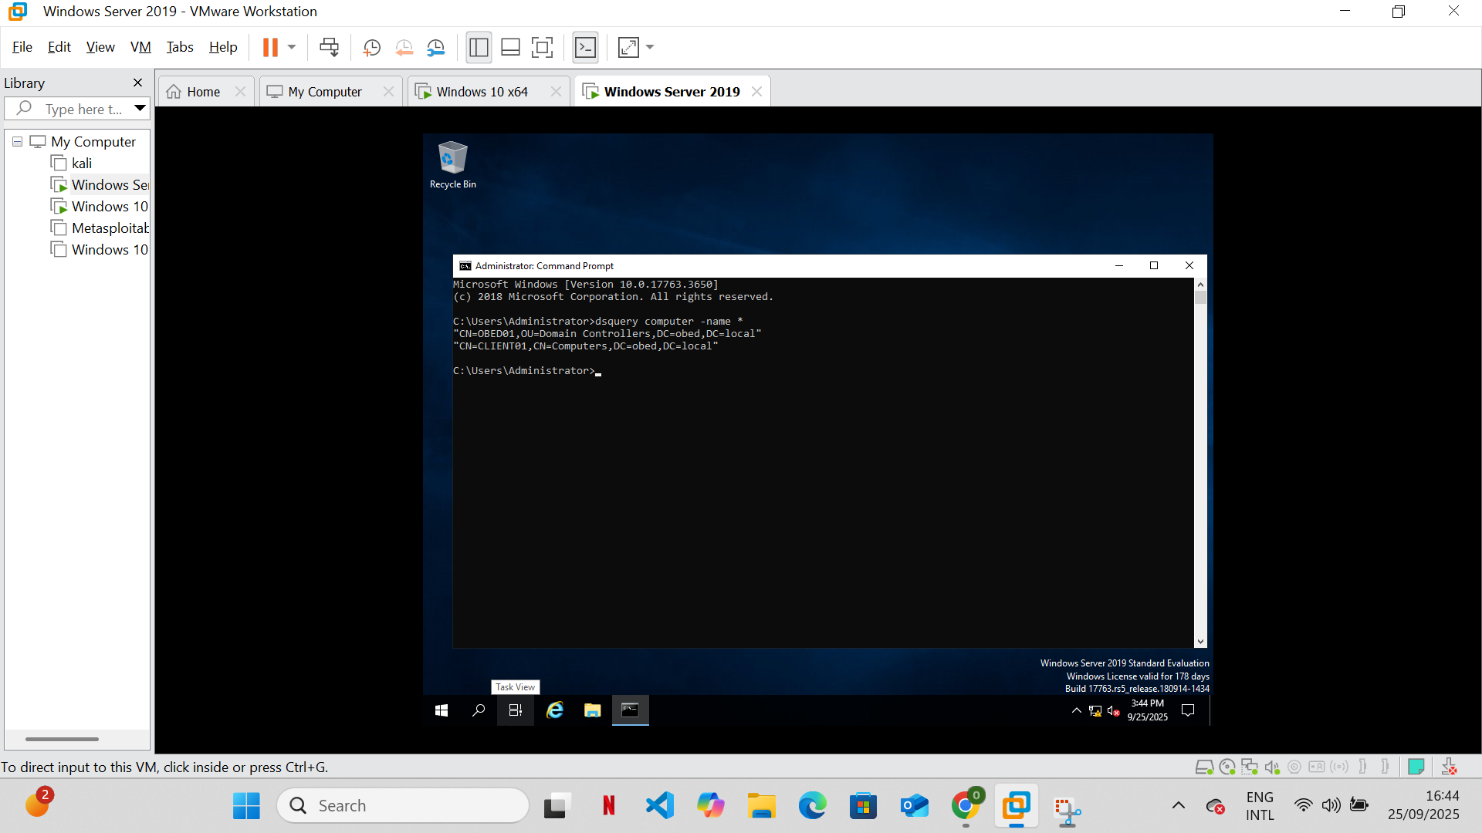
Figure 3. Domain computer inventory (OBED01 and CLIENT01).

4 | File-share authorization validation
Windows 10 client screenshots show attempts to open Finance\Accounts Payable and Finance\Accounts Receivable returning “You do not have permission to access”. The available additional screenshots document successful folder access and group/NTFS configuration. These tests illustrate access separation, but individual effective permissions require correlating group membership, share permissions, and NTFS ACLs.
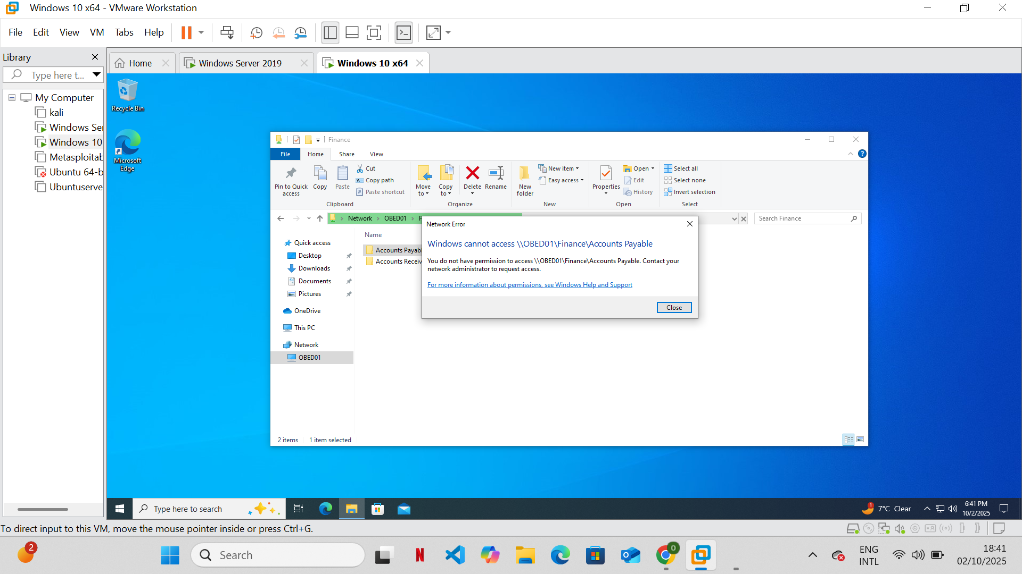
Figure 4. Accounts Payable access denied from the Windows 10 client.
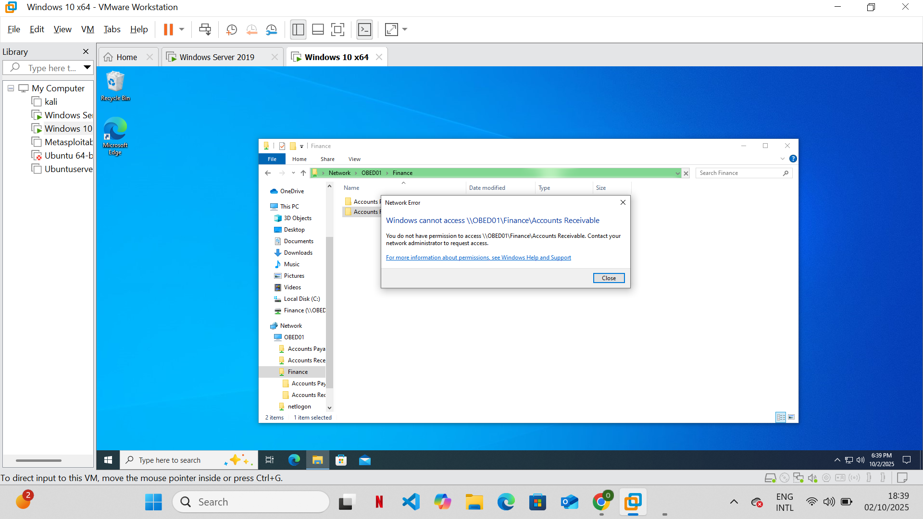
Figure 5. Accounts Receivable access denied from the Windows 10 client.
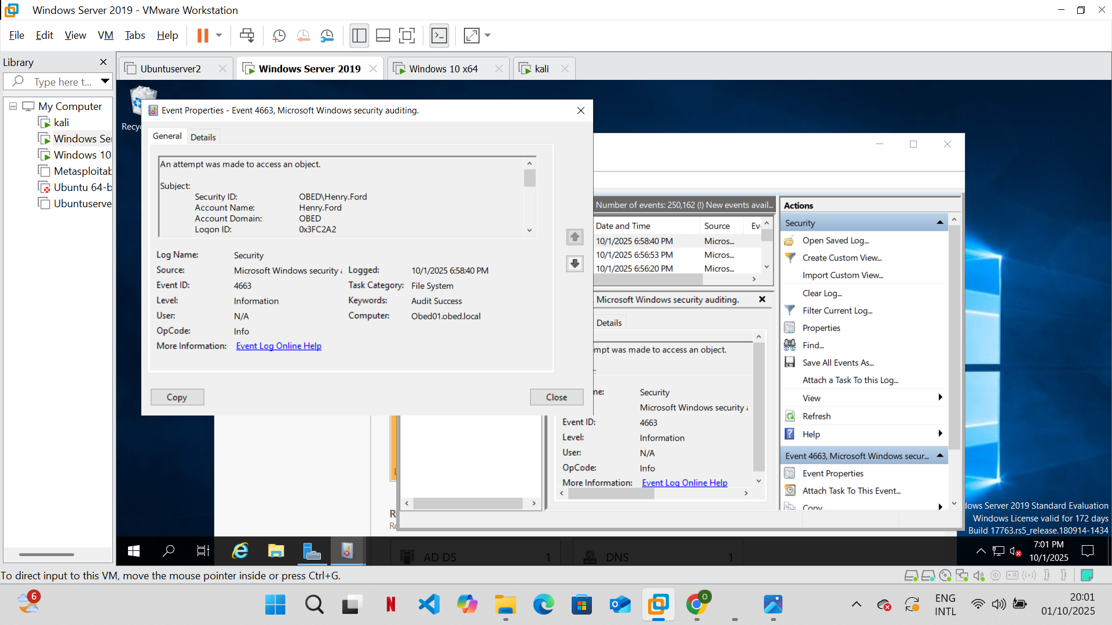
Figure 6. Accounts Payable audit event for a named account (not itself proof of file-read success).
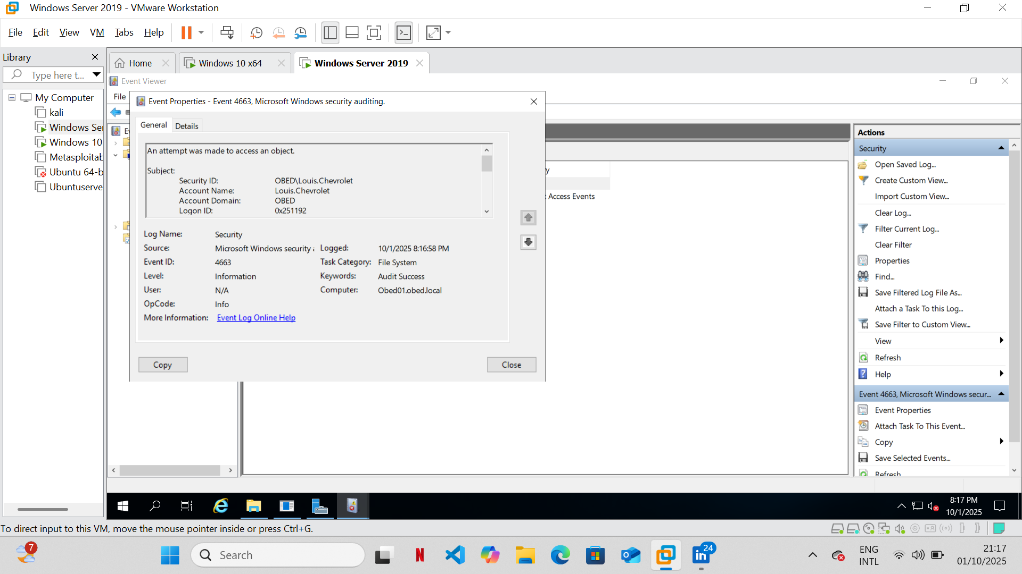
Figure 7. Accounts Receivable audit event for a named account (not itself proof of file-read success).

5 | Audit policy and event review
Group Policy Management Editor shows the legacy “Audit object access” setting defined with Success and Failure checked. Windows Server Event Viewer screenshots show Security Event ID 4663, “An attempt was made to access an object,” for named domain accounts. A 4663 audit-success record is evidence of an audited access attempt matching a success audit condition; it is not by itself a comprehensive authorization verdict for every tested folder.
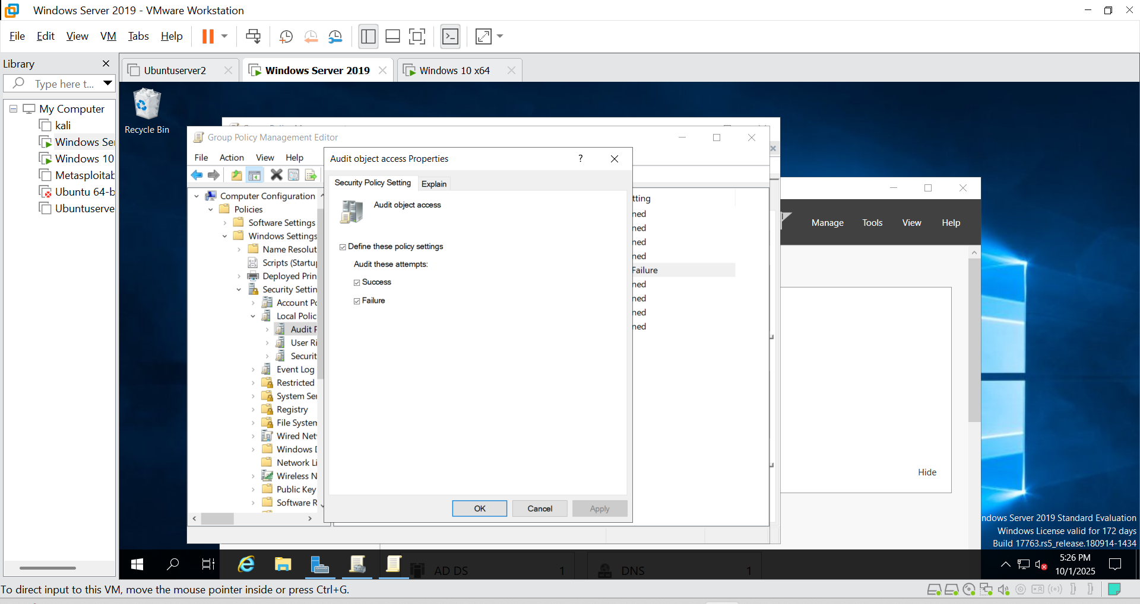
Figure 8. Audit object access configured for success and failure.

6 | Technical validation and limits
- Validated: domain OU/user/computer enumeration using dsquery.
- Validated: denied network-folder access messages on Windows 10.
- Validated: object-access audit policy settings and Security Event ID 4663 observations.
- Not established from these screenshots alone: full effective ACL matrix, GPO link/scope and client-side gpresult outcome, correlation of each denied attempt to Event ID 4656/4663/5145, or formal change-control records.
- Recommended future evidence: whoami /groups, icacls output, share ACLs, gpresult /h, and event details including Object Name, Accesses, and Access Mask.

7 | Skills demonstrated
Active Directory Domain Services (AD DS) • Organizational Units (OUs) • User/computer account enumeration • Windows Server 2019 • Windows 10 domain membership • Group Policy Management • File-share and NTFS authorization testing • Security Event Viewer • Windows auditing • VMware Workstation • Technical evidence documentation.

8 | Portfolio-ready project summary
Built and tested a VMware-based Windows Server 2019 / Windows 10 Active Directory lab for obed.local; organized departmental OUs and domain identities, validated restricted Finance share access, configured success/failure object-access auditing through Group Policy, and investigated Security Event ID 4663 records to document access-control behavior.

