CYBR3010 – Application Layer Security
SSL/TLS Inspection Lab Report
Student Name: Obed Okeukwu
Instructor: Sam El-Awour
Date: (16th December 2025)

Contents
Introduction 3
Virtual Environment 4
Network Configuration and Connectivity 5
SSL/TLS Inspection Configuration on the Firewall 6
Client Browser Behavior Before and After Certificate Installation 7
After Installing Firewall Root Certificate 8
Wireshark SSL/TLS Traffic Capture and Decryption 10
SSL/TLS Interception Process 11
7.3 Privacy, Compliance, and Legal Considerations 12
Conclusion 12
Disclaimer 12

Introduction
The purpose of this lab is to demonstrate the configuration and operation of SSL/TLS inspection on a virtual firewall within a controlled lab environment. SSL/TLS inspection allows a firewall to decrypt encrypted traffic, inspect it for threats or policy violations, and then re-encrypt the traffic before forwarding it to its destination.
In this lab, a virtual network environment was built using a virtual firewall, a Windows client, and external web resources. SSL inspection was configured on the firewall, and the impact on client browser behavior was observed before and after installing the firewall’s root certificate. Additionally, Wireshark was used to capture encrypted SSL traffic and demonstrate how SSL decryption enables visibility into otherwise protected communications.

Virtual Environment
This lab was conducted using a virtualized environment (CML or VMware), ensuring all testing occurred in a controlled and authorized setting. The environment consisted of:

Windows Client VM – Used to browse HTTPS websites
Virtual Firewall Appliance – Configured for SSL/TLS inspection
Internet / External Network – Simulated external HTTPS traffic
Wireshark – Used for packet capture and SSL analysis
Network Topology Overview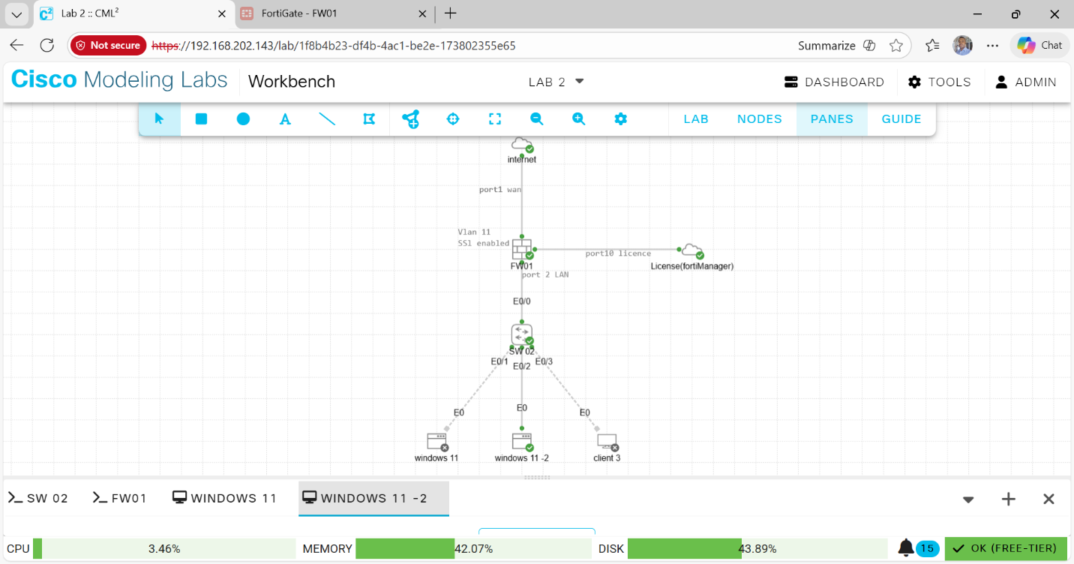Figure 1. Network Topology Diagram
This screenshot shows the complete virtual network topology, including the Windows client, virtual firewall, and external network connection. The diagram clearly illustrates traffic flow from the client through the firewall to the internet, demonstrating where SSL inspection occurs.

Network Configuration and Connectivity
  - IP Address Configuration
Each virtual machine was assigned a valid IP address within the same network segment to ensure connectivity. Proper default gateway and DNS settings were configured on the Windows client to allow internet access through the firewall.
Connectivity was verified using basic web browsing to confirm that traffic successfully passed through the firewall prior to enabling SSL inspection.
Windows IP Configuration]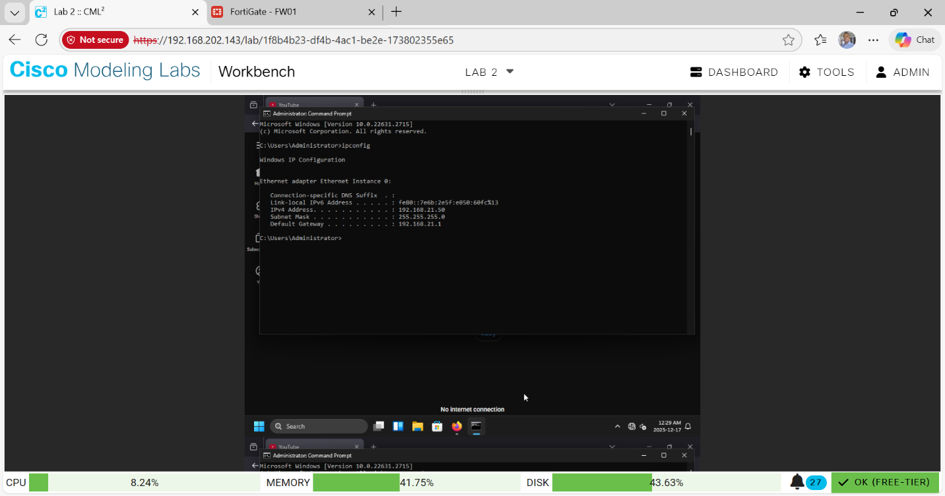Figure 2. IP address
This screenshot displays the Windows client’s IP address, subnet mask, default gateway, and DNS server configuration, confirming correct network setup.
Connectivity Verification
Ping or 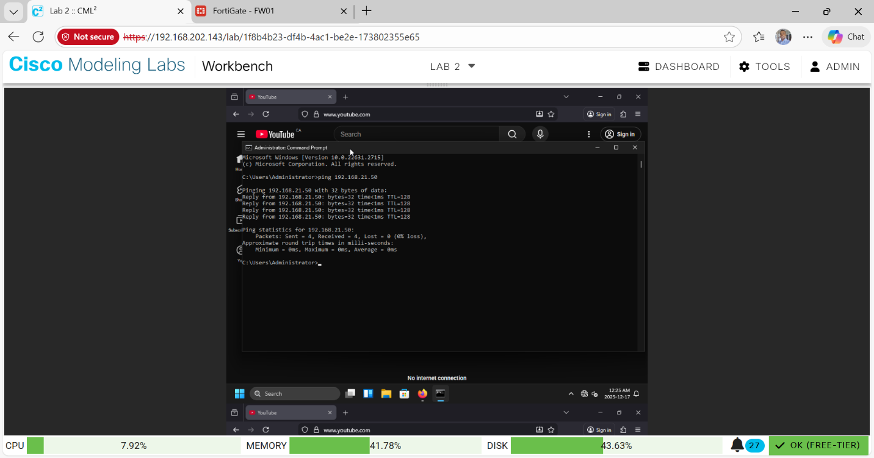Figure 3. Web Connectivity Test
This screenshot confirms successful connectivity from the Windows client through the firewall to external destinations, demonstrating that the network is functioning correctly before SSL inspection is enabled.

SSL/TLS Inspection Configuration on the Firewall
SSL/TLS inspection was enabled on the virtual firewall by creating an SSL inspection policy. The firewall was configured to perform man-in-the-middle (MITM) decryption by dynamically generating certificates for visited HTTPS sites. At this stage, the firewall uses its own self-signed root certificate to re-sign intercepted traffic.
SSL Inspection Policy Configuration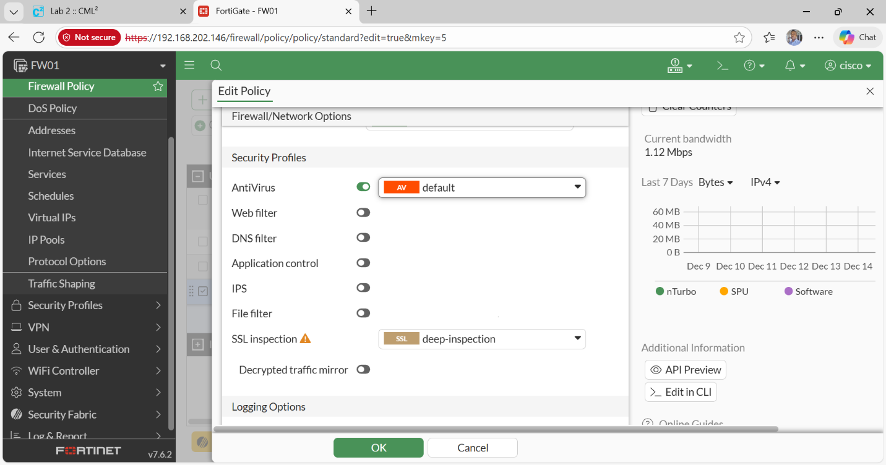Figure 4. Firewall SSL Inspection Settings
This screenshot shows the firewall configuration page where SSL/TLS inspection is enabled, including the selected inspection mode and certificate authority settings.

Client Browser Behavior Before and After Certificate Installation
  - Before Installing Firewall Certificate
Before installing the firewall’s root certificate on the Windows client, HTTPS websites displayed certificate warnings. This occurs because the browser does not trust the firewall’s certificate authority.
Browser Certificate Warning
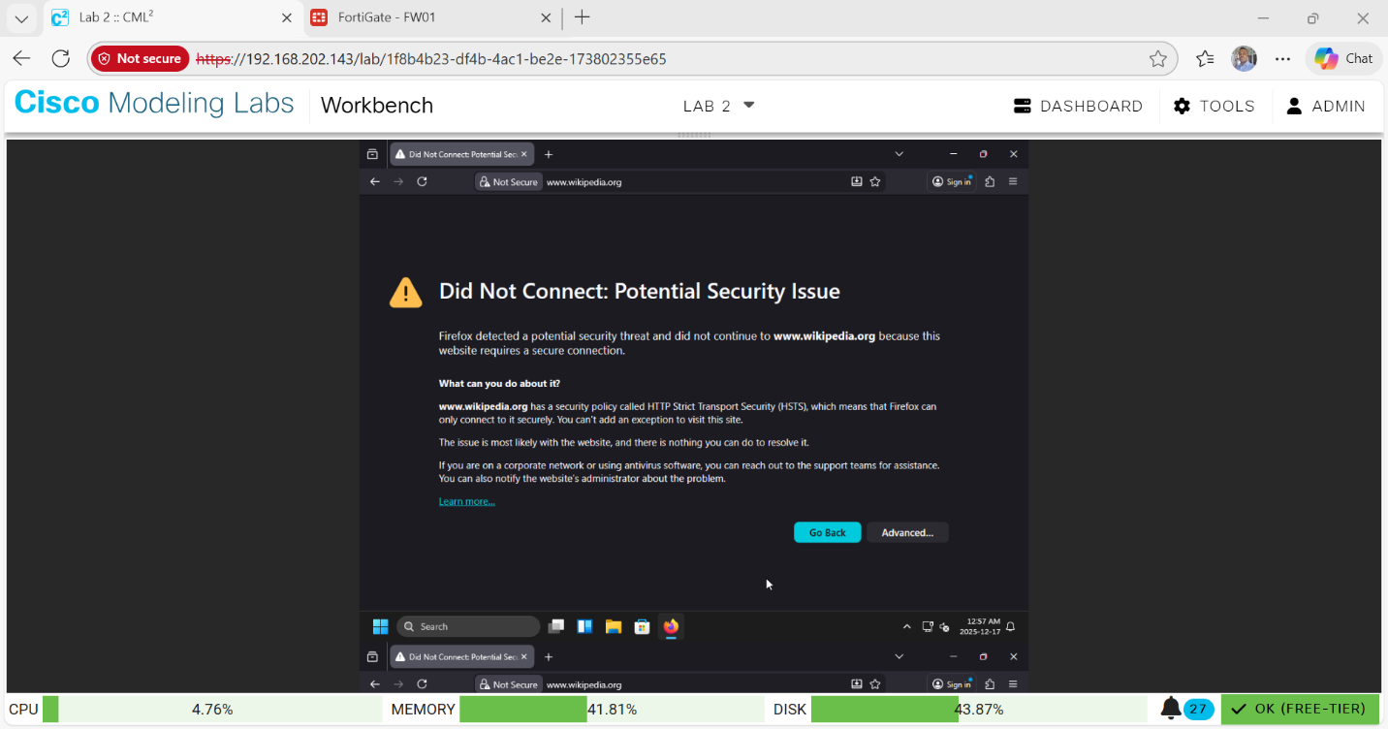figure 5. Browser warning
This screenshot shows a browser warning message indicating that the website’s certificate is not trusted, demonstrating the effect of SSL inspection without the firewall certificate installed.

After Installing Firewall Root Certificate
The firewall’s root certificate was exported and installed into the Trusted Root Certification Authorities store on the Windows client. Once installed, HTTPS websites loaded normally without warnings.
Firewall Certificate Installed on Windows
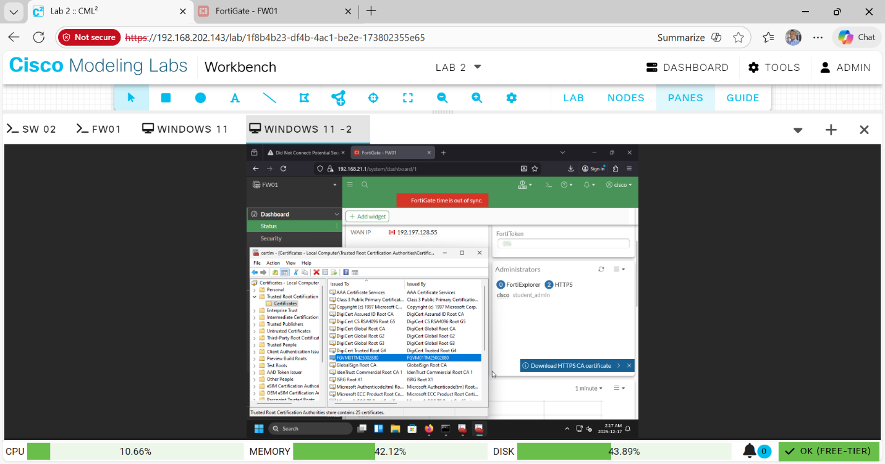Figure 6. Firewall certificate installed
This screenshot confirms that the firewall’s root certificate has been successfully installed in the windows trusted certificate store.

Browser HTTPS Working Normally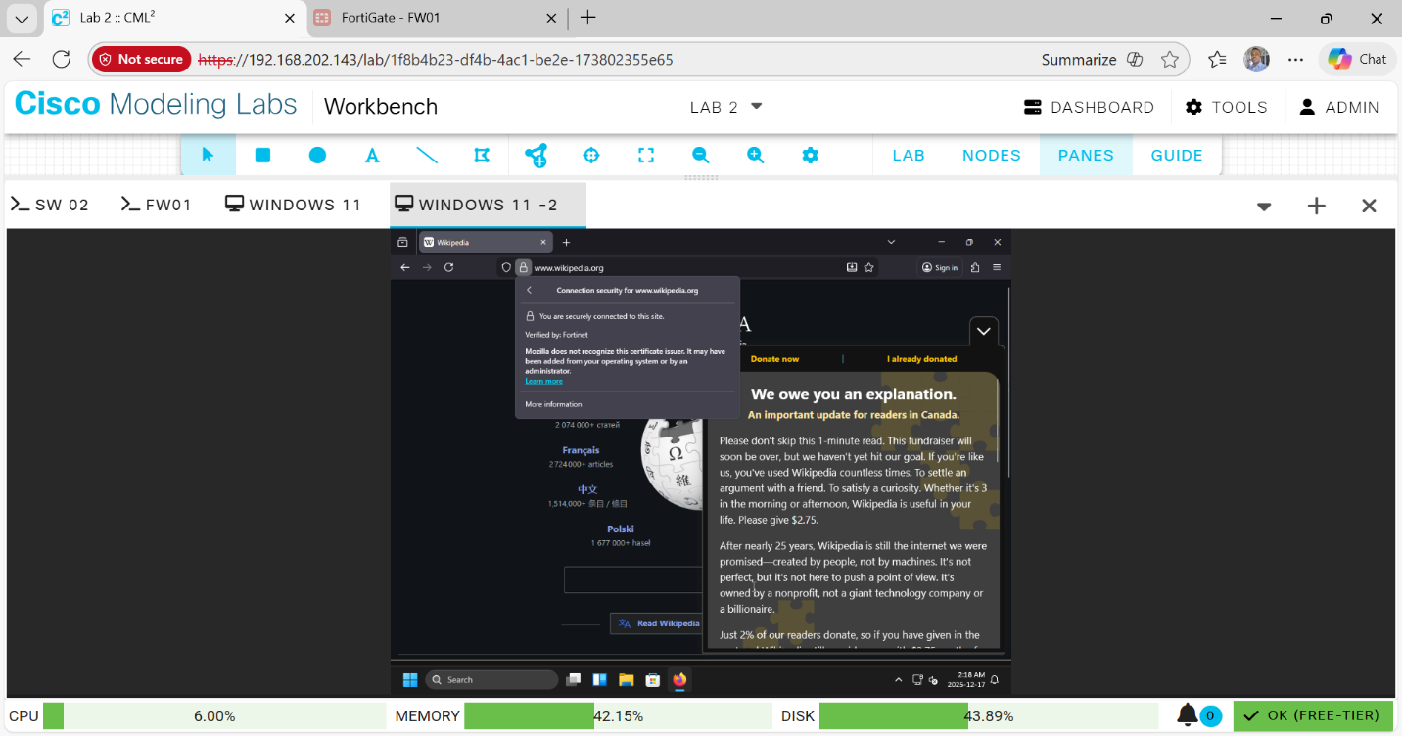Figure 8. Successful access
This screenshot shows successful access to an HTTPS website with no certificate warnings, confirming that SSL inspection is functioning correctly.

Wireshark SSL/TLS Traffic Capture and Decryption
  - Encrypted SSL Traffic (Before Decryption)
Wireshark was used to capture network traffic from the Windows client. Initially, SSL traffic appeared encrypted, showing only TLS handshake messages and encrypted payloads.
Wireshark Encrypted TLS Traffic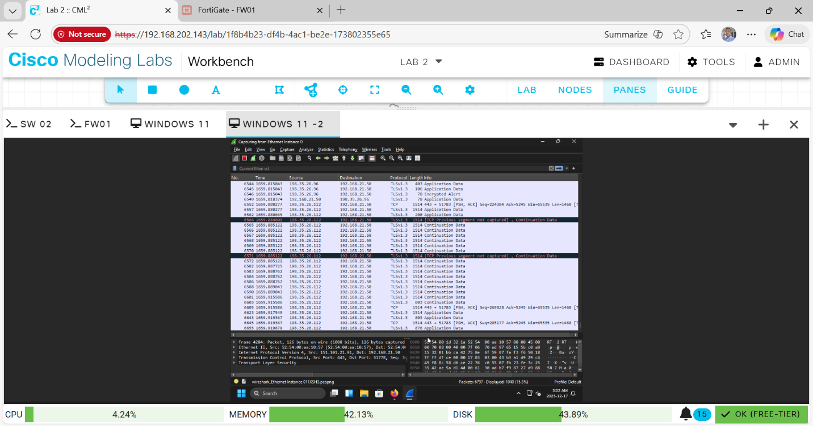Figure 9. TLS packets captured
This screenshot shows TLS packets captured in Wireshark where the payload is encrypted and unreadable, demonstrating standard SSL encryption.
  - Decrypted SSL Traffic After Configuration
By configuring Wireshark with the appropriate SSL key material encrypted traffic could be decrypted, revealing HTTP content inside the TLS session.
Wireshark Decrypted HTTPS Payload]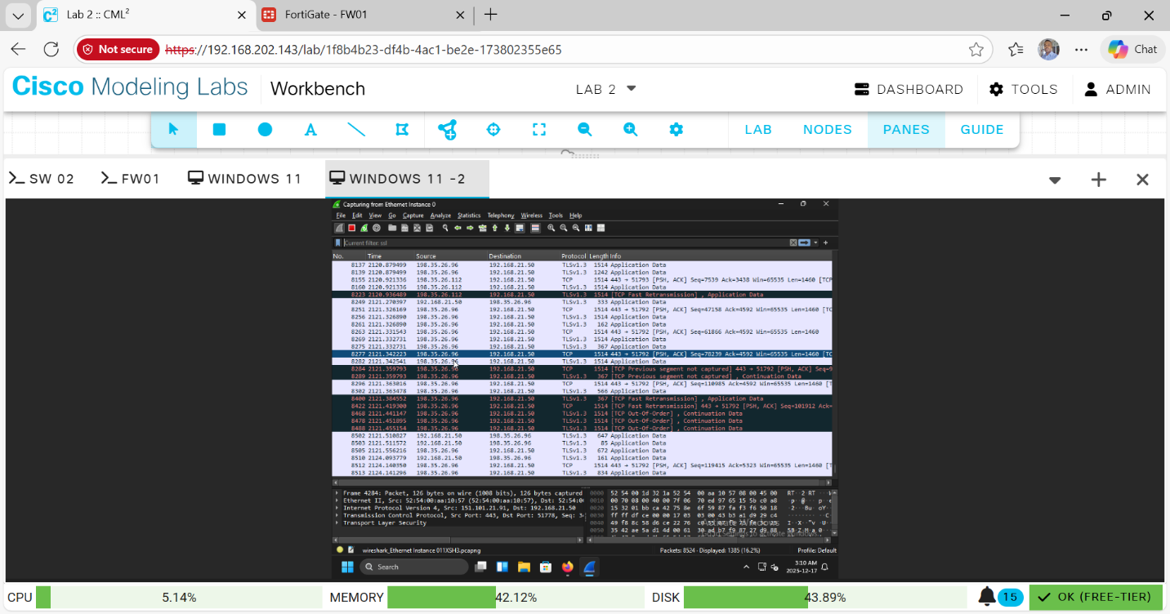
This screenshot highlights decrypted application-layer data within Wireshark, demonstrating how SSL inspection allows visibility into encrypted traffic.

SSL/TLS Interception Process
SSL/TLS interception works by positioning the firewall as an intermediary between the client and the destination server. The firewall decrypts the incoming encrypted traffic, inspects it for security threats or policy violations, then re-encrypts the traffic before forwarding it.
Certificates play a critical role in this process. The firewall generates certificates dynamically and signs them using its own root certificate authority. Trust is maintained by installing this root certificate on the client, allowing the browser to accept the re-signed certificates without warnings.
  - Technical Challenges of SSL Inspection
Several technical challenges can occur during SSL/TLS inspection:
- Certificate pinning: Some applications reject re-signed certificates, causing connectivity issues.
- Encrypted SNI: Prevents visibility into requested domains.
- Performance overhead: Decryption and re-encryption increase CPU usage on the firewall.
Potential solutions include bypassing inspection for pinned applications, using hardware acceleration, and selectively inspecting traffic rather than applying inspection globally.

7.3 Privacy, Compliance, and Legal Considerations
SSL inspection intersects with data privacy laws such as GDPR, HIPAA, and PIPEDA. Inspecting encrypted traffic may expose sensitive personal or medical information, which can violate compliance requirements if performed without proper justification.
For example, SSL inspection may be restricted when handling healthcare records (HIPAA) or personal customer data (GDPR). Organizations must implement policies such as user consent, data minimization, and logging controls to remain compliant.

Conclusion
This lab successfully demonstrated the implementation of SSL/TLS inspection in a virtualized environment. By configuring the firewall, installing the appropriate certificates, and analyzing traffic using Wireshark, the lab highlighted both the technical benefits and ethical considerations of SSL inspection. The exercise reinforced the importance of balancing security visibility with privacy and legal compliance.

Disclaimer
All activities in this lab were performed in a controlled, authorized educational environment and align with ethical cybersecurity practices

