**Orion Belete**

**Part 1 Screen Shot**

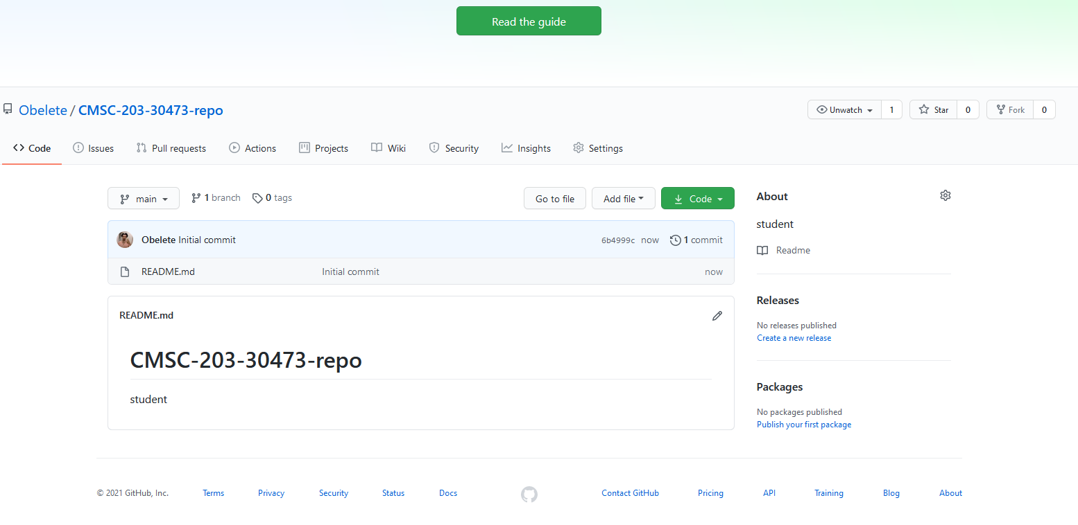

***Please Zoom in if you cannot see the little numbers. (ctrl + mouse scroll)***

**Part 2 Screen Shot 1**

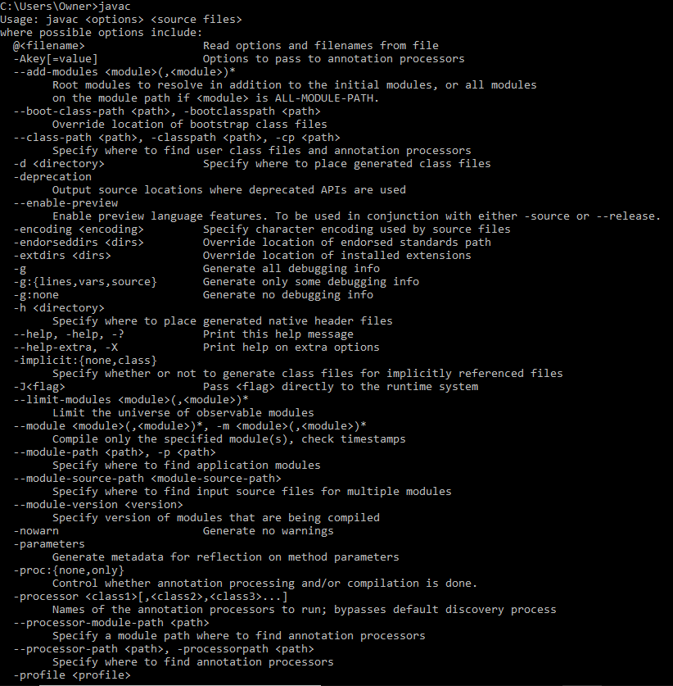

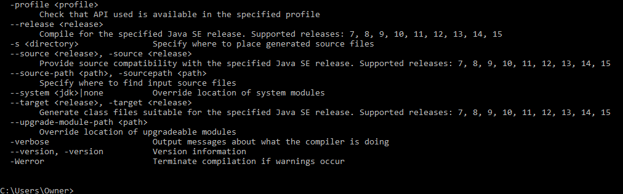

**Part 2 Screen Shot 2**

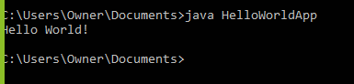

**Part 3 Screen Shot 1**

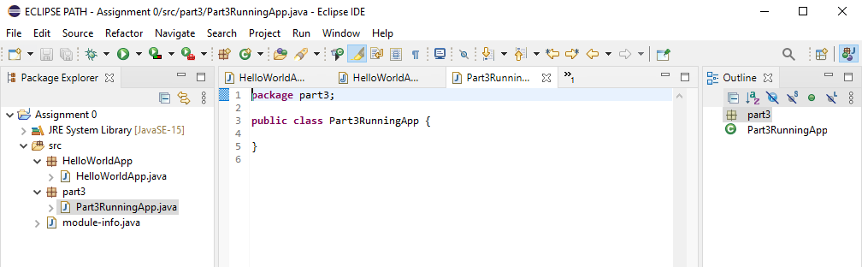

**Part 3 Screen Shot 2**

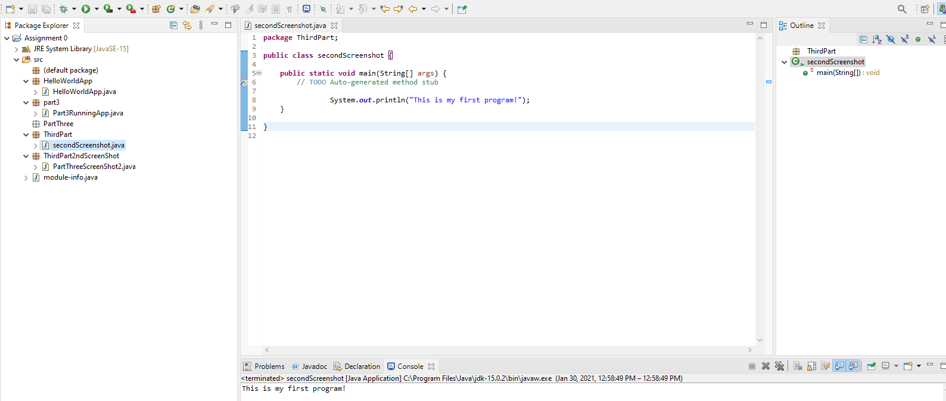

**Part 4 a&b**

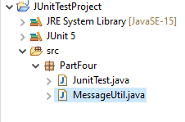

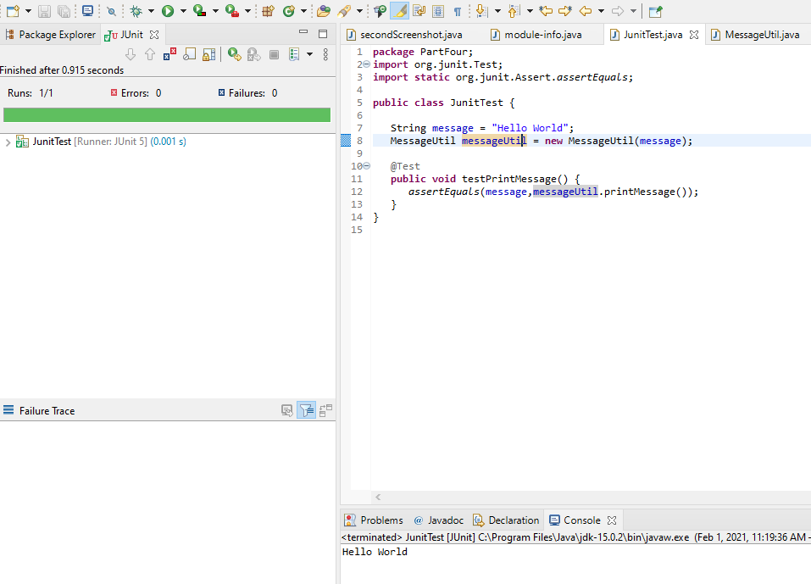

**Part 5**

1. 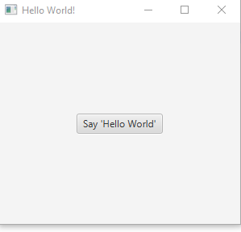
2. 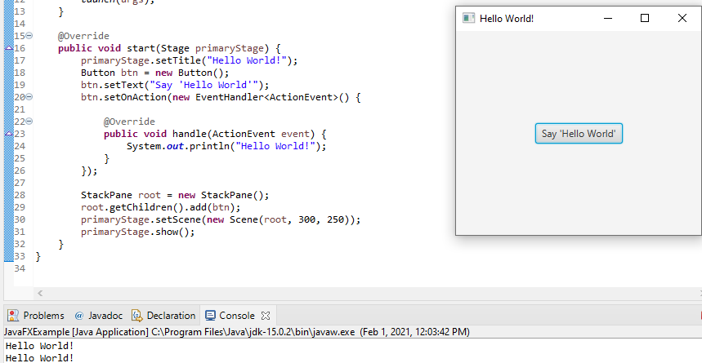
3. 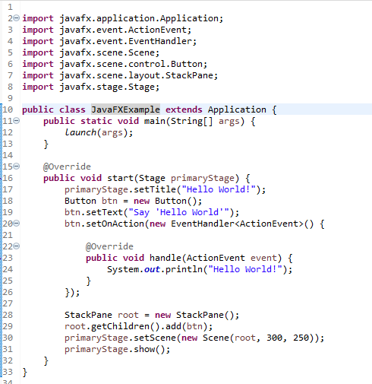

**Learning Experience:**

I have learned that Eclipse is an IDE (integrated development environment) used to program using java. We can create a Java.class file using the “javac” command in the command prompt. We can use the text “dir” to check directory using command prompt. Then by using the text “java” plus “file name” after using the “cd” (change directory command) to where the file is located, we can run the java file to print out or perform the program written in the text editor file that we saved as .java which then got compiled to .class. On top of that, I have learned that we can test our program using ‘JUnitTest’. I have learned the basics on how to open and run Eclipse. And finally, I have learned how to run a syntax using JavaFX and that we must add library to each project we open in order to run JavaFx.

I struggled with finding the right path and spelling capital cases accurately as I saved them when using command prompt that took me hours to figure out, I could not get part 2 right so I got help from a tutor and learned that my path was right just the wrong capitalization and some spellings were off. Additionally, I struggled with running JUnitTest. I am usually a bright guy and good at computers, but the instructions were very explanatory that I complicated them.

I was successful with setting up GitHub that was easy, then I got successful at installing JDK and running Java from command line. I got successful at installing eclipse and running a “hello world” program. However I had to get assistance for JunitTest and JavaFx because of the path they have to follow in order to run properly, and as I described above I kept misspelling and forgetting capital letters so I had to get help link is below.

**Resources Used**

* <https://mcstemlc.mywconline.com/schedule.php?scheduleid=sc5ff4cf>9c5e199&date=01-31-2021&focus=CMSC203

(tutoring assistance by MC)

|  |  |  |  |
| --- | --- | --- | --- |
| **#** |  | **Y/N** | **Comments** |
|  | **Assignment files:** |  |  |
|  | * FirstInitialLastName_Assignment0.docx/pdf | **Yes or No** | ***Y*** |
|  | * Source java files | **Yes or No** | ***Y*** |
|  | **Program compiles** | **Yes or No** | ***Y*** |
|  | **Program runs with desired outputs related to a Test Plan** | **Yes or No** | ***Y*** |
|  | **Documentation file: Screenshots of** |  |  |
|  | * Part1: Setup GitHub | **Yes or No** | ***Y*** |
|  | * Part 2 -Install JDK, Test java Application from Command Line | **Yes or No** | ***Y*** |
|  | * Part 3 - Install Eclipse, Test Eclipse Java Application | **Yes or No or N/A** | ***Y*** |
|  | * Part 4 - Install, Setup, Test Junit Program | **Yes or No or N/A** | ***Y*** |
|  | * Part 5 - Install, Setup, and Test JavaFX Application. | **Yes or No or N/A** | ***Y*** |
|  | * Lessons Learned | **Yes or No** | ***Y*** |
|  | * Checklist is completed and included in the Documentation | **Yes or No** | ***Y*** |