**GHANA COMMUNICATION TECHNOLOGY UNIVERSITY**



FACULTY OF COMPUTING AND INFORMATION SYSTEMS

DEPARTMENT OF INFORMATION SYSTEMS

IT 305 SOFTWARE ENGINEERING

SUBMITTED

BY

GROUP 5

LEVEL 300

GROUP E

LECTURER:

MR. JOSEPH ABANDO-SAM

16th DECEMBER , 2024

**EVENT REGISTRATION SYSTEM**

This Event Registration System is designed to let individuals register for events online conveniently. The application enables event organizers to list events and attendees to browse and sign up for events based on their interests. Users can view details such as the event name, date, time, location, and description. This system simplifies the event management process, reducing manual work for organizers and improving the registration experience for users.

**Product Vision**

The Event Registration System is an online event management platform designed FOR event organizers and attendees WHO need a convenient way to manage and register for events. It simplifies event creation, discovery, and registration THAT enhances communication between organizers and participants. UNLIKE manual processes or limited online tools, OUR PRODUCT provides a user-friendly, scalable solution with features like advanced search filters, automated email notifications, and streamlined registration workflows.

**Personas**

1. **Elizabeth Afro: The Informal Event Participant**

Elizabeth Afro, a 28-year-old marketing expert, likes to find and go to events like networking workshops and art exhibits. She appreciates a platform that is easy to use and straightforward so she can browse and sign up for events with ease. Her biggest obstacles are navigating excessively complex registration procedures and swiftly locating pertinent events. Sarah values email reminders and confirmations because they keep her organized and make sure she doesn't miss any important occasions.

1. **David Kensen: The event planner**

David Kensen is 34-year old independent event planner who specializes in swiftly handling registrations and advertising events. He frequently finds it difficult to complete laborious manual activities like delivering updates and keeping track of participant information. Alex uses technologies to monitor registration trends and draw attention to significant events. In order to save time and enhance the event experience, he is looking for a platform that makes event planning and administration easier while automating communications with guests.

1. **Gloria Oye: The regular attendee**

For relaxation and skill development, 40-year-old software programmer Gloria Oye frequently goes to tech conferences and music concerts. He appreciates technologies that make it easy for him to locate events that suit his interests and timetable. Michael wants a solution to keep track of his event history because he frequently gets overloaded with listings for unrelated events. For the purpose of organizing his past and future events, he values sophisticated search filters and a dashboard.

**User Stories**

1. As a user I would want to register for an account on the platform in order to use the event registration.
2. As an organizer, I would want to sign up as an event creator so that I may efficiently list and oversee my activities.
3. I want to make and maintain event profiles as an organizer with information like the name, date, and location so that prospective attendees have access to correct and current details.
4. As an organizer, I want to limit the number of people who can register for my events so that I can manage attendance according to the size of the venue.
5. As a user I would like to register for an event by entering my personal information. In order to confirm my attendance.
6. As the event planner, I would like to see the attendees' registration information so that I may effectively manage the attendees.

**Scenario**

1. **Registering for an Art workshop**

An occasional participant named Sarah Johnson wants to sign up for an art class that she found on the platform. She wants to successfully register for the event as her ultimate goal. In order to accomplish this, Sarah signs in, searches the website for art classes in her area, and registers. Once the event has been successfully registered for, the platform's registration button turns green. Sarah Johnson is shown as the user, and the system is portrayed as the facilitator. The current system attempts to solve the issue of the laborious and prone to mistakes manual registration procedure. Sarah will have a flawless experience thanks to the platform's easy-to-use registration form and immediate

1. **Managing events details as an organizer**

A tech conference listing is created and updated by event planner Alex Carter, who logs into the portal. Making ensuring the event profile is accurate and comprehensive in order to draw in more guests is his main goal. The event name, date, location, and capacity are among the details that Alex enters after accessing the "Create Event" area. He later makes changes to the description. Alex Carter is one of the actors who play the role of organizer. Managing or editing event details after creation is a challenge organizers encounter, which the current system attempts to solve. The solution fixes this by providing thorough event management tools and real-time updates, granting Alex

**FEATURES**

1. Registration
   * Users create an account to access the platform and register for events.
   * Organizers also register to list and manage their events.
2. Create Event
   * Event organizers can create and update event profiles.
   * Profiles include event name, description, date, time, venue, and registration capacity
3. Search Events
   * Users can search for events based on categories, date, or location.
   * Filters like “free events” or “paid events” can be added for better results.

* Event Prioritization
  + Organizers can highlight specific events, e.g., by marking them as featured or popular.

1. Register for Events
   * Users can sign up for events by providing personal details (name, email, contact).
   * Registrations are stored and can be accessed by organizers.
2. Notifications

* An example response is provided to inform the client that the selected events have been recorded.

**Systems Modeling Diagrams**

1. **Flow Chart**

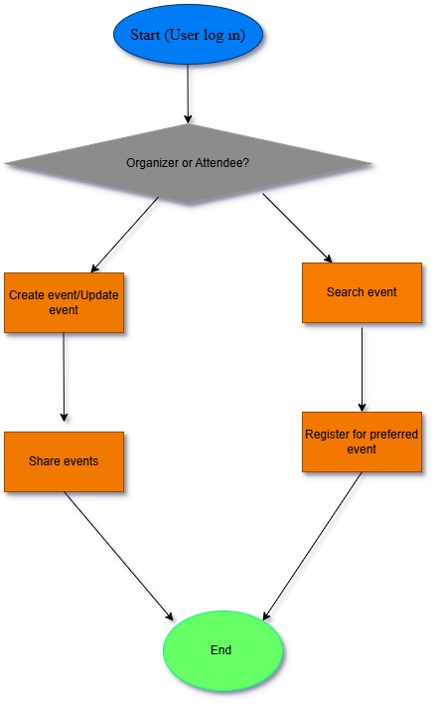

1. **Context Diagram**

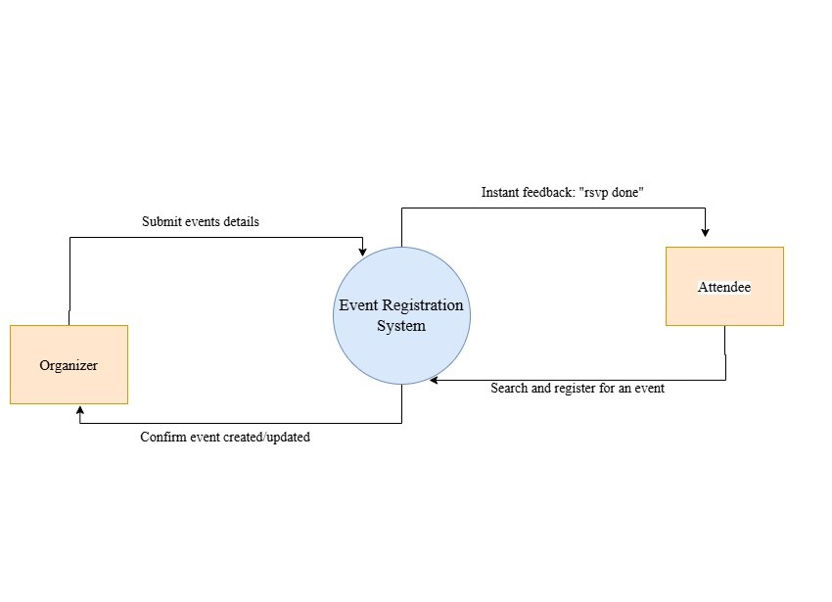

1. **Relational Diagram**

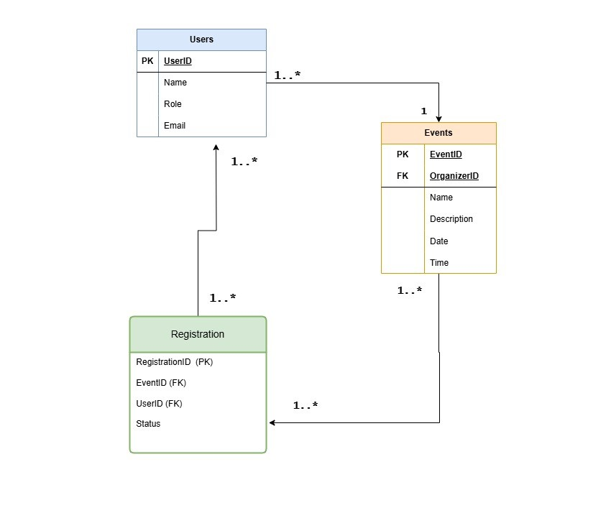

1. **Sequence Diagram**

