E-BookStore

Spécifications Technique

des IHM

Validation du document

|  |  |  |  |  |
| --- | --- | --- | --- | --- |
| Action | Grade - Nom | Qualité - Fonction | Date | Visa |
| Rédigé par |  |  |  |  |
| Contrôlé par |  |  |  |  |
| Contrôlé par |  |  |  |  |
| Approuvé par |  |  |  |  |

Historique des versions du document

|  |  |  |  |
| --- | --- | --- | --- |
| Version | Date | Commentaire | Auteur |
| <versionProjet> | <date> | <commentaire> | <auteur> |
|  |  |  |  |
|  |  |  |  |
|  |  |  |  |

Table des matières

[1 Introduction 1](#_Toc508613121)

[1.1 Description 1](#_Toc508613122)

[2 Vision statique des IHM 1](#_Toc508613123)

[2.1 Eléments à la racine des IHM 1](#_Toc508613124)

[3 Vision dynamique des IHM 1](#_Toc508613125)

[3.1 Package Racine : Vue générale des IHMs 1](#_Toc508613126)

[3.2 Package : Lancer un pal 1](#_Toc508613127)

[4 ANNEXES 1](#_Toc508613128)

[4.1 Les écrans 1](#_Toc508613129)

[4.2 Les exigences 1](#_Toc508613130)

[4.3 Les documents associés 1](#_Toc508613131)

[4.4 Les opérations associées 1](#_Toc508613132)

# Introduction

## Description

# Vision statique des IHM

## Eléments à la racine des IHM

|  |  |  |  |  |  |
| --- | --- | --- | --- | --- | --- |
| |  | | --- | | file:/tmp/CinematicRoot__47-1sBVIEeetFdz5pzgWAw13528728396457174399.png E-BookStore | | ***~~>~~*** file:/tmp/Package__48qyPBVIEeetFdz5pzgWAw6619952288373585238.png Checkout | | ***~~>~~*** file:/tmp/ViewContainer__48gaJBVIEeetFdz5pzgWAw14293883123123322011.png HomePage | | ***~~>~~*** file:/tmp/ViewContainer__48qLRRVIEeetFdz5pzgWAw5971762572218118857.png CreateAccount | | ***~~>~~*** file:/tmp/Toolkit__IxeAcKLCEeuqs9mIRWXCLA3872084623043193686.png | |

|  |  |
| --- | --- |
| **Type** | **Nom** |

|  |  |
| --- | --- |
| SubPackage : Package | Checkout |

|  |  |
| --- | --- |
| ViewContainer : Page | HomePage |

|  |  |
| --- | --- |
| ViewContainer : Page | CreateAccount |

### ViewContainer HomePage

#### Représentation graphique

|  |  |  |  |  |  |
| --- | --- | --- | --- | --- | --- |
| |  | | --- | | file:/tmp/ViewContainer__48gaJBVIEeetFdz5pzgWAw1346768358281966223.png HomePage | | ***~~>~~*** file:/tmp/ViewContainer__48jdcBVIEeetFdz5pzgWAw10748785510039226591.png SearchForm | | ***~~>~~*** file:/tmp/ViewContainer__48qLIBVIEeetFdz5pzgWAw1167930815209147620.png Books | | ***~~>~~*** file:/tmp/ViewContainer__48qLLxVIEeetFdz5pzgWAw12806410954495561537.png ShoppingCart | | ***~~>~~*** file:/tmp/ViewElement__48qLLBVIEeetFdz5pzgWAw8095393649155792624.png createAccount |  Maquette file:/tmp/HomePage%20View%20Container%20Mockup_copy-m2doc1660901855521888957.jpg |

#### Caractéristiques

|  |  |
| --- | --- |
| **Nom** | **Valeur** |
| Name | HomePage |
| Label |  |
| Widget | Page |
| Actions |  |
| Events |  |
| Description |  |
| Owned Elements | SearchForm  Books  createAccount  ShoppingCart |
| Binding |  |
| Meta-data |  |

##### Elément : SearchForm

|  |  |
| --- | --- |
| **Nom** | **Valeur** |
| Name | SearchForm |
| Label |  |
| Widget | Panel |
| Required | N/A |
| Type | N/A |
| Actions |  |
| Events |  |
| Desciption |  |
| Binding |  |
| Méta-data |  |

##### Elément : Books

|  |  |
| --- | --- |
| **Nom** | **Valeur** |
| Name | Books |
| Label |  |
| Widget | Table |
| Required | N/A |
| Type | N/A |
| Actions |  |
| Events |  |
| Desciption |  |
| Binding |  |
| Méta-data |  |

##### Elément : createAccount

|  |  |
| --- | --- |
| **Nom** | **Valeur** |
| Name | createAccount |
| Label |  |
| Widget | Link |
| Required | Non |
| Type |  |
| Actions |  |
| Events | createAccount.onClick |
| Desciption |  |
| Binding |  |
| Méta-data |  |

##### Elément : ShoppingCart

|  |  |
| --- | --- |
| **Nom** | **Valeur** |
| Name | ShoppingCart |
| Label |  |
| Widget | Panel |
| Required | N/A |
| Type | N/A |
| Actions |  |
| Events |  |
| Desciption |  |
| Binding |  |
| Méta-data |  |

#### Les exigences associées

|  |  |  |
| --- | --- | --- |
| **Elément** | **Numéro d’exigence** | **Description** |

### ViewContainer CreateAccount

#### Représentation graphique

|  |  |  |  |  |  |  |
| --- | --- | --- | --- | --- | --- | --- |
| |  | | --- | | file:/tmp/ViewContainer__48qLRRVIEeetFdz5pzgWAw3089209301818963149.png CreateAccount | | ***~~>~~*** file:/tmp/ViewElement__48qLRxVIEeetFdz5pzgWAw9756756085635195436.png email | | ***~~>~~*** file:/tmp/ViewElement__48qyMBVIEeetFdz5pzgWAw9284055356668358635.png password | | ***~~>~~*** file:/tmp/ViewElement__48qyMhVIEeetFdz5pzgWAw11074369002107164328.png name | | ***~~>~~*** file:/tmp/ViewElement__48qyNBVIEeetFdz5pzgWAw12236792972782619420.png validate | | ***~~>~~*** file:/tmp/ViewElement__48qyOBVIEeetFdz5pzgWAw8266484586405218221.png cancel |  Maquette file:/tmp/CreateAccount%20View%20Container%20Mockup_copy-m2doc2267503602241754252.jpg |

#### Caractéristiques

|  |  |
| --- | --- |
| **Nom** | **Valeur** |
| Name | CreateAccount |
| Label |  |
| Widget | Page |
| Actions |  |
| Events |  |
| Description |  |
| Owned Elements | email  password  name  validate  cancel |
| Binding |  |
| Meta-data |  |

##### Elément : email

|  |  |
| --- | --- |
| **Nom** | **Valeur** |
| Name | email |
| Label |  |
| Widget | Text |
| Required | Oui |
| Type |  |
| Actions |  |
| Events |  |
| Desciption |  |
| Binding |  |
| Méta-data |  |

##### Elément : password

|  |  |
| --- | --- |
| **Nom** | **Valeur** |
| Name | password |
| Label |  |
| Widget | Password |
| Required | Oui |
| Type |  |
| Actions |  |
| Events |  |
| Desciption |  |
| Binding |  |
| Méta-data |  |

##### Elément : name

|  |  |
| --- | --- |
| **Nom** | **Valeur** |
| Name | name |
| Label |  |
| Widget | Text |
| Required | Oui |
| Type |  |
| Actions |  |
| Events |  |
| Desciption |  |
| Binding |  |
| Méta-data |  |

##### Elément : validate

|  |  |
| --- | --- |
| **Nom** | **Valeur** |
| Name | validate |
| Label |  |
| Widget | Button |
| Required | Non |
| Type |  |
| Actions |  |
| Events | validate.onClick |
| Desciption |  |
| Binding |  |
| Méta-data |  |

##### Elément : cancel

|  |  |
| --- | --- |
| **Nom** | **Valeur** |
| Name | cancel |
| Label |  |
| Widget | Button |
| Required | Non |
| Type |  |
| Actions |  |
| Events | cancel.onClick |
| Desciption |  |
| Binding |  |
| Méta-data |  |

#### Les exigences associées

|  |  |  |
| --- | --- | --- |
| **Elément** | **Numéro d’exigence** | **Description** |

### Liste globale des View event

|  |  |  |  |
| --- | --- | --- | --- |
| **Contenu dans** | **Name** | **Type** | **Description** |

|  |  |  |  |
| --- | --- | --- | --- |
| HomePage | createAccount.onClick |  |  |

|  |  |  |  |
| --- | --- | --- | --- |
|  | search.onClick | onClick |  |

|  |  |  |  |
| --- | --- | --- | --- |
|  | addToCart.onClick | onClick |  |

|  |  |  |  |
| --- | --- | --- | --- |
|  | checkout.onClick | onClick |  |

|  |  |  |  |
| --- | --- | --- | --- |
|  | removeFromCart.onClick | onClick |  |

|  |  |  |  |
| --- | --- | --- | --- |
| CreateAccount | validate.onClick | onClick |  |

|  |  |  |  |
| --- | --- | --- | --- |
|  | cancel.onClick | onClick |  |

### Le package : Checkout

#### Représentation graphique

|  |  |  |  |
| --- | --- | --- | --- |
| |  | | --- | | file:/tmp/Package__48qyPBVIEeetFdz5pzgWAw13395403412411552954.png Checkout | | ***~~>~~*** file:/tmp/ViewContainer__48vDrhVIEeetFdz5pzgWAw6882980916647365096.png Login | | ***~~>~~*** file:/tmp/ViewContainer__48vDwBVIEeetFdz5pzgWAw16200225902572293743.png PaymentForm | |

#### Caractéristiques

|  |  |
| --- | --- |
| **Type** | **Nom** |

|  |  |
| --- | --- |
| ViewContainer : Page | Login |

|  |  |
| --- | --- |
| ViewContainer : Page | PaymentForm |

### ViewContainer Login

#### Représentation graphique

|  |  |  |  |  |  |  |
| --- | --- | --- | --- | --- | --- | --- |
| |  | | --- | | file:/tmp/ViewContainer__48vDrhVIEeetFdz5pzgWAw9284359713619175018.png Login | | ***~~>~~*** file:/tmp/ViewElement__48vDsBVIEeetFdz5pzgWAw708219282932304098.png email | | ***~~>~~*** file:/tmp/ViewElement__48vDshVIEeetFdz5pzgWAw1425554013468132886.png password | | ***~~>~~*** file:/tmp/ViewElement__48vDtBVIEeetFdz5pzgWAw17130361638910614778.png validate | | ***~~>~~*** file:/tmp/ViewElement__48vDuBVIEeetFdz5pzgWAw203645879993452253.png cancel | | ***~~>~~*** file:/tmp/ViewElement__48vDvBVIEeetFdz5pzgWAw10266053166182362288.png forgotPassword | |

#### Caractéristiques

|  |  |
| --- | --- |
| **Nom** | **Valeur** |
| Name | Login |
| Label |  |
| Widget | Page |
| Actions |  |
| Events |  |
| Description |  |
| Owned Elements | email  password  validate  cancel  forgotPassword |
| Binding |  |
| Meta-data |  |

##### Elément : email

|  |  |
| --- | --- |
| **Nom** | **Valeur** |
| Name | email |
| Label |  |
| Widget | Text |
| Required | Oui |
| Type |  |
| Actions |  |
| Events |  |
| Desciption |  |
| Binding |  |
| Méta-data |  |

##### Elément : password

|  |  |
| --- | --- |
| **Nom** | **Valeur** |
| Name | password |
| Label |  |
| Widget | Password |
| Required | Oui |
| Type |  |
| Actions |  |
| Events |  |
| Desciption |  |
| Binding |  |
| Méta-data |  |

##### Elément : validate

|  |  |
| --- | --- |
| **Nom** | **Valeur** |
| Name | validate |
| Label |  |
| Widget | Button |
| Required | Non |
| Type |  |
| Actions |  |
| Events | validate.onClick |
| Desciption |  |
| Binding |  |
| Méta-data |  |

##### Elément : cancel

|  |  |
| --- | --- |
| **Nom** | **Valeur** |
| Name | cancel |
| Label |  |
| Widget | Button |
| Required | Non |
| Type |  |
| Actions |  |
| Events | cancel.onClick |
| Desciption |  |
| Binding |  |
| Méta-data |  |

##### Elément : forgotPassword

|  |  |
| --- | --- |
| **Nom** | **Valeur** |
| Name | forgotPassword |
| Label |  |
| Widget | Link |
| Required | Non |
| Type |  |
| Actions |  |
| Events | forgotPassword.onClick |
| Desciption |  |
| Binding |  |
| Méta-data |  |

#### Les exigences associées

|  |  |  |
| --- | --- | --- |
| **Elément** | **Numéro d’exigence** | **Description** |

### ViewContainer PaymentForm

#### Représentation graphique

|  |  |  |  |  |  |  |
| --- | --- | --- | --- | --- | --- | --- |
| |  | | --- | | file:/tmp/ViewContainer__48vDwBVIEeetFdz5pzgWAw1584286470530454968.png PaymentForm | | ***~~>~~*** file:/tmp/ViewElement__48vDwhVIEeetFdz5pzgWAw5525609072028119727.png cardNumber | | ***~~>~~*** file:/tmp/ViewElement__48vDxBVIEeetFdz5pzgWAw18029360891344169267.png endDate | | ***~~>~~*** file:/tmp/ViewElement__48vDxhVIEeetFdz5pzgWAw277299083906408100.png validationDate | | ***~~>~~*** file:/tmp/ViewElement__48vDyBVIEeetFdz5pzgWAw804693226131493948.png validate | | ***~~>~~*** file:/tmp/ViewElement__48vDzBVIEeetFdz5pzgWAw9882599102218929314.png cancel | |

#### Caractéristiques

|  |  |
| --- | --- |
| **Nom** | **Valeur** |
| Name | PaymentForm |
| Label |  |
| Widget | Page |
| Actions |  |
| Events |  |
| Description |  |
| Owned Elements | cardNumber  endDate  validationDate  validate  cancel |
| Binding |  |
| Meta-data |  |

##### Elément : cardNumber

|  |  |
| --- | --- |
| **Nom** | **Valeur** |
| Name | cardNumber |
| Label |  |
| Widget | Text |
| Required | Oui |
| Type |  |
| Actions |  |
| Events |  |
| Desciption |  |
| Binding |  |
| Méta-data |  |

##### Elément : endDate

|  |  |
| --- | --- |
| **Nom** | **Valeur** |
| Name | endDate |
| Label |  |
| Widget | Text |
| Required | Oui |
| Type |  |
| Actions |  |
| Events |  |
| Desciption |  |
| Binding |  |
| Méta-data |  |

##### Elément : validationDate

|  |  |
| --- | --- |
| **Nom** | **Valeur** |
| Name | validationDate |
| Label |  |
| Widget | Text |
| Required | Oui |
| Type |  |
| Actions |  |
| Events |  |
| Desciption |  |
| Binding |  |
| Méta-data |  |

##### Elément : validate

|  |  |
| --- | --- |
| **Nom** | **Valeur** |
| Name | validate |
| Label |  |
| Widget | Button |
| Required | Non |
| Type |  |
| Actions |  |
| Events | validate.onClick |
| Desciption |  |
| Binding |  |
| Méta-data |  |

##### Elément : cancel

|  |  |
| --- | --- |
| **Nom** | **Valeur** |
| Name | cancel |
| Label |  |
| Widget | Button |
| Required | Non |
| Type |  |
| Actions |  |
| Events | cancel.onClick |
| Desciption |  |
| Binding |  |
| Méta-data |  |

#### Les exigences associées

|  |  |  |
| --- | --- | --- |
| **Elément** | **Numéro d’exigence** | **Description** |

### Liste globale des View event

|  |  |  |  |
| --- | --- | --- | --- |
| **Contenu dans** | **Name** | **Type** | **Description** |

|  |  |  |  |
| --- | --- | --- | --- |
| Login | validate.onClick | onClick |  |

|  |  |  |  |
| --- | --- | --- | --- |
|  | cancel.onClick | onClick |  |

|  |  |  |  |
| --- | --- | --- | --- |
|  | forgotPassword.onClick | onClick |  |

|  |  |  |  |
| --- | --- | --- | --- |
| PaymentForm | validate.onClick | onClick |  |

|  |  |  |  |
| --- | --- | --- | --- |
|  | cancel.onClick | onClick |  |

# Vision dynamique des IHM

## Package Racine : Vue générale des IHMs

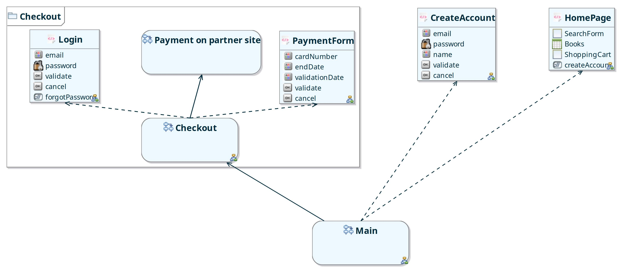

[ E-BookStore Package Diagram ]

### L’ensemble des Flows

|  |  |
| --- | --- |
| **Nom** | **Description** |

|  |  |
| --- | --- |
| Main |  |

#### Flow : Main

##### Description

##### Vue graphique

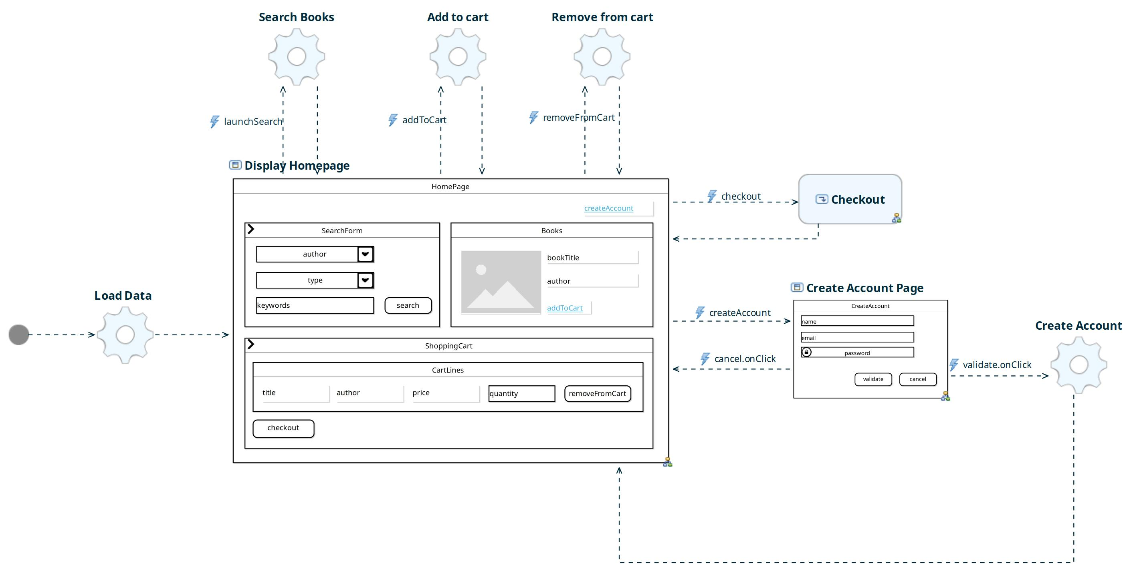

[ Main Flow Diagram ]

##### Les éléments du flow

###### Liste des Flow Events

|  |  |  |
| --- | --- | --- |
| **Name** | **Binds** | **Description** |

|  |  |  |
| --- | --- | --- |
| launchSearch | search.onClick |  |

|  |  |  |
| --- | --- | --- |
| addToCart | addToCart.onClick |  |

|  |  |  |
| --- | --- | --- |
| removeFromCart | removeFromCart.onClick |  |

|  |  |  |
| --- | --- | --- |
| createAccount |  |  |

|  |  |  |
| --- | --- | --- |
| checkout | checkout.onClick |  |

|  |  |  |
| --- | --- | --- |
| event6 |  |  |

###### Liste des States

|  |  |
| --- | --- |
| Type | Nom |

|  |  |
| --- | --- |
| InitialState | Initial |

|  |  |
| --- | --- |
| ViewState | Display Homepage |

|  |  |
| --- | --- |
| ActionState | Load Data |

|  |  |
| --- | --- |
| ActionState | Search Books |

|  |  |
| --- | --- |
| ActionState | Add to cart |

|  |  |
| --- | --- |
| ActionState | Remove from cart |

|  |  |
| --- | --- |
| ViewState | Create Account Page |

|  |  |
| --- | --- |
| ActionState | Create Account |

|  |  |
| --- | --- |
| SubflowState | Checkout |

***InitialState : Initial***

|  |  |
| --- | --- |
| Description |  |
| Actions |  |
| New Instance | N/A |
| Refresh | N/A |
| View Containers |  |
| Méta-data |  |

***ViewState : Display Homepage***

|  |  |
| --- | --- |
| Description |  |
| Actions |  |
| New Instance | Non |
| Refresh | Non |
| View Containers | HomePage |
| Méta-data |  |

***ActionState : Load Data***

|  |  |
| --- | --- |
| Description |  |
| Actions | getHomepageData |
| New Instance | N/A |
| Refresh | N/A |
| View Containers |  |
| Méta-data |  |

***ActionState : Search Books***

|  |  |
| --- | --- |
| Description |  |
| Actions | searchBooks |
| New Instance | N/A |
| Refresh | N/A |
| View Containers |  |
| Méta-data |  |

***ActionState : Add to cart***

|  |  |
| --- | --- |
| Description |  |
| Actions |  |
| New Instance | N/A |
| Refresh | N/A |
| View Containers |  |
| Méta-data |  |

***ActionState : Remove from cart***

|  |  |
| --- | --- |
| Description |  |
| Actions |  |
| New Instance | N/A |
| Refresh | N/A |
| View Containers |  |
| Méta-data |  |

***ViewState : Create Account Page***

|  |  |
| --- | --- |
| Description |  |
| Actions |  |
| New Instance | Non |
| Refresh | Non |
| View Containers | CreateAccount |
| Méta-data |  |

***ActionState : Create Account***

|  |  |
| --- | --- |
| Description |  |
| Actions |  |
| New Instance | N/A |
| Refresh | N/A |
| View Containers |  |
| Méta-data |  |

***SubflowState : Checkout***

|  |  |
| --- | --- |
| Description |  |
| Actions |  |
| New Instance | N/A |
| Refresh | N/A |
| View Containers |  |
| Méta-data |  |

###### Liste des transitions

***De Initial vers Load Data***

|  |  |
| --- | --- |
| Name |  |
| Guard |  |
| Modal | Non |
| On |  |
| Description |  |
| From | Initial |
| To | Load Data |

***De Load Data vers Display Homepage***

|  |  |
| --- | --- |
| Name |  |
| Guard |  |
| Modal | Non |
| On |  |
| Description |  |
| From | Load Data |
| To | Display Homepage |

***De Display Homepage vers Search Books***

|  |  |
| --- | --- |
| Name |  |
| Guard |  |
| Modal | Non |
| On | launchSearch |
| Description |  |
| From | Display Homepage |
| To | Search Books |

***De Display Homepage vers Add to cart***

|  |  |
| --- | --- |
| Name |  |
| Guard |  |
| Modal | Non |
| On | addToCart |
| Description |  |
| From | Display Homepage |
| To | Add to cart |

***De Display Homepage vers Remove from cart***

|  |  |
| --- | --- |
| Name |  |
| Guard |  |
| Modal | Non |
| On | removeFromCart |
| Description |  |
| From | Display Homepage |
| To | Remove from cart |

***De Display Homepage vers Create Account Page***

|  |  |
| --- | --- |
| Name |  |
| Guard |  |
| Modal | Non |
| On | createAccount |
| Description |  |
| From | Display Homepage |
| To | Create Account Page |

***De Create Account Page vers Display Homepage***

|  |  |
| --- | --- |
| Name |  |
| Guard |  |
| Modal | Non |
| On | cancel.onClick |
| Description |  |
| From | Create Account Page |
| To | Display Homepage |

***De Create Account Page vers Create Account***

|  |  |
| --- | --- |
| Name |  |
| Guard |  |
| Modal | Non |
| On | validate.onClick |
| Description |  |
| From | Create Account Page |
| To | Create Account |

***De Create Account vers Display Homepage***

|  |  |
| --- | --- |
| Name |  |
| Guard |  |
| Modal | Non |
| On |  |
| Description |  |
| From | Create Account |
| To | Display Homepage |

***De Search Books vers Display Homepage***

|  |  |
| --- | --- |
| Name |  |
| Guard |  |
| Modal | Non |
| On |  |
| Description |  |
| From | Search Books |
| To | Display Homepage |

***De Add to cart vers Display Homepage***

|  |  |
| --- | --- |
| Name |  |
| Guard |  |
| Modal | Non |
| On |  |
| Description |  |
| From | Add to cart |
| To | Display Homepage |

***De Remove from cart vers Display Homepage***

|  |  |
| --- | --- |
| Name |  |
| Guard |  |
| Modal | Non |
| On |  |
| Description |  |
| From | Remove from cart |
| To | Display Homepage |

***De Display Homepage vers Checkout***

|  |  |
| --- | --- |
| Name |  |
| Guard |  |
| Modal | Non |
| On | checkout |
| Description |  |
| From | Display Homepage |
| To |  |

***De Checkout vers Display Homepage***

|  |  |
| --- | --- |
| Name |  |
| Guard |  |
| Modal | Non |
| On |  |
| Description |  |
| From |  |
| To | Display Homepage |

## Package : Checkout

### L’ensemble des Flows

|  |  |
| --- | --- |
| **Nom** | **Description** |

|  |  |
| --- | --- |
| Checkout |  |

|  |  |
| --- | --- |
| Payment on partner site |  |

#### Flow : Checkout

##### Description

##### Vue graphique

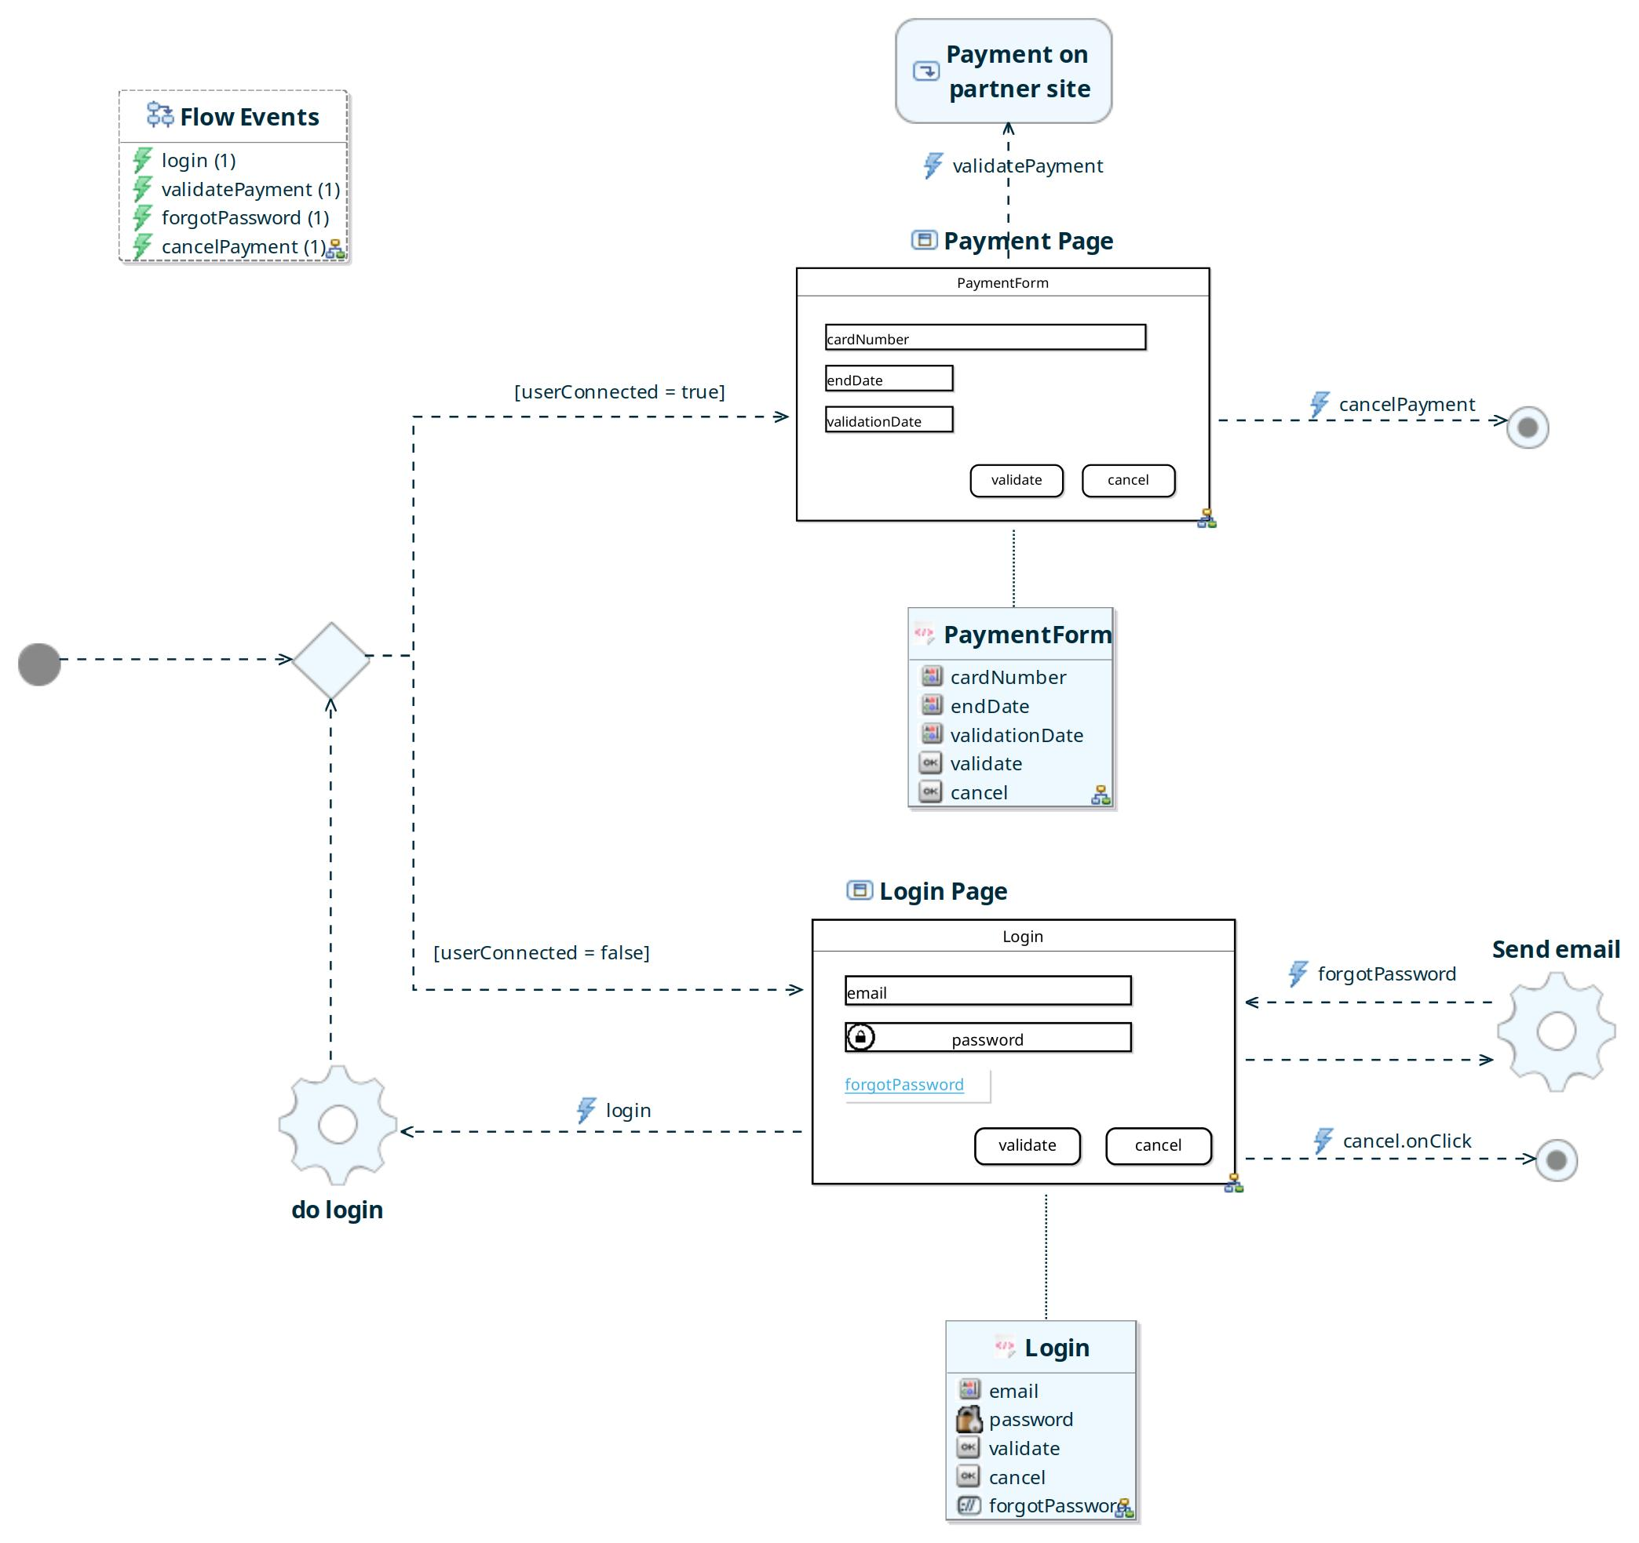

[ Checkout Flow Diagram ]

##### Les éléments du flow

###### Liste des Flow Events

|  |  |  |
| --- | --- | --- |
| **Name** | **Binds** | **Description** |

|  |  |  |
| --- | --- | --- |
| login | validate.onClick |  |

|  |  |  |
| --- | --- | --- |
| validatePayment | validate.onClick |  |

|  |  |  |
| --- | --- | --- |
| forgotPassword | forgotPassword.onClick |  |

|  |  |  |
| --- | --- | --- |
| cancelPayment | cancel.onClick |  |

###### Liste des States

|  |  |
| --- | --- |
| **Type** | **Nom** |

|  |  |
| --- | --- |
| InitialState | Initial |

|  |  |
| --- | --- |
| DecisionState | Decision |

|  |  |
| --- | --- |
| ViewState | Login Page |

|  |  |
| --- | --- |
| ViewState | Payment Page |

|  |  |
| --- | --- |
| ActionState | do login |

|  |  |
| --- | --- |
| SubflowState | Payment on partner site |

|  |  |
| --- | --- |
| ActionState | Send email |

|  |  |
| --- | --- |
| FinalState | Final |

|  |  |
| --- | --- |
| FinalState | Final |

***InitialState : Initial***

|  |  |
| --- | --- |
| Description |  |
| Actions |  |
| New Instance | N/A |
| Refresh | N/A |
| View Containers |  |
| Méta-data |  |

***DecisionState : Decision***

|  |  |
| --- | --- |
| Description |  |
| Actions |  |
| New Instance | N/A |
| Refresh | N/A |
| View Containers |  |
| Méta-data |  |

***ViewState : Login Page***

|  |  |
| --- | --- |
| Description |  |
| Actions |  |
| New Instance | Non |
| Refresh | Non |
| View Containers | Login |
| Méta-data |  |

***ViewState : Payment Page***

|  |  |
| --- | --- |
| Description |  |
| Actions |  |
| New Instance | Non |
| Refresh | Non |
| View Containers | PaymentForm |
| Méta-data |  |

***ActionState : do login***

|  |  |
| --- | --- |
| Description |  |
| Actions |  |
| New Instance | N/A |
| Refresh | N/A |
| View Containers |  |
| Méta-data |  |

***SubflowState : Payment on partner site***

|  |  |
| --- | --- |
| Description |  |
| Actions |  |
| New Instance | N/A |
| Refresh | N/A |
| View Containers |  |
| Méta-data |  |

***ActionState : Send email***

|  |  |
| --- | --- |
| Description |  |
| Actions |  |
| New Instance | N/A |
| Refresh | N/A |
| View Containers |  |
| Méta-data |  |

***FinalState : Final***

|  |  |
| --- | --- |
| Description |  |
| Actions |  |
| New Instance | N/A |
| Refresh | N/A |
| View Containers |  |
| Méta-data |  |

***FinalState : Final***

|  |  |
| --- | --- |
| Description |  |
| Actions |  |
| New Instance | N/A |
| Refresh | N/A |
| View Containers |  |
| Méta-data |  |

###### Liste des transitions

***De Initial vers Decision***

|  |  |
| --- | --- |
| Name |  |
| Guard |  |
| Modal | Non |
| On |  |
| Description |  |
| From | Initial |
| To | Decision |

***De Decision vers Payment Page***

|  |  |
| --- | --- |
| Name |  |
| Guard | userConnected = true |
| Modal | Non |
| On |  |
| Description |  |
| From | Decision |
| To | Payment Page |

***De Decision vers Login Page***

|  |  |
| --- | --- |
| Name |  |
| Guard | userConnected = false |
| Modal | Non |
| On |  |
| Description |  |
| From | Decision |
| To | Login Page |

***De do login vers Decision***

|  |  |
| --- | --- |
| Name |  |
| Guard |  |
| Modal | Non |
| On |  |
| Description |  |
| From | do login |
| To | Decision |

***De Login Page vers do login***

|  |  |
| --- | --- |
| Name |  |
| Guard |  |
| Modal | Non |
| On | login |
| Description |  |
| From | Login Page |
| To | do login |

***De Payment Page vers Payment on partner site***

|  |  |
| --- | --- |
| Name |  |
| Guard |  |
| Modal | Non |
| On | validatePayment |
| Description |  |
| From | Payment Page |
| To |  |

***De Login Page vers Send email***

|  |  |
| --- | --- |
| Name |  |
| Guard |  |
| Modal | Non |
| On | forgotPassword |
| Description |  |
| From | Login Page |
| To | Send email |

***De Send email vers Login Page***

|  |  |
| --- | --- |
| Name |  |
| Guard |  |
| Modal | Non |
| On |  |
| Description |  |
| From | Send email |
| To | Login Page |

***De Login Page vers Final***

|  |  |
| --- | --- |
| Name |  |
| Guard |  |
| Modal | Non |
| On | cancel.onClick |
| Description |  |
| From | Login Page |
| To | Final |

***De Payment Page vers Final***

|  |  |
| --- | --- |
| Name |  |
| Guard |  |
| Modal | Non |
| On | cancelPayment |
| Description |  |
| From | Payment Page |
| To | Final |

#### Flow : Payment on partner site

##### Description

##### Vue graphique

##### Les éléments du flow

###### Liste des Flow Events

|  |  |  |
| --- | --- | --- |
| **Name** | **Binds** | **Description** |

###### Liste des States

|  |  |
| --- | --- |
| **Type** | **Nom** |

###### Liste des transitions

# ANNEXES

## Les écrans

*Page : HomePage*

|  |
| --- |
| file:/tmp/ViewContainer__48gaJBVIEeetFdz5pzgWAw5047159628400234176.png HomePage |
| file:/tmp/ViewContainer__48jdcBVIEeetFdz5pzgWAw13163865202090123174.png SearchForm |
| file:/tmp/ViewContainer__48qLIBVIEeetFdz5pzgWAw17851142273170902787.png Books |
| file:/tmp/ViewContainer__48qLLxVIEeetFdz5pzgWAw17389587905943173792.png ShoppingCart |
| file:/tmp/ViewElement__48qLLBVIEeetFdz5pzgWAw16517274650110918812.png createAccount |

*Page : CreateAccount*

|  |
| --- |
| file:/tmp/ViewContainer__48qLRRVIEeetFdz5pzgWAw9038494847912462044.png CreateAccount |
| file:/tmp/ViewElement__48qLRxVIEeetFdz5pzgWAw3226798045479099410.png email |
| file:/tmp/ViewElement__48qyMBVIEeetFdz5pzgWAw11165425737756680278.png password |
| file:/tmp/ViewElement__48qyMhVIEeetFdz5pzgWAw3764569025897971801.png name |
| file:/tmp/ViewElement__48qyNBVIEeetFdz5pzgWAw14196426932909410403.png validate |
| file:/tmp/ViewElement__48qyOBVIEeetFdz5pzgWAw5673559897227833063.png cancel |

*Page : HomePage*

|  |
| --- |
| file:/tmp/ViewContainer__48gaJBVIEeetFdz5pzgWAw17476429342074583878.png HomePage |
| file:/tmp/ViewContainer__48jdcBVIEeetFdz5pzgWAw5176100043293726526.png SearchForm |
| file:/tmp/ViewContainer__48qLIBVIEeetFdz5pzgWAw17888917492710791363.png Books |
| file:/tmp/ViewContainer__48qLLxVIEeetFdz5pzgWAw12799667583737378100.png ShoppingCart |
| file:/tmp/ViewElement__48qLLBVIEeetFdz5pzgWAw10347263626141628553.png createAccount |

*Panel : SearchForm*

|  |
| --- |
| file:/tmp/ViewContainer__48jdcBVIEeetFdz5pzgWAw5199877133225710534.png SearchForm |
| file:/tmp/ViewElement__48jdchVIEeetFdz5pzgWAw7214797560199853885.png author |
| file:/tmp/ViewElement__48jddBVIEeetFdz5pzgWAw5482267791042652347.png type |
| file:/tmp/ViewElement__48jddhVIEeetFdz5pzgWAw12379709452549580402.png keywords |
| file:/tmp/ViewElement__48jdeBVIEeetFdz5pzgWAw13419577767202062552.png search |

*Table : Books*

|  |
| --- |
| file:/tmp/ViewContainer__48qLIBVIEeetFdz5pzgWAw6870030318624579629.png Books |
| file:/tmp/ViewElement__48qLIhVIEeetFdz5pzgWAw17517063471750474993.png bookImage |
| file:/tmp/ViewElement__48qLJBVIEeetFdz5pzgWAw1589119338089363458.png bookTitle |
| file:/tmp/ViewElement__48qLJhVIEeetFdz5pzgWAw17045258860458921150.png author |
| file:/tmp/ViewElement__48qLKBVIEeetFdz5pzgWAw5681276104432858212.png addToCart |

*Panel : ShoppingCart*

|  |
| --- |
| file:/tmp/ViewContainer__48qLLxVIEeetFdz5pzgWAw5571262017614275627.png ShoppingCart |
| file:/tmp/ViewContainer__48qLMRVIEeetFdz5pzgWAw9723705370985801198.png CartLines |
| file:/tmp/ViewElement__48qLPxVIEeetFdz5pzgWAw8649438646246447482.png checkout |

*Table : CartLines*

|  |
| --- |
| file:/tmp/ViewContainer__48qLMRVIEeetFdz5pzgWAw1601685034511297464.png CartLines |
| file:/tmp/ViewElement__48qLMxVIEeetFdz5pzgWAw4816860045121746623.png title |
| file:/tmp/ViewElement__48qLNRVIEeetFdz5pzgWAw5392044335112940191.png author |
| file:/tmp/ViewElement__48qLNxVIEeetFdz5pzgWAw17812688689089758520.png price |
| file:/tmp/ViewElement__48qLORVIEeetFdz5pzgWAw3689063030757547562.png quantity |
| file:/tmp/ViewElement__48qLOxVIEeetFdz5pzgWAw17567858795743833527.png removeFromCart |

*Page : CreateAccount*

|  |
| --- |
| file:/tmp/ViewContainer__48qLRRVIEeetFdz5pzgWAw5717697281940787211.png CreateAccount |
| file:/tmp/ViewElement__48qLRxVIEeetFdz5pzgWAw2078381690770701058.png email |
| file:/tmp/ViewElement__48qyMBVIEeetFdz5pzgWAw14952318047352225127.png password |
| file:/tmp/ViewElement__48qyMhVIEeetFdz5pzgWAw12057516255965404031.png name |
| file:/tmp/ViewElement__48qyNBVIEeetFdz5pzgWAw15080012089162134753.png validate |
| file:/tmp/ViewElement__48qyOBVIEeetFdz5pzgWAw6960914873505652165.png cancel |

*Page : Login*

|  |
| --- |
| file:/tmp/ViewContainer__48vDrhVIEeetFdz5pzgWAw9688992776644799032.png Login |
| file:/tmp/ViewElement__48vDsBVIEeetFdz5pzgWAw17297184933560832167.png email |
| file:/tmp/ViewElement__48vDshVIEeetFdz5pzgWAw11780904351632732547.png password |
| file:/tmp/ViewElement__48vDtBVIEeetFdz5pzgWAw16319666487233842444.png validate |
| file:/tmp/ViewElement__48vDuBVIEeetFdz5pzgWAw10142906306289604427.png cancel |
| file:/tmp/ViewElement__48vDvBVIEeetFdz5pzgWAw6989784149043938740.png forgotPassword |

*Page : PaymentForm*

|  |
| --- |
| file:/tmp/ViewContainer__48vDwBVIEeetFdz5pzgWAw5410321490475145589.png PaymentForm |
| file:/tmp/ViewElement__48vDwhVIEeetFdz5pzgWAw16689522058009723723.png cardNumber |
| file:/tmp/ViewElement__48vDxBVIEeetFdz5pzgWAw9161929011992609698.png endDate |
| file:/tmp/ViewElement__48vDxhVIEeetFdz5pzgWAw4767285341829811802.png validationDate |
| file:/tmp/ViewElement__48vDyBVIEeetFdz5pzgWAw3411517682599592961.png validate |
| file:/tmp/ViewElement__48vDzBVIEeetFdz5pzgWAw1848059470236426765.png cancel |

*Page : Login*

|  |
| --- |
| file:/tmp/ViewContainer__48vDrhVIEeetFdz5pzgWAw18063175425688137627.png Login |
| file:/tmp/ViewElement__48vDsBVIEeetFdz5pzgWAw13362033720047889432.png email |
| file:/tmp/ViewElement__48vDshVIEeetFdz5pzgWAw2591517911589545754.png password |
| file:/tmp/ViewElement__48vDtBVIEeetFdz5pzgWAw4689341434881290893.png validate |
| file:/tmp/ViewElement__48vDuBVIEeetFdz5pzgWAw445157532232036541.png cancel |
| file:/tmp/ViewElement__48vDvBVIEeetFdz5pzgWAw567157261335889824.png forgotPassword |

*Page : PaymentForm*

|  |
| --- |
| file:/tmp/ViewContainer__48vDwBVIEeetFdz5pzgWAw1469423049268228534.png PaymentForm |
| file:/tmp/ViewElement__48vDwhVIEeetFdz5pzgWAw13221281942190344264.png cardNumber |
| file:/tmp/ViewElement__48vDxBVIEeetFdz5pzgWAw13520760214318753670.png endDate |
| file:/tmp/ViewElement__48vDxhVIEeetFdz5pzgWAw1488139145971867886.png validationDate |
| file:/tmp/ViewElement__48vDyBVIEeetFdz5pzgWAw16579389712781328038.png validate |
| file:/tmp/ViewElement__48vDzBVIEeetFdz5pzgWAw11023604628127812032.png cancel |

## Les exigences

|  |  |  |  |
| --- | --- | --- | --- |
| **Ref Exigence** | **Description** | **Type Objet référencé** | **Nom Objet** |

## Les documents associés

|  |  |  |  |
| --- | --- | --- | --- |
| **Name** | **URL** | **Type Objet référencé** | **Nom Objet** |

## Les opérations associées

|  |  |  |
| --- | --- | --- |
| **Nom Opération** | **ActionSate** | **Description ActionSate** |