E-BookStore

Spécifications Fonctionnelles

Validation du document

|  |  |  |  |  |
| --- | --- | --- | --- | --- |
| Action | Grade - Nom | Qualité - Fonction | Date | Visa |
| Rédigé par |  |  |  |  |
| Contrôlé par |  |  |  |  |
| Contrôlé par |  |  |  |  |
| Approuvé par |  |  |  |  |

Historique des versions du document

|  |  |  |  |
| --- | --- | --- | --- |
| Version | Date | Commentaire | Auteur |
| <versionProjet> | <date> | <commentaire> | <auteur> |
|  |  |  |  |
|  |  |  |  |
|  |  |  |  |

Table des matières

1 Introduction 4

1.1 Description du projet 4

2 Informations générales du projet 5

2.1 Les acteurs 5

2.2 Exigences transverses 5

2.3 Etat et statuts des données 5

2.4 Exigences métier 5

2.5 Exigences techniques 5

3 Les cas d’utilisations 6

3.1 Le diagramme des uses case 6

3.2 Cas d’utilisation : <Name> 6

<coche> : mettre un « X » dans le cas où l’acteur est associé à cette tâche. 7

4 Annexes 12

4.1 Les Users Story 12

4.2 Les classes participantes 12

# Introduction

## Description du projet

*Some description about the E-BookStore System.*

Introduction au projet…

# Informations générales du projet

## Les acteurs

### Le diagramme global des acteurs

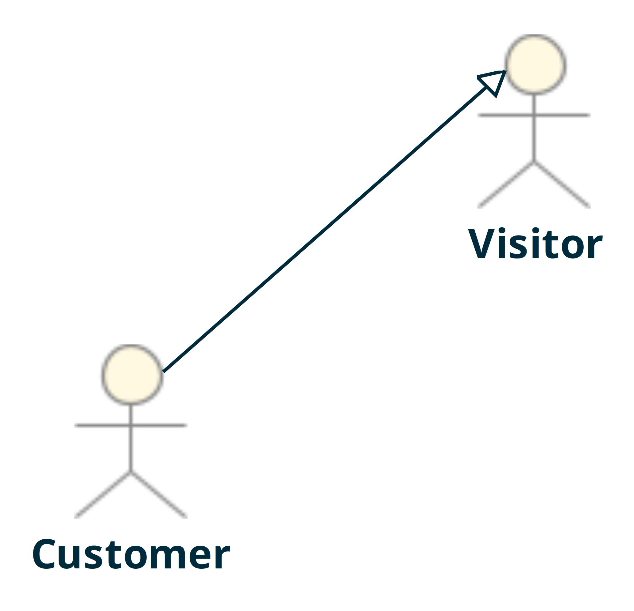

### Acteur : Customer

*Some description of the Customer actor.*

### Acteur : Visitor

*Some description of the Visitor actor.*

## Exigences transverses

*Insertion du tableau ci-dessous avec le contenu des exigences sont sans liens avec un élément GRAAL (trier sur le champ ID)*

|  |  |  |  |  |
| --- | --- | --- | --- | --- |
| ***Référence*** | ***Libellé*** | ***Description*** | ***Statut*** | ***Version*** |

|  |  |  |  |  |
| --- | --- | --- | --- | --- |
| R2 | Req2-ManageFavorite | The user shall be able to manage his favorites | Non renseigné | 1 |

## Etat et statuts des données

## Exigences métier

|  |  |
| --- | --- |
| **Type exigence** | **Description de l’exigence métier** |
|  |  |

## Exigences techniques

|  |  |
| --- | --- |
| **Type exigence** | **Description de l’exigence technique** |
|  |  |

# Les cas d’utilisations

## Le diagramme des uses case

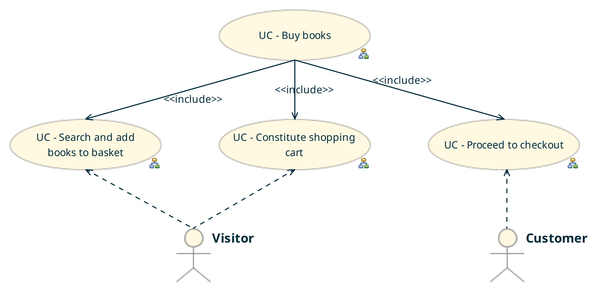

## Cas d’utilisation : UC - Buy books

### Description

### Diagramme de tâches

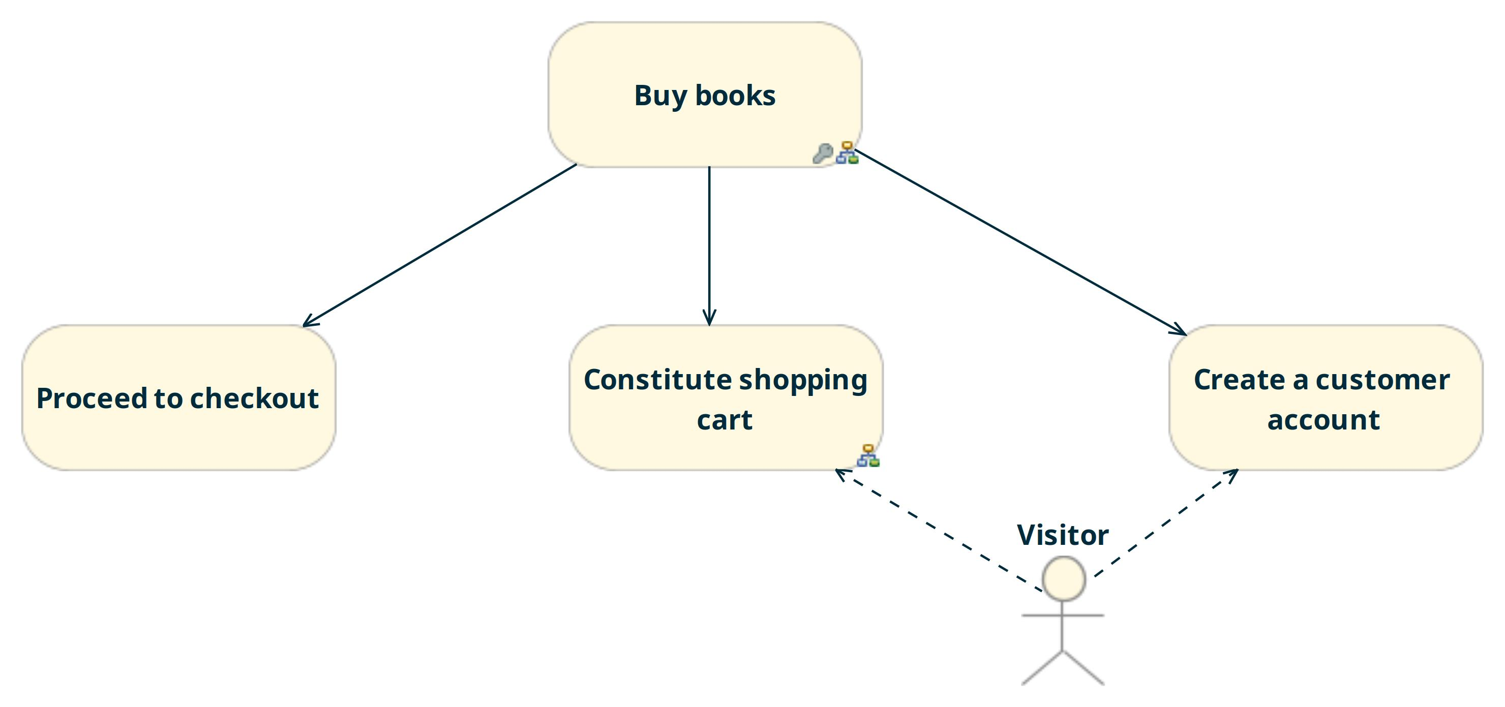

### Maquettage

UC - Buy books

Aucune maquette spécifiée à ce niveau.

### Tableau des acteurs

***UC - Buy books***

### Classes participantes

### Tâche : Buy books

#### Description

#### Plan d'actions

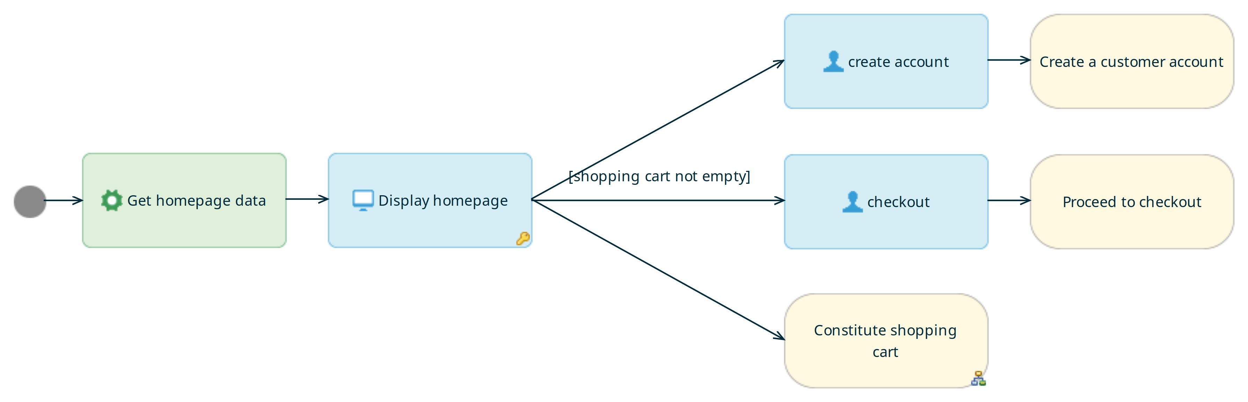

#### Pré-conditions

Pré conditions non renseignées.

#### Post-conditions

Post conditions non renseignées.

#### Les tâches en références

|  |  |
| --- | --- |
| ***Nom*** | ***Description*** |

|  |  |
| --- | --- |
| *Constitute shopping cart* |  |

|  |  |
| --- | --- |
| *Create a customer account* |  |

|  |  |
| --- | --- |
| *Proceed to checkout* |  |

#### Exigences

|  |  |  |  |  |
| --- | --- | --- | --- | --- |
| Référence | Libellé | Description | Statut | Version |

|  |  |  |  |  |
| --- | --- | --- | --- | --- |
| R1 | Req1-HomePageBeautiful | The homepage shall be beautiful | Non renseigné | 2 |

#### Messages d'erreur et d'information

|  |  |  |  |  |
| --- | --- | --- | --- | --- |
| Référence | Libellé | Description | Statut | Version |

#### Messages des traces

|  |  |  |  |  |
| --- | --- | --- | --- | --- |
| Référence | Libellé | Description | Statut | Version |

### Scénarios associés à la tâche

#### Scénario : Search books on author

Objectif :

Composition :

* *6 tâches*
* *31 noeuds*
* *38 transitions*

#### Scénario : Unknown user buy books

Objectif :

Composition :

* *6 tâches*
* *43 noeuds*
* *58 transitions*

### Tâche : Constitute shopping cart

#### Description

#### Plan d'actions

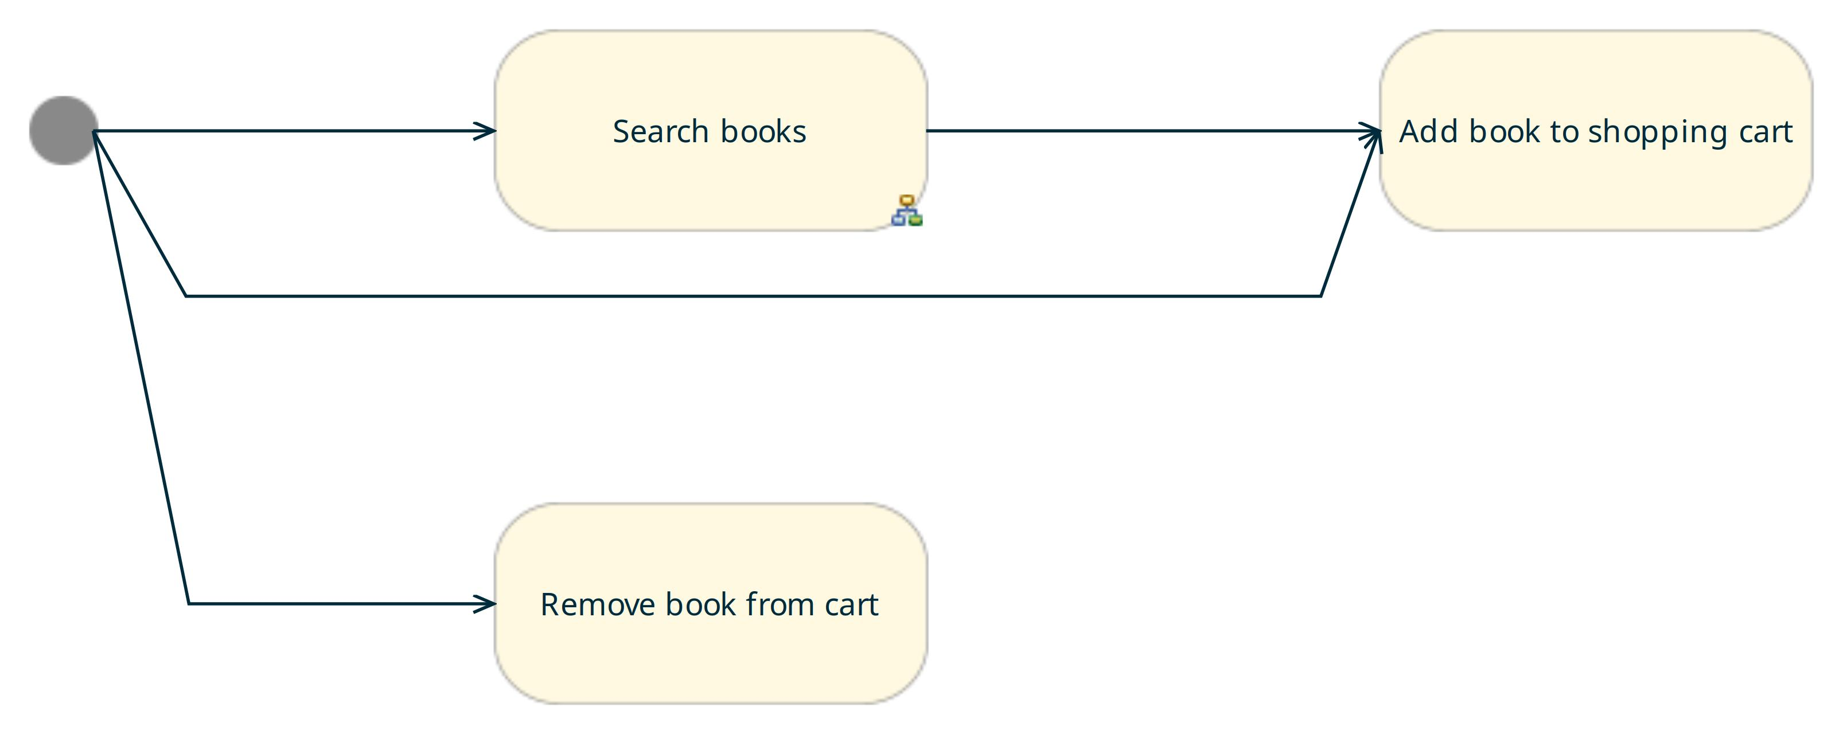

#### Pré-conditions

Pré conditions non renseignées.

#### Post-conditions

Post conditions non renseignées.

#### Les tâches en références

|  |  |
| --- | --- |
| ***Nom*** | ***Description*** |

|  |  |
| --- | --- |
| *Add book to shopping cart* |  |

|  |  |
| --- | --- |
| *Remove book from cart* |  |

|  |  |
| --- | --- |
| *Search books* |  |

#### Exigences

|  |  |  |  |  |
| --- | --- | --- | --- | --- |
| Référence | Libellé | Description | Statut | Version |

#### Messages d'erreur et d'information

|  |  |  |  |  |
| --- | --- | --- | --- | --- |
| Référence | Libellé | Description | Statut | Version |

#### Messages des traces

|  |  |  |  |  |
| --- | --- | --- | --- | --- |
| Référence | Libellé | Description | Statut | Version |

### Scénarios associés à la tâche

#### Scénario : Search books on author

Objectif :

Composition :

* *6 tâches*
* *31 noeuds*
* *38 transitions*

### Tâche : Create a customer account

#### Description

#### Plan d'actions

Il n’y a pas de plan d’action pour cette tâche.

#### Pré-conditions

Pré conditions non renseignées.

#### Post-conditions

Post conditions non renseignées.

#### Les tâches en références

|  |  |
| --- | --- |
| ***Nom*** | ***Description*** |

#### Exigences

|  |  |  |  |  |
| --- | --- | --- | --- | --- |
| Référence | Libellé | Description | Statut | Version |

#### Messages d'erreur et d'information

|  |  |  |  |  |
| --- | --- | --- | --- | --- |
| Référence | Libellé | Description | Statut | Version |

#### Messages des traces

|  |  |  |  |  |
| --- | --- | --- | --- | --- |
| Référence | Libellé | Description | Statut | Version |

### Scénarios associés à la tâche

### Tâche : Proceed to checkout

#### Description

#### Plan d'actions

Il n’y a pas de plan d’action pour cette tâche.

#### Pré-conditions

Pré conditions non renseignées.

#### Post-conditions

Post conditions non renseignées.

#### Les tâches en références

|  |  |
| --- | --- |
| ***Nom*** | ***Description*** |

|  |  |
| --- | --- |
| *Enter payment informations* |  |

|  |  |
| --- | --- |
| *Login* |  |

#### Exigences

|  |  |  |  |  |
| --- | --- | --- | --- | --- |
| Référence | Libellé | Description | Statut | Version |

#### Messages d'erreur et d'information

|  |  |  |  |  |
| --- | --- | --- | --- | --- |
| Référence | Libellé | Description | Statut | Version |

#### Messages des traces

|  |  |  |  |  |
| --- | --- | --- | --- | --- |
| Référence | Libellé | Description | Statut | Version |

### Scénarios associés à la tâche

#### Scénario : Search books on author

Objectif :

Composition :

* *6 tâches*
* *31 noeuds*
* *38 transitions*

#### Scénario : Unknown user buy books

Objectif :

Composition :

* *6 tâches*
* *43 noeuds*
* *58 transitions*

## Cas d’utilisation : UC - Constitute shopping cart

### Description

### Diagramme de tâches

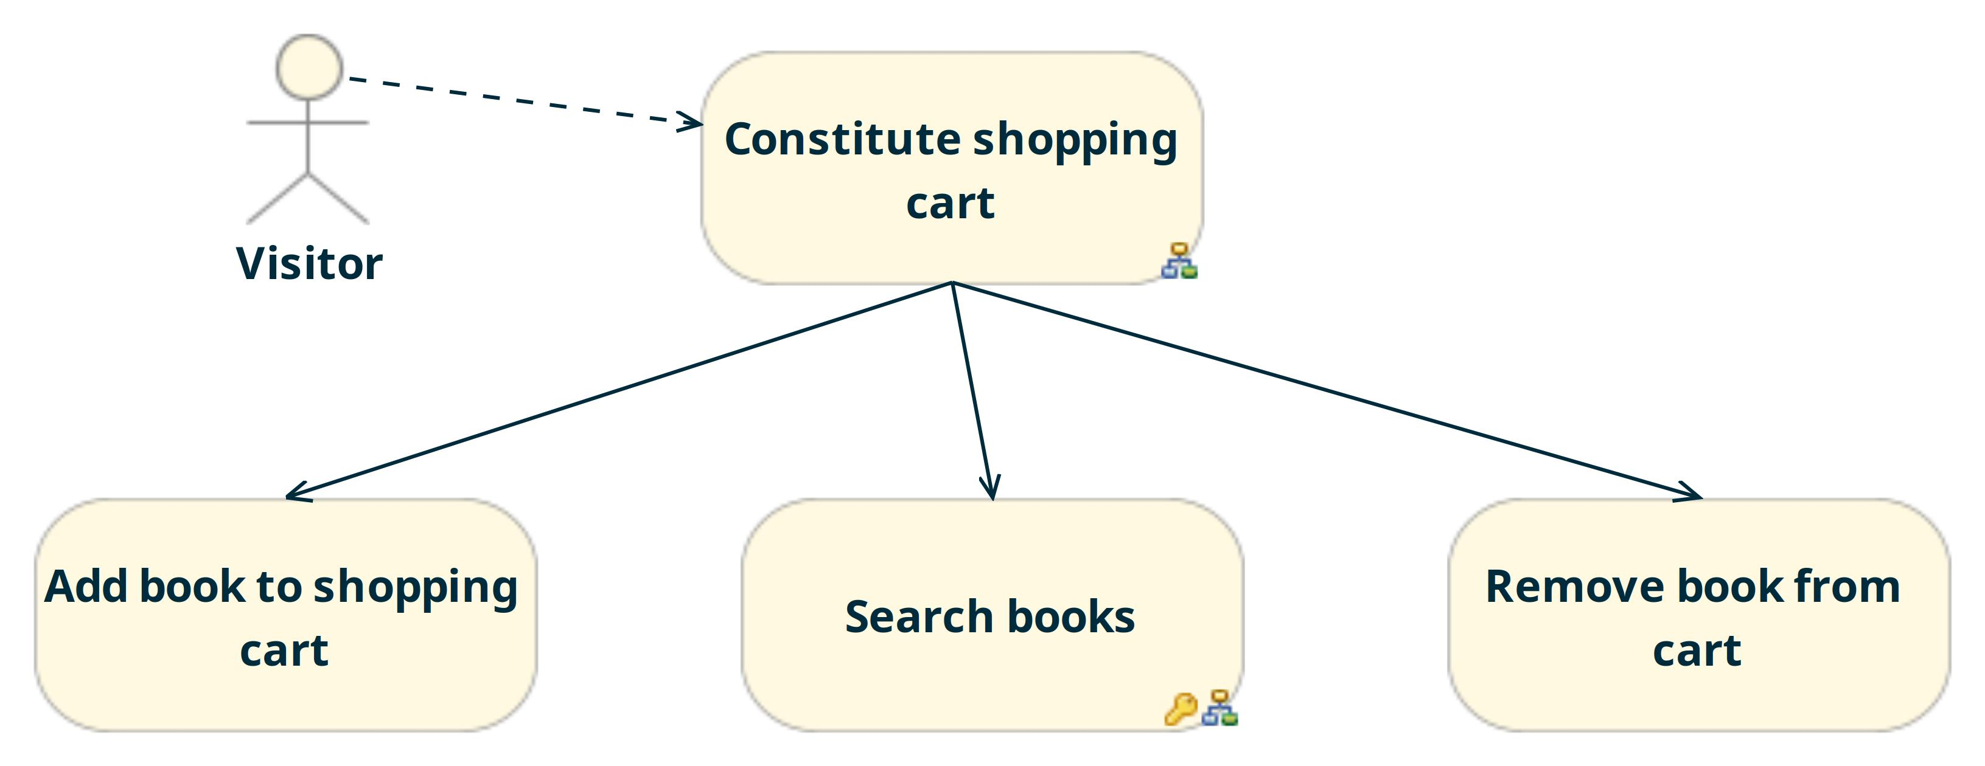

### Maquettage

UC - Constitute shopping  
cart

Aucune maquette spécifiée à ce niveau.

### Tableau des acteurs

***UC - Constitute shopping  
cart***

### Classes participantes

### Tâche : Add book to shopping cart

#### Description

#### Plan d'actions

Il n’y a pas de plan d’action pour cette tâche.

#### Pré-conditions

Pré conditions non renseignées.

#### Post-conditions

Post conditions non renseignées.

#### Les tâches en références

|  |  |
| --- | --- |
| ***Nom*** | ***Description*** |

#### Exigences

|  |  |  |  |  |
| --- | --- | --- | --- | --- |
| Référence | Libellé | Description | Statut | Version |

#### Messages d'erreur et d'information

|  |  |  |  |  |
| --- | --- | --- | --- | --- |
| Référence | Libellé | Description | Statut | Version |

#### Messages des traces

|  |  |  |  |  |
| --- | --- | --- | --- | --- |
| Référence | Libellé | Description | Statut | Version |

### Scénarios associés à la tâche

#### Scénario : Search books on author

Objectif :

Composition :

* *6 tâches*
* *31 noeuds*
* *38 transitions*

#### Scénario : Unknown user buy books

Objectif :

Composition :

* *6 tâches*
* *43 noeuds*
* *58 transitions*

### Tâche : Constitute shopping cart

#### Description

#### Plan d'actions



#### Pré-conditions

Pré conditions non renseignées.

#### Post-conditions

Post conditions non renseignées.

#### Les tâches en références

|  |  |
| --- | --- |
| ***Nom*** | ***Description*** |

|  |  |
| --- | --- |
| *Add book to shopping cart* |  |

|  |  |
| --- | --- |
| *Remove book from cart* |  |

|  |  |
| --- | --- |
| *Search books* |  |

#### Exigences

|  |  |  |  |  |
| --- | --- | --- | --- | --- |
| Référence | Libellé | Description | Statut | Version |

#### Messages d'erreur et d'information

|  |  |  |  |  |
| --- | --- | --- | --- | --- |
| Référence | Libellé | Description | Statut | Version |

#### Messages des traces

|  |  |  |  |  |
| --- | --- | --- | --- | --- |
| Référence | Libellé | Description | Statut | Version |

### Scénarios associés à la tâche

#### Scénario : Search books on author

Objectif :

Composition :

* *6 tâches*
* *31 noeuds*
* *38 transitions*

### Tâche : Remove book from cart

#### Description

#### Plan d'actions

Il n’y a pas de plan d’action pour cette tâche.

#### Pré-conditions

Pré conditions non renseignées.

#### Post-conditions

Post conditions non renseignées.

#### Les tâches en références

|  |  |
| --- | --- |
| ***Nom*** | ***Description*** |

#### Exigences

|  |  |  |  |  |
| --- | --- | --- | --- | --- |
| Référence | Libellé | Description | Statut | Version |

#### Messages d'erreur et d'information

|  |  |  |  |  |
| --- | --- | --- | --- | --- |
| Référence | Libellé | Description | Statut | Version |

#### Messages des traces

|  |  |  |  |  |
| --- | --- | --- | --- | --- |
| Référence | Libellé | Description | Statut | Version |

### Scénarios associés à la tâche

### Tâche : Search books

#### Description

#### Plan d'actions

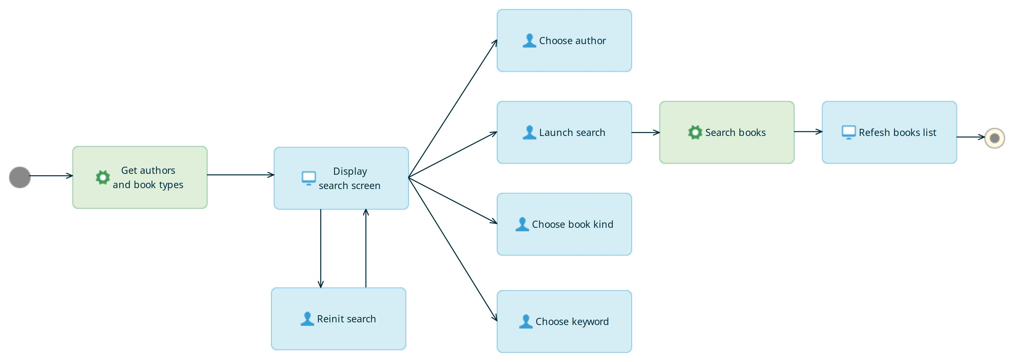

#### Pré-conditions

Pré conditions non renseignées.

#### Post-conditions

Post conditions non renseignées.

#### Les tâches en références

|  |  |
| --- | --- |
| ***Nom*** | ***Description*** |

#### Exigences

|  |  |  |  |  |
| --- | --- | --- | --- | --- |
| Référence | Libellé | Description | Statut | Version |

|  |  |  |  |  |
| --- | --- | --- | --- | --- |
| R3 | Req3-AtLeastOneSearchCriteriaMustBeSpecfied | At least one seach criteria must be entered by the user to perform a search | Non renseigné | 1 |

#### Messages d'erreur et d'information

|  |  |  |  |  |
| --- | --- | --- | --- | --- |
| Référence | Libellé | Description | Statut | Version |

#### Messages des traces

|  |  |  |  |  |
| --- | --- | --- | --- | --- |
| Référence | Libellé | Description | Statut | Version |

### Scénarios associés à la tâche

#### Scénario : Search books on author

Objectif :

Composition :

* *6 tâches*
* *31 noeuds*
* *38 transitions*

#### Scénario : Unknown user buy books

Objectif :

Composition :

* *6 tâches*
* *43 noeuds*
* *58 transitions*

## Cas d’utilisation : UC - Proceed to checkout

### Description

### Diagramme de tâches

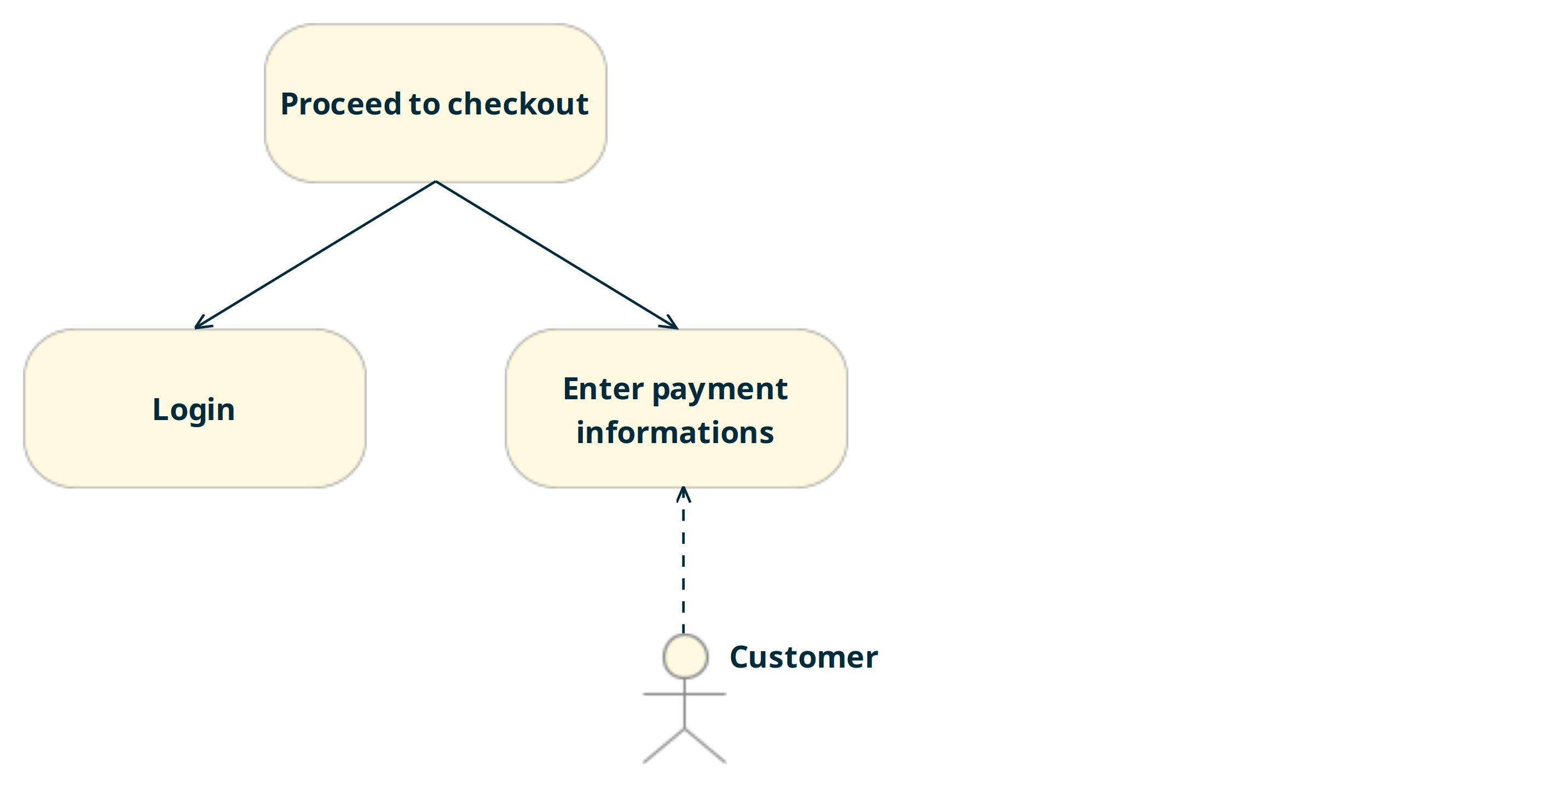

### Maquettage

UC - Proceed to checkout

Aucune maquette spécifiée à ce niveau.

### Tableau des acteurs

***UC - Proceed to checkout***

### Classes participantes

### Tâche : Enter payment informations

#### Description

#### Plan d'actions

Il n’y a pas de plan d’action pour cette tâche.

#### Pré-conditions

Pré conditions non renseignées.

#### Post-conditions

Post conditions non renseignées.

#### Les tâches en références

|  |  |
| --- | --- |
| ***Nom*** | ***Description*** |

#### Exigences

|  |  |  |  |  |
| --- | --- | --- | --- | --- |
| Référence | Libellé | Description | Statut | Version |

#### Messages d'erreur et d'information

|  |  |  |  |  |
| --- | --- | --- | --- | --- |
| Référence | Libellé | Description | Statut | Version |

#### Messages des traces

|  |  |  |  |  |
| --- | --- | --- | --- | --- |
| Référence | Libellé | Description | Statut | Version |

### Scénarios associés à la tâche

#### Scénario : Search books on author

Objectif :

Composition :

* *6 tâches*
* *31 noeuds*
* *38 transitions*

#### Scénario : Unknown user buy books

Objectif :

Composition :

* *6 tâches*
* *43 noeuds*
* *58 transitions*

### Tâche : Login

#### Description

#### Plan d'actions

Il n’y a pas de plan d’action pour cette tâche.

#### Pré-conditions

Pré conditions non renseignées.

#### Post-conditions

Post conditions non renseignées.

#### Les tâches en références

|  |  |
| --- | --- |
| ***Nom*** | ***Description*** |

#### Exigences

|  |  |  |  |  |
| --- | --- | --- | --- | --- |
| Référence | Libellé | Description | Statut | Version |

#### Messages d'erreur et d'information

|  |  |  |  |  |
| --- | --- | --- | --- | --- |
| Référence | Libellé | Description | Statut | Version |

#### Messages des traces

|  |  |  |  |  |
| --- | --- | --- | --- | --- |
| Référence | Libellé | Description | Statut | Version |

### Scénarios associés à la tâche

#### Scénario : Unknown user buy books

Objectif :

Composition :

* *6 tâches*
* *43 noeuds*
* *58 transitions*

### Tâche : Proceed to checkout

#### Description

#### Plan d'actions

Il n’y a pas de plan d’action pour cette tâche.

#### Pré-conditions

Pré conditions non renseignées.

#### Post-conditions

Post conditions non renseignées.

#### Les tâches en références

|  |  |
| --- | --- |
| ***Nom*** | ***Description*** |

|  |  |
| --- | --- |
| *Enter payment informations* |  |

|  |  |
| --- | --- |
| *Login* |  |

#### Exigences

|  |  |  |  |  |
| --- | --- | --- | --- | --- |
| Référence | Libellé | Description | Statut | Version |

#### Messages d'erreur et d'information

|  |  |  |  |  |
| --- | --- | --- | --- | --- |
| Référence | Libellé | Description | Statut | Version |

#### Messages des traces

|  |  |  |  |  |
| --- | --- | --- | --- | --- |
| Référence | Libellé | Description | Statut | Version |

### Scénarios associés à la tâche

#### Scénario : Search books on author

Objectif :

Composition :

* *6 tâches*
* *31 noeuds*
* *38 transitions*

#### Scénario : Unknown user buy books

Objectif :

Composition :

* *6 tâches*
* *43 noeuds*
* *58 transitions*

## Cas d’utilisation : UC - Search and add books to basket

### Description

### Diagramme de tâches

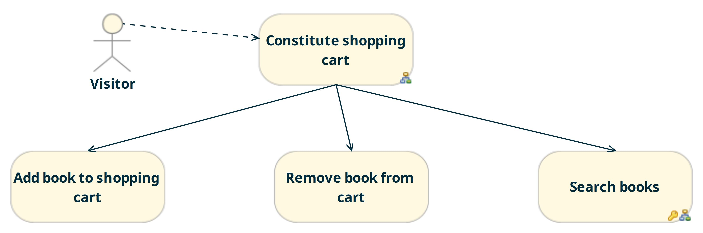

### Maquettage

UC - Search and add  
books to basket

Sample DocumentationLink Annotation:



### Tableau des acteurs

***UC - Search and add  
books to basket***

### Classes participantes

### CMMI

|  |  |
| --- | --- |
| ***Titre*** | ***Valeur*** |

|  |  |
| --- | --- |
| *DocumentationLink - Sampl* | *https://www.obeo.fr/images/logos/logo_obeo.png* |

### Tâche : Add book to shopping cart

#### Description

#### Plan d'actions

Il n’y a pas de plan d’action pour cette tâche.

#### Pré-conditions

Pré conditions non renseignées.

#### Post-conditions

Post conditions non renseignées.

#### Les tâches en références

|  |  |
| --- | --- |
| ***Nom*** | ***Description*** |

#### Exigences

|  |  |  |  |  |
| --- | --- | --- | --- | --- |
| Référence | Libellé | Description | Statut | Version |

#### Messages d'erreur et d'information

|  |  |  |  |  |
| --- | --- | --- | --- | --- |
| Référence | Libellé | Description | Statut | Version |

#### Messages des traces

|  |  |  |  |  |
| --- | --- | --- | --- | --- |
| Référence | Libellé | Description | Statut | Version |

### Scénarios associés à la tâche

#### Scénario : Search books on author

Objectif :

Composition :

* *6 tâches*
* *31 noeuds*
* *38 transitions*

#### Scénario : Unknown user buy books

Objectif :

Composition :

* *6 tâches*
* *43 noeuds*
* *58 transitions*

### Tâche : Constitute shopping cart

#### Description

#### Plan d'actions



#### Pré-conditions

Pré conditions non renseignées.

#### Post-conditions

Post conditions non renseignées.

#### Les tâches en références

|  |  |
| --- | --- |
| ***Nom*** | ***Description*** |

|  |  |
| --- | --- |
| *Add book to shopping cart* |  |

|  |  |
| --- | --- |
| *Remove book from cart* |  |

|  |  |
| --- | --- |
| *Search books* |  |

#### Exigences

|  |  |  |  |  |
| --- | --- | --- | --- | --- |
| Référence | Libellé | Description | Statut | Version |

#### Messages d'erreur et d'information

|  |  |  |  |  |
| --- | --- | --- | --- | --- |
| Référence | Libellé | Description | Statut | Version |

#### Messages des traces

|  |  |  |  |  |
| --- | --- | --- | --- | --- |
| Référence | Libellé | Description | Statut | Version |

### Scénarios associés à la tâche

#### Scénario : Search books on author

Objectif :

Composition :

* *6 tâches*
* *31 noeuds*
* *38 transitions*

### Tâche : Remove book from cart

#### Description

#### Plan d'actions

Il n’y a pas de plan d’action pour cette tâche.

#### Pré-conditions

Pré conditions non renseignées.

#### Post-conditions

Post conditions non renseignées.

#### Les tâches en références

|  |  |
| --- | --- |
| ***Nom*** | ***Description*** |

#### Exigences

|  |  |  |  |  |
| --- | --- | --- | --- | --- |
| Référence | Libellé | Description | Statut | Version |

#### Messages d'erreur et d'information

|  |  |  |  |  |
| --- | --- | --- | --- | --- |
| Référence | Libellé | Description | Statut | Version |

#### Messages des traces

|  |  |  |  |  |
| --- | --- | --- | --- | --- |
| Référence | Libellé | Description | Statut | Version |

### Scénarios associés à la tâche

### Tâche : Search books

#### Description

#### Plan d'actions



#### Pré-conditions

Pré conditions non renseignées.

#### Post-conditions

Post conditions non renseignées.

#### Les tâches en références

|  |  |
| --- | --- |
| ***Nom*** | ***Description*** |

#### Exigences

|  |  |  |  |  |
| --- | --- | --- | --- | --- |
| Référence | Libellé | Description | Statut | Version |

|  |  |  |  |  |
| --- | --- | --- | --- | --- |
| R3 | Req3-AtLeastOneSearchCriteriaMustBeSpecfied | At least one seach criteria must be entered by the user to perform a search | Non renseigné | 1 |

#### Messages d'erreur et d'information

|  |  |  |  |  |
| --- | --- | --- | --- | --- |
| Référence | Libellé | Description | Statut | Version |

#### Messages des traces

|  |  |  |  |  |
| --- | --- | --- | --- | --- |
| Référence | Libellé | Description | Statut | Version |

### Scénarios associés à la tâche

#### Scénario : Search books on author

Objectif :

Composition :

* *6 tâches*
* *31 noeuds*
* *38 transitions*

#### Scénario : Unknown user buy books

Objectif :

Composition :

* *6 tâches*
* *43 noeuds*
* *58 transitions*

# Annexes

## Les Users Story

### User Story : Search books on author

#### Description

*Non Renseignée*

#### Contenu

|  |  |
| --- | --- |
| ***Elément de la story*** | ***Type*** |

|  |  |
| --- | --- |
| *Appli Action Add to cart* | *AppliAction* |

|  |  |
| --- | --- |
| *Appli Action Add to cart ------> User View Refresh shopping cart* | *Transition* |

|  |  |
| --- | --- |
| *Appli Action Get authors and book types* | *AppliAction* |

|  |  |
| --- | --- |
| *Appli Action Get authors and book types ------> User View Display search screen* | *Transition* |

|  |  |
| --- | --- |
| *Appli Action Get homepage data* | *AppliAction* |

|  |  |
| --- | --- |
| *Appli Action Get homepage data ------> User View Display homepage* | *Transition* |

|  |  |
| --- | --- |
| *Appli Action Register payment* | *AppliAction* |

|  |  |
| --- | --- |
| *Appli Action Register payment ------> Final Node* | *Transition* |

|  |  |
| --- | --- |
| *Appli Action Search books* | *AppliAction* |

|  |  |
| --- | --- |
| *Appli Action Search books ------> User View Refesh books list* | *Transition* |

|  |  |
| --- | --- |
| *Final Node* | *FinalNode* |

|  |  |
| --- | --- |
| *Final Node* | *FinalNode* |

|  |  |
| --- | --- |
| *Final Node* | *FinalNode* |

|  |  |
| --- | --- |
| *Initial Node* | *InitialNode* |

|  |  |
| --- | --- |
| *Initial Node* | *InitialNode* |

|  |  |
| --- | --- |
| *Initial Node* | *InitialNode* |

|  |  |
| --- | --- |
| *Initial Node* | *InitialNode* |

|  |  |
| --- | --- |
| *Initial Node* | *InitialNode* |

|  |  |
| --- | --- |
| *Initial Node* | *InitialNode* |

|  |  |
| --- | --- |
| *Initial Node ------> Appli Action Get authors and book types* | *Transition* |

|  |  |
| --- | --- |
| *Initial Node ------> Appli Action Get homepage data* | *Transition* |

|  |  |
| --- | --- |
| *Initial Node ------> Task Reference Add book to shopping cart* | *Transition* |

|  |  |
| --- | --- |
| *Initial Node ------> Task Reference Remove book from cart* | *Transition* |

|  |  |
| --- | --- |
| *Initial Node ------> Task Reference Search books* | *Transition* |

|  |  |
| --- | --- |
| *Initial Node ------> User Action Choose book* | *Transition* |

|  |  |
| --- | --- |
| *Initial Node ------> User View Display payment form* | *Transition* |

|  |  |
| --- | --- |
| *Initial Node ---[user is connected]---> Task Reference Enter payment informations* | *Transition* |

|  |  |
| --- | --- |
| *Initial Node ---[user is not connected]---> Task Reference Login* | *Transition* |

|  |  |
| --- | --- |
| *Operator* | *Operator* |

|  |  |
| --- | --- |
| *Operator ------> User Action Validate* | *Transition* |

|  |  |
| --- | --- |
| *Task Add book to shopping cart* | *Task* |

|  |  |
| --- | --- |
| *Task Buy books* | *Task* |

|  |  |
| --- | --- |
| *Task Constitute shopping cart* | *Task* |

|  |  |
| --- | --- |
| *Task Enter payment informations* | *Task* |

|  |  |
| --- | --- |
| *Task Proceed to checkout* | *Task* |

|  |  |
| --- | --- |
| *Task Reference Login ---[user is connected]---> Task Reference Enter payment informations* | *Transition* |

|  |  |
| --- | --- |
| *Task Reference Search books ------> Task Reference Add book to shopping cart* | *Transition* |

|  |  |
| --- | --- |
| *Task Search books* | *Task* |

|  |  |
| --- | --- |
| *User Action Add to cart* | *UserAction* |

|  |  |
| --- | --- |
| *User Action Add to cart ------> Appli Action Add to cart* | *Transition* |

|  |  |
| --- | --- |
| *User Action Cancel* | *UserAction* |

|  |  |
| --- | --- |
| *User Action Cancel ------> Final Node* | *Transition* |

|  |  |
| --- | --- |
| *User Action Choose author* | *UserAction* |

|  |  |
| --- | --- |
| *User Action Choose book* | *UserAction* |

|  |  |
| --- | --- |
| *User Action Choose book ------> User Action Add to cart* | *Transition* |

|  |  |
| --- | --- |
| *User Action Enter card number* | *UserAction* |

|  |  |
| --- | --- |
| *User Action Enter card number ------> Operator* | *Transition* |

|  |  |
| --- | --- |
| *User Action Enter end date* | *UserAction* |

|  |  |
| --- | --- |
| *User Action Enter end date ------> Operator* | *Transition* |

|  |  |
| --- | --- |
| *User Action Enter validation number* | *UserAction* |

|  |  |
| --- | --- |
| *User Action Enter validation number ------> Operator* | *Transition* |

|  |  |
| --- | --- |
| *User Action Launch search* | *UserAction* |

|  |  |
| --- | --- |
| *User Action Launch search ------> Appli Action Search books* | *Transition* |

|  |  |
| --- | --- |
| *User Action Validate* | *UserAction* |

|  |  |
| --- | --- |
| *User Action Validate ------> Appli Action Register payment* | *Transition* |

|  |  |
| --- | --- |
| *User Action checkout* | *UserAction* |

|  |  |
| --- | --- |
| *User Action checkout ------> Task Reference Proceed to checkout* | *Transition* |

|  |  |
| --- | --- |
| *User Action create account* | *UserAction* |

|  |  |
| --- | --- |
| *User Action create account ------> Task Reference Create a customer account* | *Transition* |

|  |  |
| --- | --- |
| *User View Display search screen* | *UserView* |

|  |  |
| --- | --- |
| *User View Display search screen ------> User Action Choose author* | *Transition* |

|  |  |
| --- | --- |
| *User View Display search screen ------> User Action Launch search* | *Transition* |

|  |  |
| --- | --- |
| *User View Display homepage* | *UserView* |

|  |  |
| --- | --- |
| *User View Display homepage ------> Task Reference Constitute shopping cart* | *Transition* |

|  |  |
| --- | --- |
| *User View Display homepage ------> User Action create account* | *Transition* |

|  |  |
| --- | --- |
| *User View Display homepage ---[shopping cart not empty]---> User Action checkout* | *Transition* |

|  |  |
| --- | --- |
| *User View Display payment form* | *UserView* |

|  |  |
| --- | --- |
| *User View Display payment form ------> User Action Cancel* | *Transition* |

|  |  |
| --- | --- |
| *User View Display payment form ------> User Action Enter card number* | *Transition* |

|  |  |
| --- | --- |
| *User View Display payment form ------> User Action Enter end date* | *Transition* |

|  |  |
| --- | --- |
| *User View Display payment form ------> User Action Enter validation number* | *Transition* |

|  |  |
| --- | --- |
| *User View Refesh books list* | *UserView* |

|  |  |
| --- | --- |
| *User View Refesh books list ------> Final Node* | *Transition* |

|  |  |
| --- | --- |
| *User View Refresh shopping cart* | *UserView* |

|  |  |
| --- | --- |
| *User View Refresh shopping cart ------> Final Node* | *Transition* |

## Les classes participantes

Pas de namespaces définis.

### User Story : Unknown user buy books

#### Description

*Non Renseignée*

#### Contenu

|  |  |
| --- | --- |
| ***Elément de la story*** | ***Type*** |

|  |  |
| --- | --- |
| *Appli Action Add to cart* | *AppliAction* |

|  |  |
| --- | --- |
| *Appli Action Add to cart ------> User View Refresh shopping cart* | *Transition* |

|  |  |
| --- | --- |
| *Appli Action Check user* | *AppliAction* |

|  |  |
| --- | --- |
| *Appli Action Check user ------> Appli Action Connect user* | *Transition* |

|  |  |
| --- | --- |
| *Appli Action Check user ---[user does not exist]---> User View Display error msg* | *Transition* |

|  |  |
| --- | --- |
| *Appli Action Connect user* | *AppliAction* |

|  |  |
| --- | --- |
| *Appli Action Connect user ------> Final Node* | *Transition* |

|  |  |
| --- | --- |
| *Appli Action Get authors and book types* | *AppliAction* |

|  |  |
| --- | --- |
| *Appli Action Get authors and book types ------> User View Display search screen* | *Transition* |

|  |  |
| --- | --- |
| *Appli Action Get homepage data* | *AppliAction* |

|  |  |
| --- | --- |
| *Appli Action Get homepage data ------> User View Display homepage* | *Transition* |

|  |  |
| --- | --- |
| *Appli Action Register payment* | *AppliAction* |

|  |  |
| --- | --- |
| *Appli Action Register payment ------> Final Node* | *Transition* |

|  |  |
| --- | --- |
| *Appli Action Search books* | *AppliAction* |

|  |  |
| --- | --- |
| *Appli Action Search books ------> User View Refesh books list* | *Transition* |

|  |  |
| --- | --- |
| *Appli Action Send email* | *AppliAction* |

|  |  |
| --- | --- |
| *Appli Action Send email ------> Final Node* | *Transition* |

|  |  |
| --- | --- |
| *Final Node* | *FinalNode* |

|  |  |
| --- | --- |
| *Final Node* | *FinalNode* |

|  |  |
| --- | --- |
| *Final Node* | *FinalNode* |

|  |  |
| --- | --- |
| *Final Node* | *FinalNode* |

|  |  |
| --- | --- |
| *Initial Node* | *InitialNode* |

|  |  |
| --- | --- |
| *Initial Node* | *InitialNode* |

|  |  |
| --- | --- |
| *Initial Node* | *InitialNode* |

|  |  |
| --- | --- |
| *Initial Node* | *InitialNode* |

|  |  |
| --- | --- |
| *Initial Node* | *InitialNode* |

|  |  |
| --- | --- |
| *Initial Node* | *InitialNode* |

|  |  |
| --- | --- |
| *Initial Node* | *InitialNode* |

|  |  |
| --- | --- |
| *Initial Node ------> Appli Action Get authors and book types* | *Transition* |

|  |  |
| --- | --- |
| *Initial Node ------> Appli Action Get homepage data* | *Transition* |

|  |  |
| --- | --- |
| *Initial Node ------> Task Reference Add book to shopping cart* | *Transition* |

|  |  |
| --- | --- |
| *Initial Node ------> Task Reference Remove book from cart* | *Transition* |

|  |  |
| --- | --- |
| *Initial Node ------> Task Reference Search books* | *Transition* |

|  |  |
| --- | --- |
| *Initial Node ------> User Action Choose book* | *Transition* |

|  |  |
| --- | --- |
| *Initial Node ------> User View Display login form* | *Transition* |

|  |  |
| --- | --- |
| *Initial Node ------> User View Display payment form* | *Transition* |

|  |  |
| --- | --- |
| *Initial Node ---[user is connected]---> Task Reference Enter payment informations* | *Transition* |

|  |  |
| --- | --- |
| *Initial Node ---[user is not connected]---> Task Reference Login* | *Transition* |

|  |  |
| --- | --- |
| *Operator* | *Operator* |

|  |  |
| --- | --- |
| *Operator* | *Operator* |

|  |  |
| --- | --- |
| *Operator ------> User Action Validate* | *Transition* |

|  |  |
| --- | --- |
| *Operator ------> User Action Validate* | *Transition* |

|  |  |
| --- | --- |
| *Task Add book to shopping cart* | *Task* |

|  |  |
| --- | --- |
| *Task Buy books* | *Task* |

|  |  |
| --- | --- |
| *Task Enter payment informations* | *Task* |

|  |  |
| --- | --- |
| *Task Login* | *Task* |

|  |  |
| --- | --- |
| *Task Proceed to checkout* | *Task* |

|  |  |
| --- | --- |
| *Task Reference Login ---[user is connected]---> Task Reference Enter payment informations* | *Transition* |

|  |  |
| --- | --- |
| *Task Reference Search books ------> Task Reference Add book to shopping cart* | *Transition* |

|  |  |
| --- | --- |
| *Task Search books* | *Task* |

|  |  |
| --- | --- |
| *User Action Add to cart* | *UserAction* |

|  |  |
| --- | --- |
| *User Action Add to cart ------> Appli Action Add to cart* | *Transition* |

|  |  |
| --- | --- |
| *User Action Cancel* | *UserAction* |

|  |  |
| --- | --- |
| *User Action Cancel* | *UserAction* |

|  |  |
| --- | --- |
| *User Action Cancel ------> Final Node* | *Transition* |

|  |  |
| --- | --- |
| *User Action Cancel ------> Final Node* | *Transition* |

|  |  |
| --- | --- |
| *User Action Choose book* | *UserAction* |

|  |  |
| --- | --- |
| *User Action Choose book ------> User Action Add to cart* | *Transition* |

|  |  |
| --- | --- |
| *User Action Enter card number* | *UserAction* |

|  |  |
| --- | --- |
| *User Action Enter card number ------> Operator* | *Transition* |

|  |  |
| --- | --- |
| *User Action Enter email* | *UserAction* |

|  |  |
| --- | --- |
| *User Action Enter email ------> Operator* | *Transition* |

|  |  |
| --- | --- |
| *User Action Enter end date* | *UserAction* |

|  |  |
| --- | --- |
| *User Action Enter end date ------> Operator* | *Transition* |

|  |  |
| --- | --- |
| *User Action Enter password* | *UserAction* |

|  |  |
| --- | --- |
| *User Action Enter password ------> Operator* | *Transition* |

|  |  |
| --- | --- |
| *User Action Enter validation number* | *UserAction* |

|  |  |
| --- | --- |
| *User Action Enter validation number ------> Operator* | *Transition* |

|  |  |
| --- | --- |
| *User Action Forgot password* | *UserAction* |

|  |  |
| --- | --- |
| *User Action Forgot password ------> Appli Action Send email* | *Transition* |

|  |  |
| --- | --- |
| *User Action Launch search* | *UserAction* |

|  |  |
| --- | --- |
| *User Action Launch search ------> Appli Action Search books* | *Transition* |

|  |  |
| --- | --- |
| *User Action Reinit search* | *UserAction* |

|  |  |
| --- | --- |
| *User Action Reinit search ------> User View Display search screen* | *Transition* |

|  |  |
| --- | --- |
| *User Action Validate* | *UserAction* |

|  |  |
| --- | --- |
| *User Action Validate* | *UserAction* |

|  |  |
| --- | --- |
| *User Action Validate ------> Appli Action Check user* | *Transition* |

|  |  |
| --- | --- |
| *User Action Validate ------> Appli Action Register payment* | *Transition* |

|  |  |
| --- | --- |
| *User Action checkout* | *UserAction* |

|  |  |
| --- | --- |
| *User Action checkout ------> Task Reference Proceed to checkout* | *Transition* |

|  |  |
| --- | --- |
| *User Action create account* | *UserAction* |

|  |  |
| --- | --- |
| *User Action create account ------> Task Reference Create a customer account* | *Transition* |

|  |  |
| --- | --- |
| *User View Display search screen ------> User Action Choose author* | *Transition* |

|  |  |
| --- | --- |
| *User View Display search screen ------> User Action Choose book kind* | *Transition* |

|  |  |
| --- | --- |
| *User View Display search screen ------> User Action Choose keyword* | *Transition* |

|  |  |
| --- | --- |
| *User View Display search screen ------> User Action Launch search* | *Transition* |

|  |  |
| --- | --- |
| *User View Display search screen ------> User Action Reinit search* | *Transition* |

|  |  |
| --- | --- |
| *User View Display error msg* | *UserView* |

|  |  |
| --- | --- |
| *User View Display error msg ------> User View Display login form* | *Transition* |

|  |  |
| --- | --- |
| *User View Display homepage* | *UserView* |

|  |  |
| --- | --- |
| *User View Display homepage ------> Task Reference Constitute shopping cart* | *Transition* |

|  |  |
| --- | --- |
| *User View Display homepage ------> User Action create account* | *Transition* |

|  |  |
| --- | --- |
| *User View Display homepage ---[shopping cart not empty]---> User Action checkout* | *Transition* |

|  |  |
| --- | --- |
| *User View Display login form* | *UserView* |

|  |  |
| --- | --- |
| *User View Display login form ------> User Action Cancel* | *Transition* |

|  |  |
| --- | --- |
| *User View Display login form ------> User Action Enter email* | *Transition* |

|  |  |
| --- | --- |
| *User View Display login form ------> User Action Enter password* | *Transition* |

|  |  |
| --- | --- |
| *User View Display login form ------> User Action Forgot password* | *Transition* |

|  |  |
| --- | --- |
| *User View Display payment form* | *UserView* |

|  |  |
| --- | --- |
| *User View Display payment form ------> User Action Cancel* | *Transition* |

|  |  |
| --- | --- |
| *User View Display payment form ------> User Action Enter card number* | *Transition* |

|  |  |
| --- | --- |
| *User View Display payment form ------> User Action Enter end date* | *Transition* |

|  |  |
| --- | --- |
| *User View Display payment form ------> User Action Enter validation number* | *Transition* |

|  |  |
| --- | --- |
| *User View Refesh books list* | *UserView* |

|  |  |
| --- | --- |
| *User View Refesh books list ------> Final Node* | *Transition* |

|  |  |
| --- | --- |
| *User View Refresh shopping cart* | *UserView* |

|  |  |
| --- | --- |
| *User View Refresh shopping cart ------> Final Node* | *Transition* |

## Les classes participantes

Pas de namespaces définis.