A simple demonstration of a template :
{m: 'dh1.gif'.myTemplate()}
End of demonstration.
{m:template public myTemplate(name:String)}
{m: name.asImage().setWidth(200)}
Static Image:
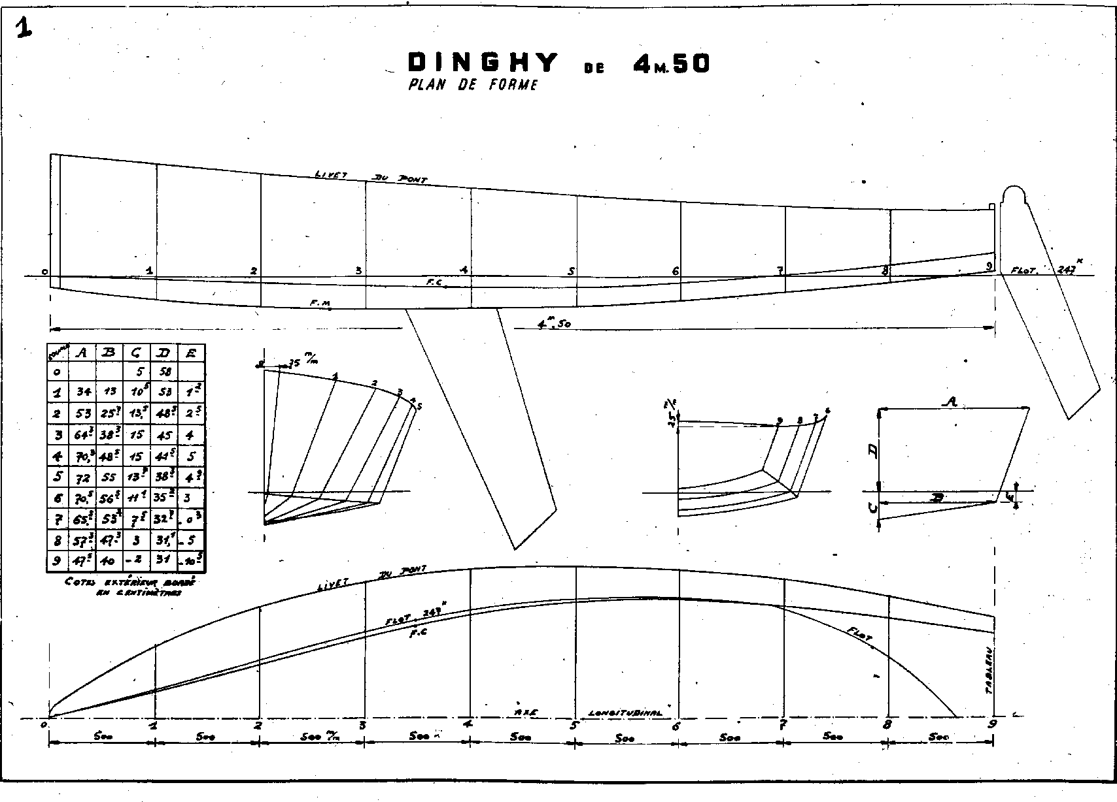
{m:endtemplate}

