{m:template public myTemplate(name:String)}
{m: name.asImage().setWidth(200)}
Static Image:
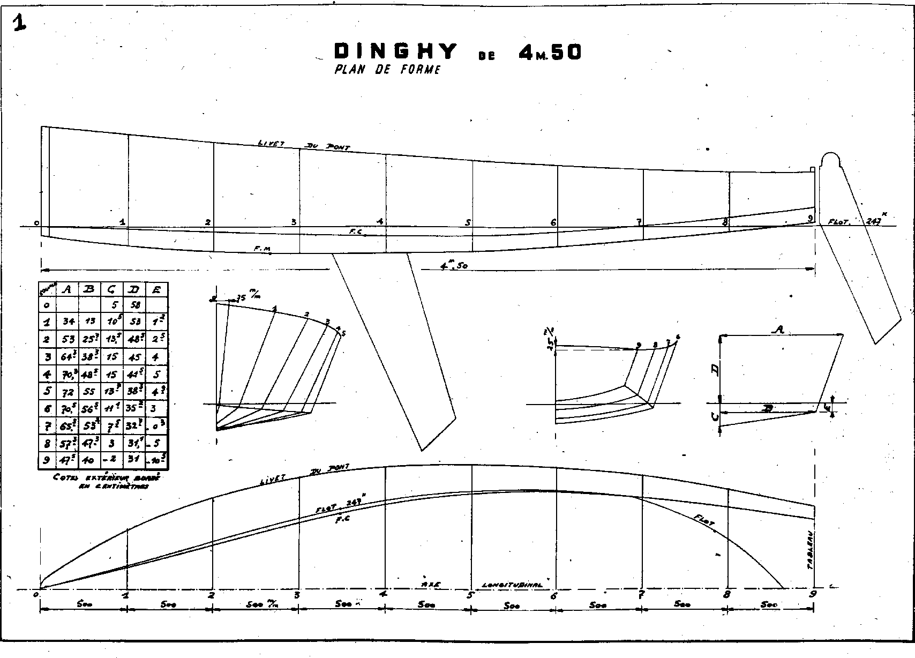
{m:endtemplate}

