A simple demonstration of a query :
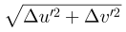
A query using a second html file with a different inlined SVG image :

End of demonstration.

