This demonstrate the simple usage of representationByName service :

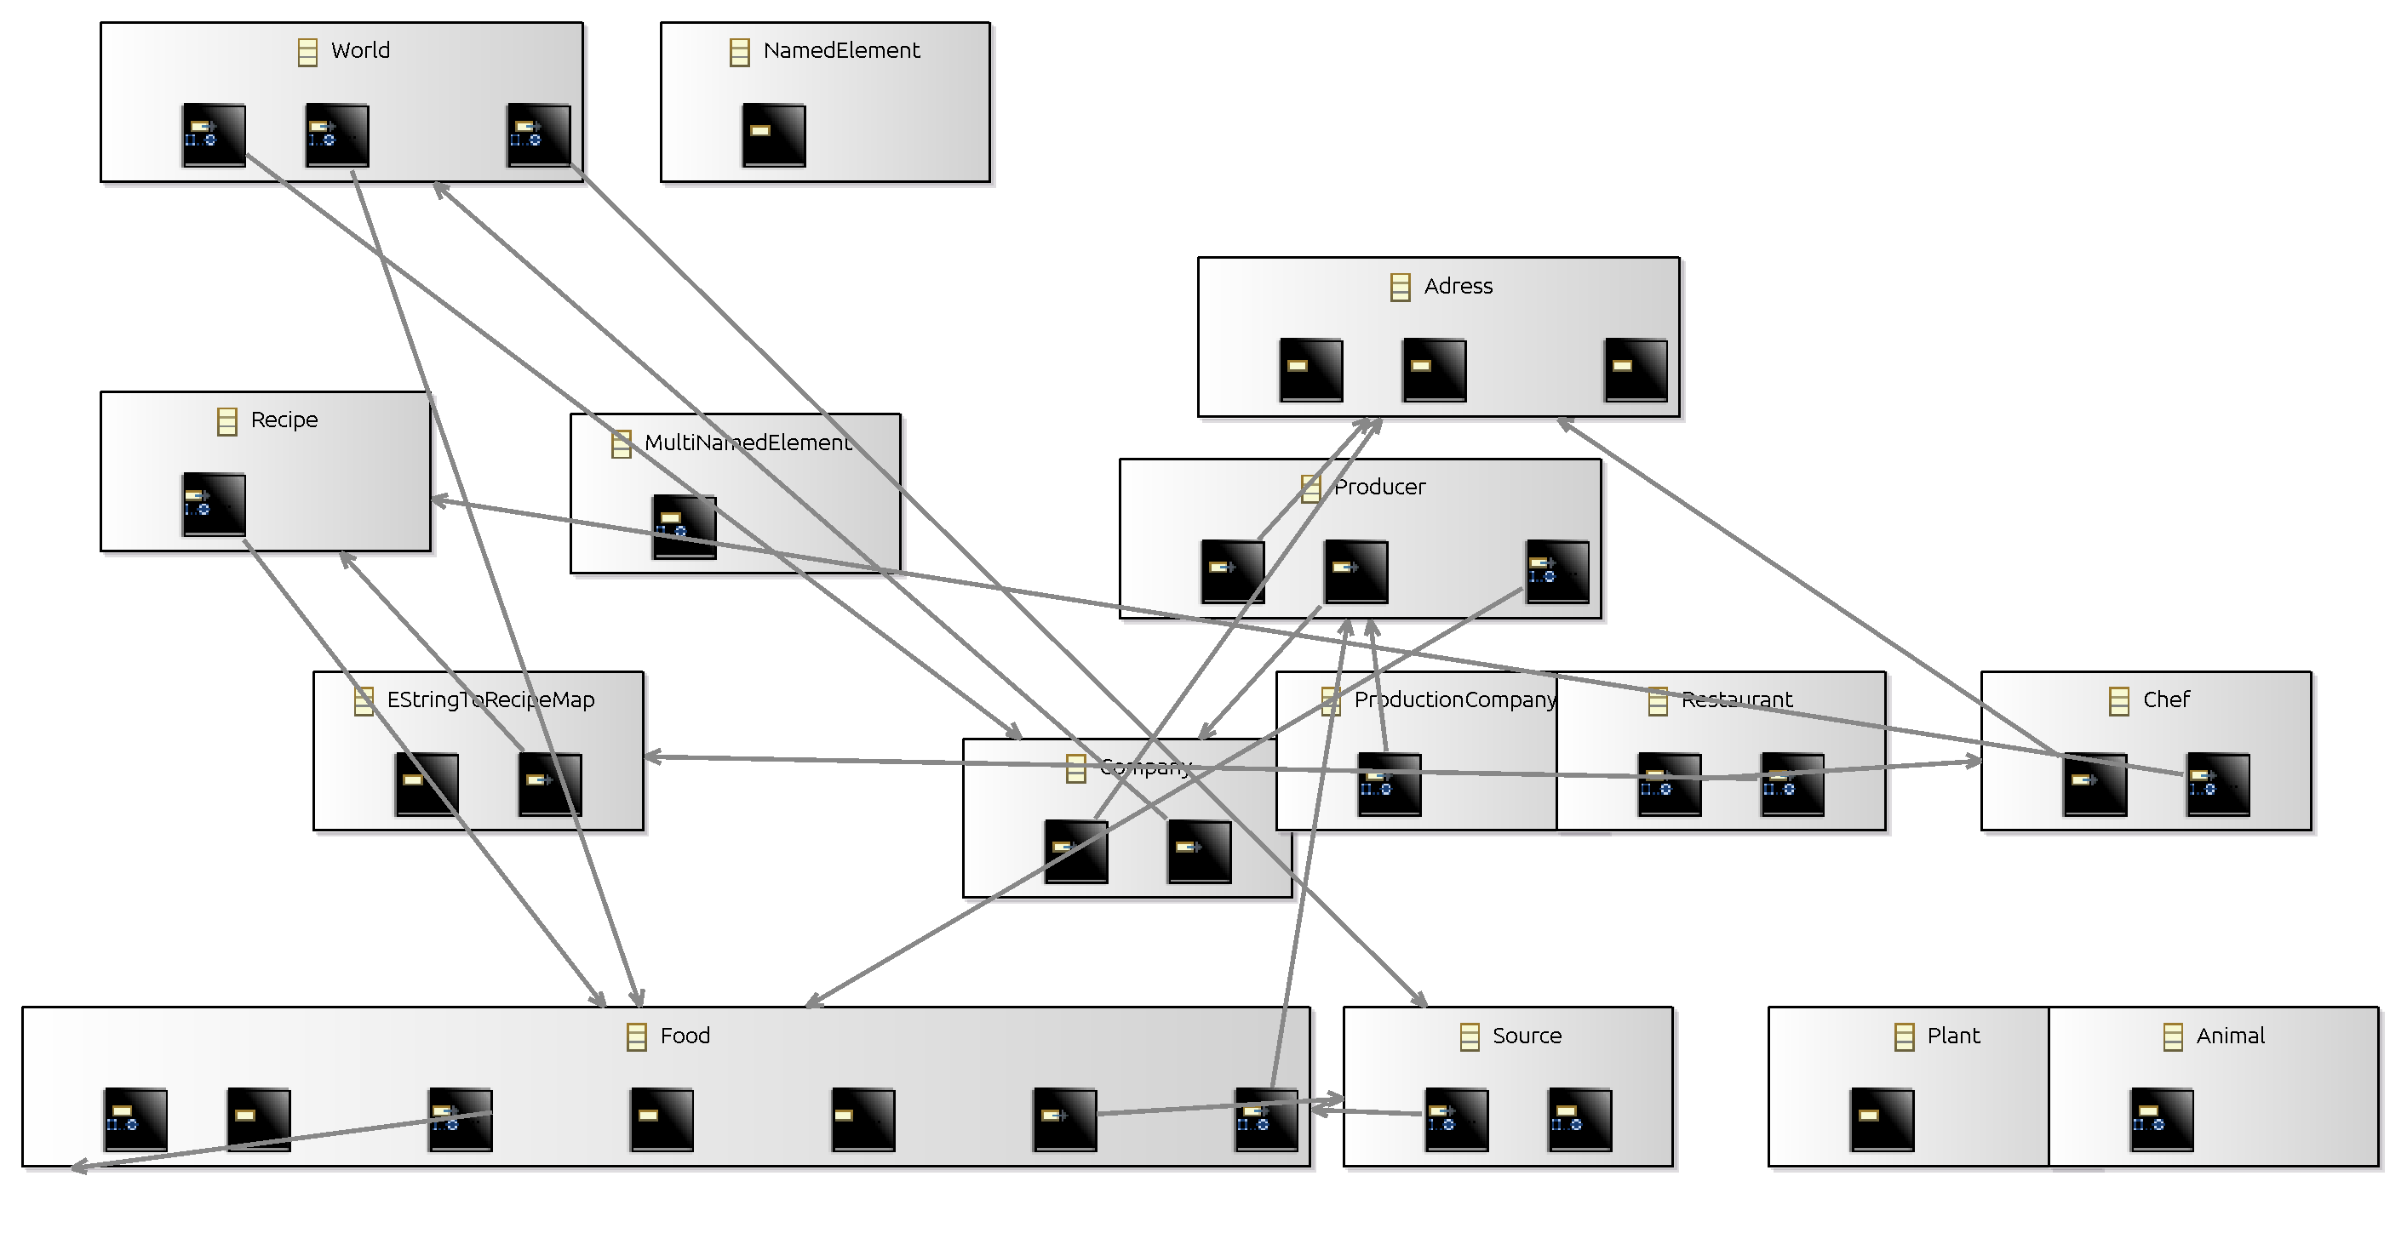

End of demonstration.

