This demonstrate the simple usage of isRepresentationDescriptionName service :

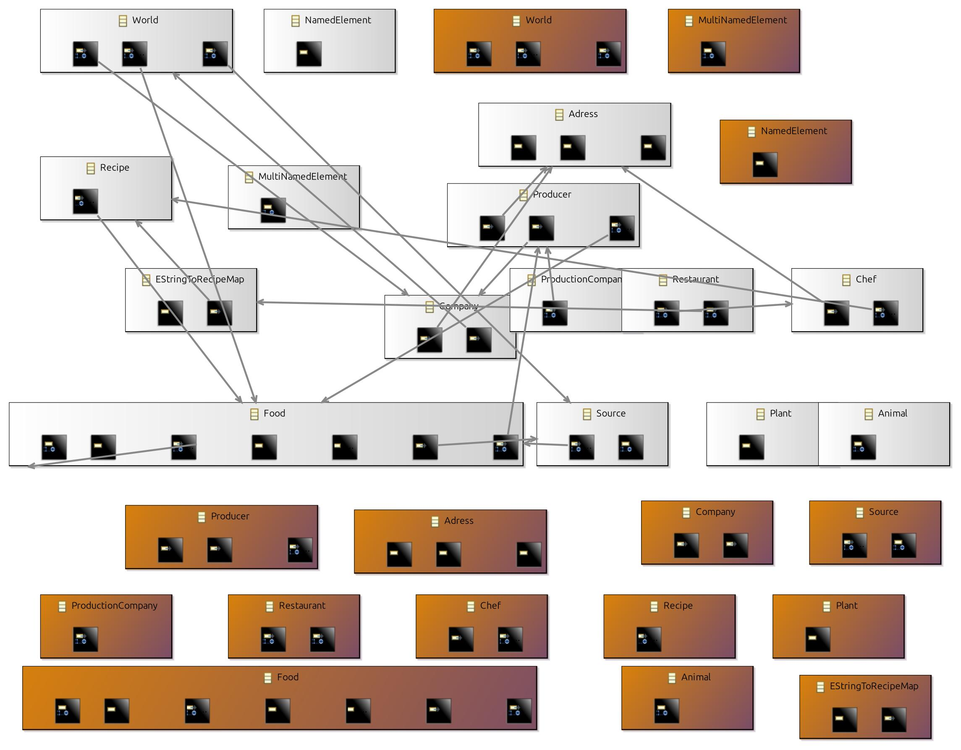

End of demonstration.

