This demonstrate the simple usage of diagram :

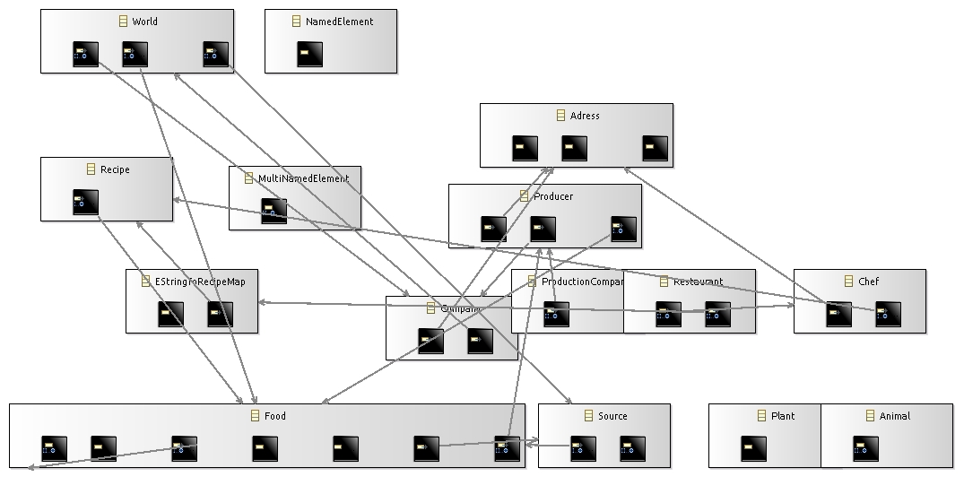

End of demonstration.