|  |
| --- |
| Embedded Systems Innovation by TNO |
| POOSL IDE  Installation Manual |
| Tool version 4.2.1  13th August 2021 |

|  |
| --- |
|  |

POOSL IDE Installation Manual

1 Installation4

1.1 Minimal system requirements4

1.2 Installing Eclipse4

1.3 Installing the POOSL IDE plug- in4

1.4 Updating the POOSL IDE5

1.5 Installation problems5

2 Test your installation using the examples6

2.1 Download the example and library POOSL projects**Erreur ! Signet non défini.**

2.2 Import the example and library POOSL projects6

2.3 Test your installation using an example6

3 User manual8

4 FAQ10

4.1 <CTRL>-<SPACE> does not work.10

4.2 Internal null pointer exception when trying to run/debug a model.10

4.3 Cannot complete the install because of a conflicting dependency.10

4.4 An error occurred while collecting items to be installed10

4.5 Something doesn’t (seem to) work.13

4.6 The installation could not be completed as requested13

4.7 “The system cannot find the path specified” when running a model14

**Introduction**

This document explains the installation of the POOSL IDE. This is a plug-in for Eclipse that relies on the POOSL simulator (Rotalumis) of Eindhoven University of Technology (<https://github.com/ObeoNetwork/POOSL>).

The latest version of this installation manual can be found at <http://poosl.esi.nl/> . Further information about the use of the POOSL IDE can be accessed through the built-in help.

# Installation

## Minimal system requirements

The POOSL IDE requires one of the following operating systems:

* Windows 7, 32 bit or 64 bit (Windows XP is not supported)
* Ubuntu 12.04, 32 bit or 64 bit (Ubuntu 18.04 is confirmed to work)
* Mac OS X 10.10 (Yosemite)

In addition it requires the following installed software:

* Eclipse IDE, version 2020-09 or newer (Eclipse 2020-12 is confirmed to work)

## Installing Eclipse

If a correct version of the Eclipse IDE has already been installed, you can skip this section. Otherwise, download the Eclipse Installer from <https://www.eclipse.org/downloads/> and execute it. Select “Eclipse Modeling Tools”, choose installation folder and accept licenses.

* Note: the Eclipse Installer includes a JRE (required to run Eclipse). It is also possible to install Eclipse via a package (<https://www.eclipse.org/downloads/packages/>) but this requires manual installation of a JRE (at least version 11) and is therefore not recommended. For the JRE and Eclipse, make sure that both are 32-bit versions, or both are 64-bit versions.

## Installing the POOSL IDE plug- in

To install the POOSL IDE plug-in in Eclipse follow these steps:

1. In Eclipse go to Help -> Install new software
2. In “Work with: “, click the Add… button. The Add Repository dialog box appears:
3. Select one of the update site listed here: <https://obeonetwork.github.io/POOSL/>
4. Enter a name for the repository and click OK.

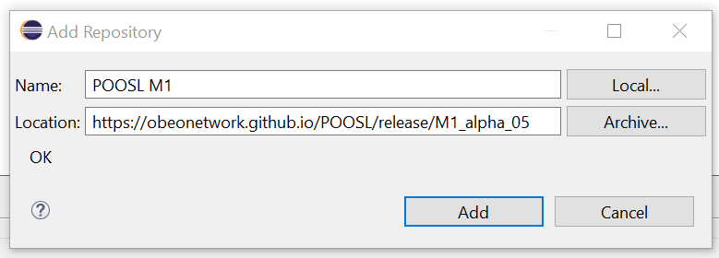

1. Select the Poosl IDE plug-in from the update site.

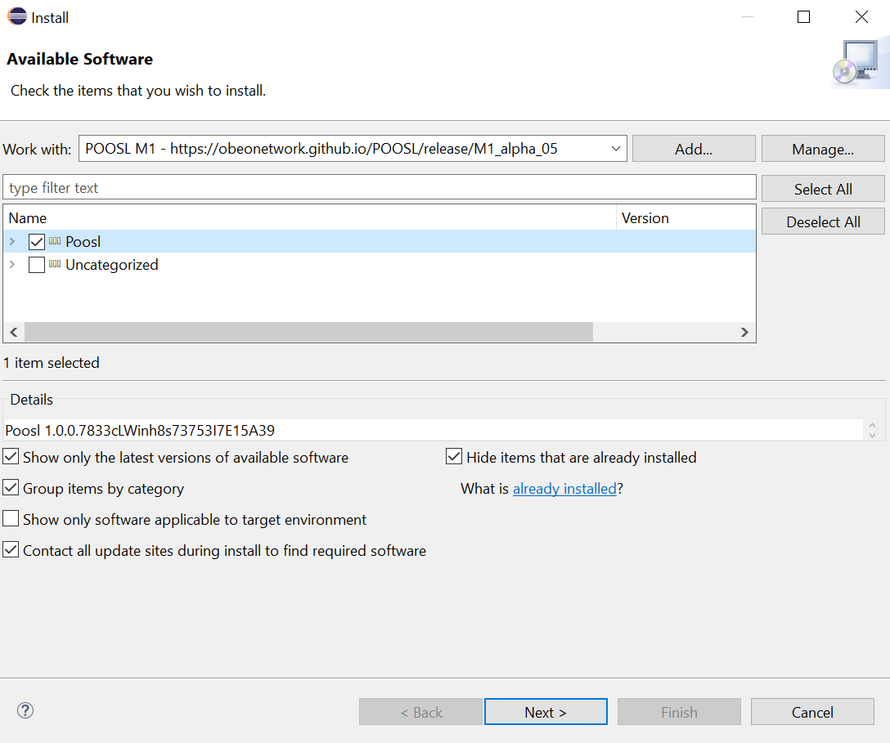

1. Click “Next” twice and accept the license agreement, click “Finish” to start the installation.  
   Because the software is not signed by Eclipse it will give a security warning. Click OK on the security warning to continue installation.
   * Installing the POOSL IDE plugin will automatically install the simulator (Rotalumis).
2. When asked, restart Eclipse.

If an error is reported during installation, please consult section 4.3, 4.4 and 4.5.

## Updating the POOSL IDE

To update the POOSL IDE follow these steps:

1. In Eclipse select Help -> Check for Updates. If a newer version of the POOSL IDE or the simulator (Rotalumis) are available, they will appear in the list of software to update.
2. Click Next to install the new updates.
3. In Eclipse select Project -> Clean… -> Clean all projects. This ensures that the metadata about the POOSL models is updated.

## Installation problems

In case errors occur after installing the POOSL IDE when opening files or running or debugging models, make sure that the correct versions of the following software are installed:

* Java Runtime Environment (JRE) version 11 or newer (see section 1.1)
* Eclipse IDE version 2020-09 or newer (see section 1.1)

# Test your installation using the examples

This section describes a procedure to check whether the installation was successful, and whether the POOSL IDE has enough permissions on your computer. To use the POOSL IDE to its full potential, it needs enough permissions to write files and to create socket connections on your machine.

## Import the example and library POOSL projects

To create POOSL projects with the examples and libraries, follow these steps:

1. Click on File -> New -> Example… -> POOSL Examples
2. Click Finish to import the projects.

## Test your installation using an example

1. Click on Window -> Perspective -> Open Perspective -> Other… -> POOSL Edit, which changes the screen layout in order to support the editing POOSL models.
2. 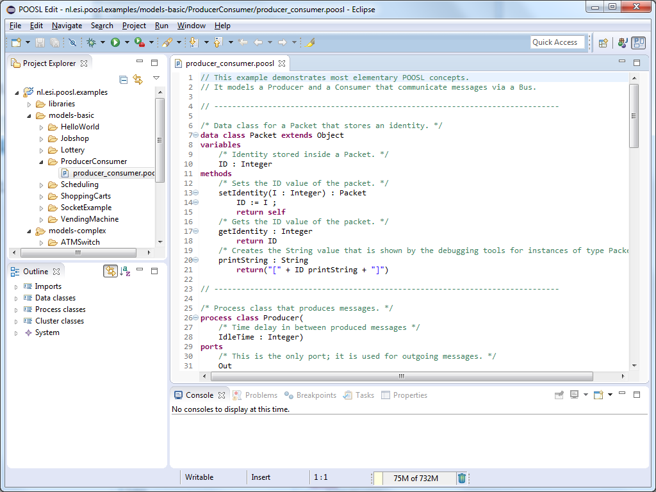Double-click on the file producer_consumer.poosl. **Check** that the contents of the file is shown in a syntax-highlighted way.

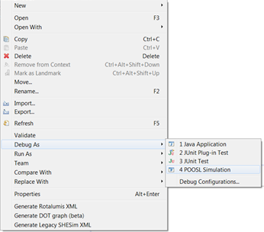

1. Right-click on the file producer_consumer.poosl and select Debug as -> POOSL simulation. The screen layout is changed in order to support the debugging of POOSL models.

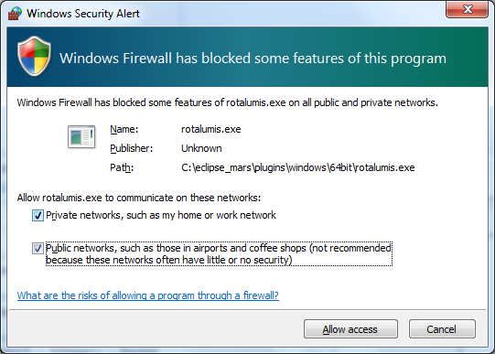When it is the first time starting a simulation, a “Windows Security Alert” window will pop-up with the question if it should block rotalumis.exe. To continue and run the simulation, click “Allow access”.

If a pop-up appears with the message “The system cannot find the path specified” follow the instructions in section 4.7.

1. If no element is selected in the Debug view (top-left corner), then select any element.
2. In the top-left corner, click on the green Resume button (indicated by the green arrow in the picture below). **Check** that the Sequence Diagram in the bottom-right corner fills up with messages.

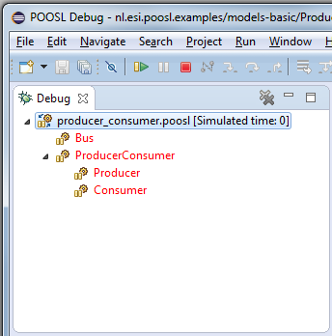

1. In the top-left corner, click on the red Terminate button (indicated by the red arrow in the picture above).
2. Editlogo.PNGIn the top-right corner, click on POOSL Edit or the logo to change back to the screen layout for editing. The edit perspective logo looks like:

# perspButtons.PNGUser manual

The user manual for the POOSL IDE can be found inside the Eclipse environment. It can be opened in several ways:

1. Click on the Help menu, and select “Help Contents”.  
   This will open the Eclipse built-in help in a separate window. The POOSL documentation is located under Contents in the Poosl booklet.  
   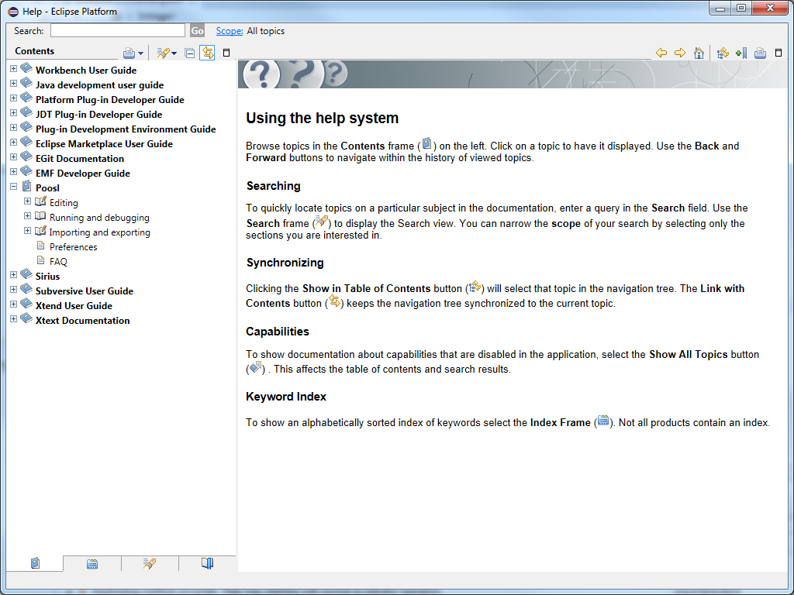

The recommended starting point for new users is Editing -> Create Projects and Models.

1. Click on the Help menu, and select “Dynamic help” (Or use keyboard shortcut <F1>).  
   This will open a window inside Eclipse. It shows brief information about the selected view, in combination with references to the help Contents.

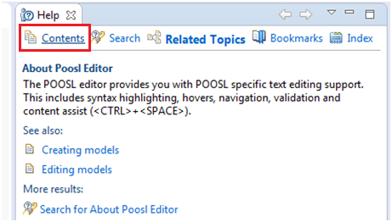

To switch between the main documentation (“Contents”) and the dynamic help (“Related Topics”), use the tabs on top of the help page.

# FAQ

## <CTRL>-<SPACE> does not work.

This is a general Eclipse problem. Some suggestions for solutions can be found online, such as:

1. Create a new workspace, and import your existing projects. Remember to check “Copy projects into workspace” to copy all your existing work to new workspace.

2. Make sure that the <CTRL>+<SPACE> combination is not hijacked by any other application (such as text input features).

3. Make sure “regional and language options” is in English language. For example, Windows, Control panel –> Region and language options. Then

* + Administrative (tab) –> Language for non-Unicode program. Make sure English (United States) is selected, others may not work.
  + Keyboards and Languages (tab) –> Change Keyboards. You’ll see a list of languages installed; remove any that you don’t want (click the language and then click the Remove button) until you only have the ones you want left.

4. Change the key combination in Eclipse, via Window -> Preferences -> General -> Keys. The default binding for command “Content Assist” is “Ctrl + Space”, but this can be changed into something else.

## Internal null pointer exception when trying to run/debug a model.

The following error may occur when you try to run or debug a model:

An internal error occurred during: "Launching …poosl". java.lang.NullPointerException

It usually indicates that your version of the Java Runtime Environment (JRE) is too old. Please check the minimal system requirements in section 1.1.

## Cannot complete the install because of a conflicting dependency.

The following error may occur during the installation of the POOSL IDE:

Cannot complete the install because of a conflicting dependency

If the remaining message refers to different version of the Eclipse Workbench, then it usually indicates that your version of Eclipse is too old. Please check the minimal system requirements in section 1.1.

## An error occurred while collecting items to be installed

The following error may occur during the installation of the POOSL IDE:

An error occurred while collecting items to be installed

session context was:(profile=epp.package.java, phase=org.eclipse.equinox.internal.p2.engine.phases.Collect, operand=, action=).

Followed by the repositories it cannot find:

No repository found containing: osgi.bundle,nl.esi.poosl.generatedxmlclasses,3.2.0.201501141011

No repository found containing: … … …

This is a known problem in Eclipse and it can be solved by reloading the software site.

1. Go to Help-> Install New Software, then select “Available Software Sites”.
2. 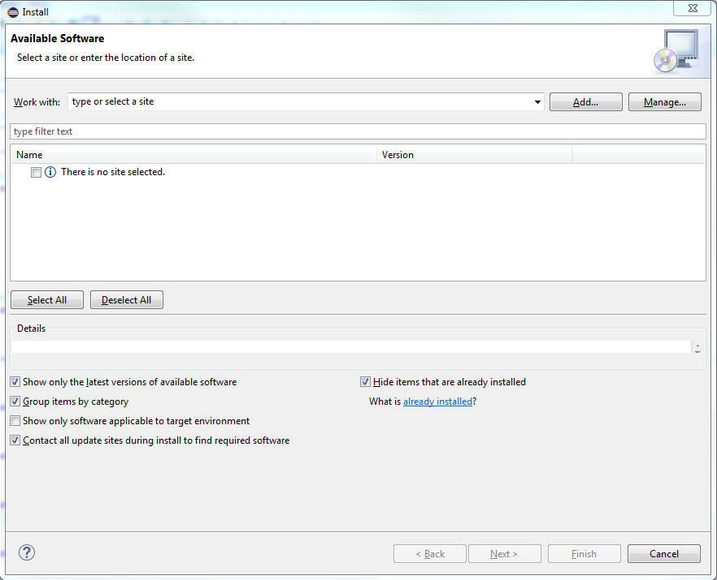Select the POOSL IDE site, and click “edit”. Change the location by removing or adding the trailing “/”, and click “OK”.
3. Sele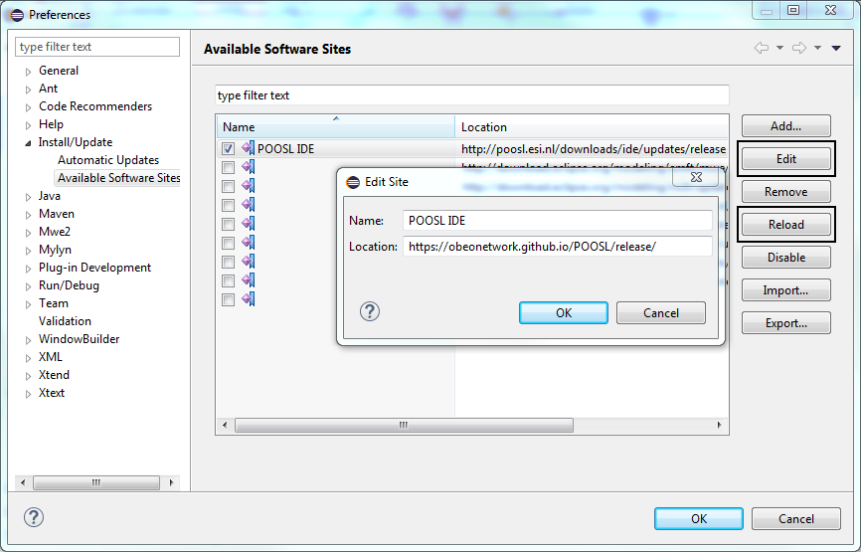ct the POOSL IDE site, and click “Reload”. Reloading may take a minute.
4. Once the software site has been reloaded, click “OK” to go back to the “Install New Software” screen.
5. 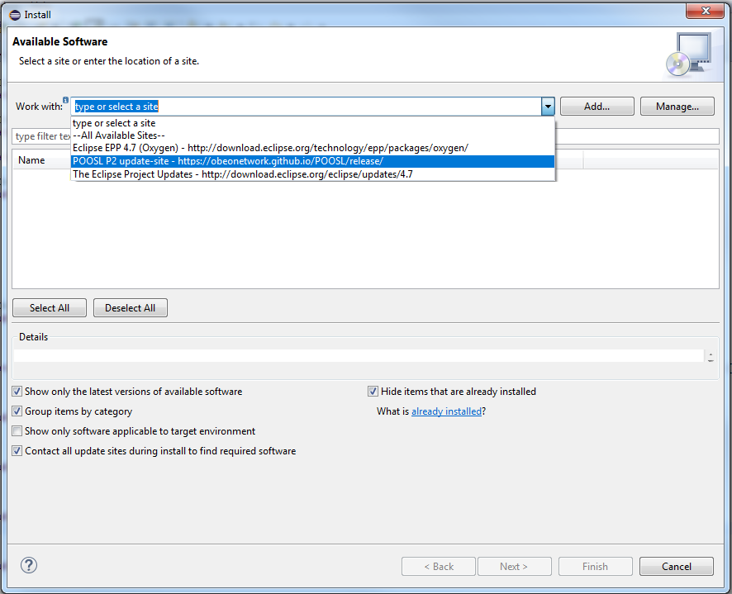The problem should now be resolved. Select the POOSL IDE site from the dropdown box to continue the installation at point 5 of the manual (section 1.3).

## Something doesn’t (seem to) work.

First of all, check whether your system meets the minimal installation requirements (see section 1.1), and the other FAQ. Depending on the problem, the following information may support experts in solving the problem that you experience:

* Version of the Java Runtime Environment
  + At the command prompt, type: java -version
* Version of Eclipse
  + Help -> About Eclipse
* Version of Xtext, Sirius and Rotalumis
  + Help -> About Eclipse -> Installation Details -> Installed Software
* Eclipse log
  + Help -> About Eclipse -> Installation Details -> Configuration -> View Error Log
* Log of the communication between Eclipse and the simulator
  + Set the logging level in the preferences
  + The Logging.html file can be found in the root of the Eclipse installation
* Console output and/or Eclipse screenshot
* The .poosl files causing the problem

## The installation could not be completed as requested

When installing/updating to POOSL IDE 3.4.1 in Eclipse Luna, the following error will occur: “The installation cannot be completed as requested”,

The original error contains:

Cannot complete the install because one or more required items could not be found.

Missing requirement: nl.esi.poosl.sirius 3.4.0.201506301149 (nl.esi.poosl.sirius 3.4.0.201506301149) **requires 'bundle org.eclipse.sirius 3.0.0' but it could not be found**

Version 3.4.0 of the POOSL IDE is the last version that supports Eclipse Luna, up to Luna SR2 (4.4.2). Updating to a higher version of POOSL IDE requires you to install Eclipse Mars or newer, as described in section 1.2.

The following error looks similar and can occur when installing the POOSL IDE in Eclipse Mars:

Cannot complete the install because one or more required items could not be found.

Missing requirement: POOSL IDE3.4.0.201506301149 (nl.esi.poosl.sdk.feature.group 3.4.0.201506301149)

**requires 'bundle org.eclipse.sirius 0.0.0' but it could not be found**

When installing the POOSL IDE plug-ins the **“Contact all update sites during installation to find required software”** checkbox was not selected. Restart the installation or press the back button and continue from section 1.3 at step 5.

## “The system cannot find the path specified” when running a model

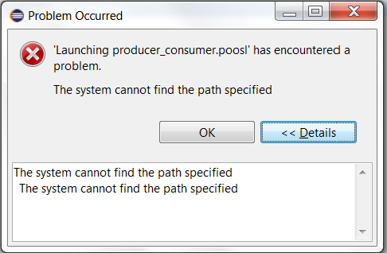The following error can occur when trying to run or debug a model:

This can mean that Eclipse has restricted access in the Eclipse installation folder. To solve this issue, either run Eclipse as administrator (Right-click on eclipse.exe, select “Run as administrator”), or move the Eclipse installation folder to a location where it has full read and write access.