Python/Pytest Automation Test Sheet
Webinar 6 — execution, triage та evidence

Environment
Field | Value
Python | 3.15.2
pytest | 9.2.0
pyserial | 3.5
DEVICE_PORT | rfc2217://localhost:4000
Firmware | BUGGY
Serial | 115200

Execution Log
ID | Test / Input | Expected | Actual | Classification | Evidence | P/F
T-01 | test_ping  Command PING | Test passed | TimeoutError: No response for command: PING | Requirement | Bug report T-01 | F
T-02 | test_status  Command STATUS | Test passed | Test passed |  | {"status":"OK","reset":true}  {"status":"OK","led":false,"pwm":0,"heap":350140}  {"status":"OK","reset":true} | P
T-03 | test_temperature_is_valid_json  Command GET TEMP | Test passed | AssertionError: Invalid JSON from device: '{"status":"OK","temperature":24.5' | Firmware | Bug report T-03 | F
T-04 | test_led_on_off  Command SET LED ON  SET LED OFF | Test passed | Test passed |  | {"status":"OK","reset":true}  {"status":"OK","led":true}  {"status":"OK","led":false}  {"status":"OK","reset":true} | P
T-05 | test_reset_restores_safe_state  Command SET LED ON  RESET  STATUS | Test passed | assert 255 == 0 | Firmware | Bug report T-05 | F
T-06 | test_unknown_command  Command PONG | Test passed | Test passed |  | {"status":"OK","reset":true}  {"status":"ERROR","code":"UNKNOWN_COMMAND"}  {"status":"OK","reset":true} | P
T-07 | test_no_response_becomes_timeout  Command NO_RESPONSE | Test passed | Test passed |  | {"status":"OK","reset":true}  {"status":"OK","reset":true}  {"status":"OK","reset":true} | P
T-08 | test_pwm_valid_boundaries  Command SET PWM 0 | Test passed | Test passed |  | {"status":"OK","reset":true}  {"status":"OK","pwm":0}  {"status":"OK","reset":true} | P
T-9 | test_pwm_valid_boundaries  Command SET PWM 1 | Test passed | Test passed |  | {"status":"OK","reset":true}  {"status":"OK","pwm":1}  {"status":"OK","reset":true} | P
T-10 | test_pwm_valid_boundaries  Command SET PWM 50 | Test passed | Test passed |  | {"status":"OK","reset":true}  {"status":"OK","pwm":50}  {"status":"OK","reset":true} | P
T-11 | test_pwm_valid_boundaries  Command SET PWM 99 | Test passed | Test passed |  | {"status":"OK","reset":true}  {"status":"OK","pwm":99}  {"status":"OK","reset":true} | P
T-12 | test_pwm_valid_boundaries  Command SET PWM 100 | Test passed | AssertionError: assert 'ERROR' == 'OK' | Firmware | Bug report T-12 | F
T-13 | test_pwm_invalid_boundaries  Command SET PWM -1 | Test passed | Test passed |  | {"status":"OK","reset":true}  {"status":"ERROR","code":"INVALID_VALUE"}  {"status":"OK","reset":true} | P
T-14 | test_pwm_invalid_boundaries  Command SET PWM 101 | Test passed | Test passed |  | {"status":"OK","reset":true}  {"status":"ERROR","code":"INVALID_VALUE"}  {"status":"OK","reset":true} | P
T-15 | test_pwm_invalid_boundaries  Command SET PWM 999 | Test passed | Test passed |  | {"status":"OK","reset":true}  {"status":"ERROR","code":"INVALID_VALUE"}  {"status":"OK","reset":true} | P
T-16 | test_pwm_additional_valid_values  Command SET PWM 15 | Test passed | Test passed |  | {"status":"OK","reset":true}  {"status":"OK","pwm":15}  {"status":"OK","reset":true} | P
T-17 | test_pwm_additional_valid_values  Command SET PWM 75 | Test passed | Test passed |  | {"status":"OK","reset":true}  {"status":"OK","pwm":75}  {"status":"OK","reset":true} | P
T-18 | test_pwm_additional_valid_values  Command SET PWM 98 | Test passed | Test passed |  | {"status":"OK","reset":true}  {"status":"OK","pwm":98}  {"status":"OK","reset":true} | P
T-19 | test_pwm_additional_invalid_values  Command SET PWM -101 | Test passed | Test passed |  | {"status":"OK","reset":true}  {"status":"ERROR","code":"INVALID_VALUE"}  {"status":"OK","reset":true} | P
T-20 | test_pwm_additional_invalid_values  Command SET PWM 10.5 | Test passed | Test passed |  | {"status":"OK","reset":true}  {"status":"ERROR","code":"INVALID_VALUE"}  {"status":"OK","reset":true} | P
T-21 | test_pwm_additional_invalid_values  Command SET PWM ‘’ | Test passed | Test passed |  | {"status":"OK","reset":true}  {"status":"ERROR","code":"INVALID_VALUE"}  {"status":"OK","reset":true} | P

FAIL Classification
Category | Check | Evidence
Test | Assert/oracle correct? | Test code, expected value
Environment | DEVICE_PORT/dependencies/port ownership? | Configuration, logs
Communication | Timeout/transport/raw bytes? | Serial logs, received bytes
Requirement | Expected explicitly supported? | Requirement ID
Firmware | Repeatable mismatch with requirement? | Actual response, repeated test results

Device LOG
ets Jul 29 2019 12:21:46
rst:0x1 (POWERON_RESET),boot:0x13 (SPI_FAST_FLASH_BOOT)
configsip: 0, SPIWP:0xee
clk_drv:0x00,q_drv:0x00,d_drv:0x00,cs0_drv:0x00,hd_drv:0x00,wp_drv:0x00
mode:DIO, clock div:2
load:0x3fff0030,len:1156
load:0x40078000,len:11456
ho 0 tail 12 room 4
load:0x40080400,len:2972
entry 0x400805dc
{"status":"READY"}
{"status":"OK","reset":true}
{"status":"OK","command":"PING"}
{"status":"OK","reset":true}
{"status":"OK","reset":true}
{"status":"OK","led":false,"pwm":0,"heap":350140}
{"status":"OK","reset":true}
{"status":"OK","reset":true}
{"status":"OK","temperature":24.5
{"status":"OK","reset":true}
{"status":"OK","reset":true}
{"status":"OK","led":true}
{"status":"OK","led":false}
{"status":"OK","reset":true}
{"status":"OK","reset":true}
{"status":"OK","led":true}
{"status":"OK","reset":true}
{"status":"OK","led":true,"pwm":255,"heap":349852}
{"status":"OK","reset":true}
{"status":"OK","reset":true}
{"status":"ERROR","code":"UNKNOWN_COMMAND"}
{"status":"OK","reset":true}
{"status":"OK","reset":true}
{"status":"OK","reset":true}
{"status":"OK","reset":true}
{"status":"OK","pwm":0}
{"status":"OK","reset":true}
{"status":"OK","reset":true}
{"status":"OK","pwm":1}
{"status":"OK","reset":true}
{"status":"OK","reset":true}
{"status":"OK","pwm":50}
{"status":"OK","reset":true}
{"status":"OK","reset":true}
{"status":"OK","pwm":99}
{"status":"OK","reset":true}
{"status":"OK","reset":true}
{"status":"ERROR","code":"INVALID_VALUE"}
{"status":"OK","reset":true}
{"status":"OK","reset":true}
{"status":"ERROR","code":"INVALID_VALUE"}
{"status":"OK","reset":true}
{"status":"OK","reset":true}
{"status":"ERROR","code":"INVALID_VALUE"}
{"status":"OK","reset":true}
{"status":"OK","reset":true}
{"status":"ERROR","code":"INVALID_VALUE"}
{"status":"OK","reset":true}
{"status":"OK","reset":true}
{"status":"OK","pwm":15}
{"status":"OK","reset":true}
{"status":"OK","reset":true}
{"status":"OK","pwm":75}
{"status":"OK","reset":true}
{"status":"OK","reset":true}
{"status":"OK","pwm":98}
{"status":"OK","reset":true}
{"status":"OK","reset":true}
{"status":"ERROR","code":"INVALID_VALUE"}
{"status":"OK","reset":true}
{"status":"OK","reset":true}
{"status":"ERROR","code":"INVALID_VALUE"}
{"status":"OK","reset":true}
{"status":"OK","reset":true}
{"status":"ERROR","code":"INVALID_VALUE"}
{"status":"OK","reset":true}

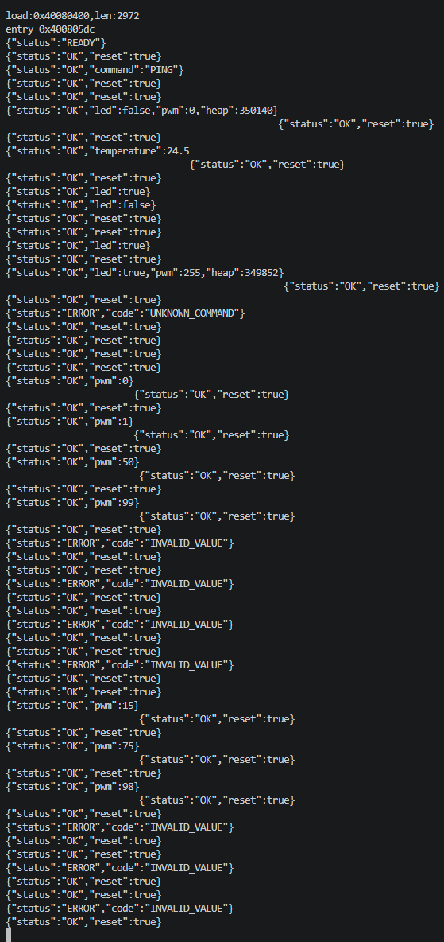

Pytest response
(.venv) PS C:\Users\ober-pc\Documents\git\EmbededQA\pytest\automation> python -m pytest -v .\tests\test_firmware_cli.py
==================================================================== test session starts =====================================================================
platform win32 -- Python 3.15.2, pytest-9.2.0, pluggy-1.7.0
rootdir: C:\Users\ober-pc\Documents\git\EmbededQA\pytest\automation
configfile: pytest.ini
collected 21 items

tests\test_firmware_cli.py F.F.F......F......... [100%]

========================================================================== FAILURES ==========================================================================
_________________________________________________________________________ test_ping __________________________________________________________________________

device = <device.Device object at 0x000002AF4C724830>

def test_ping(device):
> r = device.command("PING")
^^^^^^^^^^^^^^^^^^^^^^

tests\test_firmware_cli.py:4:
_ _ _ _ _ _ _ _ _ _ _ _ _ _ _ _ _ _ _ _ _ _ _ _ _ _ _ _ _ _ _ _ _ _ _ _ _ _ _ _ _ _ _ _ _ _ _ _ _ _ _ _ _ _ _ _ _ _ _ _ _ _ _ _ _ _ _ _ _ _ _ _ _ _ _ _ _ _ _
device.py:27: in command
raw = self.command_raw(command)
^^^^^^^^^^^^^^^^^^^^^^^^^
_ _ _ _ _ _ _ _ _ _ _ _ _ _ _ _ _ _ _ _ _ _ _ _ _ _ _ _ _ _ _ _ _ _ _ _ _ _ _ _ _ _ _ _ _ _ _ _ _ _ _ _ _ _ _ _ _ _ _ _ _ _ _ _ _ _ _ _ _ _ _ _ _ _ _ _ _ _ _

self = <device.Device object at 0x000002AF4C724830>, command = 'PING'

def command_raw(self, command):
self.ser.reset_input_buffer()
self.ser.write((command + "\n").encode())
self.ser.flush()
line = self.ser.readline().decode(errors="replace").strip()
if not line:
> raise TimeoutError(f"No response for command: {command}")
E TimeoutError: No response for command: PING

device.py:23: TimeoutError
_______________________________________________________________ test_temperature_is_valid_json _______________________________________________________________

self = <device.Device object at 0x000002AF4C7CE0D0>, command = 'GET TEMP'

def command(self, command):
raw = self.command_raw(command)
try:
> return json.loads(raw)
^^^^^^^^^^^^^^^

device.py:29:
_ _ _ _ _ _ _ _ _ _ _ _ _ _ _ _ _ _ _ _ _ _ _ _ _ _ _ _ _ _ _ _ _ _ _ _ _ _ _ _ _ _ _ _ _ _ _ _ _ _ _ _ _ _ _ _ _ _ _ _ _ _ _ _ _ _ _ _ _ _ _ _ _ _ _ _ _ _ _
..\..\..\..\..\AppData\Local\Python\pythoncore-3.15-64\Lib\json\__init__.py:371: in loads
return _default_decoder.decode(s)
^^^^^^^^^^^^^^^^^^^^^^^^^^
..\..\..\..\..\AppData\Local\Python\pythoncore-3.15-64\Lib\json\decoder.py:358: in decode
obj, end = self.raw_decode(s, idx=_w(s, 0).end())
^^^^^^^^^^^^^^^^^^^^^^^^^^^^^^^^^^^^^^
_ _ _ _ _ _ _ _ _ _ _ _ _ _ _ _ _ _ _ _ _ _ _ _ _ _ _ _ _ _ _ _ _ _ _ _ _ _ _ _ _ _ _ _ _ _ _ _ _ _ _ _ _ _ _ _ _ _ _ _ _ _ _ _ _ _ _ _ _ _ _ _ _ _ _ _ _ _ _

self = <json.decoder.JSONDecoder object at 0x000002AF49E0C050>, s = '{"status":"OK","temperature":24.5', idx = 0

def raw_decode(self, s, idx=0):
"""Decode a JSON document from ``s`` (a ``str`` beginning with
a JSON document) and return a 2-tuple of the Python
representation and the index in ``s`` where the document ended.

This can be used to decode a JSON document from a string that may
have extraneous data at the end.

"""
try:
> obj, end = self.scan_once(s, idx)
^^^^^^^^^^^^^^^^^^^^^^
E json.decoder.JSONDecodeError: Expecting ',' delimiter: line 1 column 34 (char 33)

..\..\..\..\..\AppData\Local\Python\pythoncore-3.15-64\Lib\json\decoder.py:374: JSONDecodeError

The above exception was the direct cause of the following exception:

device = <device.Device object at 0x000002AF4C7CE0D0>

def test_temperature_is_valid_json(device):
> r = device.command("GET TEMP")
^^^^^^^^^^^^^^^^^^^^^^^^^^

tests\test_firmware_cli.py:15:
_ _ _ _ _ _ _ _ _ _ _ _ _ _ _ _ _ _ _ _ _ _ _ _ _ _ _ _ _ _ _ _ _ _ _ _ _ _ _ _ _ _ _ _ _ _ _ _ _ _ _ _ _ _ _ _ _ _ _ _ _ _ _ _ _ _ _ _ _ _ _ _ _ _ _ _ _ _ _

self = <device.Device object at 0x000002AF4C7CE0D0>, command = 'GET TEMP'

def command(self, command):
raw = self.command_raw(command)
try:
return json.loads(raw)
except json.JSONDecodeError as e:
> raise AssertionError(f"Invalid JSON from device: {raw!r}") from e
E AssertionError: Invalid JSON from device: '{"status":"OK","temperature":24.5'

device.py:31: AssertionError
_______________________________________________________________ test_reset_restores_safe_state _______________________________________________________________

device = <device.Device object at 0x000002AF4C80CD60>

def test_reset_restores_safe_state(device):
device.command("SET LED ON")
device.command("RESET")
status = device.command("STATUS")
> assert status["pwm"] == 0
E assert 255 == 0

tests\test_firmware_cli.py:28: AssertionError
_______________________________________________________________ test_pwm_valid_boundaries[100] _______________________________________________________________

device = <device.Device object at 0x000002AF4C71A990>, value = 100

@pytest.mark.parametrize("value", [0, 1, 50, 99, 100])
def test_pwm_valid_boundaries(device, value):
r = device.command(f"SET PWM {value}")
> assert r["status"] == "OK"
E AssertionError: assert 'ERROR' == 'OK'
E
E - OK
E + ERROR

tests\test_firmware_cli.py:43: AssertionError
====================================================================== warnings summary ======================================================================
tests/test_firmware_cli.py: 21 warnings
C:\Users\ober-pc\Documents\git\EmbededQA\pytest\automation\.venv\Lib\site-packages\serial\rfc2217.py:465: DeprecationWarning: setDaemon() is deprecated, set the daemon attribute instead
self._thread.setDaemon(True)

tests/test_firmware_cli.py: 21 warnings
C:\Users\ober-pc\Documents\git\EmbededQA\pytest\automation\.venv\Lib\site-packages\serial\rfc2217.py:466: DeprecationWarning: setName() is deprecated, set the name attribute instead
self._thread.setName('pySerial RFC 2217 reader thread for {}'.format(self._port))

-- Docs: https://docs.pytest.org/en/stable/how-to/capture-warnings.html
================================================================== short test summary info ===================================================================
FAILED tests/test_firmware_cli.py::test_ping - TimeoutError: No response for command: PING
FAILED tests/test_firmware_cli.py::test_temperature_is_valid_json - AssertionError: Invalid JSON from device: '{"status":"OK","temperature":24.5'
FAILED tests/test_firmware_cli.py::test_reset_restores_safe_state - assert 255 == 0
FAILED tests/test_firmware_cli.py::test_pwm_valid_boundaries[100] - AssertionError: assert 'ERROR' == 'OK'
========================================================= 4 failed, 17 passed, 42 warnings in 43.91s =========================================================

Bug Report T-01
Title: Команда PING відповідає TimeoutError: No response for command: PING
Requirement: `PING` → valid JSON with `status=OK`
Environment: Python 3.15.2, pytest 9.2.0, pyserial 3.5, DEVICE_PORT rfc2217://localhost:4000, Firmware BUGGY, Serial 115200
Preconditions: система після команди RESET {"status":"OK","reset":true}
Test/Steps: запустити тест test_ping
Expected: test passed, {"status":"OK","command":"PING"}
Actual: TimeoutError: No response for command: PING
Raw Serial Evidence: {"status":"OK","command":"PING"}
Pytest Evidence:
_________________________________________________________________________ test_ping __________________________________________________________________________

device = <device.Device object at 0x0000023D9BCE4830>

def test_ping(device):
> r = device.command("PING")
^^^^^^^^^^^^^^^^^^^^^^

tests\test_firmware_cli.py:4:
_ _ _ _ _ _ _ _ _ _ _ _ _ _ _ _ _ _ _ _ _ _ _ _ _ _ _ _ _ _ _ _ _ _ _ _ _ _ _ _ _ _ _ _ _ _ _ _ _ _ _ _ _ _ _ _ _ _ _ _ _ _ _ _ _ _ _ _ _ _ _ _ _ _ _ _ _ _ _
device.py:27: in command
raw = self.command_raw(command)
^^^^^^^^^^^^^^^^^^^^^^^^^
_ _ _ _ _ _ _ _ _ _ _ _ _ _ _ _ _ _ _ _ _ _ _ _ _ _ _ _ _ _ _ _ _ _ _ _ _ _ _ _ _ _ _ _ _ _ _ _ _ _ _ _ _ _ _ _ _ _ _ _ _ _ _ _ _ _ _ _ _ _ _ _ _ _ _ _ _ _ _

self = <device.Device object at 0x0000023D9BCE4830>, command = 'PING'

def command_raw(self, command):
self.ser.reset_input_buffer()
self.ser.write((command + "\n").encode())
self.ser.flush()
line = self.ser.readline().decode(errors="replace").strip()
if not line:
> raise TimeoutError(f"No response for command: {command}")
E TimeoutError: No response for command: PING

device.py:23: TimeoutError
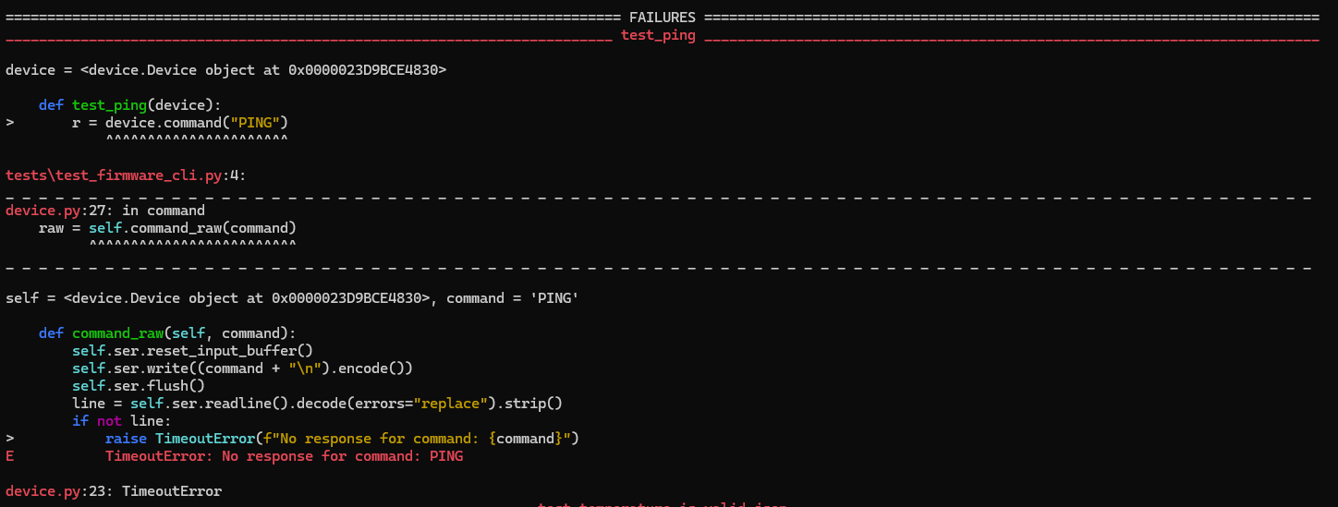
Severity: Major
Reproducibility: 100% (відтворено 4 з 4 разів)

Bug Report T-03
Title: Команда GET TEMP відповідає AssertionError: Invalid JSON from device: '{"status":"OK","temperature":24.5'
Requirement: `GET TEMP` → valid JSON; either valid temperature or explicit sensor error
Environment: Python 3.15.2, pytest 9.2.0, pyserial 3.5, DEVICE_PORT rfc2217://localhost:4000, Firmware BUGGY, Serial 115200
Preconditions: система після команди RESET {"status":"OK","reset":true}
Test/Steps: запустити тест test_temperature_is_valid_json
Expected: test passed, {"status":"OK","temperature":24.5}
Actual: AssertionError: Invalid JSON from device: '{"status":"OK","temperature":24.5'
Raw Serial Evidence:
{"status":"OK","reset":true}
{"status":"OK","temperature":24.5
{"status":"OK","reset":true}
Pytest Evidence:
_______________________________________________________________ test_temperature_is_valid_json _______________________________________________________________

self = <device.Device object at 0x0000023D9BDA20D0>, command = 'GET TEMP'

def command(self, command):
raw = self.command_raw(command)
try:
> return json.loads(raw)
^^^^^^^^^^^^^^^

device.py:29:
_ _ _ _ _ _ _ _ _ _ _ _ _ _ _ _ _ _ _ _ _ _ _ _ _ _ _ _ _ _ _ _ _ _ _ _ _ _ _ _ _ _ _ _ _ _ _ _ _ _ _ _ _ _ _ _ _ _ _ _ _ _ _ _ _ _ _ _ _ _ _ _ _ _ _ _ _ _ _
..\..\..\..\..\AppData\Local\Python\pythoncore-3.15-64\Lib\json\__init__.py:371: in loads
return _default_decoder.decode(s)
^^^^^^^^^^^^^^^^^^^^^^^^^^
..\..\..\..\..\AppData\Local\Python\pythoncore-3.15-64\Lib\json\decoder.py:358: in decode
obj, end = self.raw_decode(s, idx=_w(s, 0).end())
^^^^^^^^^^^^^^^^^^^^^^^^^^^^^^^^^^^^^^
_ _ _ _ _ _ _ _ _ _ _ _ _ _ _ _ _ _ _ _ _ _ _ _ _ _ _ _ _ _ _ _ _ _ _ _ _ _ _ _ _ _ _ _ _ _ _ _ _ _ _ _ _ _ _ _ _ _ _ _ _ _ _ _ _ _ _ _ _ _ _ _ _ _ _ _ _ _ _

self = <json.decoder.JSONDecoder object at 0x0000023D9937C050>, s = '{"status":"OK","temperature":24.5', idx = 0

def raw_decode(self, s, idx=0):
"""Decode a JSON document from ``s`` (a ``str`` beginning with
a JSON document) and return a 2-tuple of the Python
representation and the index in ``s`` where the document ended.

This can be used to decode a JSON document from a string that may
have extraneous data at the end.

"""
try:
> obj, end = self.scan_once(s, idx)
^^^^^^^^^^^^^^^^^^^^^^
E json.decoder.JSONDecodeError: Expecting ',' delimiter: line 1 column 34 (char 33)

..\..\..\..\..\AppData\Local\Python\pythoncore-3.15-64\Lib\json\decoder.py:374: JSONDecodeError

The above exception was the direct cause of the following exception:

device = <device.Device object at 0x0000023D9BDA20D0>

def test_temperature_is_valid_json(device):
> r = device.command("GET TEMP")
^^^^^^^^^^^^^^^^^^^^^^^^^^

tests\test_firmware_cli.py:15:
_ _ _ _ _ _ _ _ _ _ _ _ _ _ _ _ _ _ _ _ _ _ _ _ _ _ _ _ _ _ _ _ _ _ _ _ _ _ _ _ _ _ _ _ _ _ _ _ _ _ _ _ _ _ _ _ _ _ _ _ _ _ _ _ _ _ _ _ _ _ _ _ _ _ _ _ _ _ _

self = <device.Device object at 0x0000023D9BDA20D0>, command = 'GET TEMP'

def command(self, command):
raw = self.command_raw(command)
try:
return json.loads(raw)
except json.JSONDecodeError as e:
> raise AssertionError(f"Invalid JSON from device: {raw!r}") from e
E AssertionError: Invalid JSON from device: '{"status":"OK","temperature":24.5'

device.py:31: AssertionError
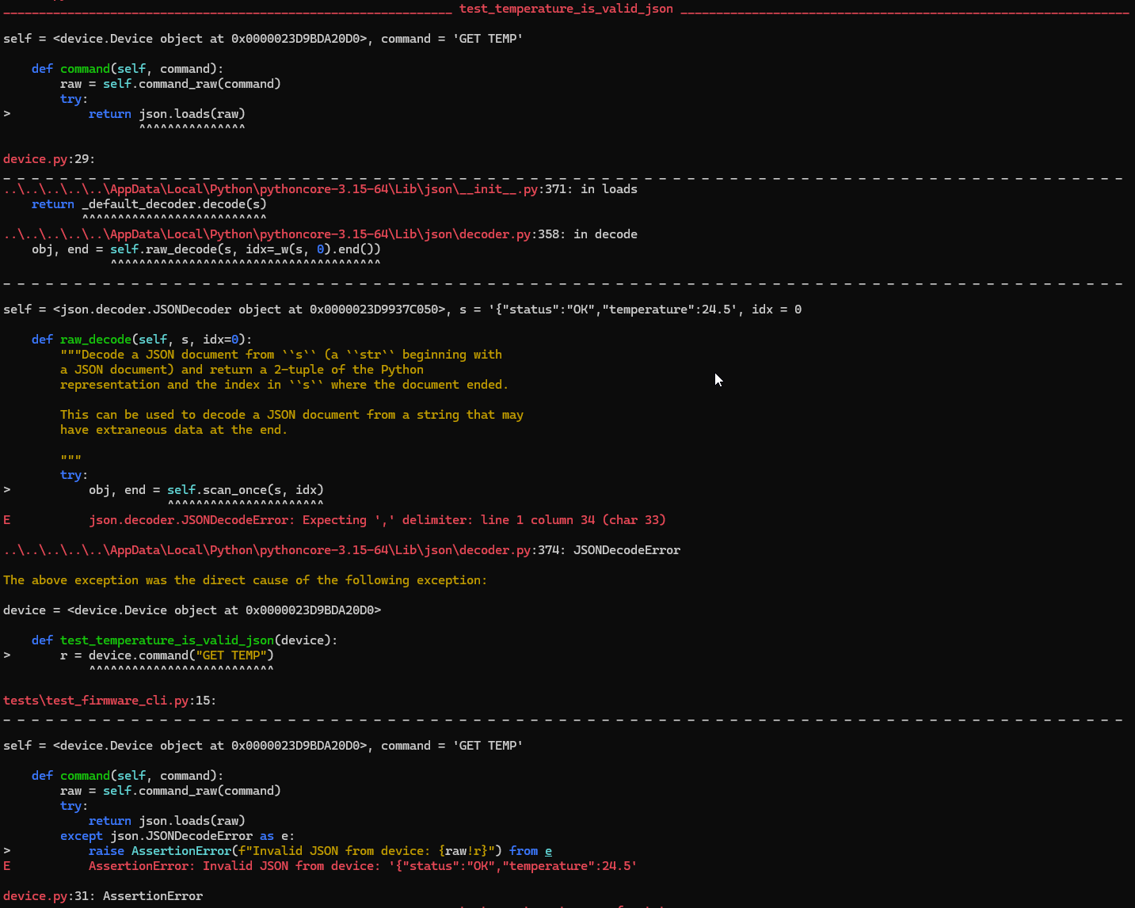
Severity: High
Reproducibility: 100% (відтворено 4 з 4 разів)

Bug Report T-05
Title: Команда RESET не скинула значення параметрів led та pwm у safe state
Requirement: `RESET` restores safe output state: LED/PWM OFF/0
Environment: Python 3.15.2, pytest 9.2.0, pyserial 3.5, DEVICE_PORT rfc2217://localhost:4000, Firmware BUGGY, Serial 115200
Preconditions: система після команди RESET {"status":"OK","reset":true}
Test/Steps: запустити тест test_reset_restores_safe_state
Expected: test passed, {"status":"OK","led":false,"pwm":0,"heap":349852}
Actual: assert 255 == 0
Raw Serial Evidence:
{"status":"OK","reset":true}
{"status":"OK","led":true}
{"status":"OK","reset":true}
{"status":"OK","led":true,"pwm":255,"heap":349852}
{"status":"OK","reset":true}
Pytest Evidence:
_______________________________________________________________ test_reset_restores_safe_state _______________________________________________________________

device = <device.Device object at 0x0000023D9BDC0E90>

def test_reset_restores_safe_state(device):
device.command("SET LED ON")
device.command("RESET")
status = device.command("STATUS")
> assert status["pwm"] == 0
E assert 255 == 0

tests\test_firmware_cli.py:28: AssertionError
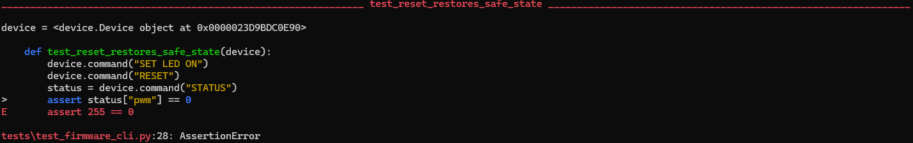
Severity: Critical
Reproducibility: 100% (відтворено 4 з 4 разів)

Bug Report T-12
Title: Команда SET PWM 100 повернула AssertionError: assert 'ERROR' == 'OK'
Requirement: `SET PWM N` accepts every integer from 0 through 100 inclusive
Environment: Python 3.15.2, pytest 9.2.0, pyserial 3.5, DEVICE_PORT rfc2217://localhost:4000, Firmware BUGGY, Serial 115200
Preconditions: система після команди RESET {"status":"OK","reset":true}
Test/Steps: запустити тест test_pwm_valid_boundaries
Expected: test passed, {"status":"OK","pwm":100}
Actual: AssertionError: assert 'ERROR' == 'OK'
Raw Serial Evidence:
{"status":"OK","reset":true}
{"status":"ERROR","code":"INVALID_VALUE"}
{"status":"OK","reset":true}
Pytest Evidence:
_______________________________________________________________ test_pwm_valid_boundaries[100] _______________________________________________________________

device = <device.Device object at 0x0000023D9BCDA990>, value = 100

@pytest.mark.parametrize("value", [0, 1, 50, 99, 100])
def test_pwm_valid_boundaries(device, value):
r = device.command(f"SET PWM {value}")
> assert r["status"] == "OK"
E AssertionError: assert 'ERROR' == 'OK'
E
E - OK
E + ERROR

tests\test_firmware_cli.py:43: AssertionError
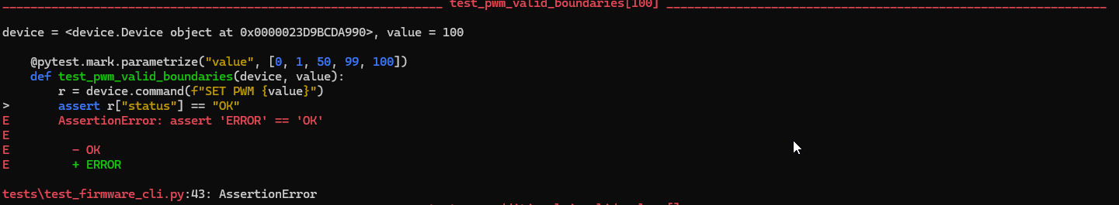
Severity: Major
Reproducibility: 100% (відтворено 4 з 4 разів)

