Game Design Document

Fill up the following document

1. Write the title of your project.
2. What is the goal of the game?

To defeat the main boss at the end

1. Write a brief story of your game.

The main boss had orphaned the main character when he was young and the main character goes for vengeance at the boss’ lair and tries to defeat him with his weapons

1. Which are the playing characters of this game?

* Playing characters are the ones who respond to the user based on the input from the user.
* Cars, monkeys, dinos, wizards, etc., are the playing characters in the game.

|  |  |  |
| --- | --- | --- |
| Number | Character Name | What can this character do? |
| 1 | Gunman | Move around, jump, shoot |
| 2 |  |  |
| 3 |  |  |
| 4 |  |  |
| 5 |  |  |
| 6 |  |  |
| 7 |  |  |
| 8 |  |  |

1. Which are the Non-Playing Characters of this game?

* Non-Playing characters are the ones that don't have an action or behavior when the user interacts with the game.
* Hurdles, stones, bananas, coins, etc., are non-playing characters in the game.

|  |  |  |
| --- | --- | --- |
| Number | Character Name | What can this character do? |
| 1 | Minions | Move towards the gunman, attack with a bat or stick |
| 2 | Adv. minion | Move, shoot |
| 3 | Adv. Minion ver2 | Move, has a shield |
| 4 | Fast minion | Moves fast towards us |
| 5 | Bulk minion | More bullets needed to defeat him |
| 6 | Boss | shoots back, he has a big healthbar, occasionally big att. |
| 7 |  |  |
| 8 |  |  |

Draw your imagination of this game. What does this game look like?

* Draw the game either on your computer or on paper.
* Add images of the game scenes to show each of the playing and non-playing characters at least once.

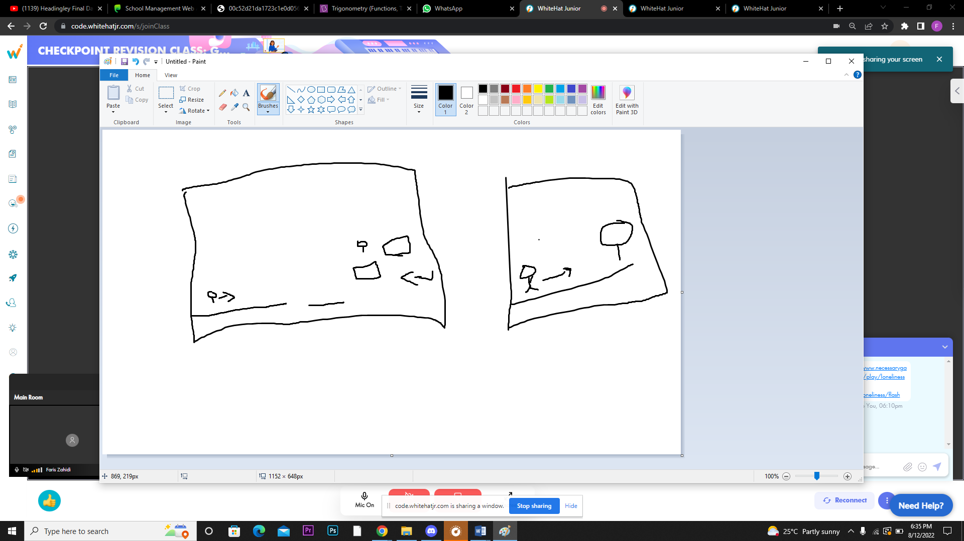

How do you plan to make your game engaging?

We can have a power ups for the gun .

bombs