**Exercise No:** 6

**Date:** 12.10.2020

**Aim:**

To predict the output for the given python program.

**Program:**

PREDICT THE OUTPUT:

# Create a tuple, also called tuple packing.

numbers = 1, 2

print(numbers)

(1, 2)

# Create tuple with paranthesis.

numbers = (1, 2, 3)

print(numbers)

(1, 2, 3)

# Create an empty tuple.

numbers = ()

print(numbers)

()

# Create a tuple with one item. Note that the trailing comma is necessary

numbers = 1,

print(numbers)

1

# Create a tuple with heterogenous items.

random_tuple = "Hey", (1, 2), 1, ["you"]

print(random_tuple)

('Hey', (1, 2), 1, ['you'])

# Create tuple with tuple() constructor.

numbers = tuple()

print(numbers)

()

numbers = tuple([1, 2]) # Takes any sequence as input

print(numbers)

(1,2)

#### Methods on tuples #####

# Get length of list by using len() method.

numbers = 5, 8, 8

print(len(numbers))

3

# Get index of an element using the index() method.

numbers = 5, 8, 8

print(numbers.index(8))

1

# Count occurences of an item in a tuple.

numbers = 5, 8, 8

print(numbers.count(8))

2

eggs = ('hello', 42, 0.5)

eggs[0]

'hello'

hello

eggs[1:3]

(42, 0.5)

len(eggs)

3

# Access elements of a tuple by indexing.

str_tuple = "hey", "there!", "how", "are", "you?"

print(str_tuple[0])

hey

print(str_tuple[len(str_tuple) - 1])

you?

print(str_tuple[-1])

you?

# Slicing a tuple.

str_tuple = "hey", "there!", "how", "are", "you?"

print(str_tuple[2:])

('how', 'are', 'you?')

print(str_tuple[:2])

('hey', 'there!')

print(str_tuple[-3:])

('how', 'are', 'you?')

print(str_tuple[:-3])

('hey', 'there!')

print(str_tuple[1:4])

('there!', 'how', 'are')

# Get a copy of the tuple by slicing.

print(str_tuple[:])

('hey', 'there!', 'how', 'are', 'you?')

# Concatenate tuples.

numbers = (1, 2)

strings = ("Hey", "there")

print(numbers + strings)

(5, 8, 8, 'Hey', 'there')

(1, 2, "Hey", "there")

# Looping through tuple using 'in'.

numbers = 1, 2

for number in numbers:

print(number)

1,2

1 2

# Check if element is present in tuple.

numbers = 1, 2

print(1 in numbers)

True

print(5 in numbers)

False

# Tuple packing.

# We are packing two items 1 and 2 into the tuple.

numbers = 1, 2

# Tuple sequence unpacking.

# Number of variables used has to be same as the number of items in the tuple.

# Unpacking the tuple and assigning its items to x and y.

x, y = numbers

# Note that this is also packing the args as a tuple which gets unpacked as the print method's arguments.

print(x, y)

1 2

**Link:**

<http://103.53.53.18/mod/hvp/view.php?id=238>

**OUTPUT:**

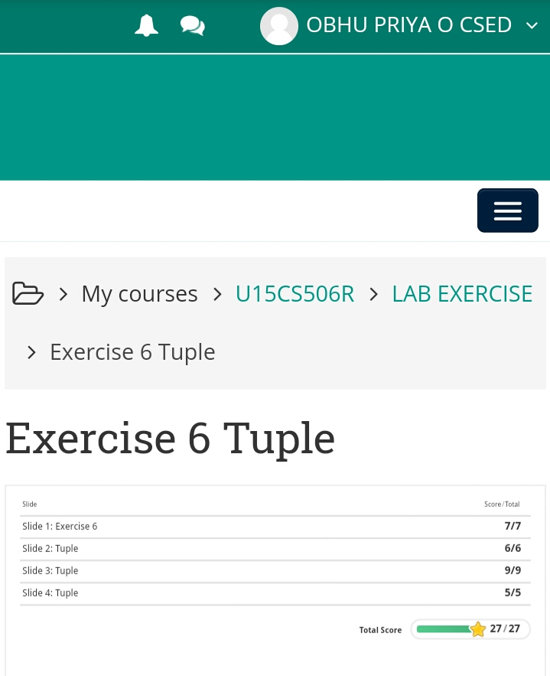

**Result:**

The output for the given program is obtained.