2016 File

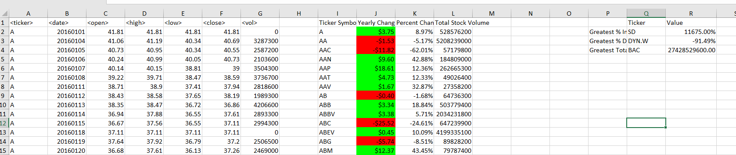

2015 File

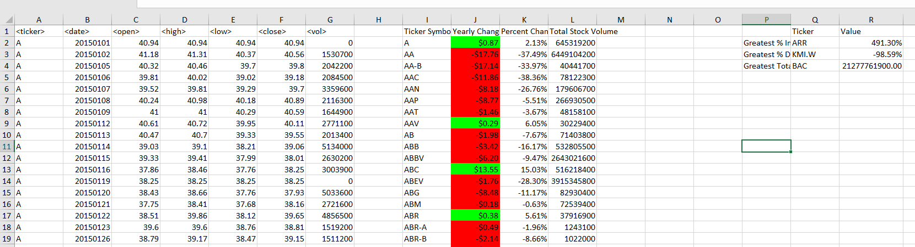

2014 File

