# 

Code Documentation

Territorial Cup: Word Duel in the Desert

**Authors:**  David Alcantar, Daniel Hankins, Steven Lowder, James Rodriguez

**Date:** 11/22/2013

**Revision:** v0.6

# 

Contents

1. Overview 4

1.1 Document Introduction 4

1.2 Software Description 4

2. Design 5

2.1 Users 5

2.2 Architecture Diagram 5

3. Functionality 6

3.1 Display 6

index.html 6

index.php 6

Web.config 6

3.2 Account Creation 6

CreateAccount.html 6

3.3 Account Recovery 6

AccountRecovery.html 6

3.4 Login 6

login.html 6

3.5 Lobby 7

Lobby.html 7

3.6 Account Information 7

Options.html 7

settings.html 7

3.7 Change Password 7

ChangePassword.html 7

3.8 Game Creation 7

NewGame.html 7

3.9 Gameplay 8

GamePage.html 8

gameBoard.js 8

jquery-1.10.2.min.js 8

game.controller.php 8

game.model.php 8

4. Database 9

4.1 Schema 9

4.2 Classes 9

database.class.php 9

dictionary.model.php 9

5. Style Sheets 10

5.1 Base 10

styles.css 10

5.2 Game Board 10

GameboardStyle.css 10

5.3 Lobby 10

LobbyStyles.css 10

# 1. Overview

## 1.1 Document Introduction

This document explains the purpose of each file written for the *Territorial Cup: Word Duel in the Desert* web game. The document is organized according to the functionality that each file is most closely associated with. The document should provide adequate understanding of each file and their functions/interactions, but does not include details that pertain to specific lines of code, which can instead be found as code comments within the files.

## 1.2 Software Description

*Territorial Cup: Word Duel in the Desert* is a game that puts players into a battle for territory. Players take turns making words from a board of letters. Letters are picked from anywhere on the board to spell a word and claim them as the player’s color. Each letter is worth a point. Whoever has the highest score at game completion wins. The score is determined by the number of letters per color at the end of the game, and the game ends when every letter has a color.

Game mechanics are in place to increase competition. So far, these mechanics include the ability for players to lock down letters in an effort to prevent opponents from using them, and the ability for players to steal an opponent’s letters that have not yet been locked down. To lock down a letter, a player must surround that letter (minus corners) with letters of their own color.

Game statistics are kept to allow users to monitor their successes in the Territorial Cup. This also promotes a social aspect to the game wherein users are compelled to share their victories via social media.

The frontend of the game is written in HTML5, allowing it to be a cross-platform web application independent of the operating system. It adjusts to different screen sizes using CSS3 media queries. The backend is written in PHP, hosted on a Windows Azure server connected to a SQL Server database.

# 2. Design

## 2.1 Users

Users of the system include those with an internet-enabled, electronic device with a web browser capable of rendering HTML5. They connect to the system by accessing the application web page via the internet, where they register an account and sign in to the system. Once signed in, users are presented with a game lobby where they are able to create and join games, view game statistics, and manage their accounts.

## 2.2 Architecture Diagram

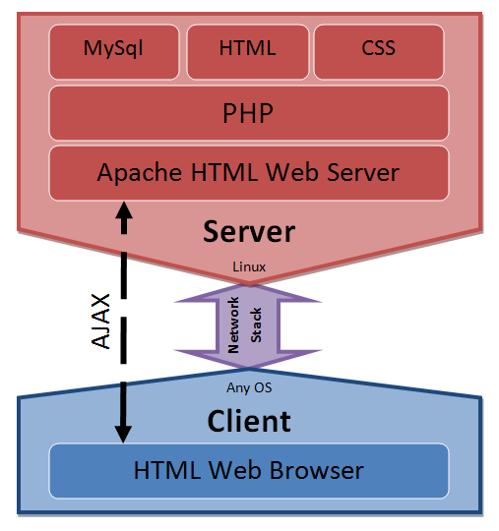

(Figure 1: Architecture Diagram)

# 3. Functionality

## 3.1 Display

### index.html

The index page displays all of the content that the client accesses by echoing the appropriate HTML page through “index.php”.

### index.php

Functions as the display controller for the website. All HTML pages are echoed through this file as the client requests them. In addition, the gameplay controller is instantiated by this file when a user attempts to create or access a game.

### Web.config

The web server configuration has been edited with a rule to rewrite any URL a user accesses to “/index.php”. This is to ensure that all pages are echoing through it.

## 3.2 Account Creation

### CreateAccount.html

Functions as the account creation page for new users. This page uses the base “styles.css” style sheet to format its content. It is built with a basic form that requires the user to enter a user name, e-mail, and password, but also requires the user to pick the college that they will represent in the game.

## 3.3 Account Recovery

### AccountRecovery.html

Functions as the account recovery page for existing users. This page uses the base “styles.css” style sheet to format its content. It is built with a basic form that requires the user to enter their existing registered e-mail address. For security purposes, the user will not be notified if the e-mail entered is invalid. Instead, they are instructed to check their spelling in the event that they have not yet received an account recovery e-mail, or to register a new account if they haven’t already.

## 3.4 Login

### login.html

Functions as the point of entry for registered users. This page uses the base “styles.css” style sheet to format its content. It is built with a basic form that requires the user to enter their user name and password. For security purposes, the user will not be notified which of the fields is incorrect upon an invalid login attempt. Instead, they receive a generic “Invalid user name or password” message. The login page also contains links to the account creation and account recovery pages.

### 

## 3.5 Lobby

### Lobby.html

Functions as the game lobby for users that have successfully logged in. This page uses the unique “LobbyStyles.css” style sheet to format its content. It is built with a basic form that allows the user to create a new game, continue an existing game, or view player options including statistics and account settings.

## 3.6 Account Information

### Options.html

Functions as the intermediary page between the user and the account statistics page, and the account settings page. This page uses the base “styles.css” style sheet to format its content.

### settings.html

Functions as the intermediary page between the user and the password management page. Also allows the user to change the e-mail address associated with their account. This page uses the base “styles.css” style sheet to format its content.

## 3.7 Change Password

### ChangePassword.html

Functions as the account password changing page for authenticated users. This page uses the base “styles.css” style sheet to format its content. It is built with a basic form that requires the user to enter their current password, and a new password with verification.

## 3.8 Game Creation

### NewGame.html

Functions as the new game creation portal for authenticated users. This page uses the base “styles.css” style sheet to format its content. It is built with a basic form that allows the user to select whether they want to create a new game with a known friend/user or with a randomly select opponent.

## 3.9 Gameplay

### GamePage.html

### gameBoard.js

### jquery-1.10.2.min.js

### game.controller.php

### game.model.php

# 4. Database

## 4.1 Schema

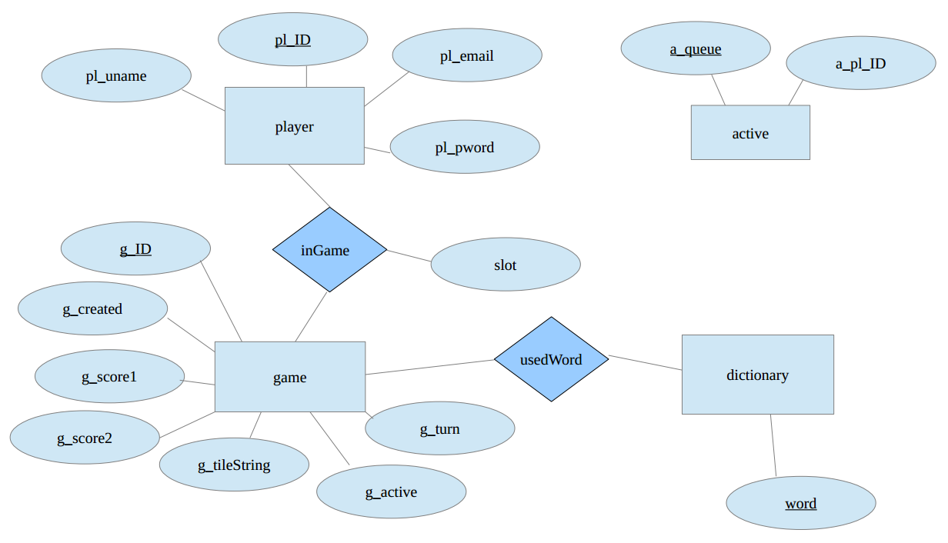

(Figure 2: Database Schema)

For a full list of tables, columns, types, and keys, please view the “db_schema.pdf” file.

## 4.2 Classes

### database.class.php

### dictionary.model.php

# 5. Style Sheets

## 5.1 Base

### styles.css

## 5.2 Game Board

### GameboardStyle.css

## 5.3 Lobby

### LobbyStyles.css