# CS255 System Design Document

Ronald W. Sudol III

SNHU CS255

Project Two

02/19/2023

## UML Diagrams

### UML Use Case Diagram

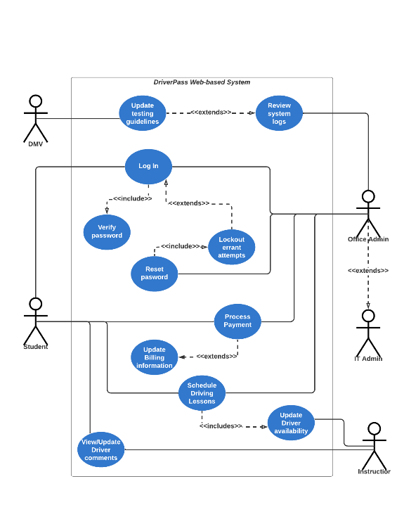

### UML Activity Diagrams

### UML Sequence Diagram

### UML Class Diagram

## Technical Requirements

Hardware:

* Display Monitor
* Keyboard/Mouse
* Internet-accessible device

Software:

* Web Browser (Chrome, Firefox, etc…)
* Cloud Management Software (Azure, Google Cloud, etc…)

Tools:

* Schedule/Calendar Tools
* Payment Processing Tools (PayPal, Aero Pay, etc…)

Infrastructure:

* Internet Connection
* Power Supply
* Car Insurance according to local guidelines
* Cloud-based Data Storage