Ronald W. Sudol III
SNHU CS255
Project Two
02/19/2023

Slide 1

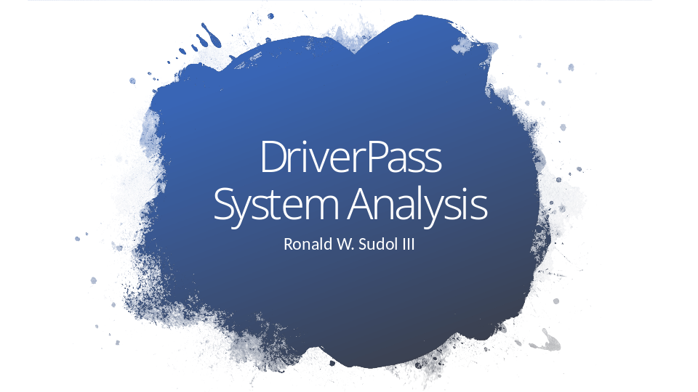

DriverPass System Analysis Presentation

Slide 2

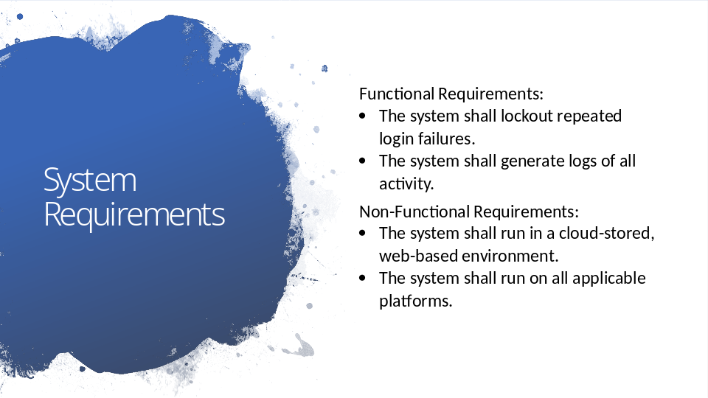

Functional requirements are specific functions that the system must provide. The functional requirements we see here are that the system shall lockout out repeated login failures and that it shall generate logs of all activity. These functional requirements work to meet DriverPass’ needs by ensuring the system is secure. By not allowing users that try to login and repeatedly fail to continue to attempt to login, the system can help prevent unauthorized users from gaining access to the system. By generating readable reports of any changes made to the system, DriverPass can monitor activity and make sure that no malicious or problematic changes have been made to their system. Given that the system will be handling personal information like credit card numbers, ensuring that this information is protected is vital to both DriverPass and its clients.
Non-functional requirements are more about the general properties we want the system to display. The non-functional requirement we see here are that the system should be cloud-stored, web-based, and should run on all standard devices that a customer or employee may be utilizing. These meet DriverPass’ needs by ensuring that the system is accessible to the broadest possible market while also minimizing the amount of new hardware and maintenance included with the new system. DriverPass can make itself available to many new clients without having to worry about setting up or maintaining servers.

Slide 3

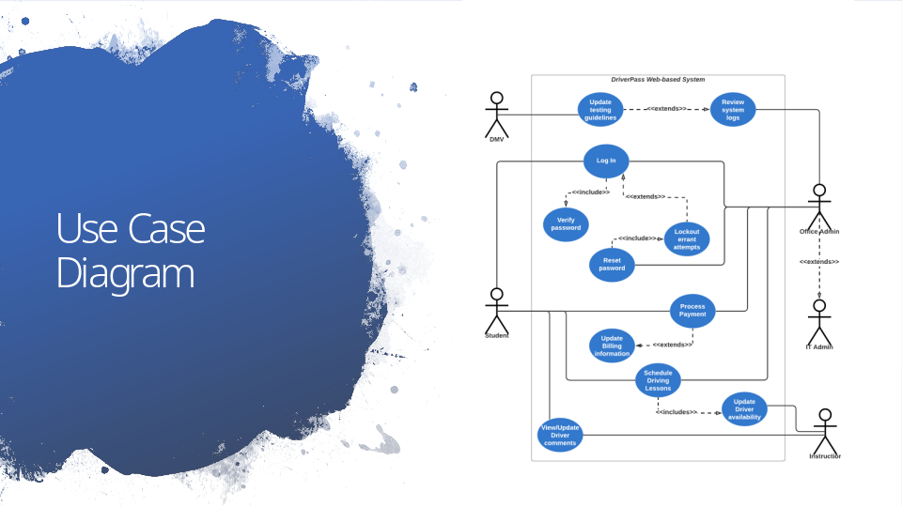

This basic diagram illustrates how a student, an instructor, office personnel, and even the DMV will be working with the system. In the case of the student, we can see that the system will provide a way for the student to log in, a way for the student to make payments for the learning package of their choice, a way for the student to schedule in-person driving lessons at an available time that is convenient for them, and a way for the student to view feedback from their driving instructor. The meets DriverPass’ needs by opening the company up to a new online market and ensuring that this new business traffic is handled smoothly. The log-in process which is shared by all users also accounts for the lock out of multiple failed login attempts which helps keep data safe for DriverPass and its clients as previously discussed.
Instructors will be able to update their availability so that students may only schedule appointments for times when an instructor is available. Further an instructor can leave feedback about a student’s progress that the student can later view. This meets DriverPass’ needs by creating a more personal online interaction between students and instructors and ensuring that scheduling goes smoothly.
The DMV will be able to update testing guidelines directly and these changes will be automatically kept track of for later review. This meets DriverPass’ needs by ensuring their students are preparing themselves with the most current information available and allowing DriverPass to keep track of these changes for security purposes as previously discussed.
Finally, office personnel will can ensure that payments are properly processed, update client’s billing information in the case of a client coming into or calling the office with new payment info, access the scheduling system in the event of a client who wishes to schedule an appointment in-person or over the phone, and for specially designated IT or administrative personnel there will be access to the lock out system for the purpose of resetting client’s passwords or even denying access to employees who have left the company. This meets DriverPass’ needs by allowing access to important business operations both from the new online storefront and from their physical location. It also further works to keep DriverPass’ system safe.

Slide 4

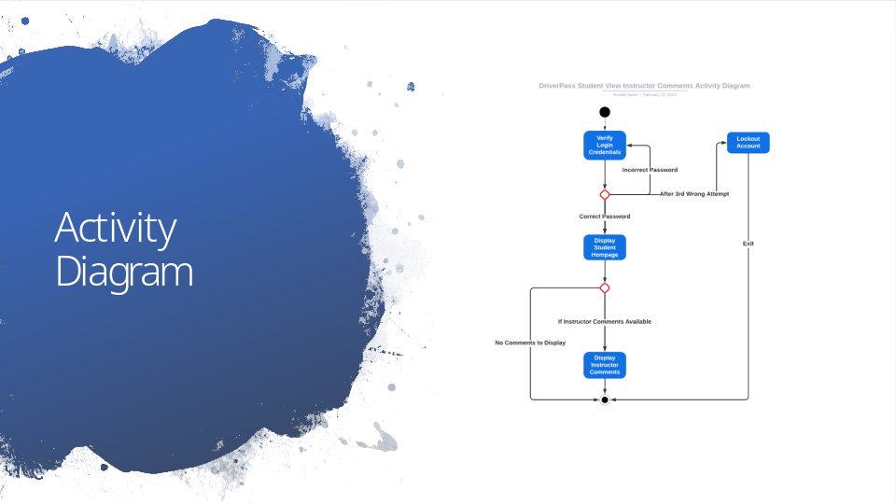

This diagram focuses specifically on how a student may go about accessing the system to review feedback from their instructor. The first step to accessing the system will be to log in by using a predetermined username and password. The diagram also illustrates that if the student enters a wrong password or username three consecutive times, they will be denied access. Once the student enters the correct log in information, they will be shown a homepage. According to the diagram provided during our initial interview, the student will be able to view a variety of information about their progress. If an instructor has left feedback for the student, the student can navigate to the bottom of the homepage where these feedback comments will be displayed. This meets DriverPass’ needs by having a simple and interactive homepage that allows students to quickly and easily access information about their progress.

Slide 5

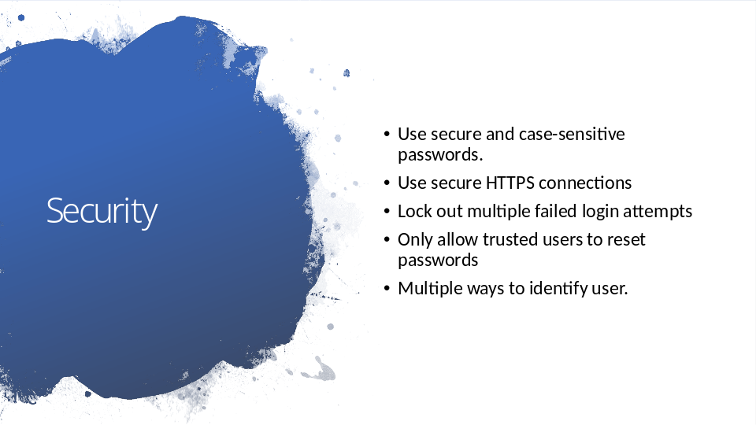

Security is an important consideration in designing any system. Because DriverPass’ system will be accessible through the internet, security is particularly important. Ensuring that passwords are adequately difficult to guess by requiring passwords to be of a certain length and made of a wide variety of characters helps to prevent hackers from accessing authorized user’s accounts. Locking out user’s after too many failed login attempts also reduces the number of times someone can “guess” a password. Only allowing trusted personnel to reset locked out passwords further restricts someone’s ability to access the system maliciously. In the instance of a user that forget their password, the system can account for other ways of the user proving who they are such as predetermined questions that only the user might know the answer to or by sending a link to reset the password directly the email on file for that user. Further, HTTPS encrypts data that is transferred over the internet to make it useless to someone who might intercept between trusted parts of the system.

Slide 6

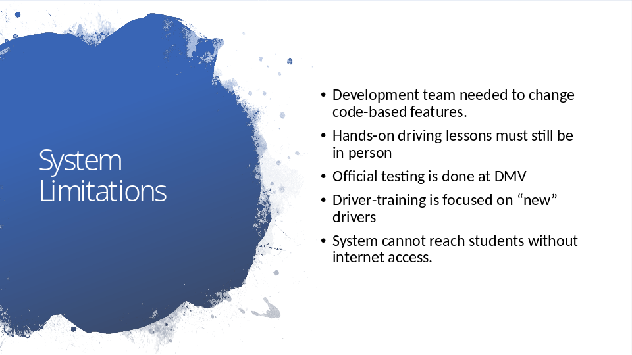

All systems are bound to have some limitations. Because DriverPass does not have its own programming team, major changes to the systems code will require that DriverPass reach out to a development team since they will be unable to make the changes themselves. While DriverPass’ system will provide an adequate way for students to take online practice tests, hands-on training will still need to be done in person as the system does not include virtual-reality-based driving. While the DMV testing guidelines will be kept up to date, official testing will still need to be done in-person at the local DMV. DriverPass’ system is primarily focused on new drivers that are getting their license for the first time and does not account for other types of driver training such as Advanced Defensive Driving or punitive Driver Re-Training and other types of driver testing that may be offered by the DMV. Finally, the system is only available to student who have an active internet connection so in areas where internet maybe be inaccesible or during service outages, students will not be able to access the DriverPass system.

