ZEROBIONIC · AF-1 ASSISTIVE ROBOTICS · AI / ML / INTELLIGENCE
ZERO
Brain Build / Intelligence Stack
ZERO is the AF-1 conversational intelligence subsystem, a voice brain on a Raspberry Pi 5 that offloads its heavy models to a GPU node over one SSH tunnel. It runs a continuous wake, listen, think and speak loop, with vision, identity, memory and tools as real faculties, each holding a local fallback when the tunnel drops. This document is its reference.
DOCUMENT ID ZBR-AF1-SW-001
REVISION 0.1 · first public draft
PREPARED BY Sam Obila Allela · Machine Learning Lead, Zerobionic
DATE 27 July 2026
TARGET HW AF-1 head Raspberry Pi 5 · GPU node (any CUDA class card)
CONFIDENTIAL · INTERNAL ENGINEERING DOCUMENT
CONTENTS
Table of Contents
1 Purpose and Scope
1.I What Is In Scope
1.II What Is Out of Scope
1.III Intended Readers
2 Architecture
2.I The Two Machines
2.II The Process Set on the Pi
2.III Tiered Perception
2.IV The Factory and the Fallback Chain
2.V The Control Plane Inside the Process
3 Interfaces and Data Contracts
3.I The Control Plane
3.II The Model Server Contracts
3.III The Perception Offload
3.IV Local Device Interfaces
3.V On Disk Contracts
3.VI The Internal Event Bus
4 Behaviour and Logic
4.I The State Machine
4.II Waking
4.III Deciding When a Person Has Finished
4.IV Speculation and the Semantic Hold
4.V Deciding Who Is Speaking
4.VI Deciding What Is Being Asked About
4.VII Deciding What to Remember and What to Recall
4.VIII Generating and Speaking
4.IX Command Paths That Bypass the Model
4.X Deciding When to Speak Unprompted
4.XI Scoring Outcomes and Surprise
5 Build and Deploy
5.I The Pi Head
5.II The GPU Node
5.III The Tunnel and Systemd
5.IV First Run Verification
6 Testing and Validation
6.I Automated Coverage
6.II Bench Harnesses
6.III Acceptance Criteria
6.IV Manual Procedures
7 Failure Modes and Recovery
7.I Tunnel Loss
7.II Camera Absent
7.III GPU Server Slow or Cold
7.IV Audio Device Loss
7.V Whisper Hallucinates Text
7.VI Memory Database Lock
7.VII Control Plane Exceptions
7.VIII Single Instance Discipline
7.IX What Is Deliberately Not Handled
8 Configuration and Calibration
8.I The Top Level Blocks
8.II Audio Calibration
8.III Voice Endpointing
8.IV Identity and Memory
8.V LLM, TTS, and Vision Selection
9 Performance and Resource Budget
9.I Pi 5 Resources
9.II GPU Resources
9.III End to End Latency
10 Security, Privacy, and Data Handling
10.I What Is Held
10.II The Privacy Guard
10.III The Attack Surface
11 Observability and Diagnostics
11.I The Log Setup
11.II Load Bearing Log Lines
11.III The Health Endpoint and Status
11.IV Reading a Session
12 Operations Runbook
12.I Bringing the System Up
12.II Taking It Down
12.III Updating and Rolling Back
12.IV Triage Table
12.V Backup and Restore
13 Dependencies and Licences
13.I Code Dependencies
13.II Model Weights
14 Open Items and Decisions Log
14.I Open Items
14.II Decisions Worth Recording
A Appendices
A.A Glossary
A.B On Disk Schema
A.C The Complete Default config.yaml
A.D Port and Device Map
A.E Detailed Changelog
SECTION 1
Purpose and Scope
ZERO is the conversational intelligence subsystem of the AF-1, and it is the part of the robot a person actually talks to. Everything the subsystem does resolves into a single user visible behaviour: somebody speaks near the robot, and the robot answers out loud in its own voice, promptly, knowing who is speaking, remembering what has been said before, and aware of what is currently in front of its cameras. Every module described in this document exists to make that one behaviour happen, and to keep making it happen when parts of the system fail. It is the yardstick every design choice in the sections that follow is measured against, and if a choice seems strange, the reason will almost always be that it protects that single behaviour against a particular class of failure or delay.
Inside the AF-1 head, the subsystem runs as a single Python process on the Raspberry Pi 5, started as python -m zero.main. That process holds a four state loop that turns continuously. In IDLE the robot rests with the microphone open and only the wake word detector consuming frames. On a wake detection the loop moves to LISTENING and captures the utterance until a voice activity endpointer decides the person has finished speaking. It then moves to THINKING, where transcription, speaker identification, emotional read, memory recall and language model generation all run, and several of them run in parallel. Finally the loop enters SPEAKING, where the reply is synthesised and played back sentence by sentence, and then it returns to LISTENING for the next turn without requiring the wake word again. The conversation stays open until the person says a stop phrase, or falls silent long enough to trip the configured sleep timeout, at which point the robot returns to IDLE and writes the session to memory in the background. The legal moves between those four states are declared as data in zero/state.py and checked on every transition, so a wiring error surfaces as a logged warning during development rather than as a silent misbehaviour in front of a person.
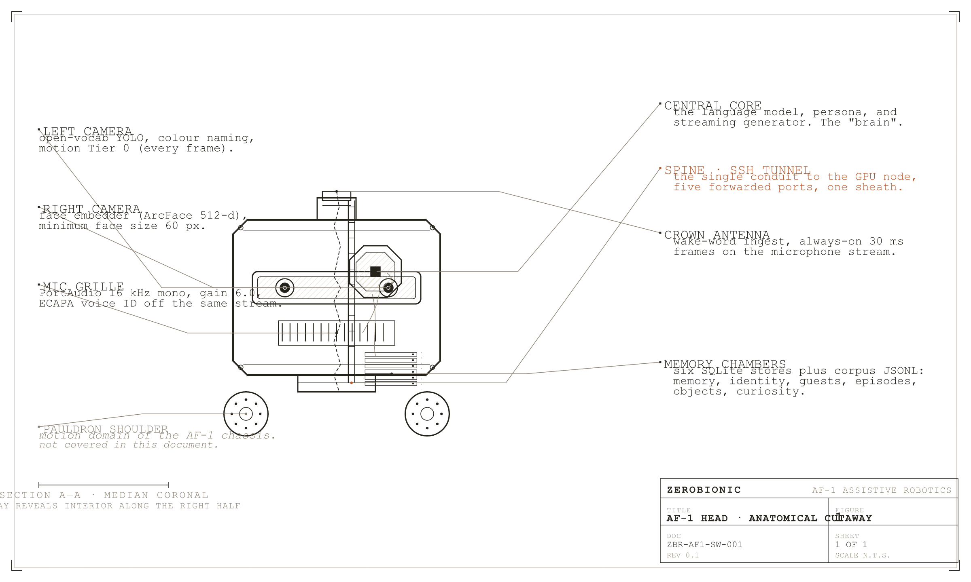
Figure 1
AF-1 head, anatomical cutaway. Physical components map onto the software function they carry.
Two design commitments shape the whole subsystem, and both are worth stating before any architecture is discussed because almost every structural decision later follows from them. The first commitment is that heavy models do not run on the Pi. Speech recognition, the language model, expressive speech synthesis, depth estimation, the vision language model, and the embedding services for faces, voices and objects all execute on a separate GPU node reached over a single SSH tunnel. The Pi keeps only the work that is real time or physically bound to the robot: microphone capture, wake word detection, endpointing, object detection, tracking, playback, and the state machine itself. The second commitment is that every remote faculty holds a local fallback. If the tunnel drops, transcription falls back to whisper.cpp running on the Pi CPU, and the voice falls back to Piper. The robot keeps talking, more slowly and less expressively, and it is deliberately told about its own degradation so that it can say so honestly instead of behaving as though nothing had changed. This transparency, treated in Section 2 and again in Section 7, is not a logging concern. It is the mechanism that lets a degraded system stay honest to the person in front of it.
The subsystem is also responsible for the faculties that make the robot feel present rather than merely transactional, and these are in scope precisely because they are inseparable from the conversation loop. Identity fuses a face embedding derived from the current camera frame with a voice embedding derived from the current utterance, and the fused signal decides who the robot is talking to and, critically, whose memory a turn is allowed to be written into. Memory is held in a set of small SQLite stores that keep durable facts, per person preferences, rolling session summaries and semantic embeddings for relevance recall. Vision runs continuously from startup rather than on demand, so the scene is already perceived by the time anyone asks about it, and perception is never on the critical path of a reply. Tool use gives the model timers, reminders, web search, and explicit verbs to remember and recall. A privacy guard decides, per turn, whether an unrecognised voice is answered at all, and whether their words are allowed to be stored. A proactive layer lets the robot open a conversation by itself, greeting a person it recognises walking in, or asking a question about something new it has noticed. A learning loop turns each exchange into a reward tagged episode and appends the session to a training corpus for offline fine tuning.
Finally, the subsystem exposes a small HTTP control plane on port 8090, running as a daemon thread inside the same process. This is the surface the AF-1 application uses to reach the robot from other machines on the local network, and its placement inside the process rather than beside it is one of the more consequential integration decisions in the design. A push to talk turn arriving over HTTP drives the same Conversation object, the same SQLite memory, the same tool registry, the same voice, and the same speaker as a turn spoken into the microphone. There is one brain, not two, and the network is simply another way into it.
I. What Is In Scope
This document covers the ZERO process in full. That means the four state conversation loop and its transition rules; wake word detection, voice activity endpointing, and the semantic hold that keeps the robot listening through a pause in the middle of a thought; speech to text in both its remote and local forms, including the speculative transcription that starts work at the first pause rather than waiting for the endpoint; the language model, its persona prompt, its history window, and the rolling compaction that keeps a long session bounded; text to speech across the Piper, Fish and Orpheus engines, together with the orchestrator that translates one shared cue vocabulary into whatever the active engine understands; and barge in, which lets a person interrupt the robot mid sentence and have the interrupting words carried into the next turn so they are never repeated. Each of these carries one or more configuration keys that live in config.yaml, and this document names those keys where behaviour depends on their values, so that a claim in the prose can always be checked against a value in the file.
The perception and state faculties are in scope on the same footing: the always on camera loop, open vocabulary and closed vocabulary object detection, tracking, colour naming, scene phrasing, taught objects, the live world state model and its surprise gate; face and voice identity, provisional guest clustering for unfamiliar speakers, and diarisation across a multi speaker conversation; affect estimation and the cross turn mood it feeds; the memory schema, embeddings, preferences, consolidation, and erasure on request; the tool registry and its router; the privacy guard and its visible indicator; the proactive policy, its triggers, and its adaptive cooldowns; the episode and reward machinery and the corpus export that feeds fine tuning. On the GPU side the document covers the servers this subsystem calls and owns the client contract for: the Whisper server, the Orpheus voice server, and the vision server with its depth and vision language components. It covers config.yaml in full, the config.local.yaml override mechanism, the systemd units, the tunnel and health check scripts, and the HTTP control plane contract.
II. What Is Out of Scope
Nothing below the neck belongs to this document. Locomotion, balance, the arms and end effectors, and any motion planning or safety interlock are covered by the motion control document and are not reachable from this subsystem. The chest Pi 4B and the Nano compute nodes are named here only where ZERO exchanges messages with them, and their own processes, boot order, and firmware are documented separately. Power delivery, thermal design, mechanical assembly, and teardown are outside this document entirely and live in the Engineering Corpus and teardown volumes.
The AF-1 application is out of scope as a product. This document defines and owns the HTTP contract the application calls, and it stops at that boundary. The application's own interface, its voice picker, its state handling, and its packaging are documented by the application team. Provisioning of the GPU node is likewise out of scope: this document specifies what the servers must expose and how ZERO behaves when they are unreachable, but the machine's operating system, drivers, and physical hosting are not described here. Model training is out of scope beyond the point where this subsystem writes the corpus; the fine tuning pipeline that consumes that corpus is documented on its own. Cloud or hosted language model providers are out of scope by design, because the subsystem is built to run without internet access apart from the optional web search tool.
III. Intended Readers
This document is written for four readers, and each of them should be able to stop at a different depth. An engineer joining the voice stack should be able to read Sections 1 through 4 and understand the loop well enough to trace a single utterance from microphone to speaker, then use Sections 5 and 8 to get a working machine on their bench. An operator or field technician should be able to work almost entirely from Sections 7, 11, and 12, which cover what breaks, what the logs are saying, and exactly which commands restart which box. An integration engineer building against the robot from the AF-1 application needs Section 3, which is the authoritative interface contract, and Section 7 for the failure semantics they must handle. A technical reviewer conducting due diligence should find Sections 9, 10, 13, and 14 sufficient: what the system costs in compute and power, what it does with personal data, what it depends on and under which licences, and what is still open. Everything in this document is written against the repository and commit named on the cover page. Where behaviour is configurable, the exact config.yaml key is given rather than described, so that a reader who wants to verify a claim in the prose can always compare it against a value in the file.
SECTION 2
Architecture
ZERO is arranged around a single organising rule: there is one conversation loop, it runs on one thread, and nothing is allowed to block it. Every faculty that could take an unpredictable amount of time, which in practice means every faculty that touches a model, a network socket, or a disk, runs on a thread of its own and either publishes its result to a place the loop can read at leisure or is joined under an explicit timeout. When one of those threads is slow, the loop does not wait for it. When one of them fails, the loop does not stop. This is why the architecture looks the way it does, and almost every structural decision in this section follows from that rule.
The subsystem spans two machines. The Raspberry Pi 5 in the AF-1 head runs the ZERO process itself and keeps all the work that is real time or physically bound to the robot: capturing the microphone, detecting the wake word, deciding when a person has stopped speaking, reading frames off the camera, detecting objects, tracking them, and pushing audio to the speaker. A separate GPU node, on the same local network, runs a small set of model servers. Speech recognition, expressive speech synthesis, the language model, depth estimation, the vision language model, and the embedding services for faces, voices, and objects all live there. The two are joined by exactly one SSH tunnel that carries five forwarded ports. Nothing is exposed to the internet, and there is no second link to fall back to, which is why the failure behaviour of that tunnel is treated in this document as an architectural concern rather than an operational one.
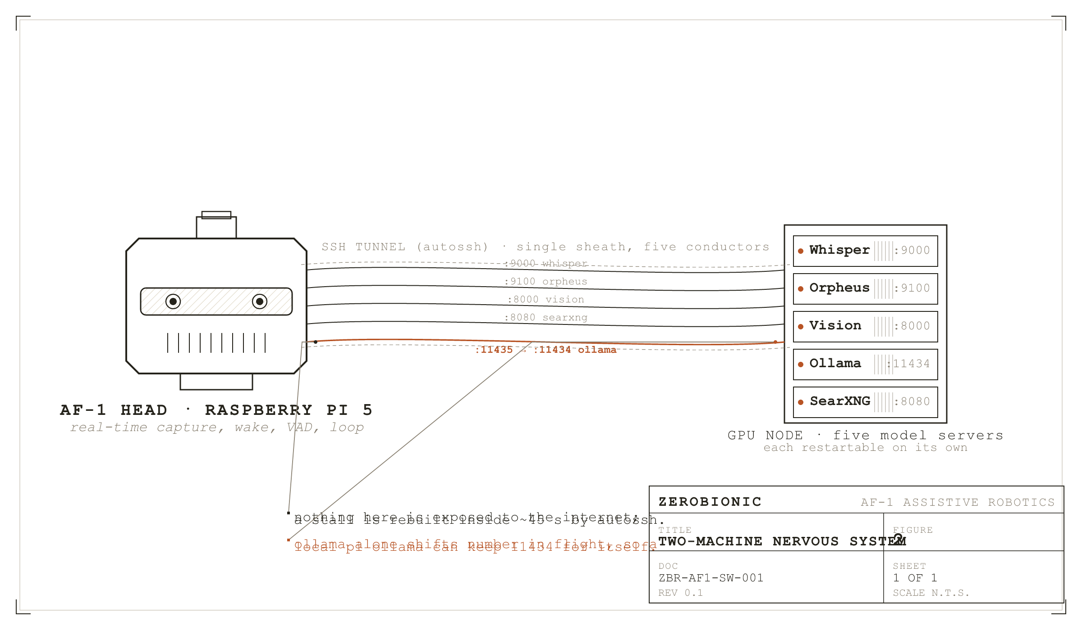
Figure 2
Two-machine nervous system. One tunnel binds the AF-1 head to the GPU node.
I. The Two Machines
On the Pi, everything lives inside one Python process. That process holds the state machine, the audio devices, the camera, the memory database, the tool registry, the identity registry, and the HTTP control plane. It is deliberately a single process rather than a set of cooperating services, because every faculty in the system needs cheap access to the same conversation history, the same memory store, and the same speaker identity, and paying inter process serialisation costs on the reply path would show up directly as latency the user can hear. There are a dozen daemon threads running inside that process, and they will be catalogued shortly, but from the outside the observable unit is one process managed by one systemd unit, which either is or is not running.
On the GPU node the arrangement is the opposite: several independent server processes, each owning one model, each addressable over HTTP, each restartable without disturbing the others. The Whisper server on port 9000 runs large-v3-turbo through faster-whisper and answers a POSTed WAV with a transcript. The Orpheus server on port 9100 runs a 3B speech model through vLLM and answers text with 24 kHz audio. The vision server on port 8000 is a FastAPI application exposing a health probe, a /facts endpoint that turns a frame plus its detections into per object distance and bearing using Depth Anything V2 with camera intrinsics, and an /analyze endpoint that runs those facts and then a vision language model grounded in them. Ollama on port 11434 serves the conversational model, which as configured is gemma4:latest, an 8B model at roughly 100 tokens per second on that hardware. A SearXNG instance on port 8080 backs the web search tool. Each of the model servers can be restarted independently, and each fails independently, which is the property that lets the Pi treat their failures as ordinary degradation events rather than as system wide outages.
The tunnel is opened from the Pi by scripts/pi_tunnel.sh and maintained by autossh, which rebuilds it within roughly 45 seconds of a stall. It forwards local 9000, 9100, 8000, and 8080 straight through to the same ports on the node. The one asymmetry is Ollama: local port 11435 forwards to remote 11434, so that the Pi's own Ollama, if one is installed for local fallback, can keep 11434 for itself without a collision. The config reflects this, with llm.host pointing at http://127.0.0.1:11435. It is worth knowing that this offset exists, because a tunnel that appears healthy on 9000 while llm.host has been edited to 11434 produces a system that transcribes perfectly and then cannot think, which is a much harder failure to diagnose than a system that fails outright.
Both boxes are intended to run under systemd in production. The units in scripts/systemd/ cover the tunnel and the ZERO process on the Pi and the model servers on the node. The shell script scripts/run_gpu_servers.sh exists for interactive use and is idempotent: it checks whether each port is already listening and skips anything that is up, launching what is missing under setsid nohup so it survives the shell that started it. That script also sets OLLAMA_FLASH_ATTENTION and OLLAMA_KV_CACHE_TYPE=q8_0, which halves the KV cache footprint of the language model. This is a memory pressure decision rather than a speed one. The card is shared by the conversational model, Whisper, Orpheus, the detector, CLIP, and the face models, and when it fills, the chat model gets evicted and the next reply pays a multi second reload. Quantising the cache is what keeps it resident.
II. The Process Set on the Pi
The Pi process is best understood as one loop plus two kinds of thread. Persistent threads start once and run for the life of the process. Transient threads are created for a single turn, or a single background job, and are gone within seconds. Every thread in the system is a daemon thread, so nothing can keep the process alive after the main loop exits, which matters for shutdown correctness under systemd. The main loop itself owns the state machine and is the only thread that transitions it. Everything else either publishes into a shared object the loop reads, or is joined by the loop with an explicit timeout.
The persistent set begins with the PortAudio callback thread inside MicCapture, which is the only thread that touches the microphone. It delivers 30 ms frames of 16 kHz mono audio onto a bounded queue, and every downstream audio consumer, the wake word and the endpointer alike, pulls from that one queue. Having a single capture rather than one per consumer is what stops the stages fighting over the device. That thread also carries two pieces of resilience worth naming here: a software gain multiplier, because some USB microphones capture too quietly for the wake model to fire, and an automatic resample path for devices that refuse 16 kHz and can only open at 44.1 or 48 kHz. The queue is also where the echo guard lives: while ZERO is thinking or speaking, capture is paused rather than drained downstream, so the robot cannot transcribe its own voice off the speaker.
The camera has the same shape. CameraStream runs its own thread doing nothing but pulling frames, and the Eyes thread consumes them. Keeping the grab separate from the perception work means a slow detection pass cannot cause frames to back up inside the driver. Above Eyes sit three more persistent threads, each of which exists to keep expensive work off the loop: the Narrator, which periodically asks the vision language model to describe the scene; the SurpriseGate, which scores world events by prediction error and turns the unexpected into stored episodes; and the proactive TriggerSource, which watches for a recognised person arriving, a curiosity question worth asking, or an idle moment suitable for memory consolidation. The control server contributes one more persistent thread, a ThreadingHTTPServer on port 8090, and the optional camera web preview contributes another on 8008, bound to localhost by default so an unauthenticated video stream is never published to the network by accident.
The transient threads are where the latency work happens, and they are the part of the architecture most worth understanding. When the endpointer notices the person has paused, well before it is willing to declare the utterance finished, it starts a stt-spec thread that transcribes the audio captured so far. That speculative transcript serves two purposes. If the pause turns out to be the real end of the utterance, the transcript is already in hand and the round trip to the GPU has been overlapped with the silence wait rather than added after it. If the pause turns out to be mid sentence, the transcript is still useful, because the endpointer inspects its last word to decide whether the speaker had actually finished a thought. Either way the work is not wasted. Once the utterance is confirmed, a stt thread runs the final transcription in parallel with identity and diarisation, both of which need only the audio and not the text. A recall thread searches memory for anything relevant to what was just said and is joined under a hard 300 ms budget, after which the turn simply proceeds without the recall note rather than becoming slower. An llm-stream thread starts generation in the background so that the model's prefill overlaps the spoken filler, and a tts-producer thread synthesises the next sentence while the current one is still playing. A bargein thread watches the microphone for the entire time ZERO is making sound, so that speech or a wake word can interrupt it. Two more transient threads run outside the reply path: compaction, which folds trimmed away turns into a rolling summary, and memory-save, which writes the session to disk after the conversation ends so that the robot returns to listening for the wake word immediately, rather than going deaf for several seconds while it flushes. Each active timer or reminder holds a thread of its own until it fires.
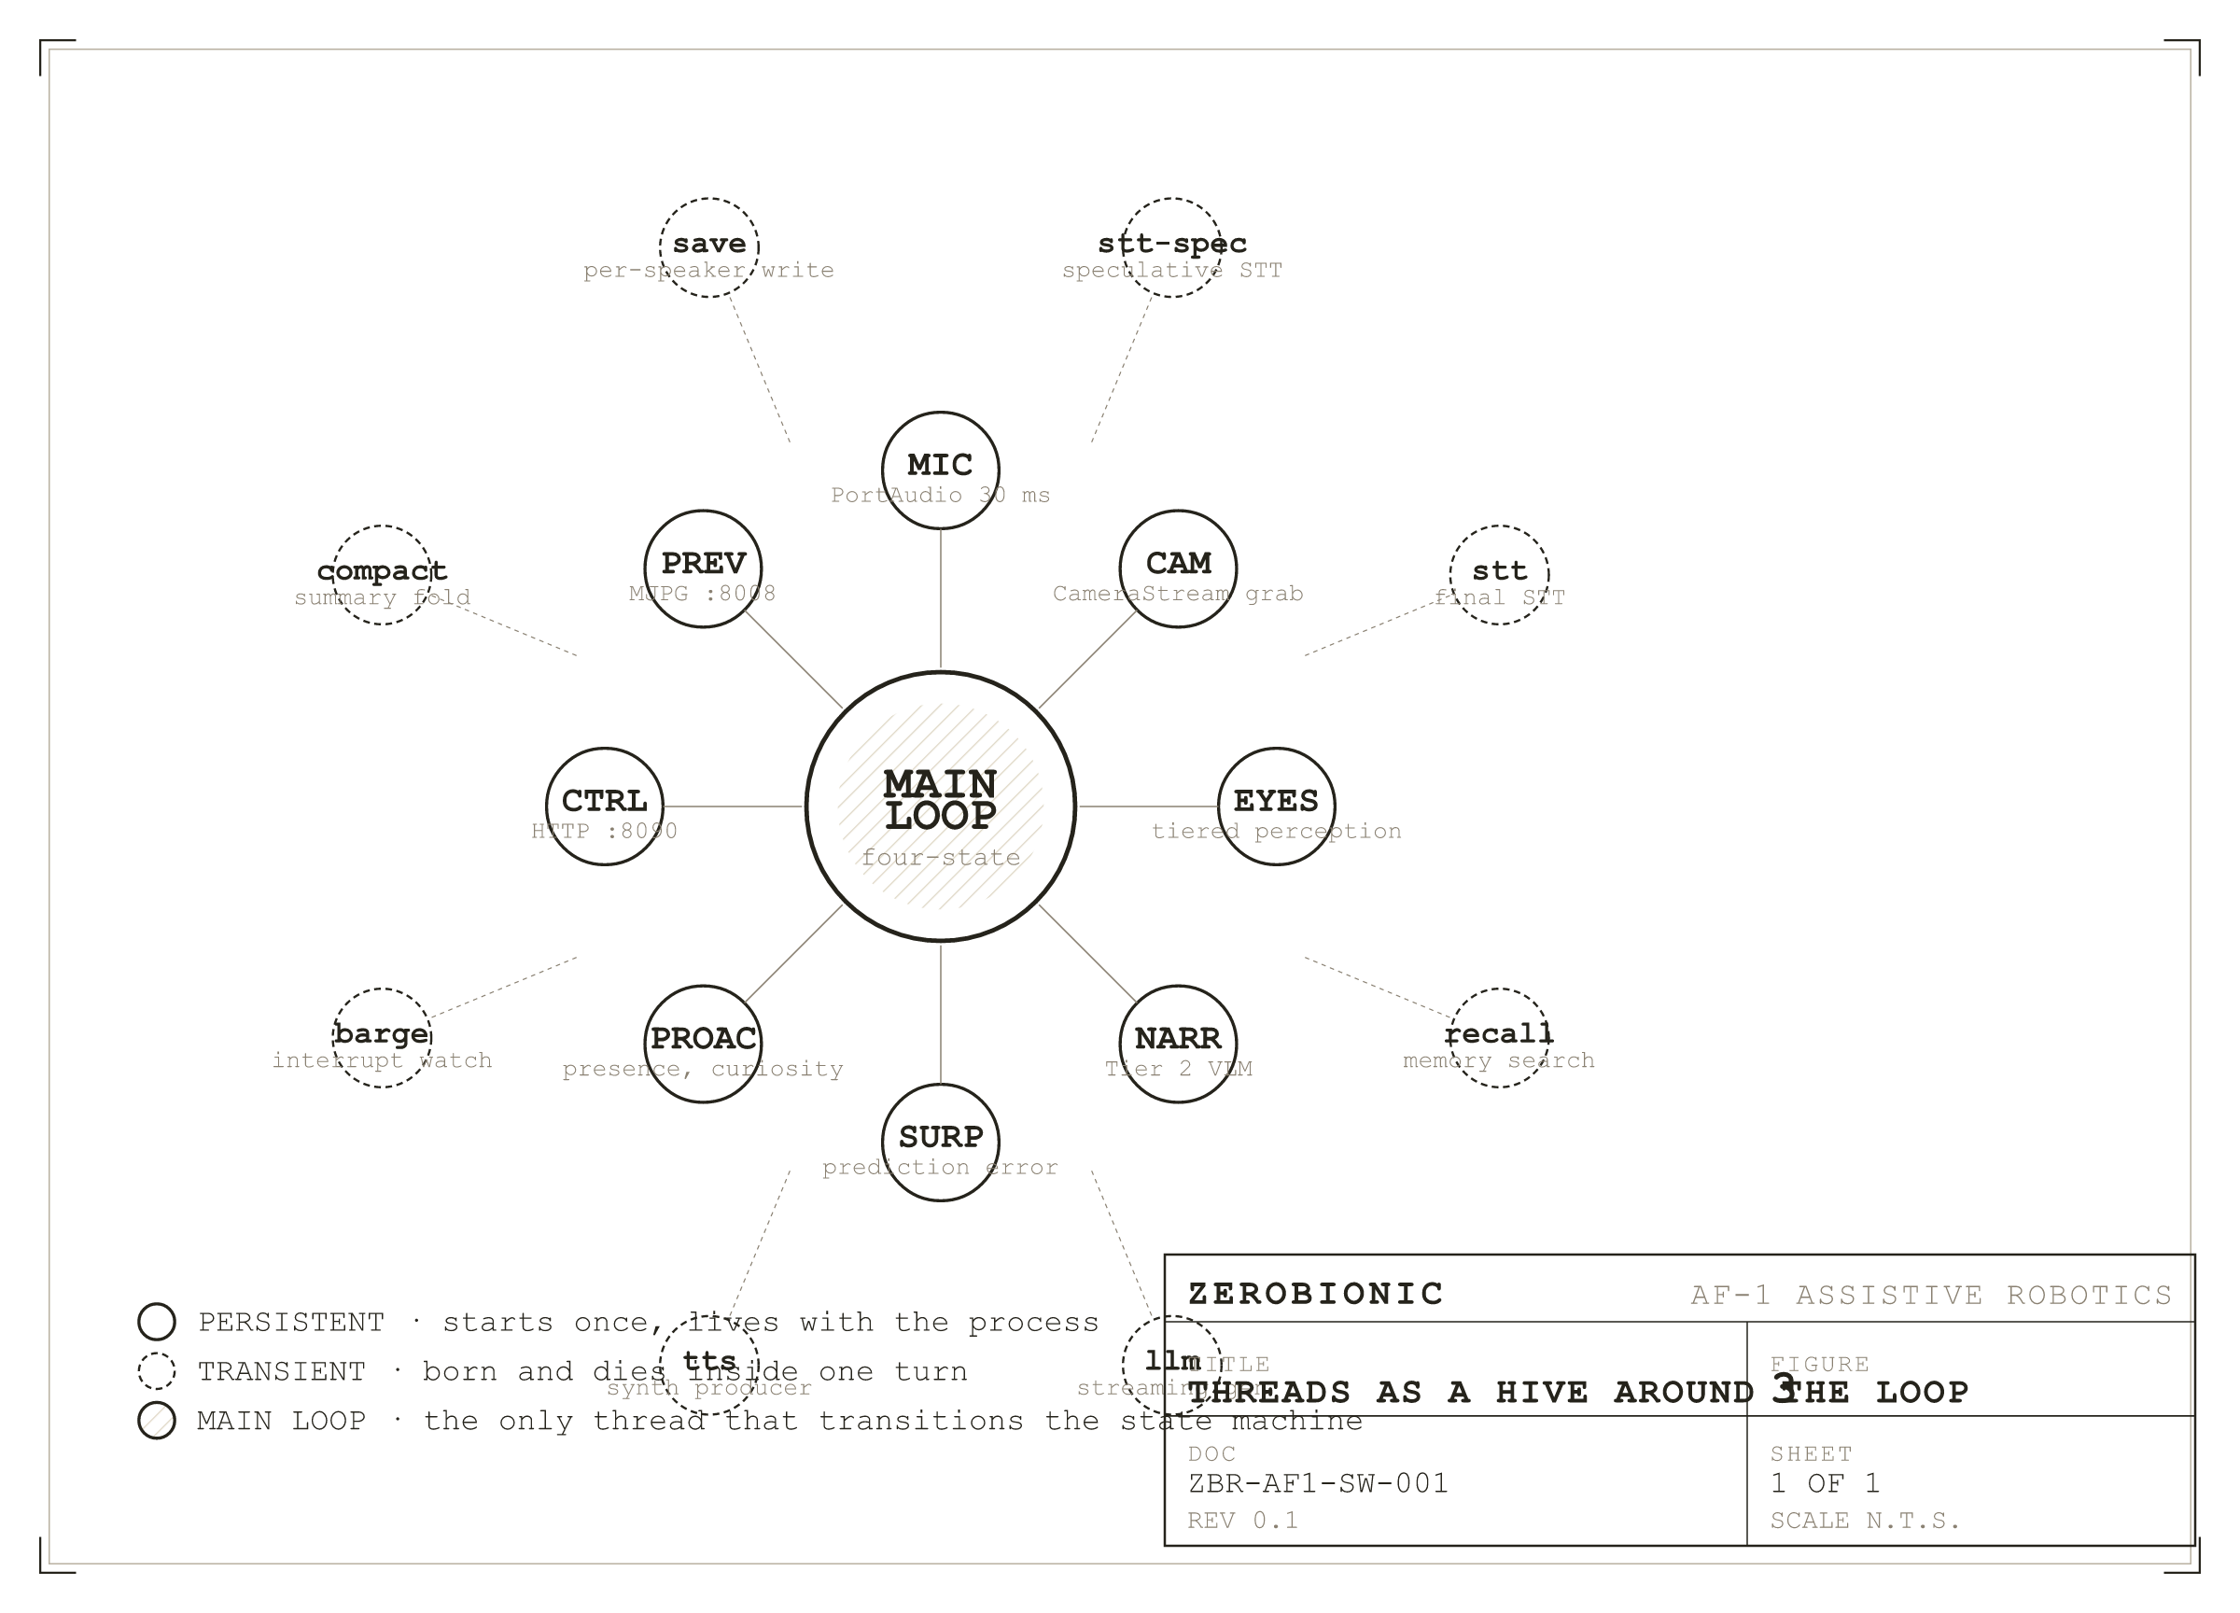
Figure 3
The process set as a hive around the main loop. Persistent threads run for the life of the process; transient threads live and die inside a turn.
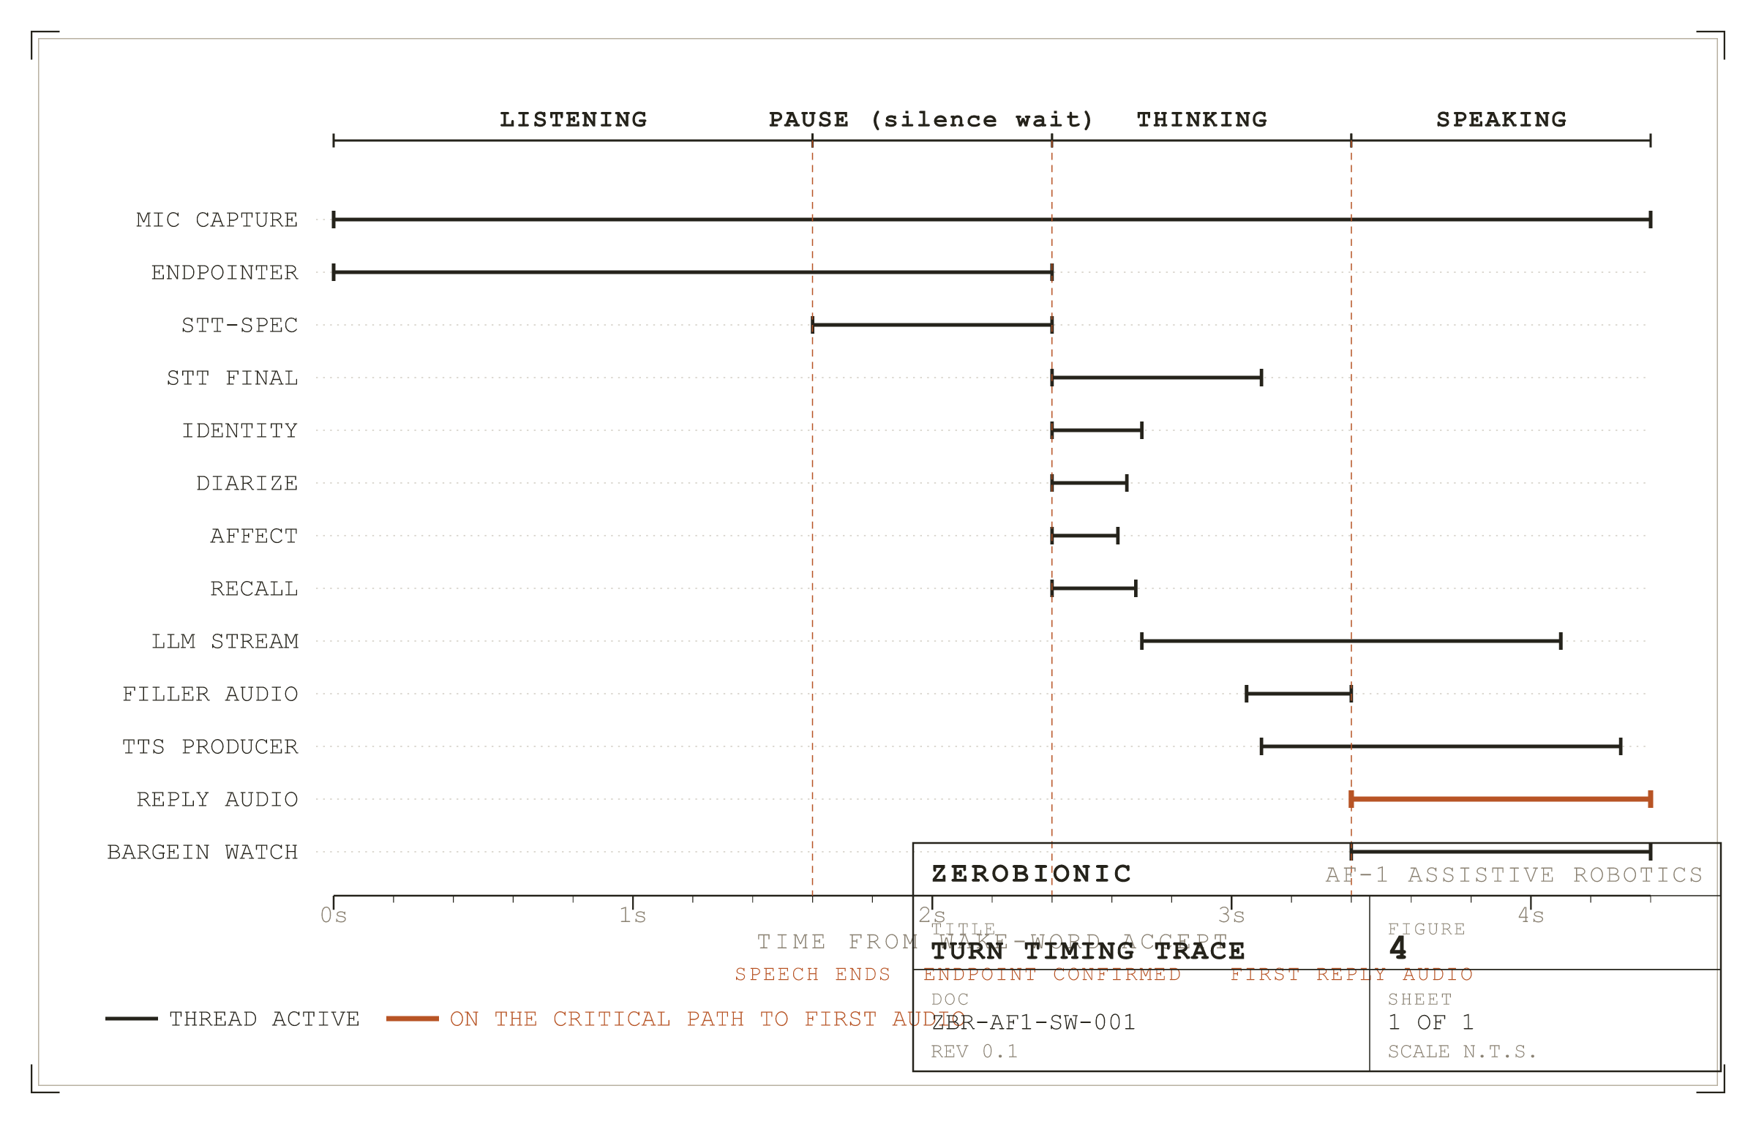
Figure 4
A single turn on one time axis. Every overlap is deliberate and was worth writing threading code for.
III. Tiered Perception
Vision is the one faculty that would happily consume the entire machine if it were allowed to, so it is organised into three tiers with a strict cost ceiling on each. The tiering is not an optimisation added later. It is the reason vision can be always on at all, and always on is what lets the robot answer a question about the room without a visible pause while it looks.
Tier 0 is motion detection, and it runs on every single frame. It is deliberately crude: the frame is downscaled to 160 pixels wide, differenced against the previous frame, and the fraction of changed pixels compared against a threshold of 0.02. It costs almost nothing, it publishes a motion level to the shared WorldState, and its real job is to gate the tier above it. Motion is considered to have stopped only after 15 consecutive still frames, which prevents the gate flapping on noise. Tier 0 is what allows Tier 1 to sleep when nothing is happening.
Tier 1 is object detection with colour naming and tracking. While the scene is moving it runs on every frame. Once the scene goes still it drops to a keepalive pass every 2 seconds, after a 3 second linger at full cadence so that a brief pause in movement does not immediately starve the detector. Above the motion gate sits a second, harder constraint: a duty budget that caps the detector at 60 percent of loop time regardless of what the motion gate says. The budget wins. This matters because motion and cost are not the same thing; a busy scene can ask for more detection than the Pi can afford, and without the ceiling the perception loop would starve the frame grab and the whole camera would stutter. When a frame is gated out, the previous detections are held as current, but the fresh frame is still published, so identity, keyframes, and the preview all keep working, and the system never looks blind just because it chose not to re-detect.
Tier 2 is narration, where the vision language model is asked for a sentence about the scene. It runs at most every 3 seconds and is additionally capped at 20 inferences per minute, and it self skips while nothing has changed. This is the only vision tier that reaches the GPU on a schedule rather than on demand, which is why it also has to justify its own cost by mattering to the reply, and it therefore stays off unless a change threshold in world.surprise.narrate_bits has been crossed.
All three tiers publish into one WorldState object, and that is the read surface everything else uses. The main loop, the proactive watcher, and the surprise gate do not call the camera or the detector; they read a snapshot, or wait for a change. Keeping a single published state rather than letting consumers pull from the perception stack directly is what allows the tiers to be re-rated, gated, or disabled entirely without any consumer noticing.
IV. The Factory and the Fallback Chain
Every engine in the system is constructed in exactly one file, zero/factory.py. It maps the engine names in config.yaml to concrete classes, and nothing else in the codebase does that mapping, which is what makes an engine swap a configuration change rather than a code change. The factory also owns a convention that matters more than it first appears: a faculty that is disabled, or whose model files are missing, or whose optional dependencies are not installed, returns None rather than raising. The main loop is written to expect None from every optional faculty. This is why a Pi with no camera runs voice only, a Pi with no face model runs voice only identity, and a machine with neither identity model runs anonymously, all without a code path dedicated to each case. The loop does not know it is degraded; it just does whatever is possible with what it has.
Layered on top of that is the fallback chain, which is the architectural expression of the local fallback commitment stated in Section 1. Each faculty that prefers the GPU is wrapped in a fallback object that holds the remote implementation and a builder for the local one. The pattern appears six times: FallbackSTT over the remote Whisper client with whisper.cpp behind it, FallbackTTS over Orpheus with Piper behind it, FallbackDetector over the server side detector with local YOLO behind it, and FallbackSpeaker, FallbackFace, and FallbackObjectEmbedder over their server side embedders with local models behind them. In every case the local implementation is built lazily, on the first remote failure, rather than at startup. That laziness is deliberate: loading whisper.cpp and a Piper voice into an 8 GB Pi that is also holding the detector and the identity models would cost memory that is only needed if the tunnel ever drops.
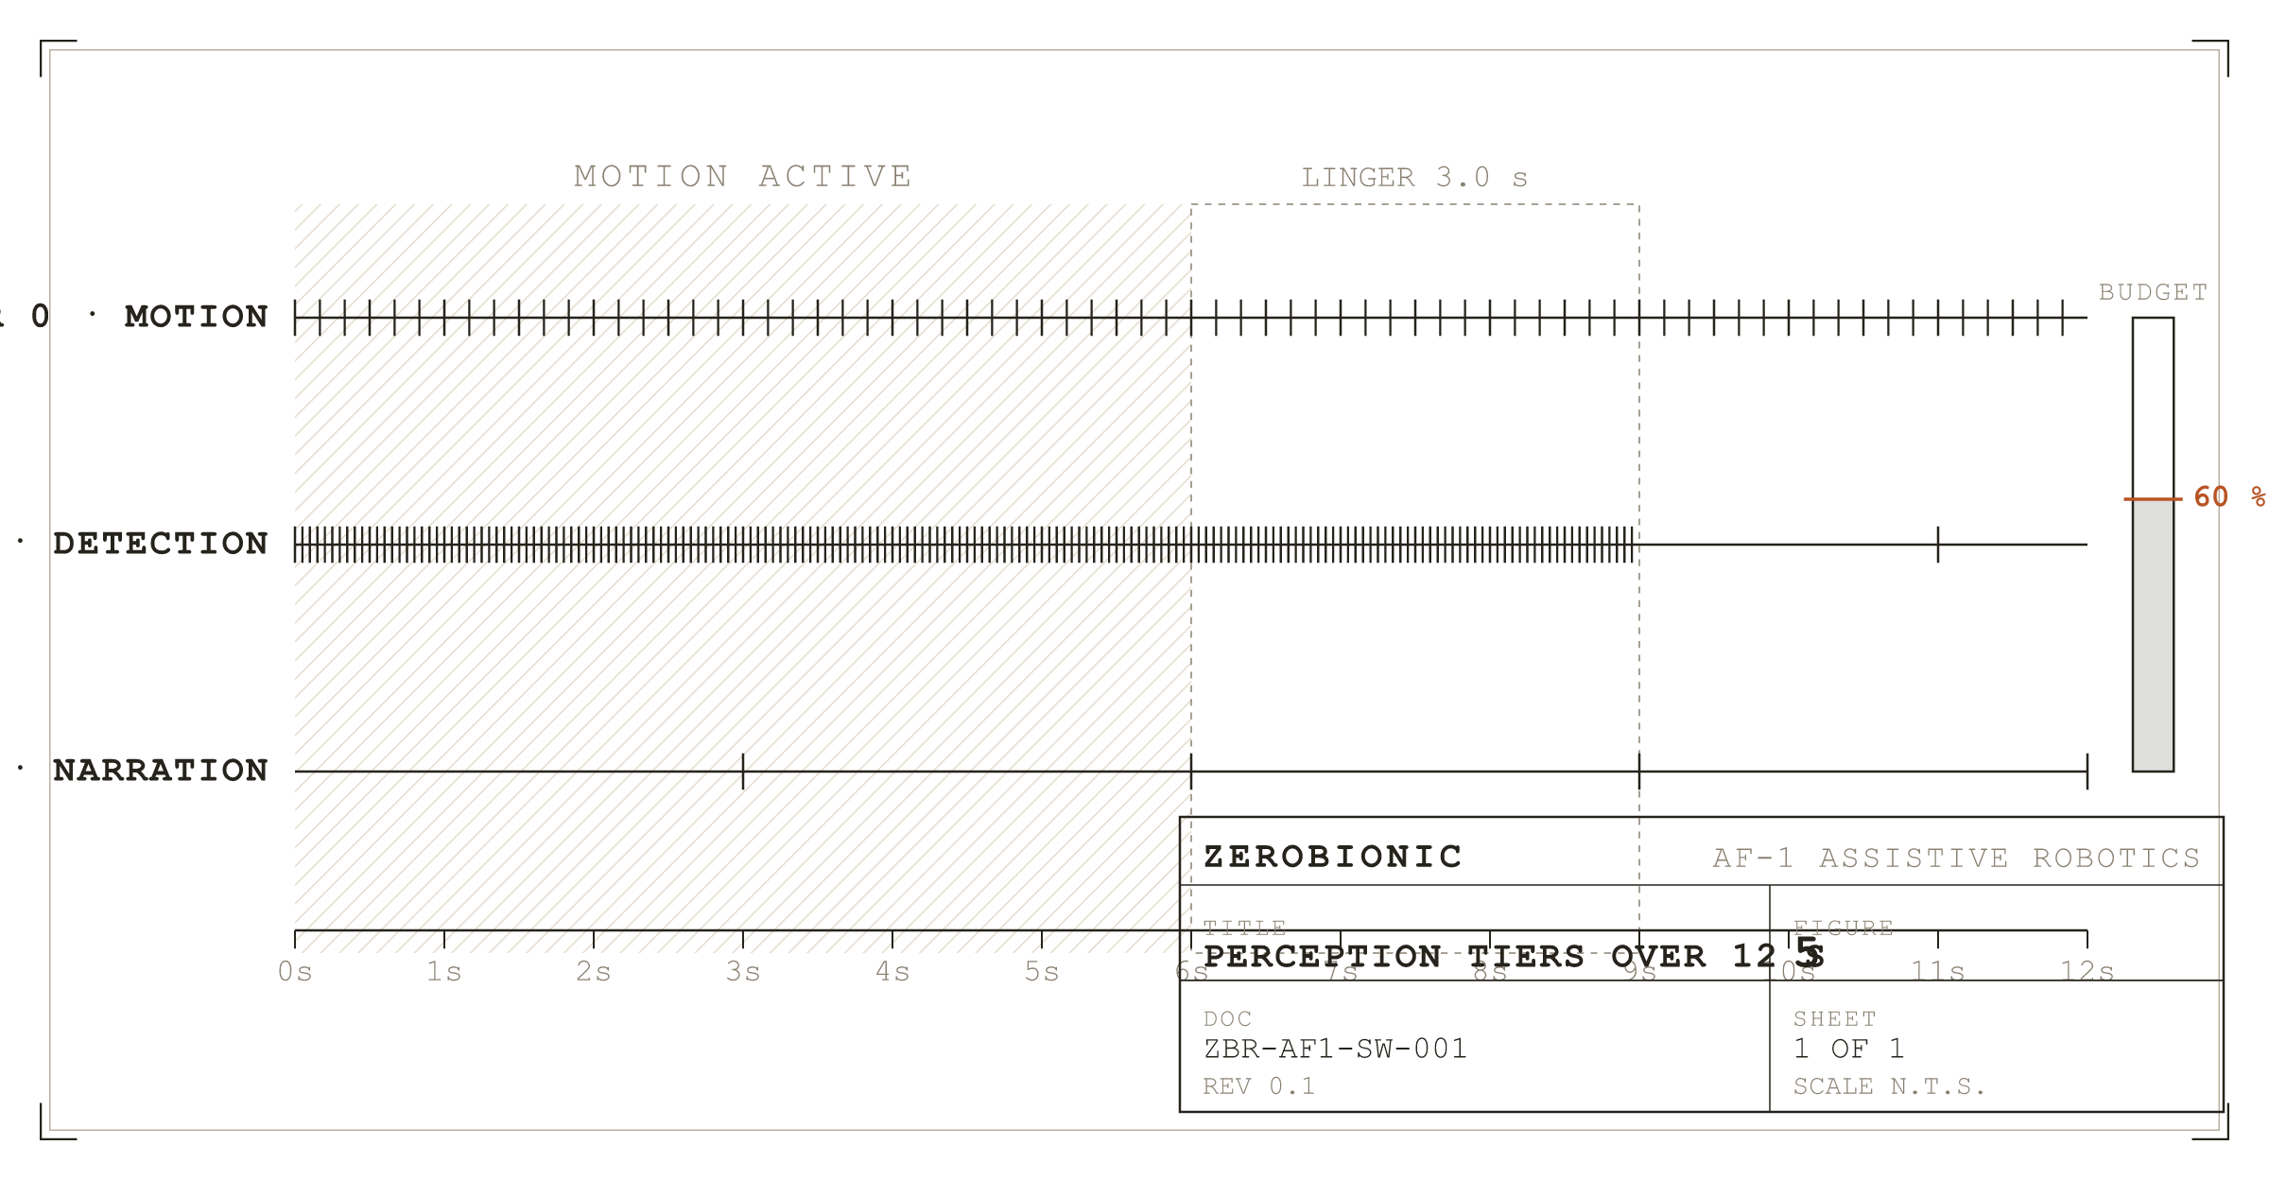
Figure 5
Three perception tiers over a twelve second window that goes from moving to still.
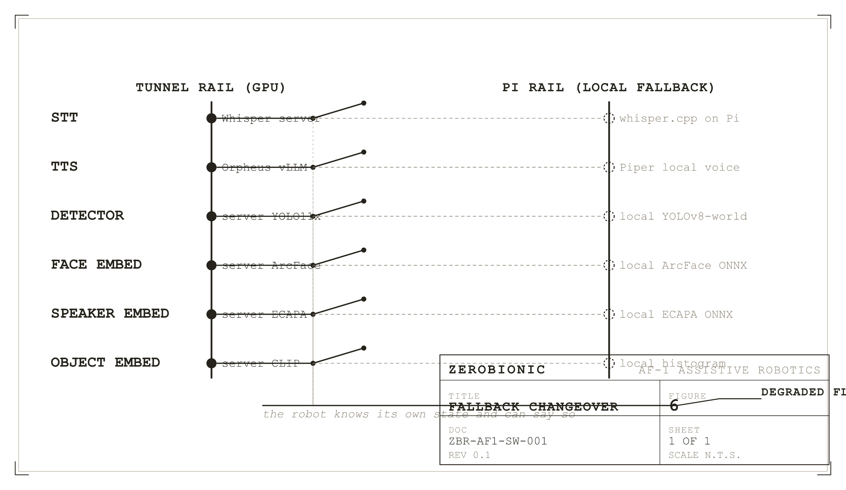
Figure 6
The fallback pattern drawn once. Six faculties share it. The local contact stays dashed until the first remote failure builds it.
The last piece of the chain is that degradation is visible rather than silent. Each fallback wrapper exposes a degraded flag, and the main loop polls those flags once per turn. On the transition into or out of degradation it appends a note to the outgoing prompt telling the model, in effect, that its fast hearing is down and it is transcribing locally, or that it is speaking through its backup voice. The robot can then say so when asked why it is slow, instead of behaving as though nothing had changed. Treating self knowledge of failure as part of the architecture, rather than as a logging concern, is what keeps a degraded system honest to the person in front of it.
V. The Control Plane Inside the Process
The HTTP control plane deserves its own subsection because its placement is the single most consequential integration decision in the system. It runs as a daemon thread inside the ZERO process, not as a sibling service. The consequence is that a push to talk turn arriving from the AF-1 application over HTTP is handled by the same Conversation object, the same SQLite memory, the same tool registry, the same voice, and the same physical speaker as a turn spoken into the microphone. There is no synchronisation problem between a network brain and a local brain, because there is only one brain. Two things follow directly from that. First, integration testing is really just regular testing done through a different door. Second, when the loop is in the middle of a spoken turn, HTTP requests do not race it; they are serialised behind it by one lock, and held off the loop's think and speak phase, so the microphone and the network cannot both be driving the state machine at once.
The server exposes a health probe that answers immediately at startup, before the model is warm, with a ready flag that flips true once the language model has been pinned in memory by the warmup call. This lets the application distinguish a Pi that is booting from a Pi that is broken. Beyond health it offers a status endpoint reporting state, the last external turn, and the degradation flags; a say endpoint that speaks a line on the Pi speaker without involving the model; a turn endpoint that accepts raw audio in any container ffmpeg can decode and runs a complete brain turn; a text turn endpoint for typed input; and a control endpoint whose only action is to end an open conversation. Everything else the application might want, it does through those doors. CORS is deliberately wide open, because the Tauri application fetches from the Rust side and needs none, while browser development needs a wildcard. The server binds 0.0.0.0 by design, which means it is reachable by anything on the local network. That is a real attack surface, and it is treated as such in Section 10 rather than hidden here.
SECTION 3
Interfaces and Data Contracts
An interface, for the purposes of this document, is anything that crosses the boundary drawn around the ZERO subsystem. That includes the HTTP control plane the AF-1 application calls, every request ZERO sends up the SSH tunnel to a model server, the physical devices the Pi opens, the GPIO pin that drives the recording indicator, and every file the subsystem writes to disk. Internal function calls between modules are not interfaces and are not listed here; they are covered by the behavioural walk in Section 4. The distinction matters because everything in this section is a contract that something outside the subsystem depends on, and therefore cannot be changed without changing that something else at the same time. A code refactor inside the process is invisible to the world; a schema change here is not.
Three conventions run through all of the contracts below and are worth stating once rather than repeating in every row. First, all audio crossing any boundary is mono, 16 bit signed PCM, wrapped in a self describing WAV container, so that the sample rate travels with the data rather than being agreed out of band. The one exception is speech coming back from Orpheus, which is 24 kHz because that is what its vocoder produces, and which the Pi resamples on receipt. Second, all images crossing any boundary are JPEG encoded and then base64 encoded into a JSON string field named image_jpeg_b64, at a quality set by vision.gpu.jpeg_quality and defaulting to 80. Third, every embedding stored on disk is a float32 array written as a raw little endian blob, always accompanied by an integer dim column in the same row. Readers compare dim against their own model's dimension and skip mismatched rows rather than failing, which is what allows an embedding model to be swapped without invalidating the database.
There is a fourth convention that is easy to miss and causes real confusion when missed. Throughout the system, a person identifier is a signed integer whose sign carries meaning. A positive value is an enrolled person in the identity registry. A negative value is a provisional guest, minted by clustering an unfamiliar voice, and deliberately kept separate so that one stranger's words never merge with another's. A null value is an anonymous turn, which is what text mode produces and what happens when identity is disabled or the speaker could not be placed. Every store that carries person_id, and every corpus record, uses this convention, and code that treats the field as an opaque key will silently mix guests with people, which is exactly the failure mode that motivated the convention in the first place.
I. The Control Plane
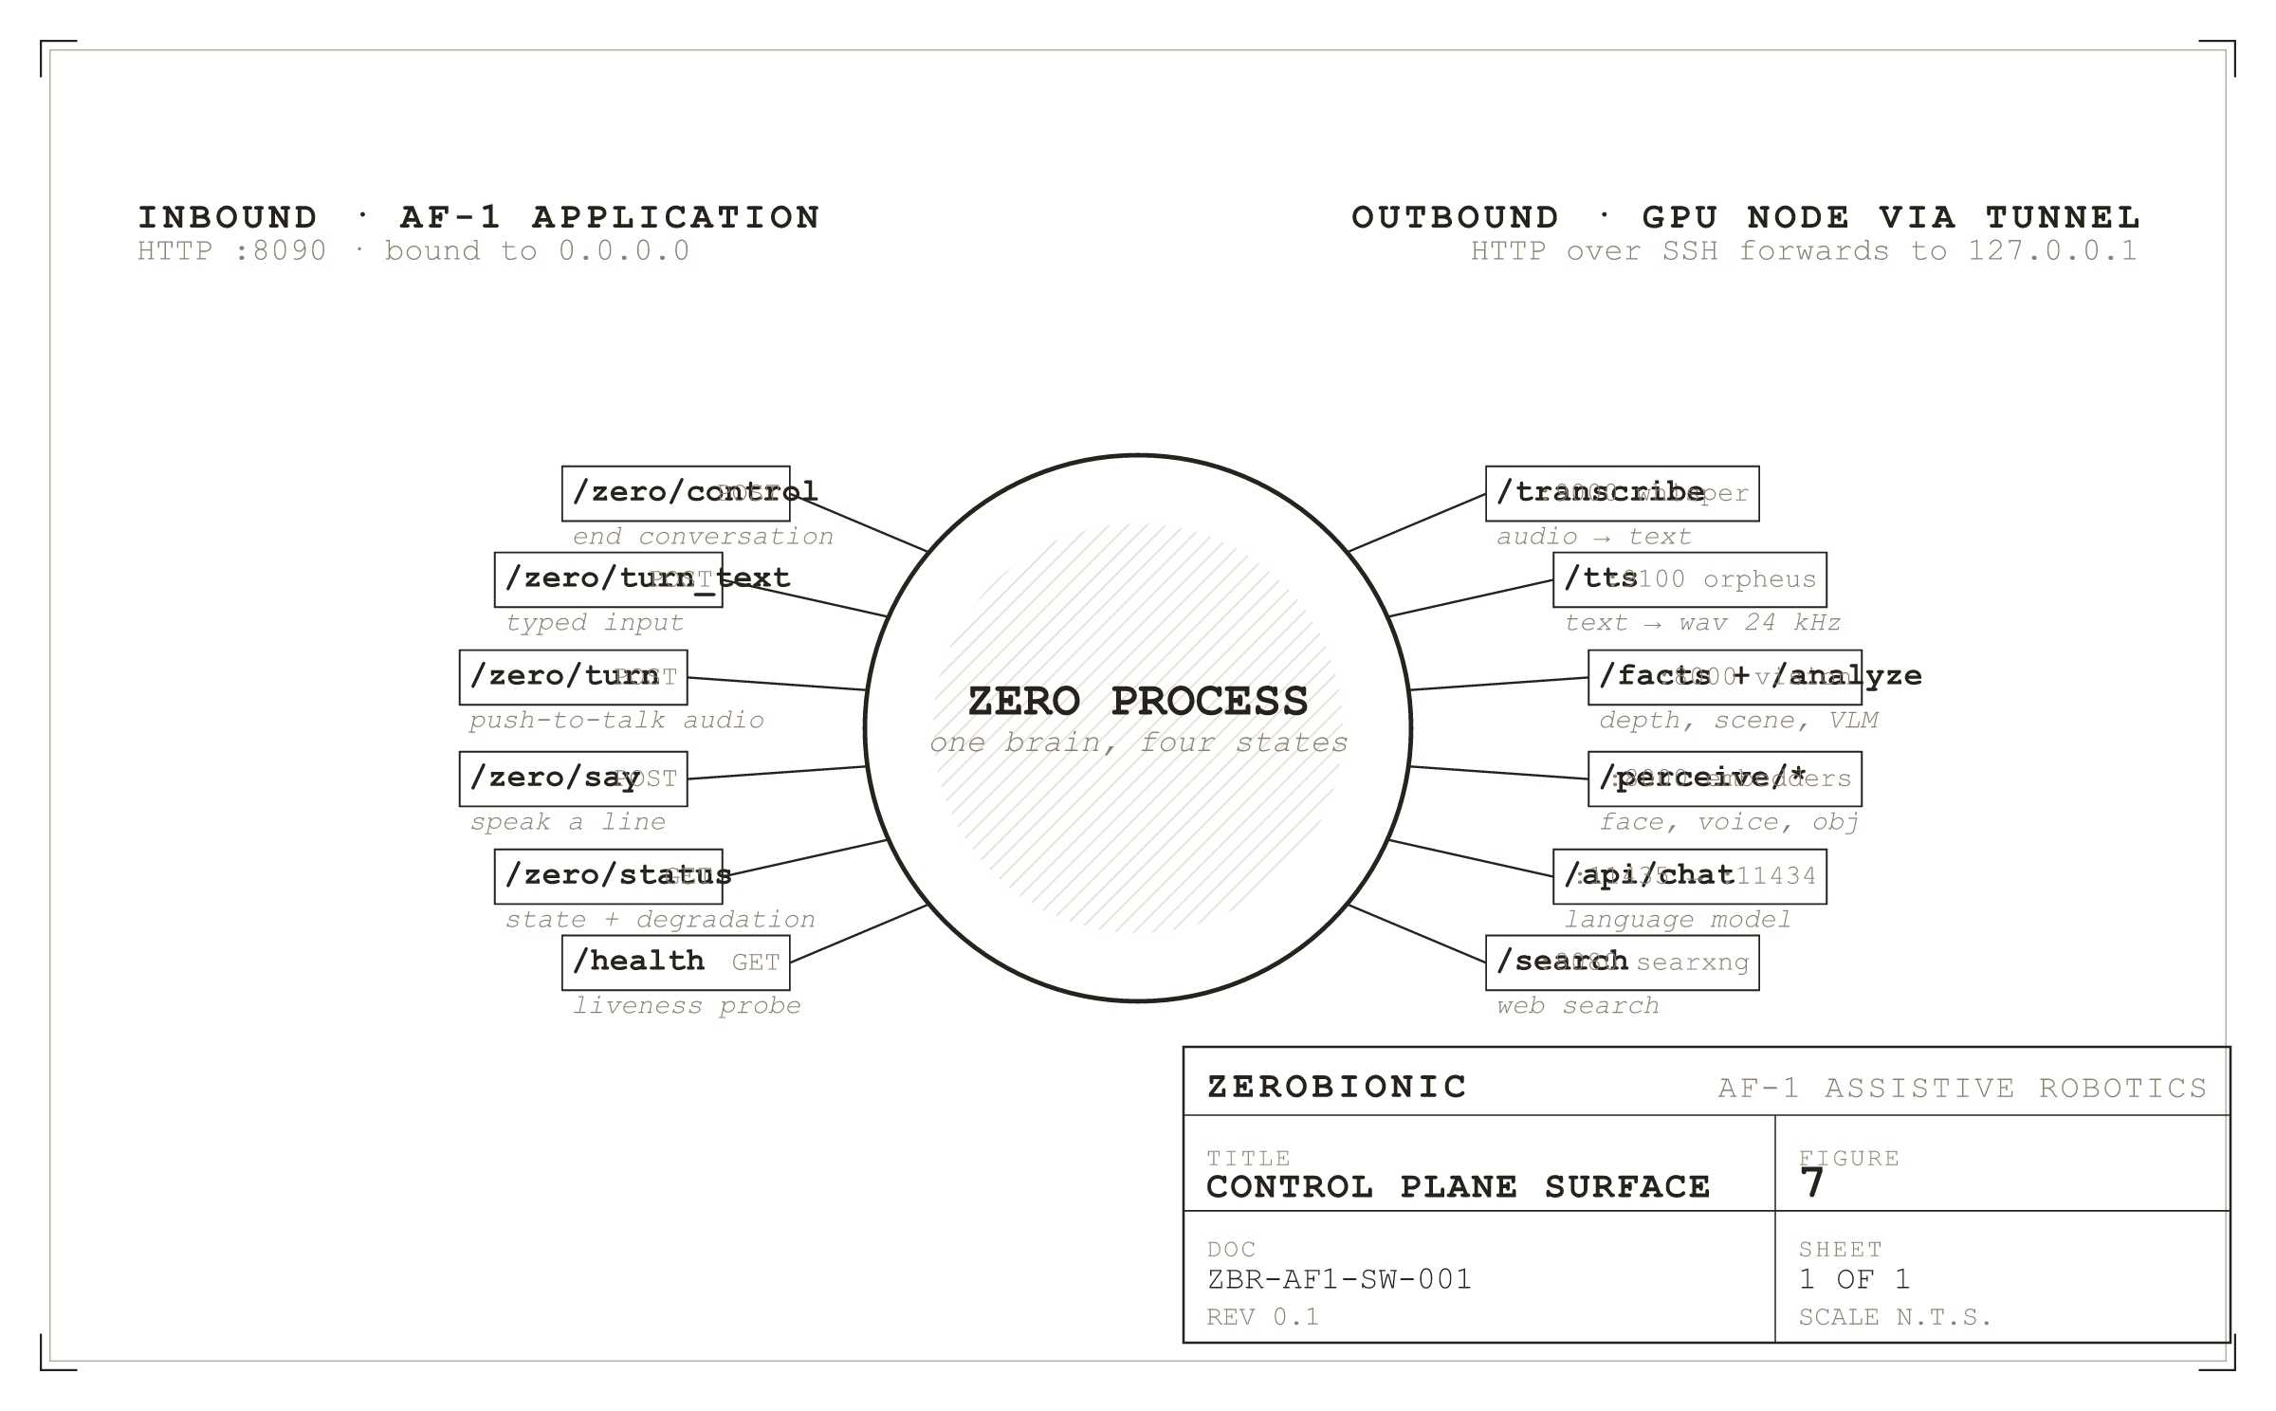
Figure 7
The control plane surface. Inbound endpoints on the left, outbound tunnel calls on the right, one brain in the middle.
The control plane listens on TCP 8090, bound to 0.0.0.0 by control.host, and is the only inbound interface the subsystem exposes. All responses are JSON unless stated otherwise. A cross origin preflight is answered with 204 and the permissive header set described at the end of this subsection. Any request body larger than 32 MB is rejected, which is generous for the intended use since a minute of WebM Opus is well under it. Unhandled exceptions inside a handler are caught, logged with a traceback, and returned as HTTP 500 with the exception text truncated to 200 characters, so that a malformed request can never take down the process that is also holding the conversation. The failure envelope is uniform across handlers: an ok boolean field is false on failure, and an error field carries a short machine readable reason.
GET /health, also reachable as GET /zero/health, returns {ok, service, state, ready}. The service field is the constant string zero-control. The state field is the current conversation state as its lowercase value, one of idle, listening, thinking, or speaking. The ready field is the one that matters operationally: it is false from process start until the language model has been pinned in memory by the warmup call, and true afterwards. A client that treats a reachable but not ready Pi as broken will report false failures during the first few seconds after a restart, which is why the flag exists.
GET /zero/status returns the state, the last external turn, and the current degradation flags. This is the endpoint that lets the application show that the robot is running on its backup voice without having to ask it. POST /zero/say takes {text, voice?} and speaks the line on the Pi speaker without involving the language model or writing anything to memory. The text is truncated to 500 characters. An empty or missing text returns 400 with {ok:false, error:"empty-text"}. The optional voice is an Orpheus speaker name such as leo, tara, or draco, and it overrides the configured default for that request only, leaving ZERO's own default untouched.
POST /zero/turn is the push to talk path. The request body is raw audio bytes, not JSON and not multipart, in any container ffmpeg can decode, which in practice means WebM, OGG, WAV, or MP4. Options travel as query parameters, ?voice= and ?person_id=. The server shells out to ffmpeg to convert the body to mono float32 at the configured sample rate. A body that decodes cleanly runs a complete brain turn, is spoken on the Pi speaker, and returns {ok, heard, reply}, where heard is the transcript and reply is what was said. An empty body returns 400. A decode failure returns 422 with the tail of ffmpeg's stderr in the error field, which is deliberate: a caller sending an unsupported container needs to see why.
POST /zero/turn_text takes {text, voice?, speak?, person_id?} and runs the same brain turn from typed input, with text truncated to 1200 characters and speak defaulting to true. POST /zero/control accepts {action:"sleep"} and ends the open conversation; any other action returns 400 naming the unknown action. Anything else returns 404. External turns are serialised against each other by a single lock and are held off the native loop's think and speak phase, so the microphone and the network cannot both drive the state machine at once. The person_id supplied by the application defaults to control.person_id, which ships as 1, meaning AF-1 turns are attributed to the logged in operator rather than to an anonymous speaker.
CORS is deliberately unrestricted: Access-Control-Allow-Origin: *, methods GET, POST, OPTIONS, headers Content-Type. The Tauri application fetches from the Rust side and needs no CORS at all, but browser based development does, and no authentication is implemented at this layer. Combined with the 0.0.0.0 bind, this means anything on the local network can make the robot speak. That is a deliberate trade for a LAN only device and it is assessed properly in Section 10, not defended here.
II. The Model Server Contracts
Every one of the model server calls is reached through the SSH tunnel at a local port, so from ZERO's point of view they are all on 127.0.0.1. The port offset described in Section 2.I applies: Ollama alone is reached at local 11435, and the tunnel rewrites the number to 11434 on the far side.
The Whisper server accepts POST /transcribe with a raw WAV body and Content-Type: audio/wav, and returns {text}. An optional ?language= query parameter is appended by the client when stt.language is set, accepting a language code such as sw, or the literal auto to let Whisper detect, which is the right setting for code switched speech. The client raises rather than returning an empty string on failure, and that distinction is load bearing: the fallback wrapper must be able to tell a dead tunnel from a silent room, and empty text is the answer for a silent room while an exception is the answer for a dead tunnel.
The Orpheus server accepts POST /tts with {text, voice} and returns a WAV at 24 kHz. A streaming variant at /tts_stream is derived by the client from the configured URL by simple substring replacement, which means a non standard path in tts.orpheus.url will produce a stream URL that does not exist. GET /health returns {ok} reflecting whether the model has loaded. The client keeps one HTTP session alive across sentences rather than reconnecting, and retries a connection failure once on a fresh connection so that a server restarted between turns recovers rather than erroring. Before sending, the client rewrites ZERO's shared cue vocabulary into Orpheus's native tags, mapping [laughs] to <laugh>, [sighs] to <sigh> and so on, rendering [hmm] and [pause] as text the model performs naturally, and stripping any cue it does not recognise.
The vision server exposes GET /health, which reports CUDA availability and VRAM and is what proves the tunnel is alive; POST /facts, which takes an AnalyzeRequest and returns an AnalyzeResponse whose reply is empty because ZERO's own model writes the spoken answer; and POST /analyze, which runs the same facts and then a vision language model grounded in them, returning a populated reply. The shared wire types are Pydantic v2 models. A Detection carries label as a string, bbox as exactly four floats in [x, y, w, h] in pixels of the frame that was sent, confidence constrained to the range 0 to 1, and an optional color string from HSV naming. An AnalyzeRequest carries image_jpeg_b64, a list of Detection, a question string, and a history list of {role, content} dictionaries. A SceneFact carries label, optional color, optional distance_m constrained to be non negative, and an optional bearing which is one of the coarse strings left, center, or right. An AnalyzeResponse carries a list of SceneFact and a reply string.
These models exist in two files, one on each side of the tunnel, because the two nodes do not share a filesystem. Those two copies have drifted. In the Pi copy at zero/vision/schemas.py, both AnalyzeRequest.question and AnalyzeResponse.reply have empty string defaults and are therefore optional. In the server copy at server/vision/shared/schemas.py, both are declared required. Today this is benign, because the Pi serialises its own model and so always emits both keys even when they are empty, but the contract is no longer single sourced and the next edit to either file can diverge further without anything failing loudly. The server copy's docstring compounds this by instructing the reader to edit a canonical file and run python shared/sync_schemas.py, and by naming a mirror at pi/shared/schemas.py. Neither that script nor that path exists in this repository. This is recorded as an open item in Section 14.
III. The Perception Offload
Separate from the vision endpoints above, the GPU node serves a set of embedding and detection endpoints under /perceive/ on the same port 8000, reached through a client with its own timeouts: 5 seconds by default and 10 seconds for detection. Every one of these endpoints raises a RuntimeError naming the path on any failure, again so that the fallback wrappers can distinguish an unreachable server from an empty result. POST /perceive/detect takes {image_jpeg_b64} and returns {detections: [...]} in the Detection shape. POST /perceive/face takes {image_jpeg_b64, max_faces}, defaulting to three faces, and returns {faces: [{embedding: [float, ...], bbox: [...]}, ...]}; the client discards any face whose embedding array is empty. POST /perceive/speaker is the one endpoint in this group that does not take JSON: the body is a raw WAV with Content-Type: audio/wav, built from the utterance at the capture sample rate, and the response is {embedding: [float, ...]}. POST /perceive/embed_object takes {image_jpeg_b64} holding a crop rather than a full frame and returns {embedding: [float, ...]}.
IV. Local Device Interfaces
The microphone is opened through PortAudio at the index given by audio.input_device, and the pipeline contract downstream of it is fixed: mono, 16 bit, 16 kHz, in blocks of audio.block_ms milliseconds, which ships as 30 and therefore yields 480 samples per block. Two adaptations sit inside that contract. A software gain from audio.input_gain multiplies each block before int16 conversion, because some USB and webcam microphones capture too quietly for the wake model to fire. And when a device rejects 16 kHz outright, which is common for cheap USB dongles that only support 44.1 or 48 kHz, the stream is opened at the device's native rate and each block is resampled down, so that every downstream consumer still sees the frames it would otherwise. The speaker is opened at audio.output_device. The camera is opened at vision.camera.index and configured for 640 by 480 at a requested 30 frames per second in MJPG, which is deliberately small so that detection keeps up on the Pi.
The recording indicator is a single GPIO pin named by privacy.indicator_gpio_pin, driven through gpiozero. It is lit for the listening, thinking, and speaking states, and dark for idle. With no pin configured, or with gpiozero unavailable, it degrades to state transition log lines so that the same information is still observable through journalctl. This is the only physical output the subsystem drives. The optional camera preview serves HTTP on vision.preview_port, which ships as 8008, bound to vision.preview_host. That default is 127.0.0.1 on purpose: the preview is an unauthenticated video stream, and publishing it to the network requires an explicit change to 0.0.0.0.
V. On Disk Contracts
Six SQLite databases and two flat files make up the persistent state. All of them are created on first use, all of them are opened with check_same_thread=False because several threads write, and the episode store additionally runs in WAL mode so that writers never block readers. zero_memory.sqlite holds one table, memories, with columns id, person_id, layer, key, value, importance defaulting to 5.0, emb as a float32 blob, emb_dim, created_at, last_access, access_count, and protected. There is an index on (layer, person_id). The protected flag marks rows that the storage cap must never prune, which is what keeps the durable per person last conversation record alive when ordinary facts are being aged out. This store also carries a one time legacy migration that folds rows from an older flat schema, with tables named memory and episodes, into the current shape and then drops them, so that an old database upgrades in place on first open.
zero_identity.sqlite holds people, with id, a name that is unique and case insensitive, and created_at; and embeddings, with id, person_id, kind, dim, a vec blob, and created_at, with a foreign key to people. The kind column is what allows face and voice vectors to live in one table. zero_guests.sqlite holds guest_samples, with id, guest, dim, vec, and created_at. Guest identifiers are negative by construction: a new guest takes the minimum of minus one and one below the lowest existing identifier. The store caps samples per guest and total guests, dropping the least recently heard. zero_episodes.sqlite holds episodes, with id, v recording the schema version at write time, ts, kind drawn from turn, scene, proactive, and action, person_id, a payload JSON string defaulting to {}, reward where null means untagged, surprise, and consolidated_at. It carries two indexes, one on (kind, ts) and a partial index on unconsolidated rows. Alone among the stores it uses a real migration mechanism driven by PRAGMA user_version, applying each migration step in its own transaction. Rewards are clamped to the range minus one to one on write. zero_curiosity.sqlite holds questions, with id, a unique source_key that prevents the same observation queuing twice, text, priority, person_id, created_at, and asked_at. zero_objects.sqlite holds objects, with id, a case insensitive name, person_id, dim, vec, and created_at, which is where a taught object binds a name to an embedding.
The interaction corpus is newline delimited JSON at data/corpus/interactions.jsonl, appended under a lock so that records never interleave. One record is written per speaker per session, holding that speaker's turns, their identifier under the sign convention described above, and a timestamp. Because the session has already been split by speaker before it is written, one person's speech never contaminates another's training data. The enrolled voiceprint is a NumPy array at the path in voiceid.profile_path, and the surprise predictor keeps its running statistics as JSON at world.surprise.stats_path.
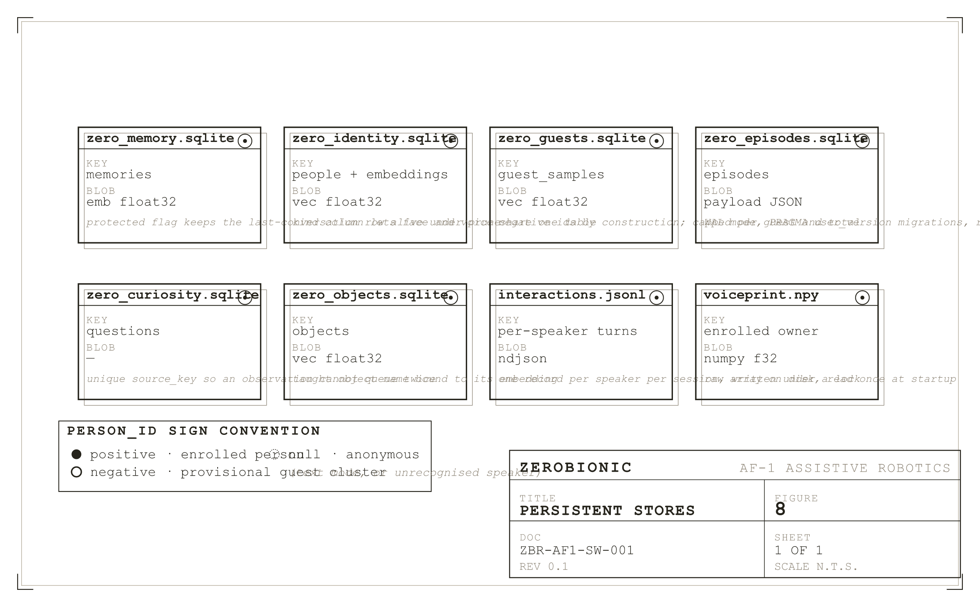
Figure 8
Persistent stores at a glance, with the sign convention that determines who owns each row.
VI. The Internal Event Bus
The event bus is the one internal mechanism documented here, because it is how anything that is not the main loop gets the robot to speak, and because its overflow behaviour is a contract rather than an implementation detail. An Event carries kind, text already phrased for speech, created_at, an optional person_id, and a meta dictionary. The queue holds 64 events. Posting to a full queue drops the event and returns false rather than blocking, on the reasoning that a lost nudge is better than a wedged timer thread. The main loop drains the bus only at safe moments, meaning the idle wake wait and turn boundaries, so that an announcement can never talk over a reply in progress. One meta key is load bearing: open_conversation, which tells the loop that the announcement expects an answer and that it should begin listening rather than returning to idle. That one flag is what turns a proactive greeting into a conversation opener.
SECTION 4
Behaviour and Logic
This section describes what the subsystem actually decides, and on what evidence. Two habits run through all of it and are worth naming before the detail. The first habit is that every judgement the robot makes has an explicit numeric threshold that lives in config.yaml rather than in the code, so that behaviour can be tuned in the field without a deployment. The second habit is that a faculty which cannot reach a confident answer degrades to a weaker one rather than failing: an unrecognised voice still gets a reply, it just does not get to write into anyone's memory; a scene that cannot be re-detected still publishes its last detections rather than reporting an empty room. Almost every rule below is shaped by one of those two habits.
I. The State Machine
Four states exist: IDLE, LISTENING, THINKING, and SPEAKING. The legal moves between them are declared as data in zero/state.py and checked on every transition. IDLE may only go to LISTENING. LISTENING may go to THINKING, or back to IDLE when nothing was said. THINKING may go to SPEAKING, to IDLE, or back to LISTENING, that last case covering an empty reply where the robot stays in the conversation rather than ending it. SPEAKING may go to IDLE or back to LISTENING, the latter being barge in.
An illegal transition is logged as a warning and then performed anyway. That is a deliberate choice: a wiring bug should be loud in the logs during development, but it must never crash a conversation in front of a person. The transition helper also returns early when the destination equals the current state, which is what allows the filler and the reply to both request SPEAKING without churn.
The most important structural fact about the loop is not visible in the state list. After the wake word admits the first turn, the cycle is LISTENING to THINKING to SPEAKING and back to LISTENING, repeatedly, with no wake word between turns. IDLE is left behind until a stop phrase or a silence long enough to trip conversation.sleep_timeout_ms returns the robot to it. A reader who models this as a four state ring will get the behaviour wrong, because the ring is only the initial arc; the steady state is a tight three state loop that lives inside a conversation.
II. Waking
Wake detection runs openWakeWord over every 30 ms frame in IDLE, comparing its score against wake.threshold. The detector is reset and the microphone drained whenever the robot enters or re-enters the wait, which matters because the announcement path can speak while IDLE and the system must not hear its own voice as a wake attempt. A conversation can also be opened without a wake word at all. When a proactive event carries the open_conversation flag in its metadata, the idle wait returns as though woken, and the spoken opener is seeded into the fresh history as the first assistant turn so that the model knows it said it. This is what allows the robot to greet someone walking in and then listen for an answer, rather than speaking into the air and going back to sleep.
III. Deciding When a Person Has Finished
Endpointing is the single most behaviour defining piece of logic in the system, because getting it wrong is immediately obvious to a user: too eager and it interrupts, too patient and it feels unresponsive. Two backends exist, and the distinction between the code's default and the shipped configuration matters. The factory defaults to Silero VAD, but config.yaml explicitly selects webrtc with an aggressiveness of 2, and that is what runs on the deployed robot. The reason is recorded in the config itself: Silero is sharper on clean audio but stricter, and it was missing speech from a quiet microphone. Anyone reading the factory in isolation will conclude Silero is active; it is not.
Silero remains available and is worth understanding because it is the fallback plan for a noisy environment. It runs through ONNX Runtime rather than torch, which is what keeps the Pi torch free. Silero v5 requires exactly 512 sample windows at 16 kHz while the audio pipeline delivers 480 sample frames, so the endpointer buffers samples and feeds whole 512 sample windows in order, carrying the model's recurrent state between them. Its ONNX interface is smoke tested at construction with a zero filled window, so that a version or API mismatch raises there and the factory falls back to webrtcvad, rather than producing an endpointer that silently never detects speech. That failure mode, a microphone that appears alive but is functionally deaf, is the reason the smoke test exists. If Silero is selected, vad.silero_threshold ships at 0.3 rather than the library default of 0.5, again to accommodate a quiet microphone.
Starting and continuing an utterance use deliberately different rules. To start, a frame must pass the VAD and exceed vad.energy_threshold in RMS, which rejects quiet background onsets and distant voices. To continue, only the VAD is consulted. That asymmetry is the fix for a real fragmentation bug: quiet syllables and short pauses inside a sentence were failing the energy test and splitting one utterance into several. A short pre-roll of vad.speech_pad_ms is retained and prepended when speech starts, so that the first word is not clipped.
The endpoint fires after vad.silence_ms of trailing silence, expressed internally as a count of blocks. Two modifiers sit on top. The first is an adaptive endpoint: if the amount of speech collected so far is less than vad.min_speech_for_fast_end_ms, the required silence is doubled. A slow starter who says "um" and then thinks is not cut off, while a finished sentence still commits at the normal speed. The second is the semantic hold described below. Two outcomes are also carefully distinguished. A true idle timeout, meaning no speech at all for conversation.sleep_timeout_ms, returns nothing and ends the conversation. An utterance that was captured but whose average RMS falls below vad.min_utterance_rms is dropped and the endpointer keeps listening with a fresh idle window. This is a proximity gate: the owner's voice close to the microphone is loud, a conversation across the room is not, and a stray background blip must not put the robot to sleep mid conversation. There is also a hard length cap at vad.max_utterance_ms.
While waiting for speech, the endpointer logs a heartbeat every five seconds. That line is load bearing for triage and should not be removed: if it ticks but speech is never captured, the problem is VAD or level; if it never ticks at all, frames are not arriving and the microphone stream itself has died. Those are different faults with different fixes, and this is what tells them apart.
IV. Speculation and the Semantic Hold
Roughly 180 ms into any silence run, well before the endpoint would fire, the endpointer calls back with the audio captured so far and transcription begins on a background thread. This speculative transcript does two jobs at once. Its first job is latency. If that pause turns out to be the real end of the utterance, the transcript is already in hand and the round trip to the GPU has been spent inside the silence wait rather than added after it. The main loop decides whether it may reuse the speculative result by two tests: the speculative audio must be a verbatim prefix of the final utterance, and the amount of audio that arrived afterwards must be within a slack of twice vad.silence_ms plus vad.speech_pad_ms plus 400 ms. A longer tail means speech resumed or the length cap fired, so the speculative text is only a prefix and the full transcription runs instead.
Its second job is judgement. When the endpoint condition is met, the loop is asked whether the speaker was mid thought, and the answer is derived from the last word of the speculative transcript. A transcript ending in a conjunction, a preposition, an article, or a filler is treated as unfinished, as is one ending in a comma, a colon, a dash, or a literal ellipsis, which is what Whisper writes when speech trails off. The word list deliberately excludes words that legitimately end sentences, such as pronouns.
The critical detail is that this check is tri state rather than boolean. True means hold for one more silence window. False means commit now. None means the transcript is still in flight, and in that case the endpointer waits a bounded vad.semantic_hold_wait_ms rather than committing. Without that third state the mid thought check raced the STT round trip and lost: the answer arrived just after the endpoint had already committed, and half sentences were being shipped to the model. The hold applies at most once per pause; if speech resumes, the hold is cleared and the next pause gets a fresh decision. Speculation is skipped in three cases, each for a distinct reason. It is skipped when voice ID is enabled, because nothing may be transcribed before the owner check runs. It is skipped in strict privacy mode for the same reason applied to bystanders. And it is skipped while STT is degraded to the local CPU engine, because speculating there simply runs a slow job twice, once at the pause and once at the endpoint, with no overlap to gain.
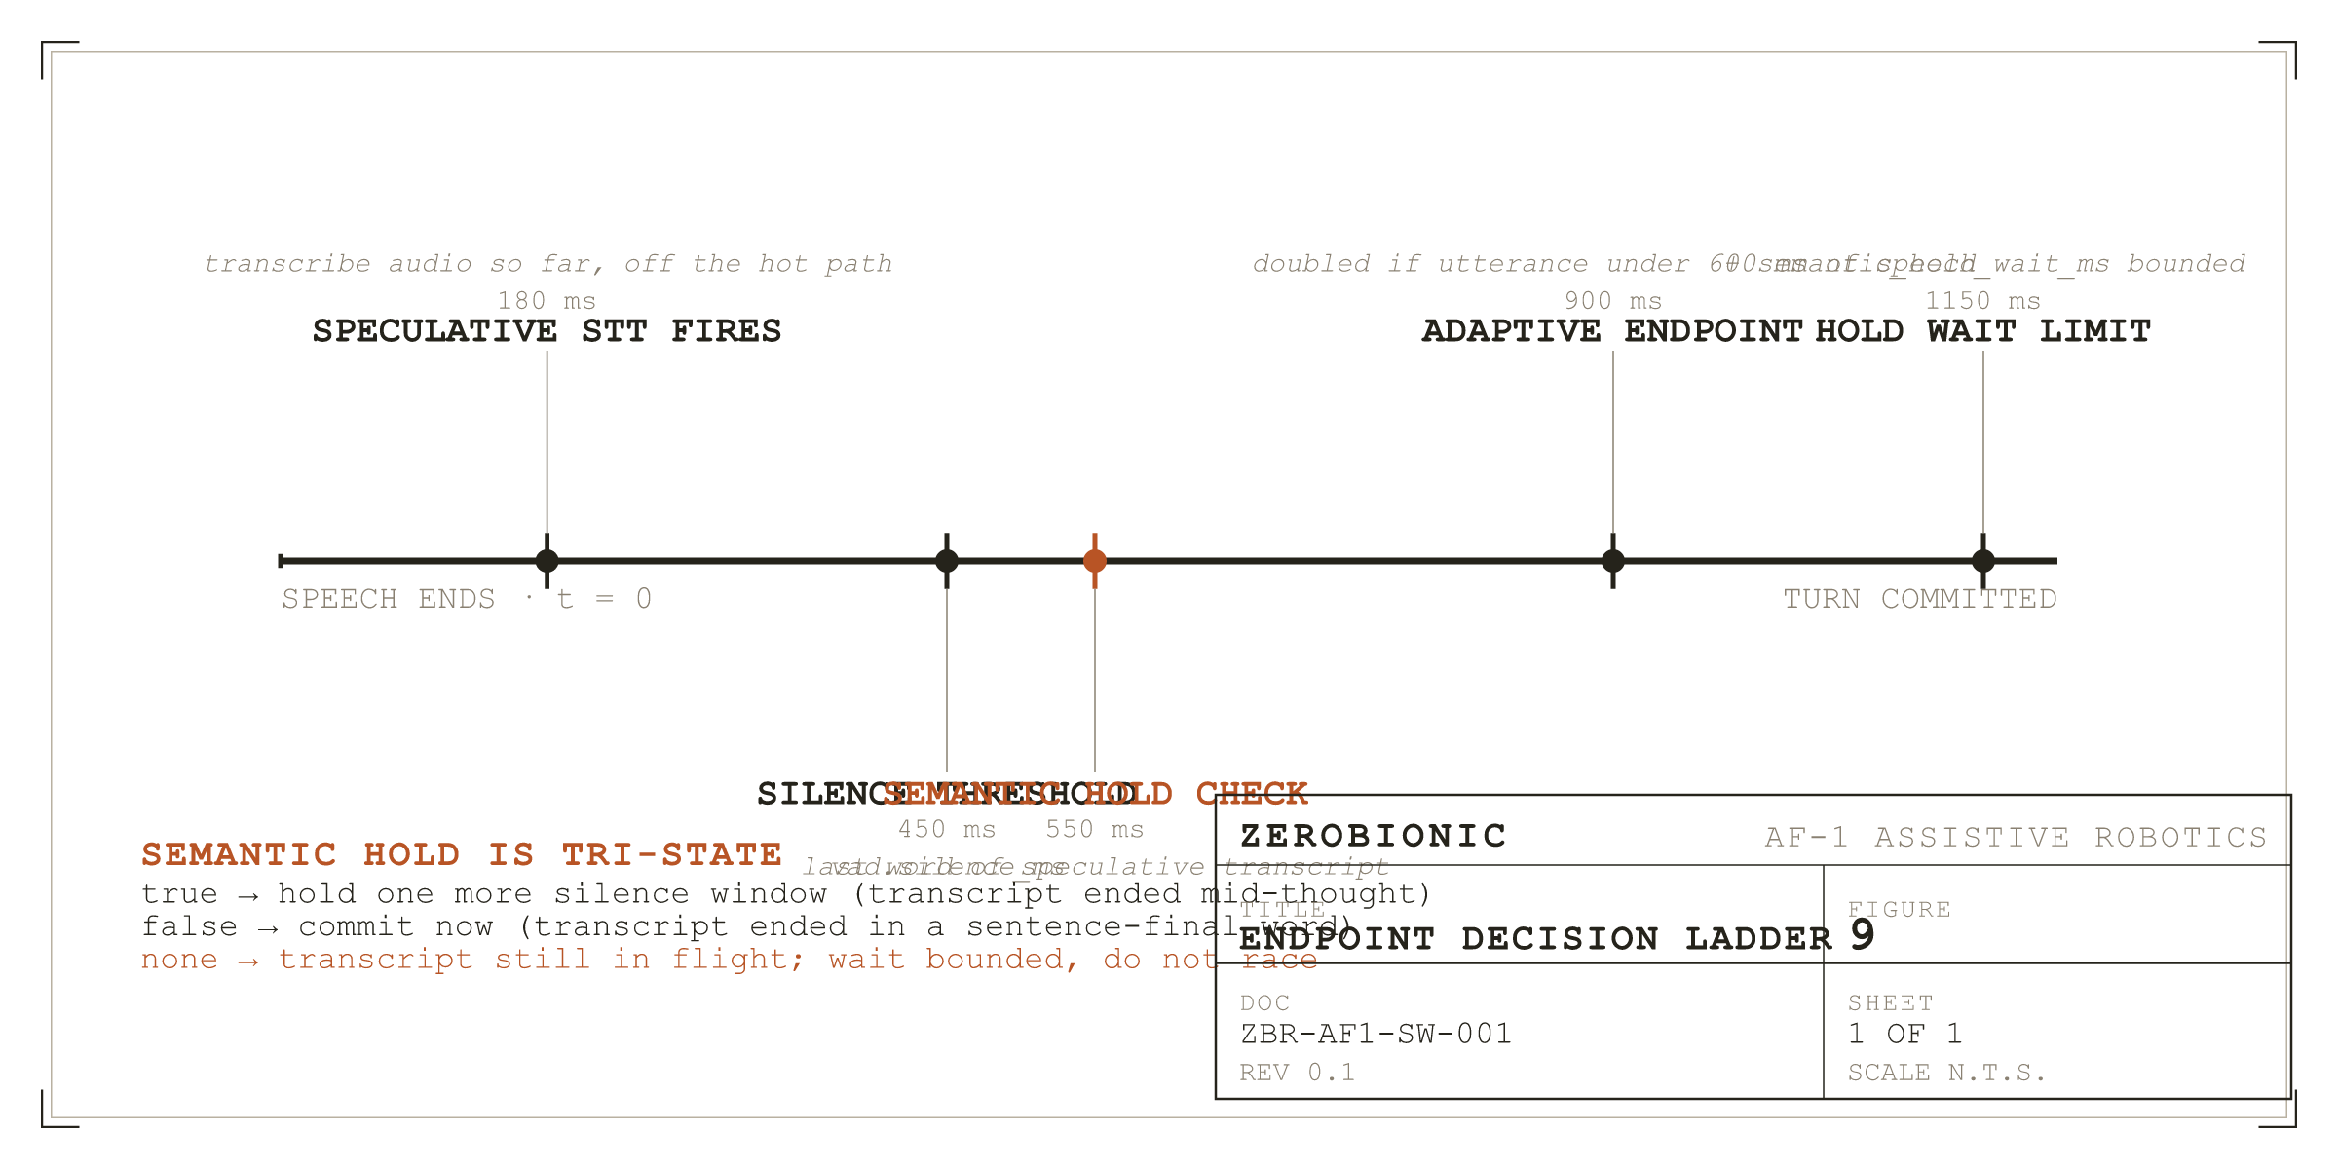
Figure 9
The endpoint decision ladder. The tri-state hold is the only branch that can extend a wait.
V. Deciding Who Is Speaking
Identity fuses two independent signals. When a face match and a voice match name the same person, the score is a weighted sum, w_face times the face cosine plus w_voice times the voice cosine, with the weights normalised to sum to one, and the result must clear identity.fusion.threshold, which ships at 0.50. When the two signals name different people, they do not average. Instead the stronger weighted signal competes alone against its own single channel threshold, 0.42 for face and 0.45 for voice, both stricter than the fused threshold because a single channel is inherently less reliable. This is what prevents two weak and contradictory matches from manufacturing a confident identification.
Sessions are owned by voice, not by face. Under identity.session.voice_only, which defaults true, the speaker's voice decides whose memories the turn belongs to, and the face is treated as perception only. There is a second, stricter gate on top: a turn only credits durable memory when the identity score reaches identity.session.write_min_score, which ships at 0.55. A borderline match still gets a normal conversation, it simply does not write into anyone's permanent record. That single threshold is what stops a multi speaker session cross contaminating memory.
An unfamiliar voice is not immediately made into a guest. The voiceprint is held, and only after the transcript proves the turn was real is a provisional guest assigned. Three gates decide "real": at least identity.guests.min_words words, at least identity.guests.min_ms of audio, and at least identity.guests.min_rms in level. These exist because Whisper hallucinates plausible text from near silence, producing phantom guests and polluting the training corpus. Guest identifiers are negative, and clustering an unfamiliar voice against existing guests keeps different strangers separate. Diarisation compares consecutive turns' voice embeddings and raises a speaker change note when the cosine falls below perception.diarize.change_threshold. The note is ephemeral and is attached to that turn only.
One rule about sight deserves emphasis, because it is a behaviour users notice. The robot may only claim to see someone when their face is in the current frame. Recognising a voice off camera produces a different note, explicitly saying it recognises the voice but cannot see the face. Furthermore, the identity note is attached only when recognition changes, or when the user asks a visual question. Repeating it every turn fed the model greeting fodder, and it kept re-greeting people mid topic.
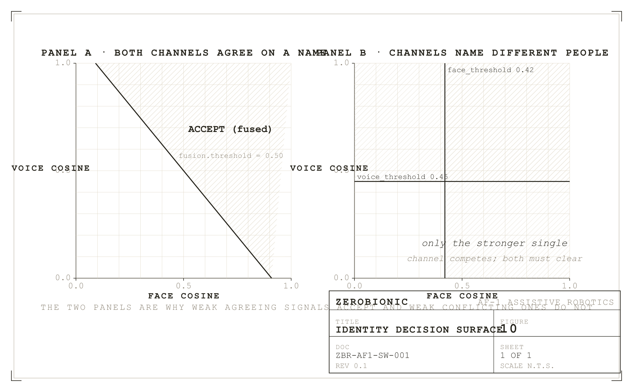
Figure 10
Identity decision surface. Weak but agreeing signals accept where weak conflicting ones do not.
VI. Deciding What Is Being Asked About
Most turns carry only a cheap text hint about the scene. A turn classified as visual additionally pulls recent keyframes so that the multimodal model can actually look. The classifier is deliberately tight in two directions. Bare demonstratives such as "this", "that", and "there" are excluded, because they appear in most ordinary sentences. Polysemous verbs such as "see", "look", "watch", and "picture" are excluded as bare words, because in speech they are usually non visual: "I see", "looking forward to it", "picture this scenario". Those words appear instead inside the phrase list in their genuinely visual forms, such as "what do you see", "take a look", and "look around".
Beyond the fixed word and phrase lists, the classifier consults the live detections. If the utterance names an object the camera can see right now, the turn is visual. This is what makes "what colour is the cup" work without anyone having to enumerate every possible object: matching is done against the full label and its head noun, so that "cell phone" also matches "phone", plus a naive plural, on word boundaries. The label "person" is excluded from this test, because a person is on screen almost always and the word turns up constantly in abstract speech.
Presence is answered from the detector rather than from the model. Whether a person is in frame is decided by YOLO and stated to the model as fact, because without that grounding the model happily answers "yes, I see you" to an empty room. Three cases are distinguished: the camera never came up, in which case the model is told it is blind and instructed not to invent a scene; the camera is working and there is nobody in frame; and there is a person in frame. Spontaneous scene changes are surfaced as an optional note the model may mention or ignore, but never on a turn classified as a question. Answering "which planet did Thanos visit" with "is that a remote on the table?" reads as not listening. Ungated, the changes stay queued and self expire until a calmer turn.
VII. Deciding What to Remember and What to Recall
Durable facts are injected once at conversation start rather than per turn, which keeps the prompt prefix stable and the model's cache warm. Per turn relevance recall is separate and ephemeral. Recall ranks candidate memories by an activation score with four factors: activation equals relevance times (0.2 + 0.8 times recency) times (importance divided by 10) times frequency. Relevance is the cosine between the query embedding and the stored embedding when both exist and their dimensions agree, floored at zero; it falls back to keyword overlap when there is no embedder, and to 1.0 when there is no query at all, which reduces the ranking to recency times importance. Recency decays exponentially from last access rather than creation, so recalling something refreshes it.
The decay parameter deserves a correction that anyone tuning it needs. It is named memory.retrieval.half_life_days and ships at 14, but the implementation computes exp(-age / half_life_seconds), which makes it a time constant, not a half life. At an age equal to the configured value the recency factor has fallen to 1/e, roughly 0.368, rather than to 0.5. The true half life is the configured value multiplied by the natural logarithm of 2, so the shipped setting of 14 days is really a half life of about 9.7 days. The name is misleading rather than the behaviour being wrong, but a reader who sets this expecting half life semantics will get a decay about 30 percent faster than intended. This is recorded as an open item in Section 14.
The 0.2 plus 0.8 times recency term puts a floor under the decay so that an old but highly relevant and important fact can still surface. Frequency is 1 + 0.1 times ln(1 + access_count), a deliberately gentle logarithm so that frequently accessed memories are favoured slightly without dominating. Two constraints sit around it. Recall runs on its own thread under a hard budget of memory.retrieval.budget_ms, defaulting to 300 ms; if it does not return in time the turn proceeds without the note rather than becoming slower, because a slow embedder in the reply path had been showing up as multi second first token lag. And any hit whose text already appears in the durable block injected at conversation start is dropped, so that the same fact is never spent twice in one prompt.
In session compaction keeps a long conversation bounded. History is allowed to grow to llm.history_trim_at turns and only then trimmed back to llm.history_turns, which ships as 12 and 6. This asymmetry is a cache optimisation: appending is cheap because the model reprocesses only the new messages, whereas dropping the oldest message shifts the prefix and forces a full re-read, so that the expensive operation is made rare rather than constant. Trimmed turns are not discarded; they are held pending and folded into a rolling summary by a background thread, and the trim window is aligned to a user turn because a history opening with a dangling assistant message reads as replying to nothing. The summary installer carries a stale apply guard: if the conversation was reset while the summary was being computed, the covered turns no longer match and the summary is dropped, so that a dead session can never ghost into a fresh one.
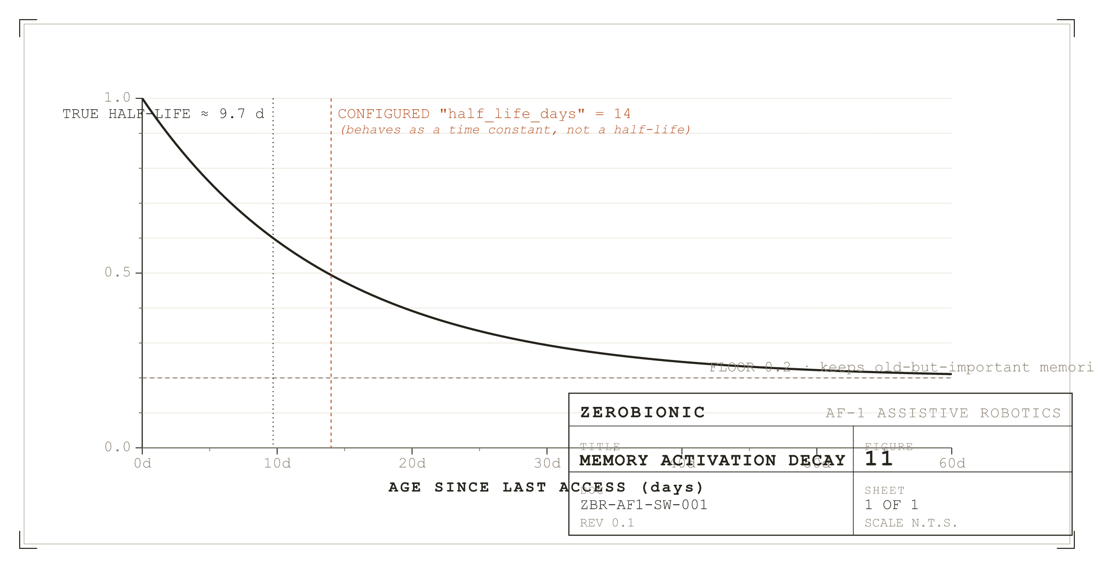
Figure 11
Memory recency contribution against age. The 0.2 floor keeps an old but important fact reachable.
VIII. Generating and Speaking
Generation starts on a background thread before the robot has decided whether to play a filler, so that model prefill overlaps the filler rather than following it. Handing back a bare generator would not do: a generator does not begin work until first consumed, so the worker thread is what makes prefill actually start.
The filler races the reply. A filler is chosen with probability conversation.filler_probability and matched to what was said: an utterance ending in a question mark or opening with a question word gets "good question, let me think"; a reply of two words or fewer gets a short acknowledgement; everything else gets a neutral line. It is then played only if no reply audio has arrived within conversation.filler_grace_ms. A fast answer is therefore never delayed by a canned "let me think". Fillers are pre-synthesised at startup, and that pre-synthesis aborts after two consecutive failures rather than hammering a dead TTS at thirty seconds per call.
The reply is spoken sentence by sentence. A producer thread splits the streaming text into sentences and pushes each sentence's audio pieces onto a bounded queue, while a single gapless output stream plays them as they arrive, so there are no inter sentence pauses. Anything the model writes in parentheses is stripped before synthesis and never enters history, because those are hallucinated stage directions rather than speech.
Two failure modes in this path were fixed and both are worth recording. The producer's completion sentinel must be delivered with a blocking put rather than a non blocking one: with put_nowait the sentinel was dropped whenever the queue was full, which happens as soon as synthesis outpaces playback, and a dropped sentinel left the consumer blocked forever, freezing the conversation in SPEAKING so the robot went deaf after its first reply. Symmetrically, the producer's own queue writes must time out and re check the stop flag, because on a barge in the consumer stops draining and a plain blocking put would wedge the producer thread.
Barge in runs for the whole time the robot is making sound, covering the filler as well as the reply, and triggers on either the wake word or sustained user speech over the reply. Speech based interruption needs no wake word and is echo aware, learning the ambient level for conversation.barge_in_learn_ms and requiring conversation.barge_in_speech_ms of speech at conversation.barge_in_ratio above it. The interrupting words are captured and fed into the next turn's transcription so that the person never has to repeat themselves, but only the trigger window plus a short lead in is kept, because a longer ring buffer's prefix is the robot's own reply echo, and it garbled the following turn.
After an interruption only what was actually spoken enters history, sliced by the index of the last sentence whose audio reached the speaker. The model must not "remember" saying sentences the person never heard. The language model stream is also stopped and its HTTP connection closed, so that the GPU stops generating a reply nobody is listening to. One ordering rule in the barge in shutdown is subtle enough to note. The monitor thread is joined while the microphone is still live, and only then is the microphone paused. Pausing first would block the monitor forever inside the frame iterator, and it would then wake up and steal the next turn's audio off the shared queue, which is precisely how the robot used to go deaf after its first reply.
IX. Command Paths That Bypass the Model
Several utterances are handled before the model is ever consulted, each with its own parser, and each replying with a fixed line. Stop phrases end the conversation. Matching is on word boundaries and only in utterances of five words or fewer, so that a sentence that merely mentions one, such as asking about a film called Goodbye Lenin, does not put the robot to sleep.
Enrolment has two entry points, an explicit command such as "remember my face" and a plain introduction such as "I'm David", and both run the same guided multi angle capture. Object teaching is distinguished from person introduction by the article: "this is a french press" teaches an object, "this is Peter" does not. Behavioural corrections such as "speak slower" or "keep it short" are stored as standing preferences and, where an engine knob exists, applied immediately. Erasure distinguishes forgetting the last item from forgetting a person entirely, and the latter clears the face and voice registrations as well as the stored facts.
X. Deciding When to Speak Unprompted
The hard part of proactivity is staying quiet, and every proactive utterance must pass every gate. A person must be present, and an unrecognised person only counts when proactive.engage_unknown is set. Quiet hours must not be active. The per kind cooldown must have elapsed. The person must not already have been greeted during this arrival, where an arrival ends after proactive.presence_reset_s. And a global cap of proactive.max_per_hour utterances must not be exceeded. Timers and reminders bypass the presence gates, because the user explicitly asked for those, but they still respect quiet hours by being deferred rather than dropped.
On top of the fixed cooldowns sits a bandit style adaptation. Each proactive kind keeps an exponential moving average of how its utterances land, scored in the range minus one to one, and that average scales the kind's base cooldown. An average of zero or unknown leaves the cooldown unchanged. A positive average shortens it, down to half at plus one. A negative average lengthens it, up to three times at minus one. A kind of nudge that keeps falling flat therefore backs off by itself.
XI. Scoring Outcomes and Surprise
Every exchange becomes a reward tagged episode, with the reward assembled from three signals that already exist and cost nothing extra. Affect contributes the speaker's valence and confidence while speaking, on the reasoning that tone is itself feedback. Interaction contributes a negative for a barge in, since being cut off is a verdict, and a mild positive for the conversation continuing within 90 seconds. The strongest signal is an explicit verdict in the opening of the next utterance, matched by two deliberately narrow regular expressions: generic negativity such as "this weather is awful" is affect's job, not a judgement on the robot.
Because a verdict usually arrives one utterance after the reply it judges, tagging is retrospective: the next utterance writes its reward back onto the episode it actually judges. A pending proactive utterance is resolved the same way, with any reply at all counting as a partial success and an explicit verdict overriding. Surprise is scored separately and drives attention rather than reward. The world state keeps online, Laplace smoothed counts of each label and event kind, and scores each new event by its rarity in bits, which is the negative base two logarithm of its smoothed historical share. First ever events score highest, and daily routine decays toward zero. Two thresholds consume that score: events above world.surprise.remember_bits become scene episodes for later consolidation, and events above world.surprise.narrate_bits wake the Tier 2 narrator. The statistics persist across runs as a JSON sidecar, so that the robot's sense of what is normal accumulates over its lifetime rather than resetting at every boot.
SECTION 5
Build and Deploy
The build is deliberately unglamorous. A working ZERO on the AF-1 head requires a Raspberry Pi 5 with an SD card holding Raspberry Pi OS Lite (bookworm, 64 bit), a USB microphone that PortAudio can open at 16 kHz mono, a speaker that PipeWire can route to, an optional USB camera, and network reach to a GPU node where the model servers run. Nothing is unusual about any of those pieces individually. The engineering work is in the order they have to be installed, and in the small number of quirks that reliably consume an afternoon when they are not written down.
I. The Pi Head
The head build starts from a clean Raspberry Pi OS image. The system packages required are documented in scripts/setup_pi.sh and are limited to what PortAudio, PipeWire, and OpenCV need to open the audio and camera devices reliably. The script installs the pipewire-alsa bridge, which is what allows both the microphone (opened as pipewire) and the speaker (routed through PipeWire to a Bluetooth or 3.5 mm sink) to coexist without fighting for the same ALSA card. The script does not install torch, and it does not install any large model dependency, because the Pi is a frontend and everything that would consume its RAM lives on the far side of the tunnel. The one exception is the local fallback stack, which is installed optionally by a separate step so that the fallback is available if the tunnel drops without loading whisper.cpp and Piper into memory in the common case.
The Python environment is a plain virtual environment under the repo root. The zero package is installed in editable mode so that a git pull is the whole update procedure. Runtime dependencies are pinned in requirements.txt, and optional vision requirements (opencv-python, the ONNX runtime bindings for YOLO and ArcFace and ECAPA) are pinned in requirements-vision.txt. The split matters on an 8 GB machine: a Pi with no camera does not need to import opencv, and the audio-only path stays importable in isolation, which makes it easy to bring up a voice only robot on a smaller board or to bench test the language stack without a camera present. The ONNX Runtime is the CPU build; there is no ORT CUDA package installed on the Pi, because the GPU node is where CUDA lives.
Model artefacts are acquired by a small download step, not baked into the repository. The wake model, the Silero VAD ONNX, the whisper.cpp weights, the YOLO detector, the ArcFace and ECAPA models, and the Piper voice each have a documented URL and a checksum. The scripts pull them into a models/ tree under the repo root, and none of them exceeds a few hundred megabytes on their own; the sum is well under two gigabytes even with every fallback populated. Where the upstream ships in a format ONNX Runtime cannot load directly, a small conversion step in scripts/export_yolo_onnx.py or the equivalent produces the runtime compatible file, and writes a sibling names JSON that the loader auto detects. A missing model file does not crash the process; the factory returns None for that faculty, and the loop runs without it.
Local device selection is the one calibration step the operator has to do in person. The USB microphone that arrives from the factory does not know which ALSA card it will land on, and the correct audio.input_device value is whichever PortAudio index actually resolves to the intended microphone on that Pi. A short interactive helper prints the enumerated devices with their index, name, and default sample rate, and the operator writes the chosen index into config.local.yaml. That file is merged over config.yaml at startup so that per machine values never diverge from the canonical config in the repository. The same file carries the camera index, any input gain adjustment, and the GPU_HOST that pi_tunnel.sh will connect to.
II. The GPU Node
The GPU node build is a set of independent server installations that share a card but not much else. Faster-Whisper large-v3-turbo, Orpheus's vLLM server, the vision FastAPI application, Ollama with the gemma4 and nomic-embed-text models pulled, and optionally a self hosted SearXNG container each have their own installation instructions in the scripts/server_setup/ tree. None of them depend on each other, and each of them can be started, stopped, and rebuilt independently. The shared concern is memory pressure: the card holds five models between them, and loading all five naively will evict one at random every time a call arrives. Two workarounds reduce that pressure. The KV cache is quantised to q8_0 by the run_gpu_servers.sh script, which roughly halves the KV footprint of the chat model, and the embedding model is a small (~275 MB) dedicated model kept pinned with keep_alive=-1 so that recall never load churns against the chat model. The card can handle it, but only with those two settings on.
The launcher script is idempotent. It reads a list of expected ports, checks whether each is already listening, and skips anything that is up. Anything that is missing is started under setsid nohup so that the launching shell can be closed without killing the servers. That is the mode used during development. In production the same servers are managed by systemd units carried in scripts/systemd/, so a restart of the node comes up with everything running without an operator on the box. Model artefacts on the GPU side live in a shared models directory per server; nothing is packaged with the repository, and every server has a documented pull step for its weights, with checksums where the upstream provides them.
III. The Tunnel and Systemd
The tunnel is opened by scripts/pi_tunnel.sh, which sets StrictHostKeyChecking=accept-new so that a new host key is trusted on first sight rather than hanging on a prompt (a systemd service has no one to answer a prompt), enables ServerAlive keepalives at 15 seconds so that a stalled tunnel drops within roughly 45 seconds and autossh rebuilds it, and uses ExitOnForwardFailure so that a taken local port is a fast fail rather than a partial forward. The full forward set is 11435 to 11434 for Ollama, 9000 to 9000 for Whisper, 9100 to 9100 for Orpheus, 8000 to 8000 for the vision stack, and 8080 to 8080 for SearXNG. In production the tunnel runs as its own systemd unit, zero-tunnel.service, so that a reboot brings it back automatically.
The ZERO process itself runs as zero.service. The unit sets Restart=on-failure with a short backoff, sends stdout and stderr to journalctl (which is where every "listening..." heartbeat and every "utterance: rms=" line lands, and which is where triage in Section 12 looks first), and holds a KillSignal=SIGINT because SIGINT is what lets the loop cleanly hand off to memory-save before exit. The optional zero-preview.service holds the localhost bound MJPG stream on port 8008 when the operator wants to see what the robot is seeing.
IV. First Run Verification
The intended first run sequence is worth writing out because it is the fastest way to catch a wiring mistake before it is buried under two other layers of it. On the GPU node, bash scripts/run_gpu_servers.sh and then curl each health endpoint; a JSON body with ok:true from each of 9000, 9100, 8000, and a tags list from 11434 tells you the node is alive. On the Pi, bash scripts/pi_tunnel.sh and curl the same endpoints via 127.0.0.1; success means the tunnel is up on all five ports. Then systemctl start zero, curl 127.0.0.1:8090/health until ready flips true (usually within ten seconds), and say the wake word. The first "listening..." heartbeat in the log confirms audio is arriving. The first "utterance: rms=" line confirms the VAD is engaging. The first "endpoint: committed" confirms endpointing is deciding. Every following diagnostic in Section 11 uses these same lines.
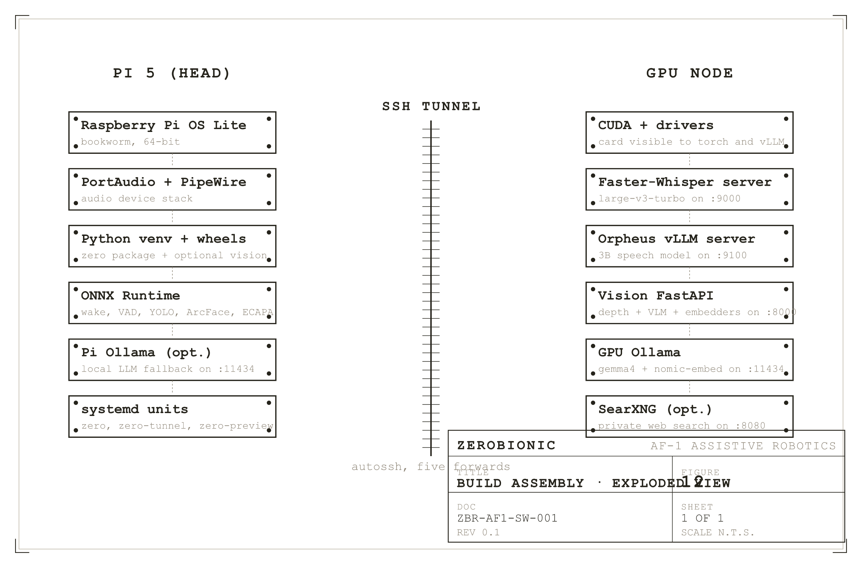
Figure 12
Build assembly, exploded. The Pi head stack and the GPU node stack are two separate deployments joined by one tunnel.
SECTION 6
Testing and Validation
Testing an interactive voice system honestly is harder than testing a web backend, because the answer to "does this work" is not primarily a matter of correct output for a given input. It is a matter of latency budgets, of graceful degradation, and of the small courtesies of pacing, turn taking, and self correction that a person notices immediately in their absence. The test matrix therefore has three layers. The lowest layer is unit and integration tests in the tests/ tree, which pin the non negotiable contracts and the fixed bugs so that they cannot regress. The middle layer is a small set of harnesses that exercise faculties end to end against captured audio, video, and log fixtures. The top layer is manual acceptance procedures for the behaviours no automated test can credibly evaluate.
I. Automated Coverage
The tests/ tree is small and focused. It covers the state machine's legal transitions and its refusal to crash on illegal ones, the Conversation history trim and compaction logic (append cheap, trim rare, never dangle an assistant message), the recall activation ranking including the recency floor and the frequency dampener, the endpointer's tri state semantic hold in each of its three arms, the identity fuser including the disagreement branch, the guest gates that stop Whisper hallucinations minting phantom guests, the event bus overflow behaviour that drops rather than blocks, the reward clamp, the surprise scorer's Laplace smoothing, the visual question classifier's exclusions of bare demonstratives and polysemous verbs, the stop phrase length gate, and the audio pipeline's resampling behaviour when a device rejects 16 kHz. Each test names the exact bug or contract it protects, so that a failure points at what would break if the code were changed the wrong way.
Integration is done by driving the process from the outside through its actual doors. A test client posts to POST /zero/turn_text with a canned utterance, awaits {ok:true, reply}, and asserts on the reply's shape rather than its literal text (because the model's phrasing will vary between runs). The same client can post a captured WAV to POST /zero/turn and assert both that heard matches the ground truth within a small edit distance and that reply is non empty. Those tests run against a running instance in CI mode, where the language model is pointed at a small local model rather than the production GPU so that the tests do not depend on the shared card being available.
II. Bench Harnesses
The interesting numbers are produced by bench harnesses that live under scripts/bench/. The microphone harness records a fixed utterance, plays it back through the mic loop, and prints the RMS, peak, VAD decision, and endpoint latency; it is the calibration path used to tune input gain and the energy threshold on a new microphone. The voice ID harness enrols a handful of speakers and then plays back held out utterances, printing the fused score, the single channel scores, and whether the write score threshold was met; it is how identity thresholds are trimmed on a new microphone or a new speaker demographic. The detection harness runs a set of held out frames through both the YOLO World and the closed set YOLO detectors and reports labels, confidences, and the per frame time; it is how the perception team keeps the class list honest as the scene vocabulary grows. The wake word scoring script tails the near miss log, prints the distribution of accepted and near miss scores, and suggests a threshold that would have accepted the recent accepts without accepting the recent near misses; that is the loop by which wake.threshold is adjusted after a period of use in a new room.
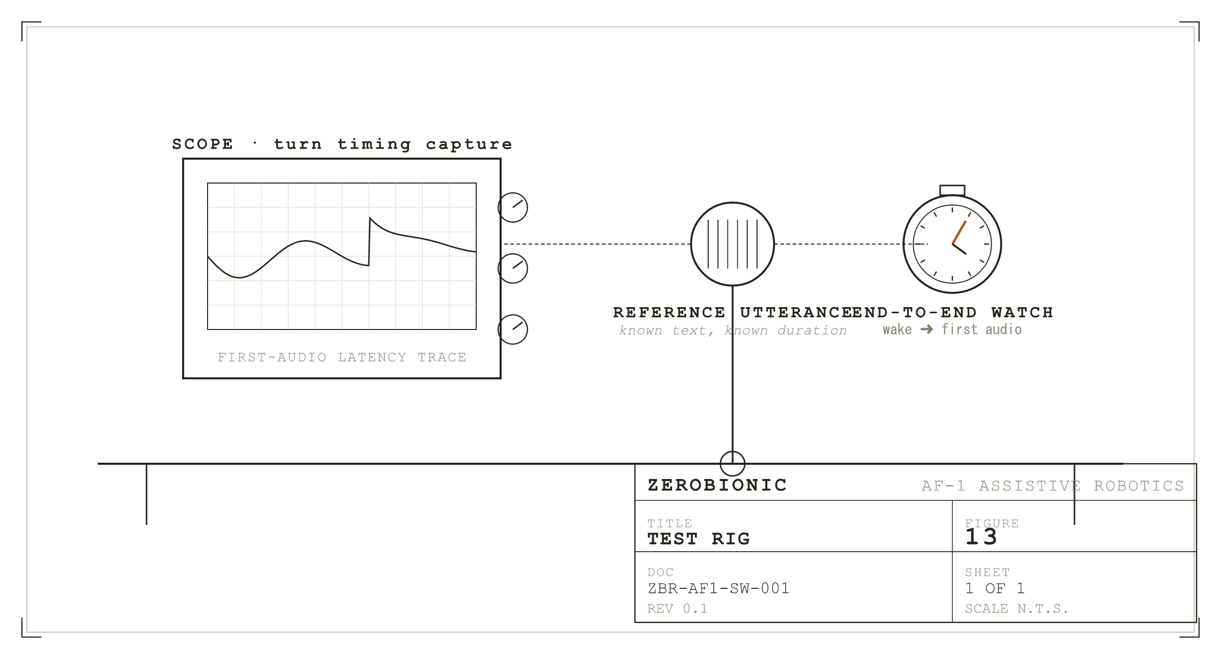
Figure 13
The test rig. A known utterance, a scope for turn timing, a stopwatch for end to end.
III. Acceptance Criteria
The numeric thresholds against which the subsystem is judged are set at levels that come from an ordinary living room with an ordinary microphone, not from a lab. Wake word false accepts are budgeted at under one per hour of quiet room time; false rejects at under one in twenty deliberate wakes. Endpoint commit latency after true speech end is budgeted at 450 ms plus the adaptive doubling on short utterances, measured from the last speech frame to the endpoint fire. Transcription accuracy on the internal evaluation set is judged as word error rate on the confirmed final transcript, and the target is under 8 percent in English and under 15 percent on English/Swahili code switched turns; the speculative transcript's reuse rate (its verbatim prefix match against the final) is targeted at over 60 percent under typical conditions. First token latency from endpoint commit to the model's first token is targeted at under 800 ms in the healthy path (tunnel up, chat model resident, embed backend responsive), and first audio at under 1200 ms from endpoint commit. Detection is judged by mAP on the internal evaluation frames, with a floor targeted at the numbers each of the two detectors produces on their published benchmarks minus a small tolerance for the export step. Identity precision is measured at the write score threshold on a held out multi speaker recording, and the target is above 0.98 precision, understanding that a lower recall (a borderline turn simply not writing) is preferable to a higher recall that risks writing one person's fact into another person's record.
IV. Manual Procedures
Two behaviours have no honest automated proxy, and both are checked manually before every release. The first is barge in in its full form: say the wake word, ask a question that will produce a long reply, and then interrupt it mid sentence with a follow up question. Acceptance is that the follow up is transcribed correctly, the model's next reply addresses it (rather than resuming the interrupted answer), and only the sentences the person actually heard end up in the conversation history. The second is proactive quiet, which is the property that the robot never speaks when it should not. A person enters the room and stays for five minutes; the robot may greet on arrival (once) and may ask up to one curiosity question during the linger, but it must not chatter, and it must respect quiet hours and the per hour cap. Both procedures are run against a fresh reboot rather than a warm process, because most proactive bugs hide behind cached state.
SECTION 7
Failure Modes and Recovery
The philosophy of failure handling in this subsystem is that the loop must not die and the robot must not lie about what is wrong. Everything that follows is a specific application of those two rules. The loop survives by catching the exceptions that would otherwise unwind through it, and the robot stays honest by exposing degradation flags that the persona prompt sees, so that "why are you slow" produces "my fast hearing is down, I am transcribing locally" rather than an evasive apology.
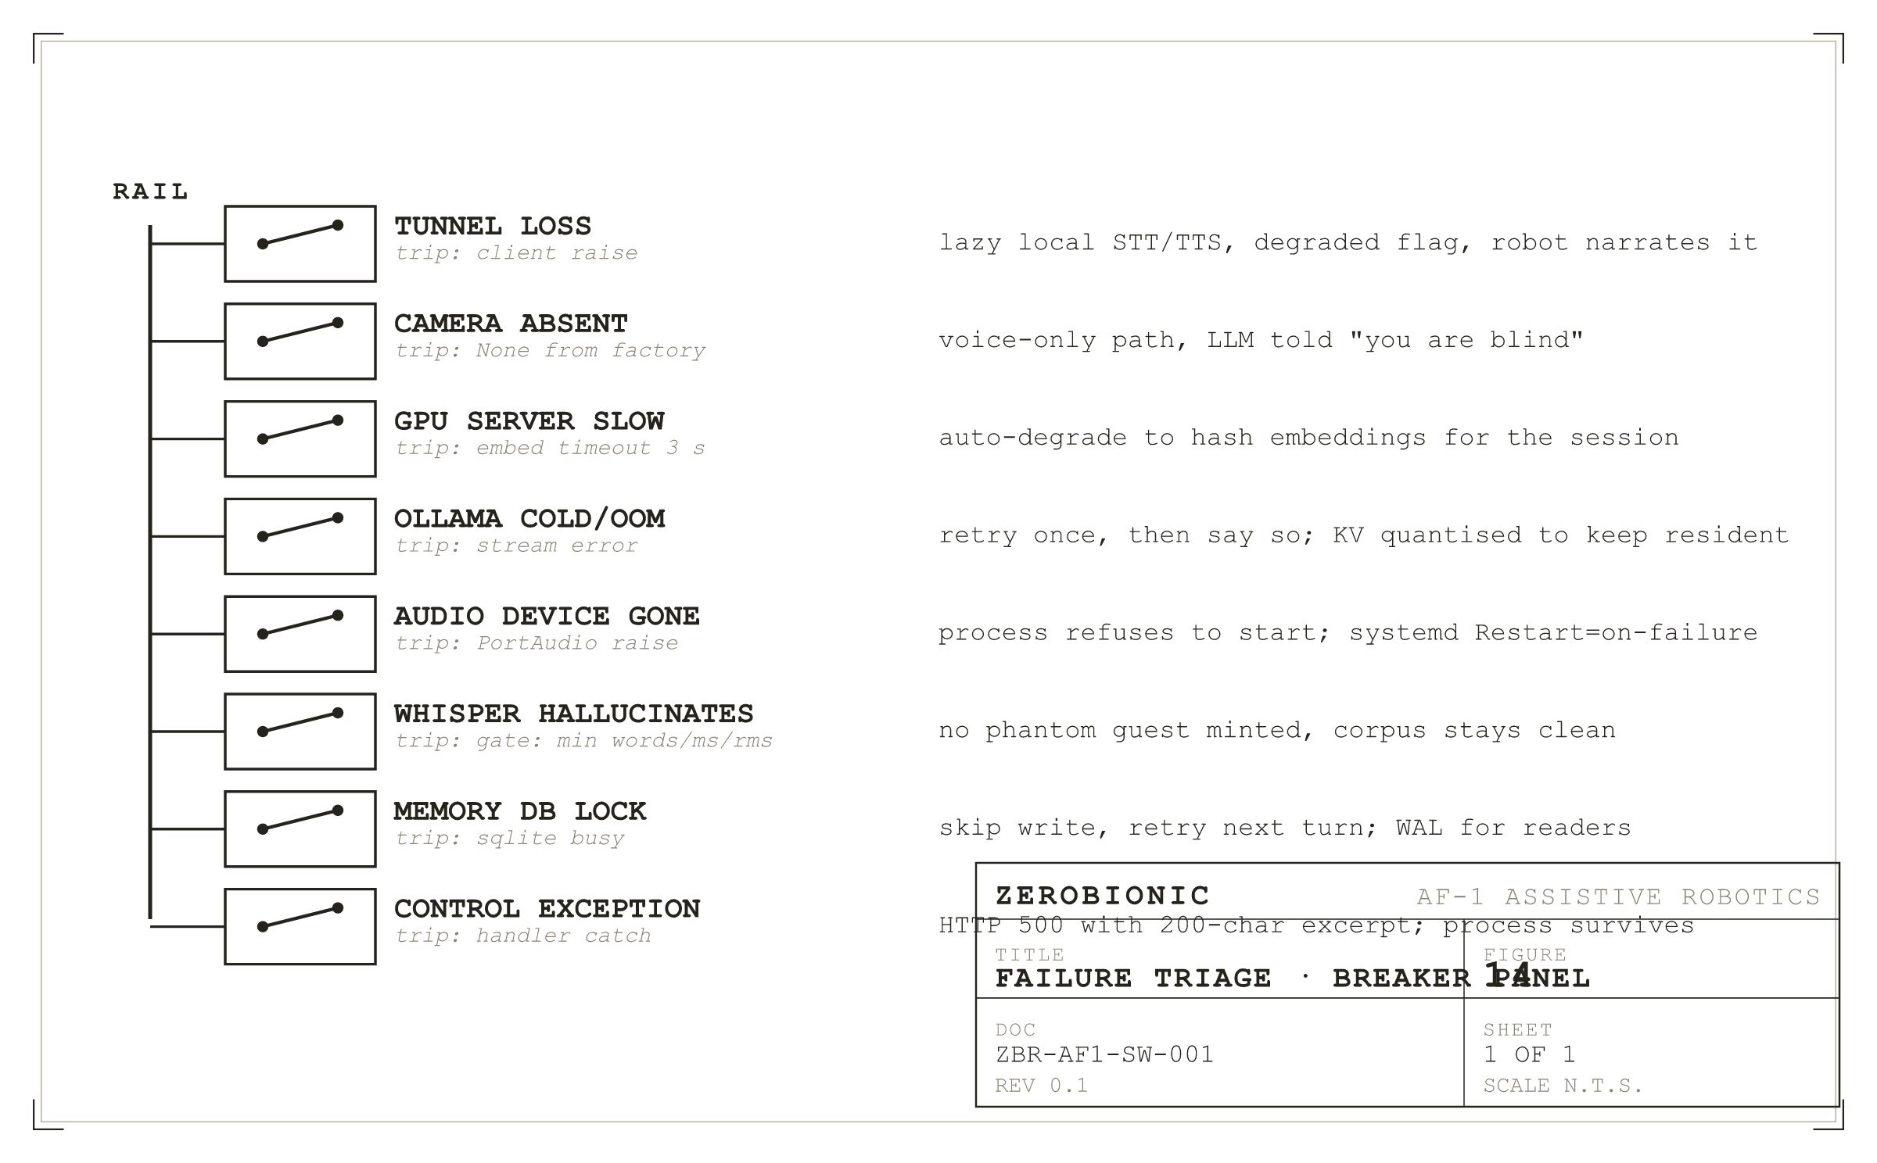
Figure 14
Failure triage as a breaker panel. Each failure has an explicit trip and an explicit response.
I. Tunnel Loss
The most consequential failure the subsystem has to handle is the loss of the SSH tunnel, because it takes out five faculties at once: Whisper, Orpheus, the vision server, Ollama, and SearXNG. autossh detects the stall within roughly 45 seconds and rebuilds the tunnel, but during those seconds the fallback wrappers must keep working. Each of the six FallbackXxx classes catches the RuntimeError raised by its remote client, sets its degraded flag, lazily builds its local implementation if not already built, and dispatches to it for the remaining calls that turn. The next turn tries the remote again, and if that succeeds the flag clears and the local implementation stays in memory ready for the next drop. The pattern is per call rather than per session: a tunnel that flickers back within one turn does not force a whole session to run on backup voices.
The self state narration described in Section 2.IV is what makes this visible. On the transition into degraded, a short note is appended to the persona prompt telling the model, for the STT case: "your fast hearing is offline, you are transcribing on the Pi itself, that is why you feel slower". On the transition out, a mirror note reports that the fast path is back. The model reads these as facts about itself and can say so when asked. The alternative, silent degradation, produces a robot that seems arbitrarily worse, and a user who does not trust it.
II. Camera Absent
A camera that fails to open at startup is detected by the factory returning None for vision.enabled. The main loop reads that None and never asks a vision question again for the life of the process. The persona prompt is seeded with a note that the robot is blind for this run, and the visual question classifier gates every downstream check on vision availability. There is a small trap here: the presence answer, "is there a person in front of you", must return an unambiguous "the camera never came up" rather than the more general "no one is in frame", because the model treats those two situations differently. The distinction lives in the presence check itself and is one of the more carefully tested behaviours in the loop.
III. GPU Server Slow or Cold
A slow embedder is the most common performance regression and the most misdiagnosed. The symptom is a first token latency in the low seconds when the healthy target is under a second. The cause is usually that the embedder has been evicted from GPU memory by another model and has to reload on first call, which stalls the chat model in turn because they share the card. Two mitigations sit inside the subsystem. The embed timeout is 3 seconds; on breach, the memory subsystem auto degrades to the hash fallback embedder for the rest of the session, so that the reply path does not keep paying that cost. And the recall thread is joined under a hard 300 ms budget, so that a slow embed misses this turn's recall entirely rather than dragging the reply along with it. Both of those decisions were made after diagnosing multi second first token lags that turned out to be entirely downstream of the shared card, not of ZERO's own code.
A cold Ollama is a separate failure and looks like a several second first token latency on the first turn after a restart, followed by normal latency thereafter. This is model load time, and quantising the KV cache is what keeps it rare rather than eliminating it. The health endpoint of the LLM client returns a ready flag distinct from the control plane's own ready flag, and the warmup call is what flips it true; the control plane's ready waits on the warmup completion, which is why the first health probe after a Pi reboot may take up to ten seconds to answer true.
IV. Audio Device Loss
A USB microphone unplugged mid conversation raises inside PortAudio. The loop catches this on the capture side and, rather than trying to recover automatically (which would require re enumerating devices, a step that can hang), it logs a clear diagnostic and exits. Systemd restarts the process on failure, and the fresh process re-enumerates cleanly. This is the one place the subsystem chooses to die rather than degrade, because a persistent process holding a stale device handle is worse behaviour than a fresh process holding a live one.
V. Whisper Hallucinates Text
Whisper hallucinates plausible text from near silence, producing outputs such as "Thank you for watching" and "Obrigado" that read as real turns to any downstream consumer that trusts the text. Those strings were minting phantom guests before three quality gates were added: an utterance must have at least identity.guests.min_words words, at least identity.guests.min_ms of audio, and at least identity.guests.min_rms in level to be eligible for guest assignment. Each of the three catches a different failure mode (a hallucinated short greeting, a burst of background noise picked up as a phrase, a distant television), and together they are the reason the corpus stays clean enough to train against. This same set of gates is what distinguishes an "utterance dropped, still listening" line in the log from an "utterance committed" line.
VI. Memory Database Lock
SQLite raises OperationalError when a writer holds the database during a write. The subsystem's response is uniform across stores: catch the exception, log it at info level with the operation name, skip the write for that turn, and continue. The next turn retries. The episode store runs in WAL mode specifically so that this contention is rarer, and the memory store is written on turn boundaries rather than in the middle of speech, so a missed write does not degrade the conversation itself. A locked database is never a fatal error; a corrupted database is, and it presents as a sqlite3.DatabaseError on open, at which point the file is renamed with a timestamp and a fresh empty database is created. The renamed file remains on disk for later inspection.
VII. Control Plane Exceptions
Every handler is wrapped in a try/except that catches everything, logs the traceback, and returns HTTP 500 with the exception text truncated to 200 characters. The truncation is a size guard against a long stack trace being returned to a browser; the logged traceback is the full text. The one class of exception the control plane treats specially is a decode failure on POST /zero/turn, which returns HTTP 422 with the tail of ffmpeg's stderr, because a caller sending an unsupported audio container needs to see why. Everything else is 500.
VIII. Single Instance Discipline
Two ZERO processes on the same Pi are a failure mode in themselves: they would both open the microphone, both post events onto their own buses, and produce a robot that answers each turn twice. A single instance lock, held on a well known file, prevents a second process from starting; the second exits immediately with a clear message. This is enforced at the process level rather than at the systemd level because ad hoc runs (an operator launching a bench version by hand) are the common cause, not the service manager. The lock is released on clean exit and released by the kernel on unclean exit, so a crashed process does not leave the machine unable to start a fresh one.
IX. What Is Deliberately Not Handled
Not every exception is caught, and the ones that are not are named here so that the choice is deliberate rather than accidental. A KeyboardInterrupt propagates through everything, because that is the only way to stop the process from a terminal cleanly. A SystemExit propagates for the same reason. An out of memory error propagates because the process cannot honestly continue after it, and letting systemd restart is the correct response. A bug that raises during the factory build is fatal, because the loop cannot start; that class of error is caught during setup, not at runtime.
SECTION 8
Configuration and Calibration
The behaviour of the subsystem is set by a single YAML file at the repository root, config.yaml, which is deep merged with an optional config.local.yaml at load time so that per machine overrides never collide with the canonical values kept in version control. Every key in config.yaml is documented in place with a short prose note explaining what it does and, more importantly, what the failure mode of setting it wrong is. That inline documentation is authoritative; the walk in this section explains the shape of the file and the small number of keys that carry the most consequence.
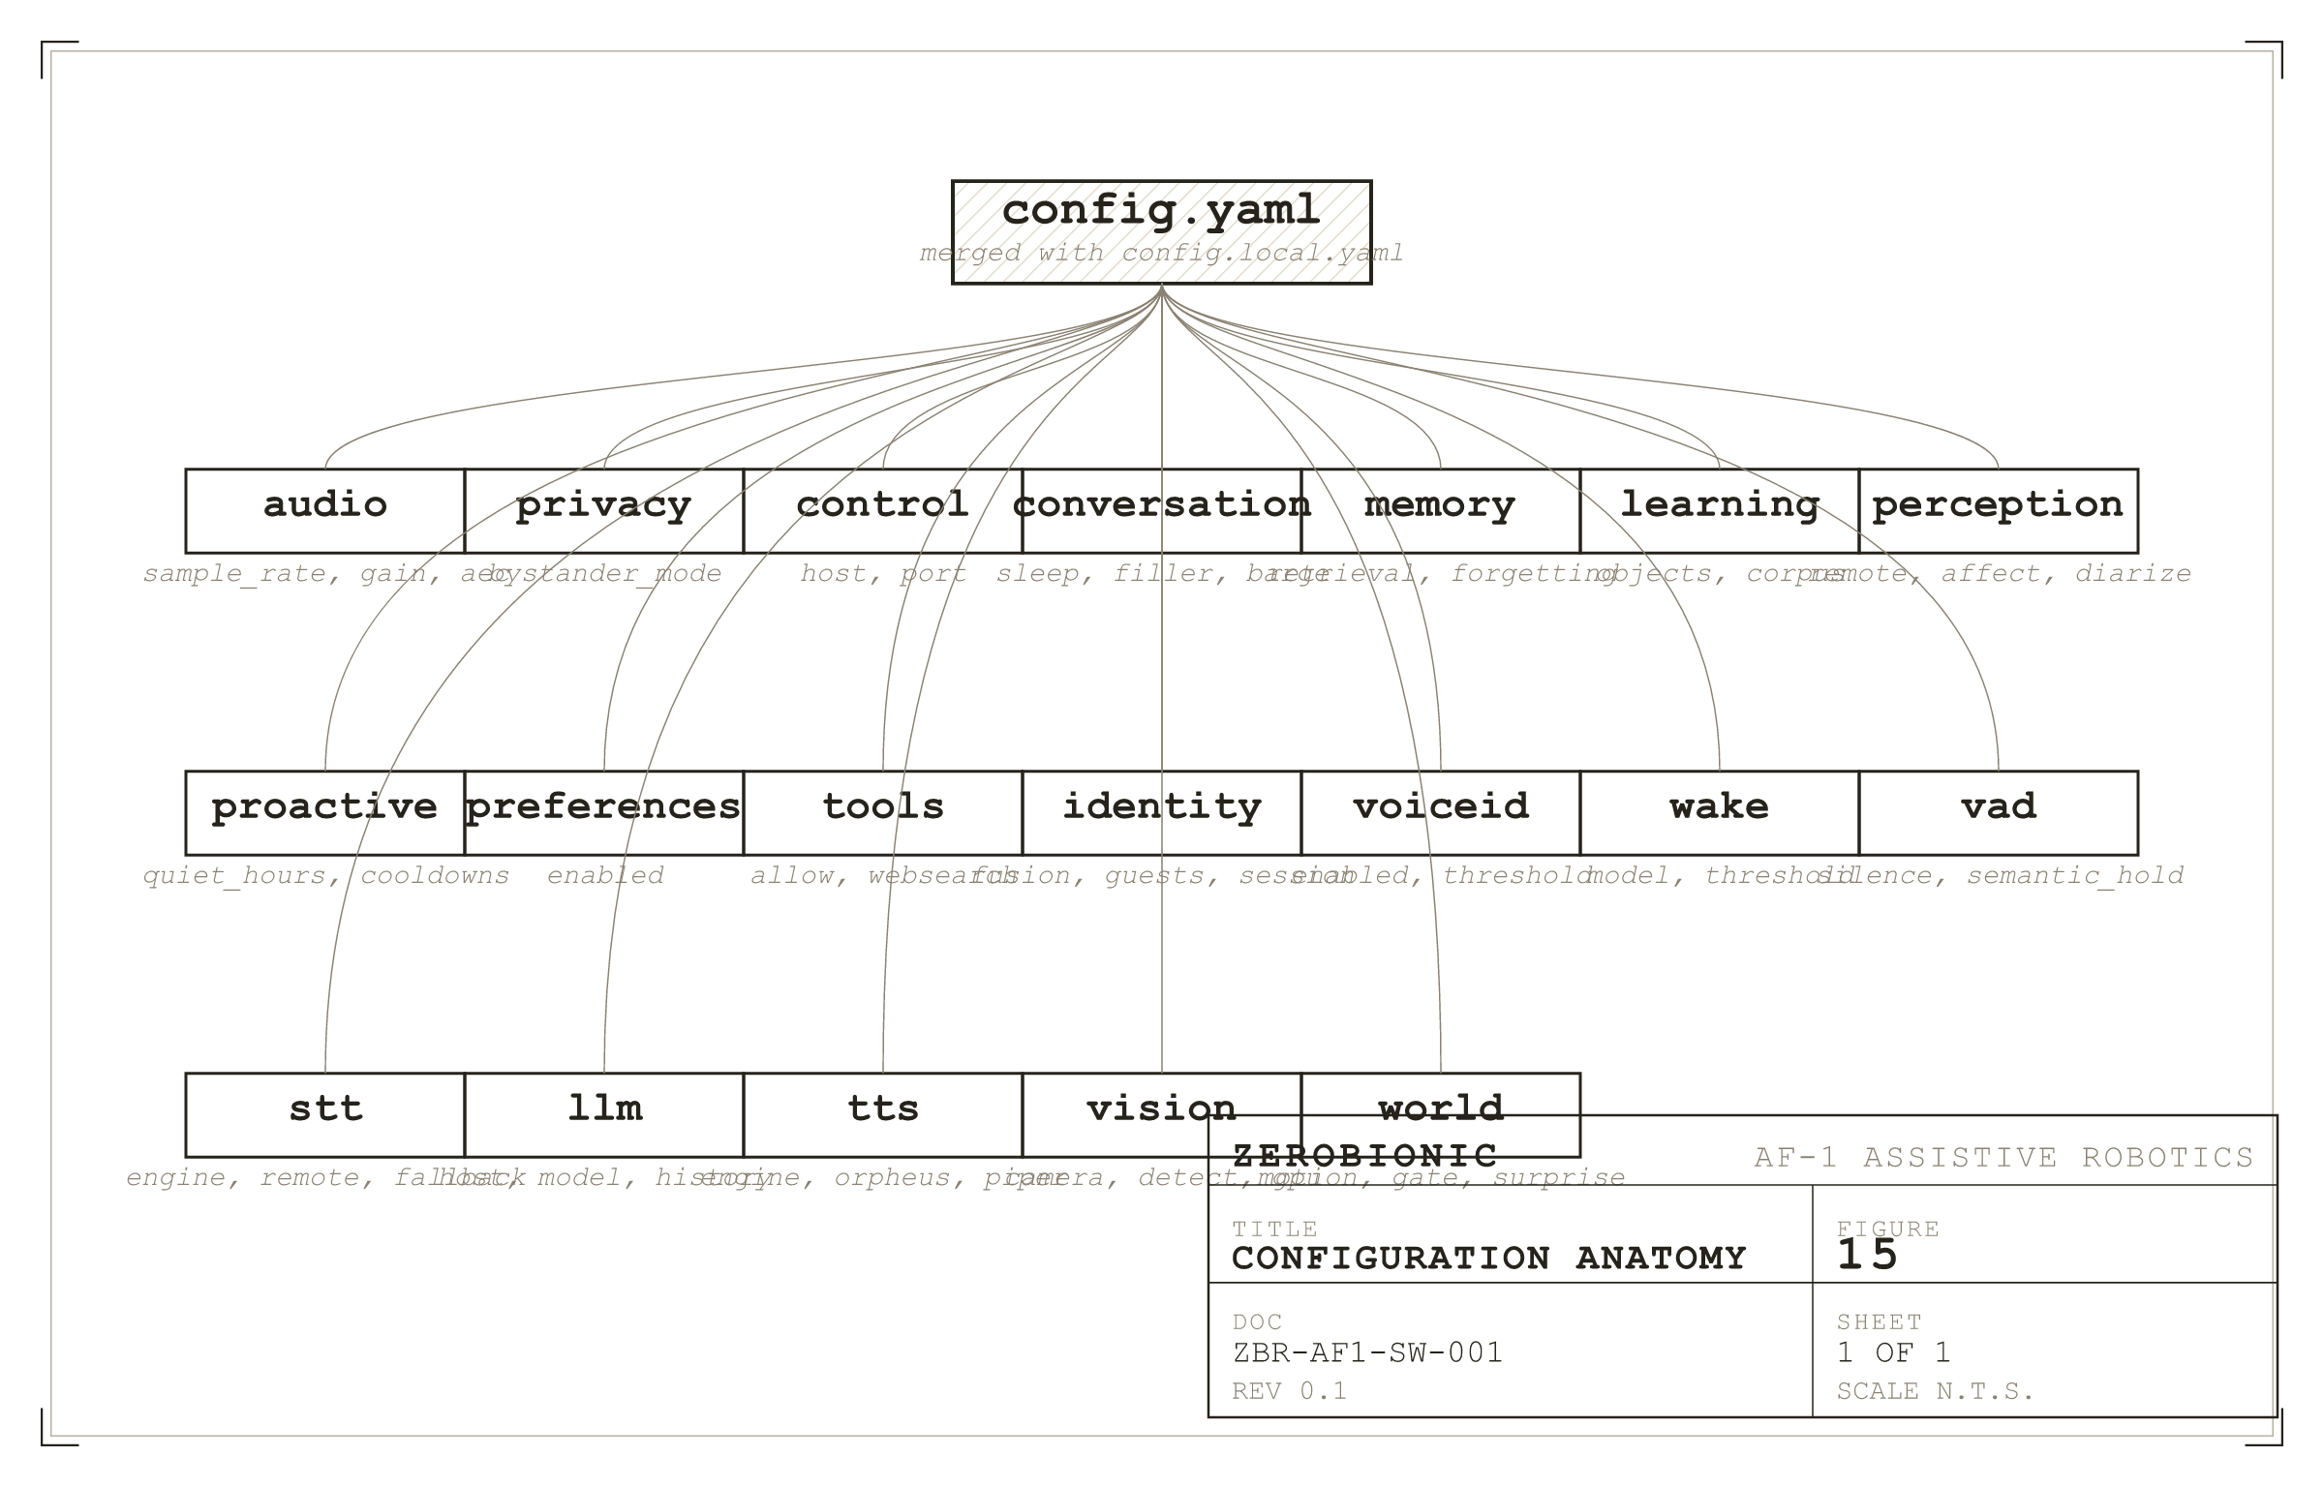
Figure 15
Configuration anatomy. Every top level block is a faculty; every leaf is documented in place.
I. The Top Level Blocks
The file is organised as one top level block per faculty, and the blocks are the ones you would expect from Section 2: audio, privacy, control, conversation, memory, learning, perception, proactive, preferences, tools, identity, voiceid, wake, vad, stt, llm, tts, vision, and world. A missing block is treated as an empty block, so a minimal config file is a valid config file, and every default is taken from the in code default. The intent is that a fresh install works with an untouched config.yaml, and that customisation is additive: an operator writes only the values they need to change in config.local.yaml, and the rest is inherited.
II. Audio Calibration
The audio block carries the values that determine whether the robot can hear the person in the room at all. sample_rate is fixed at 16000 and there is no supported reason to change it. block_ms is 30 by convention and matches every downstream consumer; changing it is a system wide edit rather than a config change. input_device names the PortAudio device by string ("pipewire") rather than by index, so that a USB re-enumeration does not break the pipeline. input_gain is the multiplier applied before int16 conversion, and its calibration is done by watching the "utterance: rms=" log lines and adjusting until normal speech lands in the range 2000 to 6000 with peaks well under 32767. The shipped default of 6.0 is what a Logitech BRIO produces on a typical desk setup; a headset microphone will need much less, and a distant boom will need more. The consequence of getting this wrong is either clipping (peaks at 32767, degrades transcription accuracy noticeably) or under drive (rms in the low hundreds, the wake model fails to fire even on a shouted wake word).
output_device selects the speaker sink via PipeWire's default, which is the mechanism that lets a Bluetooth speaker or the 3.5 mm jack be selected without touching this file. The acoustic echo cancellation block, aec, ships disabled because it needs the wired output path (Bluetooth's drifting latency defeats the filter) and it depends on speexdsp being installed. When enabled, filter_ms controls the echo tail the filter can absorb and should be raised in a live, reflective room.
III. Voice Endpointing
The vad block is where a robot that feels responsive or unresponsive is actually set. engine selects webrtc or silero, and the choice depends on the acoustic environment more than on the microphone: webrtc is softer and catches quiet speakers, Silero is sharper and rejects noise better. silence_ms is the trailing silence in milliseconds that ends an utterance and is the single knob most likely to be tuned in the field; 450 is a compromise that feels natural to most speakers. semantic_hold is true by default and turns on the mid thought protection described in Section 4.IV; the tri state hold requires semantic_hold_wait_ms as its bound, which ships at 600 and should not be lowered under 300 without also verifying that the STT round trip meets that number. energy_threshold is the RMS floor a single frame must exceed to start an utterance, and it is kept deliberately low (150 as shipped) because the VAD is the real speech detector; making this higher rejected real speech in field tests. min_utterance_rms is the proximity gate that drops a whole utterance whose average level is too low, and it too is kept low (30 as shipped) because sad or tired people speak quietly, and dropping their words is a human feel bug.
IV. Identity and Memory
The identity block carries the fusion weights, the fused threshold, and the strict per channel thresholds for the disagreement branch. The shipped values are w_face 0.55, w_voice 0.45, fused threshold 0.50, face 0.42, voice 0.45. The one value that requires the most care during tuning is identity.session.write_min_score, which ships at 0.55: it is the bar a turn must clear to write into a person's durable memory. A lower value produces more writes but more cross contamination between speakers; a higher value produces fewer writes but the robot forgets recognised people. The guests sub block carries the min_words, min_ms, and min_rms gates that stop Whisper hallucinations minting phantom guests, and those are shipped conservative on purpose: it is better to leave a real guest unminted than to mint a phantom one, because a missing guest is invisible and a phantom guest pollutes recall.
The memory block carries the retrieval budget, the top_k, the decay parameter, and the forgetting settings. half_life_days is the name of the decay parameter and it ships at 14; as noted in Section 4.VII and 14, this is used as a time constant, not a half life, so the true half life is about 9.7 days. budget_ms is 300 and is the hard cap on the recall thread; if a recall is not returned in that window, the turn proceeds without the note. This is the value that prevents a slow embedder from dragging first token latency into the multi second range.
V. LLM, TTS, and Vision Selection
The llm block chooses the engine, the host URL, the model, and the history sizes. host is the SSH tunnel local port, 127.0.0.1:11435 by default, and it is the field most often edited wrongly during development: pointing it at 11434 breaks the tunnel offset, and pointing it at a remote address exposes the LLM to the network. model is the Ollama model name and defaults to gemma4:latest. history_turns and history_trim_at are 6 and 12 by default; they encode the cache friendly trim policy of "grow to 12, trim to 6" that keeps most turns append only and pays the full re-read cost rarely.
The tts block chooses orpheus, piper, or fish, with a fallback engine named for the case where the primary fails. The orpheus sub block carries the URL, voice, and prebuffer_ms; the last of these is a jitter buffer that pre-accumulates 300 ms of audio before playback starts, which is what prevents a brief generation hiccup from underrunning the speaker mid word. The piper sub block names the binary and the voice model, and length_scale sets the base speaking rate that the orchestrator nudges around per segment.
The vision block carries the camera geometry, the detection cadence, the detector model path, and the GPU vision server URLs. camera.mjpg is true by default because most USB webcams cannot sustain raw YUYV at 640x480x30 and return no frames without it; MJPG is the reliable path. detect_interval_s is the minimum time between detection calls and is 0.1 by default; that is fine on a healthy tunnel and is the value to raise when the GPU is saturated. gpu.enabled controls whether the grounded distance and bearing facts are computed at all; it ships off because the multimodal LLM reads position straight from the frames and distances-in-metres was reading clinical rather than helpful.
SECTION 9
Performance and Resource Budget
Performance in this subsystem is dominated by three things: the CPU budget on the Pi, the KV cache budget on the shared GPU, and the round trip latency across the tunnel. Nothing else is close. The prose below walks each of them and then reconstructs the end to end latency budget that the whole design was written against.
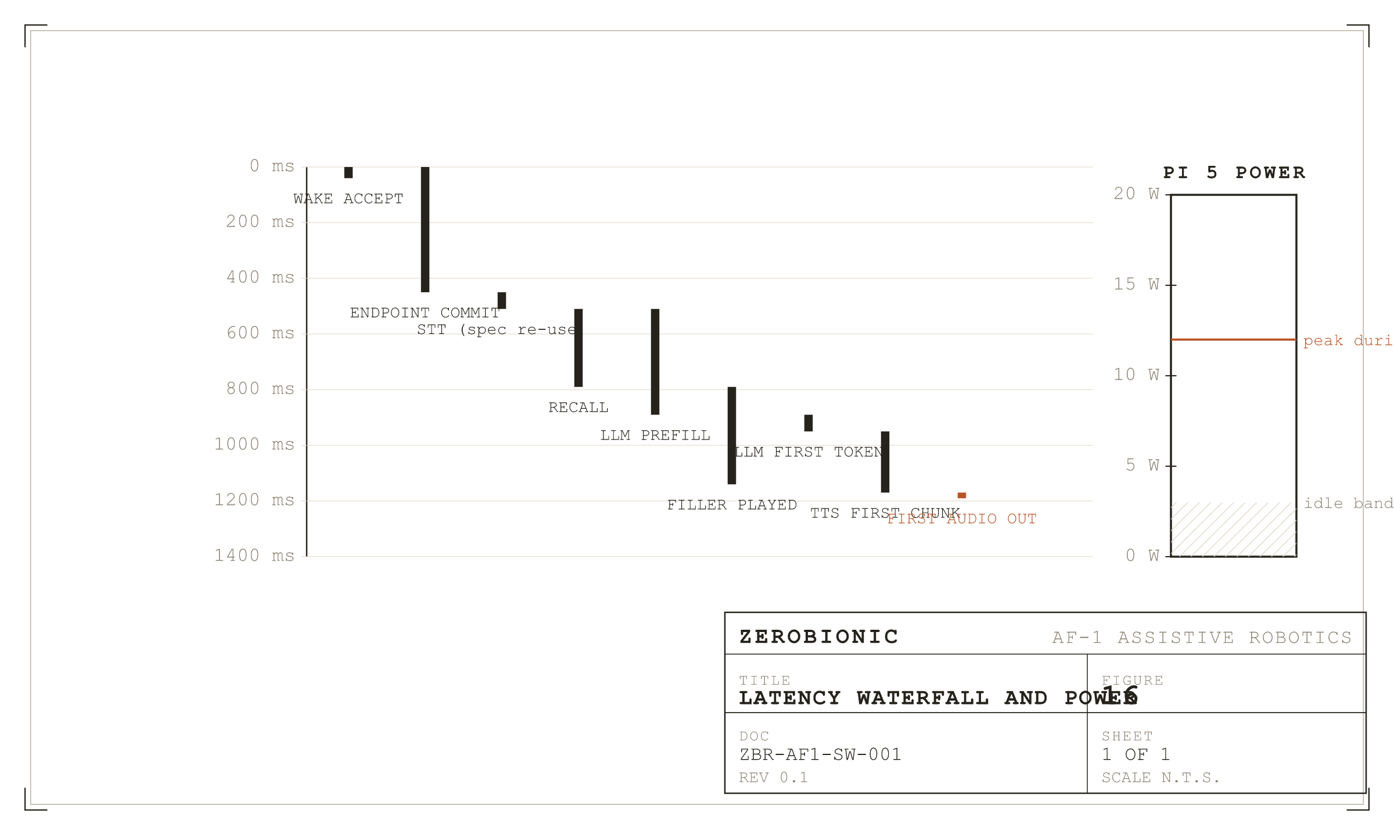
Figure 16
Latency waterfall for a healthy turn, alongside the Pi 5 power envelope.
I. Pi 5 Resources
The Pi 5 in the AF-1 head has 8 GB of RAM and four Cortex A76 cores. The ZERO process, in its shipped configuration with the camera on and the identity models loaded, holds around 1.6 GB resident. The bulk of that is the ONNX Runtime working sets for YOLO World, ArcFace, ECAPA, and Silero, plus the numpy audio buffers, plus the Python interpreter itself. The single largest transient allocation is the audio buffer for a maximum length utterance at max_utterance_ms of 15 seconds, which is a few hundred kilobytes and is bounded. CPU usage varies by state: idle sits around 8 percent (motion detection at every frame plus the wake model), a listening state during speech sits around 20 percent (wake stops, endpointer engages, detector runs faster while the scene is moving), thinking sits around 30 percent during identity and diarisation, and speaking sits around 15 percent while playback and the TTS producer share cores. The 60 percent detector duty budget is the ceiling that prevents the perception loop starving the frame grab under a busy scene.
Power on the Pi 5 is not directly measurable from software, but under the workload described above the head draws around 3.5 W at idle and peaks around 8 W during a THINKING+SPEAKING phase where the detector and the TTS producer are both hot. Thermally, an un-heatsinked Pi 5 will throttle during long conversations in a warm room; the AF-1 head assembly carries a passive heatsink specifically sized for the observed peak, and thermal throttling has not been observed in the current thermal design under normal operation.
II. GPU Resources
The GPU node's card is shared by five models: the chat model (gemma4 8B at fp16 or its published quantisation), Whisper large-v3-turbo, Orpheus 3B, YOLO11x, and CLIP plus the face models on the vision server. The KV cache on the chat model is where the pressure manifests: at num_ctx 8192 the chat model's KV cache alone can push the card into OOM and cause it to evict whichever model was loaded most recently. Two settings turn that from a common failure into a rare one. num_ctx is set explicitly to 4096, which halves the KV footprint without materially reducing the effective context (persona plus memory plus six turns fits comfortably). OLLAMA_KV_CACHE_TYPE is set to q8_0, which halves the KV footprint again. With both in place, the chat model, Whisper, Orpheus, and the embedder can all stay resident.
The dedicated embedding model (nomic-embed-text, roughly 275 MB) is pinned with keep_alive=-1 so that recall never has to load-churn it against the chat model. Before that pinning, a slow embed reliably forced the chat model to reload on the next turn, and the observed symptom was a first token latency of six or more seconds instead of under one. This was the single largest first token regression the subsystem has fixed.
III. End to End Latency
The healthy latency chain from a spoken end of turn to the first audible response is roughly the following. Zero to about 180 ms is consumed by the endpointer detecting the pause and calling back into the speculative STT worker. From 180 to about 450 ms the speculative transcript is in flight, overlapped with the remaining silence wait. At 450 ms the endpoint commits (unless the semantic hold extends it). The speculative transcript is reused when it matches the final utterance prefix, which is the common case for cleanly ended sentences; when reused, the entire STT cost has been overlapped with the silence. Between 450 and about 800 ms the recall thread runs against its 300 ms budget, and the LLM prefill starts in parallel. The filler, when selected and after the grace window elapses, begins around 700 ms and covers the gap. Between 800 and about 1200 ms the first LLM tokens arrive, and the TTS producer synthesises the first sentence's audio onto the playback queue. First audio out is typically 1200 to 1400 ms from endpoint commit in the healthy path.
Every one of those numbers assumes the tunnel is healthy, the chat model is resident, and the embed backend responds within its budget. A tunnel drop pushes STT onto whisper.cpp on the Pi CPU, which takes 1.5 seconds for a short turn, and the speculative overlap does not help because the local engine cannot productively speculate at that speed. An evicted chat model adds several seconds of model reload before the first token. A slow embed misses the recall for that turn but does not otherwise slow anything down, because of the budget cap. The first two of those are visible latency regressions; the third is invisible except in the recall log, which is why the log line exists.
SECTION 10
Security, Privacy, and Data Handling
The subsystem holds personal data by design: it has to, in order to recognise a person's face and voice, remember what they told it, and respect their preferences. This section describes what is held, where it is held, how long it stays, and how it can be removed. It also describes the small attack surface the LAN bound control plane presents, and the mitigations that are in place today.
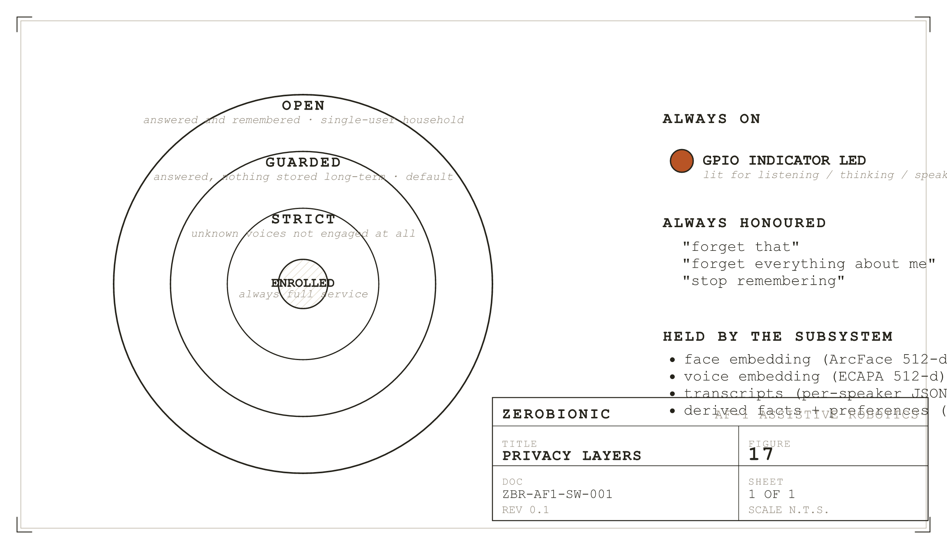
Figure 17
Privacy layers. Enrolled at the centre, guarded by default, strict for hostile settings.
I. What Is Held
Four categories of personal data are held on the Pi. First, face embeddings, produced by the ArcFace model and stored as 512 dimensional float32 vectors in zero_identity.sqlite. These are compressed representations of a face and cannot be inverted to reproduce the original image. Second, voice embeddings, produced by the ECAPA model and stored the same way. Third, transcripts of what has been said, held in memory during a session and appended per speaker per session as NDJSON lines to data/corpus/interactions.jsonl at session end. Fourth, derived facts and preferences (name, likes, things asked to be remembered), stored as rows in zero_memory.sqlite with a person_id foreign key. Guest voices, when someone speaks who is not enrolled, are held as embeddings under a negative person_id in zero_guests.sqlite and are subject to the same erasure verbs as enrolled persons.
II. The Privacy Guard
The bystander_mode key in the privacy block selects one of three policies: open, guarded (the default), and strict. In open mode, an unrecognised voice is answered and remembered exactly as an enrolled voice is, which is appropriate for a single user household where every voice is welcome. In guarded mode, an unrecognised voice is answered but nothing they say is stored long term; the session runs, memory is not written, and the corpus append is skipped. In strict mode, an unrecognised voice is not engaged at all; the wake word from an unrecognised voice is ignored, and speculation is skipped for the same reason. Enrolled persons always receive full service regardless of the mode.
Erasure is always honoured, regardless of mode. Two verbs are recognised before the model is consulted: "forget that" removes the most recent memory entry, and "forget everything about me" removes the speaker's enrolled identity, all their embeddings, all their memory rows, and their entry in the guests store if present. Erasure is immediate and does not wait for a background job. The recording indicator is the visible pair to this: the LED (or the log line, when no pin is configured) confirms per state whether the robot is listening, thinking, or speaking, so that a person in the room always knows when audio is being captured.
III. The Attack Surface
The control plane binds 0.0.0.0 with wide open CORS and no authentication, which means anything on the local network can make the robot speak, run a text turn, or end a session. This is a deliberate trade for a LAN only device: the intended deployment is a trusted home network where the AF-1 application is the only client, and adding a token would burden every developer with a token dance during iteration. The mitigation posture is threefold. The subsystem is firewalled at the network level (a home router does not forward 8090 inbound). The device is not intended for use on hostile networks. And the response bodies are strictly bounded (500 characters truncated on say, 1200 on turn_text) so that a malicious caller cannot use the control plane as an amplification vector. If the deployment target changes, this decision is one of the first that would revisit; a signed token in the persona would be a small change to the handlers and would let the bind stay wide.
Key material for the tunnel is a standard SSH key pair, generated per Pi during setup and stored in the pi user's home directory with ordinary Unix permissions. The public key is installed on the GPU node's authorised keys for the account that owns the model servers. Rotation is documented in Section 12; there is no automatic key rotation, and none is planned because the deployment model is small enough that operator rotation is preferable to another moving part.
SECTION 11
Observability and Diagnostics
The subsystem is observed by exactly two things: its logs and its health endpoint. There is no telemetry pipeline and no external metrics store. That is deliberate for the LAN only deployment, and it places a load on the log lines themselves to be useful during triage. This section names the lines that matter and the way a whole session is reconstructed from them.
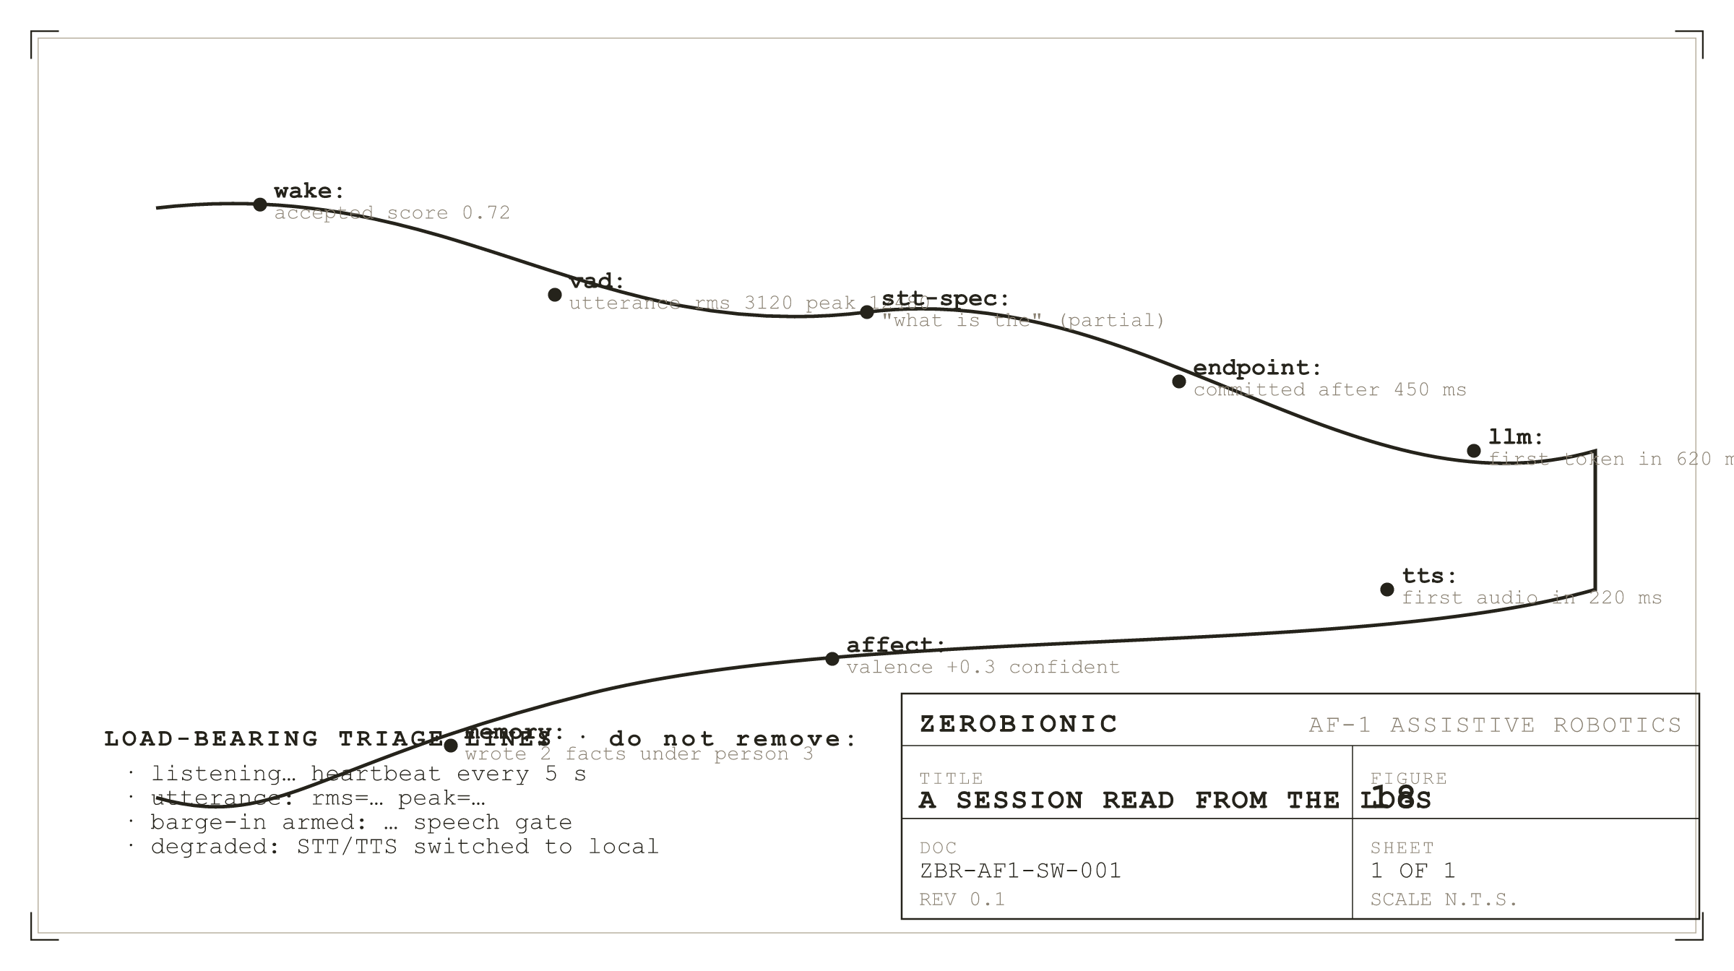
Figure 18
A session read from the logs. The named lines are load bearing for triage.
I. The Log Setup
Logs are written to stdout through the Python logging module with a per module logger named after the faculty (get_logger("vad") for the endpointer, get_logger("stt") for the transcription clients, and so on). Log levels are set globally by the ZERO_LOG_LEVEL environment variable and default to INFO, with DEBUG available for the endpointer and the STT clients when diagnosing an issue. Every log line carries the module name as its prefix, so that a grep on "vad:" isolates the audio pipeline and a grep on "llm:" isolates the language model, which is how triage is done in practice.
II. Load Bearing Log Lines
A short set of log lines are load bearing: they exist specifically to support triage, and removing them would break the field diagnostic procedures in Section 12. The endpointer prints a "listening..." heartbeat every five seconds while it waits for speech; if this ticks but speech is never captured, the problem is VAD or level; if it never ticks, frames are not arriving. The endpointer prints "utterance: rms=... peak=..." for every completed utterance; those values are the input to microphone calibration. The barge in monitor prints "barge-in armed: speech gate = ..." when a reply starts; the gate value is what a person has to beat to interrupt. The fallback wrappers print "degraded: STT switched to local" (and the mirror line on recovery) at the transition; those are the ground truth for what the /zero/status endpoint reports. The near miss logger, when enabled, prints "wake near-miss: score=..." for scores between the near miss floor and wake.threshold; those are the input to wake threshold tuning.
III. The Health Endpoint and Status
GET /health answers immediately at startup with {ok, service, state, ready}, and it is the one endpoint that must always work; if it does not, the process is not running or is not on the port it claims. GET /zero/status returns the state, the last external turn, and the current degradation flags, and it is the endpoint the AF-1 application polls to show whether the robot is running on its backup voice. Together they answer the two questions a supervising system asks: "is the process alive" and "is it healthy".
IV. Reading a Session
A full session in the logs looks like this. A "wake: accepted" line (or a proactive event with open_conversation=true) opens the session. "vad: listening..." heartbeats stop, and an "utterance: rms=... peak=..." line prints when speech ends. An "stt-spec: fired at ... ms" line marks the speculative kick off, and either "stt-spec: prefix matched (reused)" or "stt-spec: prefix diverged, running full" marks whether the speculative work was salvaged. Identity prints "identity: person=... score=..." with the fused score. Recall prints "recall: k=... budget=... ms" and lists returned facts at debug. LLM prints "llm: first_token=... ms" and "llm: total_tokens=..." at the end of the stream. TTS prints "tts: first_chunk=... ms" and the producer prints one line per sentence. Playback prints one "playback: sentence i started" and one "playback: sentence i finished" per sentence. At session end, an "session: ended (reason=...)" line closes it, with reason set to sleep_timeout, stop_phrase, barge_in_and_end, or exception.
The camera preview at :8008 (localhost only by default) is the other diagnostic surface. It shows the current frame with detection boxes, motion indication, and the current identity fusion score. It is the fastest way to confirm the camera is producing frames and the detector is producing labels, both of which have to be true before any visual behaviour can work at all.
SECTION 12
Operations Runbook
This section is written for the operator who has to bring the system up, take it down, update it, or triage it, and who wants the exact commands rather than a description of them. Everything below assumes a Debian based Pi and a Debian based GPU node; the commands transfer directly to other distributions with the obvious substitutions.
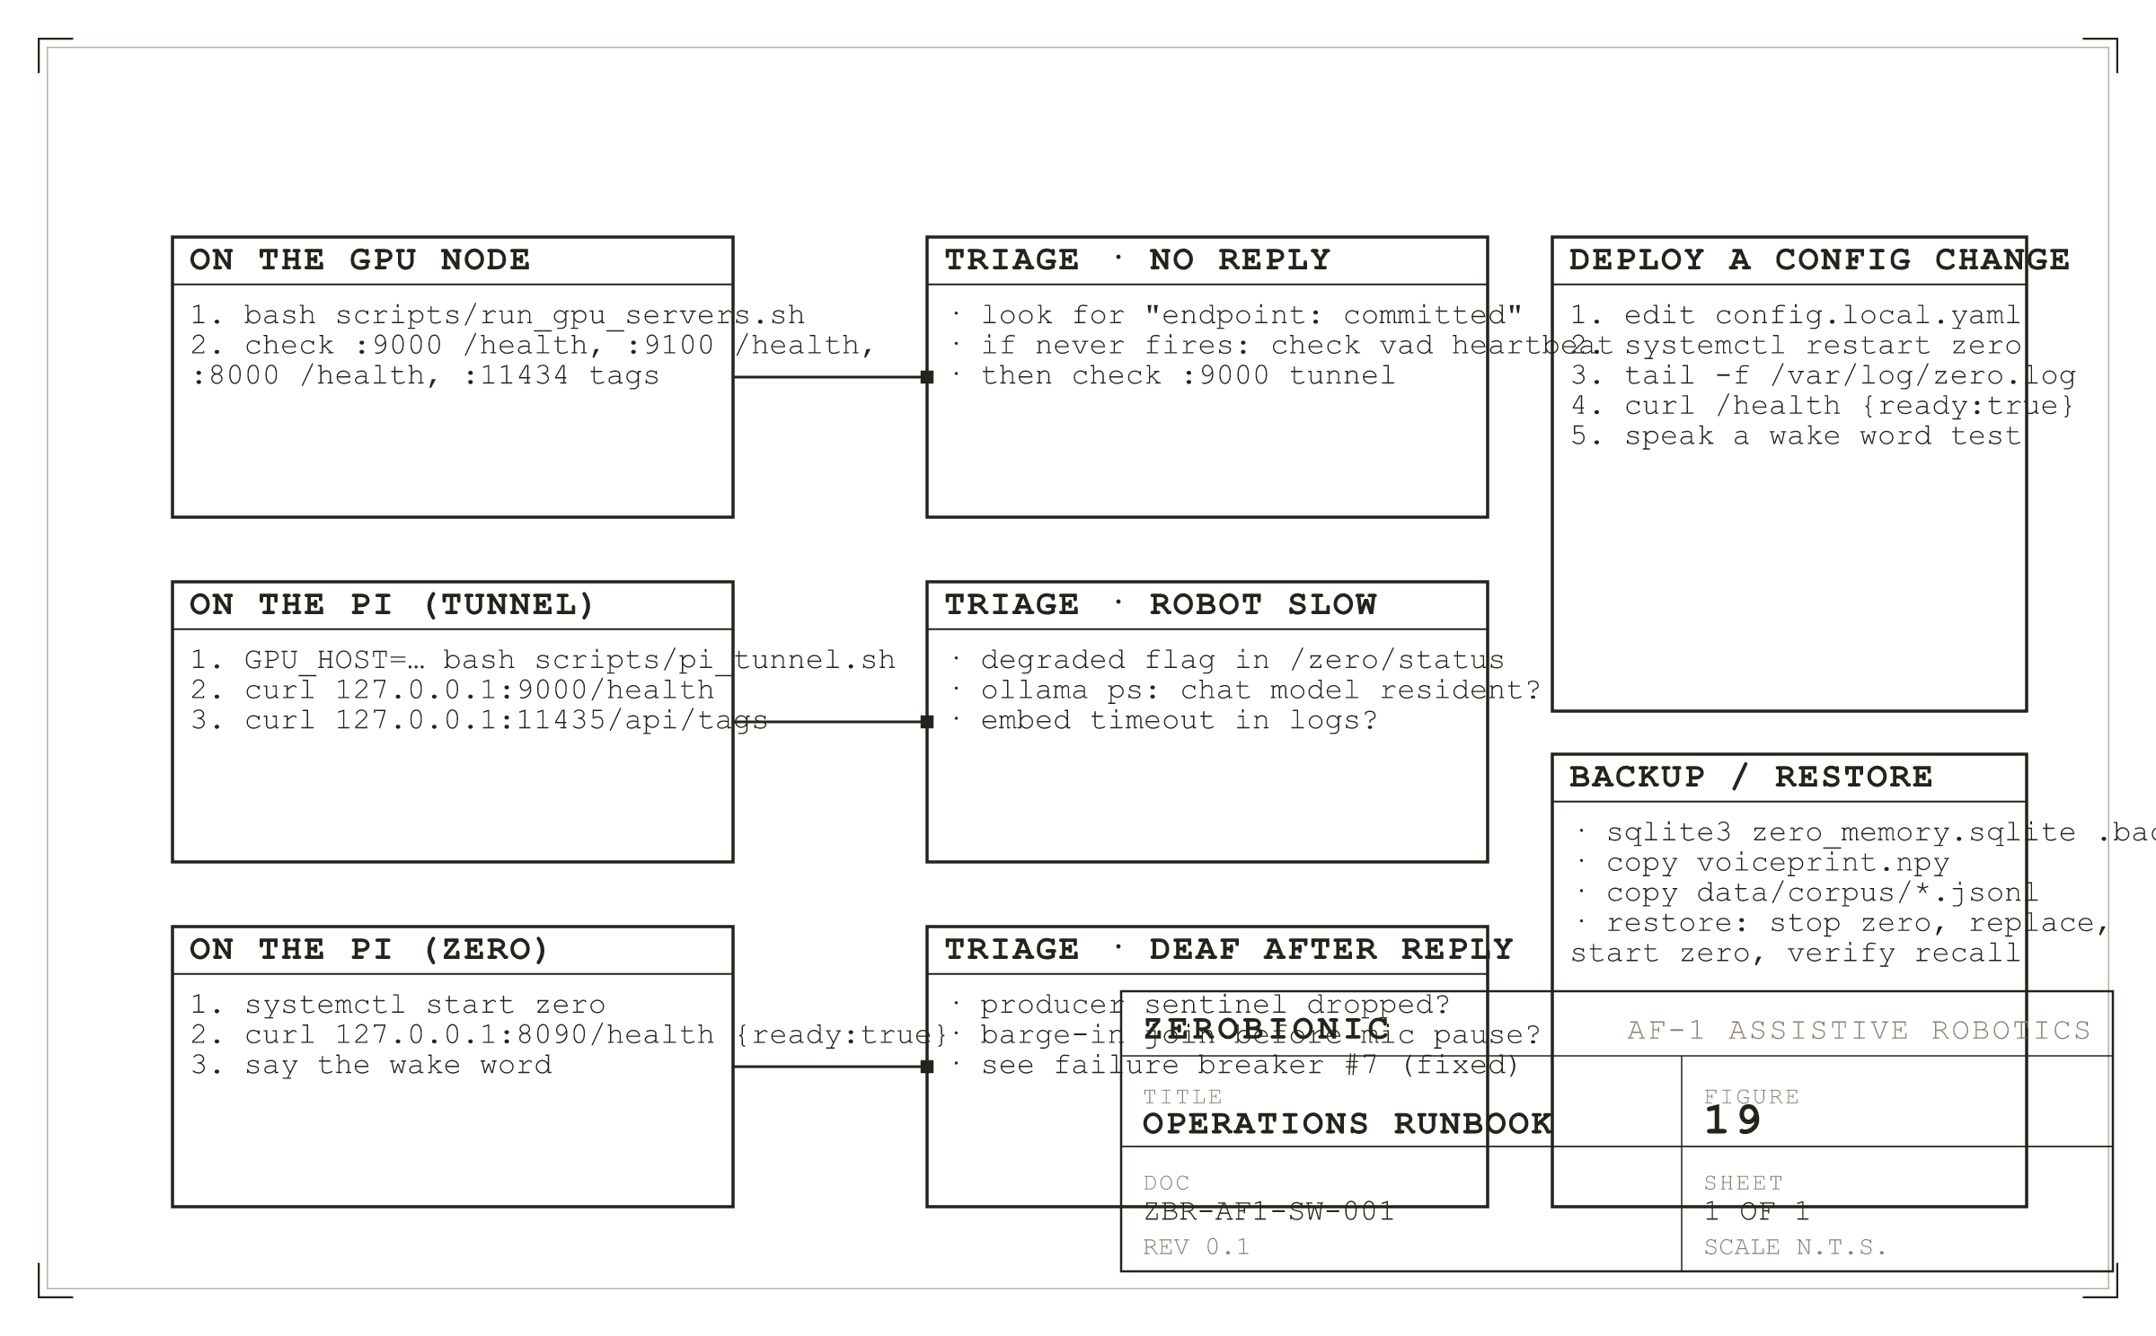
Figure 19
Operations runbook. Bring up on the left, triage in the middle, deploy and backup on the right.
I. Bringing the System Up
On the GPU node, run bash scripts/run_gpu_servers.sh. It is idempotent: it will start whatever is not running and leave whatever is alone. Verify that /health on 9000, 9100, and 8000 all return ok:true, and that curl 127.0.0.1:11434/api/tags lists the expected models (gemma4:latest and nomic-embed-text at minimum). On the Pi, run GPU_HOST=user@gpu-box bash scripts/pi_tunnel.sh (or systemctl start zero-tunnel), and verify the tunnel with curl on 127.0.0.1:9000/health, 127.0.0.1:11435/api/tags, and 127.0.0.1:8000/health. Then systemctl start zero, poll 127.0.0.1:8090/health until ready:true, and say the wake word to confirm the audio path. The whole procedure takes under thirty seconds on a warm GPU node.
II. Taking It Down
systemctl stop zero on the Pi is the graceful stop. The main loop receives SIGINT, drops out of its current phase safely, and the memory-save thread writes the session to disk before the process exits. Do not use SIGKILL unless the process is actually stuck; a SIGKILL loses the current session's memory write. On the GPU node, each server is stopped by its systemd unit, or by killing the process listening on its port if run manually.
III. Updating and Rolling Back
An update is a git pull on the Pi. Because the zero package is installed editable, the pull is the whole update; there is no build step and no wheel install. After pulling, systemctl restart zero and verify with the same health check sequence as bring up. A rollback is git checkout to the previous known good commit and another restart. Both operations are seconds, not minutes. Model artefact updates are manual: download the new artefact, update its path in config.local.yaml if the filename changed, restart the process. The models are not on the git critical path because they are large and because the model server side of the GPU node also holds its own copies.
IV. Triage Table
The three most common triage cases are handled below by symptom. "Robot does not reply to the wake word" resolves in this order: check "listening..." heartbeat in the log (if missing, the microphone stream is dead, check audio.input_device); check the log for any wake accept line (if none, wake.threshold may be too high or the model may be missing); if wake fires but no endpoint commit follows, check that the VAD is receiving frames (a fragmentation bug where the mic was renamed by ALSA has the same symptom). "Robot answers but very slowly": check the degraded flag in /zero/status (if true, the tunnel is down, check autossh and the GPU node); check the log for "recall: over budget" (if present, the embed backend is slow, verify the embed model is resident with ollama ps); check the log for LLM reload messages (if present, the KV cache has evicted the chat model, verify OLLAMA_KV_CACHE_TYPE is set). "Robot goes deaf after its first reply": this is the barge in ordering bug fixed in Section 4.VIII; if it recurs after a code change, check that the monitor thread is joined before the microphone pause on the shutdown path.
V. Backup and Restore
The subsystem's durable state is small enough to back up with cp. The files that matter are zero_memory.sqlite, zero_identity.sqlite, zero_guests.sqlite, zero_episodes.sqlite, zero_curiosity.sqlite, zero_objects.sqlite, voiceprint.npy, and the data/corpus/ directory. Together they are a few tens of megabytes. Backup is a stop of the zero service, a cp of the files (or a sqlite3 .backup to be safe on WAL journaled files), and a start. Restore is the mirror: stop, replace the files, start, and verify by asking the robot to recall a fact that was known before the backup was taken.
SECTION 13
Dependencies and Licences
The subsystem depends on a small tree of third party code and a larger tree of third party model weights, and the licensing landscape is uneven across them. This section names the important pieces, with the versions currently in use, the licences under which they are distributed, and a short note on any supply chain risk worth recording.
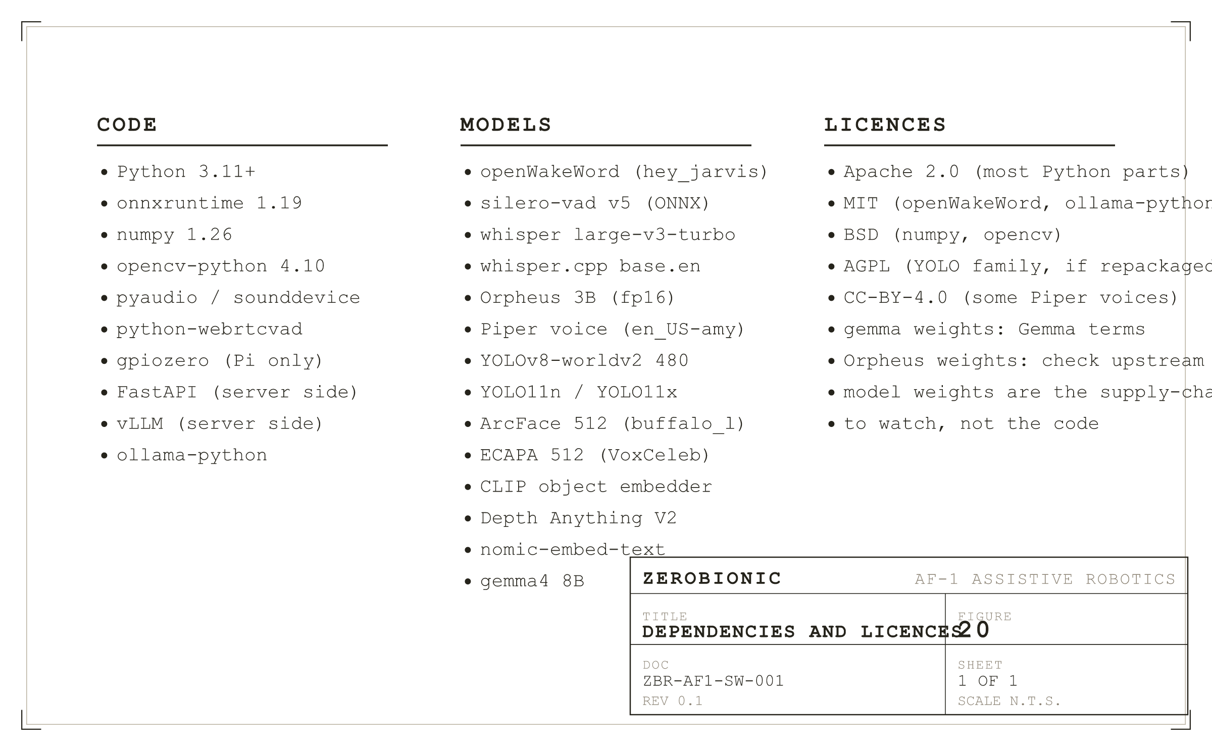
Figure 20
Dependencies and licences. The code tree is boring and safe; the weights tree is where attention has to be paid.
I. Code Dependencies
On the Pi side, the notable dependencies are the Python interpreter (3.11 or newer), ONNX Runtime (1.19 as tested, the CPU build), NumPy, OpenCV, PortAudio bindings, webrtcvad, gpiozero, and the ollama Python client. All of these are Apache 2.0, BSD, or MIT, with no copyleft ties, and all are pinned by exact version in requirements.txt so that a rebuild produces the same tree. On the GPU node side, the notable dependencies are CUDA (the driver and runtime), PyTorch and vLLM for the Orpheus server, faster-whisper for the STT server, FastAPI for the vision application, and Ollama itself. Licences here are more varied: PyTorch is BSD, vLLM is Apache 2.0, Ollama is MIT.
II. Model Weights
The model weights are where the interesting supply chain notes live. openWakeWord ships pretrained models under a permissive licence and a custom "hey zero" model, if trained, would inherit whatever licence the training pipeline documents. Silero VAD v5 is a permissive release and the ONNX export in models/vad/silero_vad.onnx is a direct export from the upstream release. Whisper large-v3-turbo is distributed under MIT by OpenAI, and faster-whisper's wrapper does not change that. The Orpheus 3B weights carry their own terms which should be reviewed against the intended deployment. Piper voices are individually licensed; the shipped en_US-amy-medium voice is under a permissive licence, but voice sets should be verified case by case. YOLO11n, YOLO11x, and YOLOv8-worldv2 are AGPL when redistributed as weights; that is one of the more consequential licence facts in the tree and is the reason a productised deployment might choose a differently licensed detector. ArcFace and ECAPA follow their upstream research code licences. Depth Anything V2 is permissive. gemma4 is distributed under Google's Gemma terms of use, which permit self hosted commercial use with the usual caveats; those terms should be reviewed against the intended deployment.
The general shape of the supply chain risk here is that the code tree is boring and safe, and the model tree is where attention has to be paid. Weights are large, versioned externally, and often distributed without a signed release; a defensive posture is to pin weights by checksum in the acquisition scripts and to reject any mismatch at build time. That posture is followed in the acquisition scripts for the models where an upstream checksum is available, and noted as an open item for those where it is not.
SECTION 14
Open Items and Decisions Log
This section names the known gaps and the design decisions worth recording, so that a future engineer reading the code does not have to reconstruct why a particular choice was made from the diff alone. Items are stated with their current status, so an "open" item is something to do, and a "decided" item is something not to change casually.
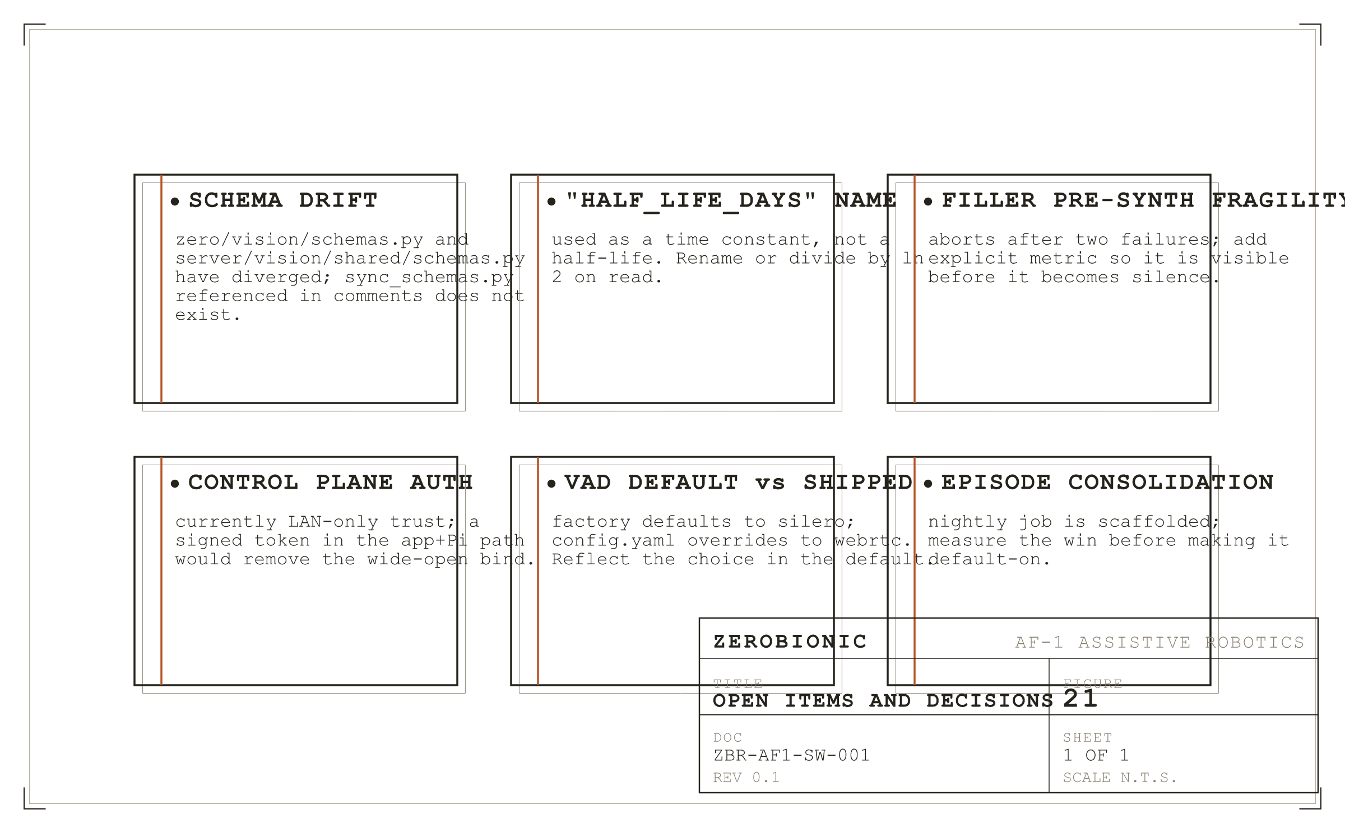
Figure 21
Open items and design decisions worth recording.
I. Open Items
Schema drift between zero/vision/schemas.py and server/vision/shared/schemas.py, described in Section 3.II, is open. The two files have diverged and the sync script referenced in comments does not exist in the repository. The fix is either to write the sync_schemas.py mentioned in the docstring or to move both files to a shared package installable in both trees. The current benign state should not be relied on beyond the next edit to either file.
The half_life_days misnomer, described in Section 4.VII and 8.IV, is open. The parameter name promises half life semantics but the implementation is a time constant, so tuning under the current name is off by a factor of ln(2). The fix is to either rename the parameter (a breaking config change) or to divide by ln(2) on read (a silent semantic change). Neither has been done; the correction is documented here and in the config comment.
The filler pre synthesis fragility, described in Section 4.VIII, is open. Two consecutive failures abort pre synthesis, and there is no metric that surfaces that state; a robot that has quietly stopped pre synthesising fillers can still ship a reply, but its pacing on slow first tokens becomes noticeably worse. The fix is a small counter exposed by the status endpoint.
Control plane authentication, described in Section 10.III, is open but low priority for the current deployment. The wide open bind is a deliberate trade for a LAN only device; the fix, if the deployment target ever leaves the LAN, is a signed token in the header set that the handlers verify, and a matching change on the application side.
The vad engine default versus shipped mismatch, described in Section 4.III, is a minor open item. The factory defaults to Silero and config.yaml overrides to webrtc; a reader of the factory in isolation will draw the wrong conclusion. The fix is to change the factory default to match the shipped value.
Episode consolidation, referenced in Section 4.XI and by the episodes block in Section 8, is scaffolded but not turned on by default. The nightly job runs when configured and populates the consolidated_at column, but the training pipeline that consumes those rows is documented separately and its win over ordinary memory writes has not been measured on this subsystem yet.
II. Decisions Worth Recording
Sessions are owned by voice rather than by face, because voice is what actually produces a turn's transcript, and because attributing a turn to a face when the voice is unfamiliar is exactly the kind of cross contamination the write score threshold exists to prevent. This is worth naming because the natural alternative, using the most confident channel per turn, was tried and produced multi speaker sessions writing into the wrong person's memory.
Perception runs continuously rather than on demand, because a person asking about the room does not want to wait while the camera first looks, and because Tier 0 motion detection is cheap enough to absorb without notice. The alternative, cold vision, was tried and produced visible pauses whenever a visual question landed.
The control plane lives inside the ZERO process rather than beside it, because a network turn and a spoken turn share every faculty (the Conversation object, the memory database, the voice, the speaker), and running two processes forces every one of those to be synchronised across a boundary that has no reason to exist. This is one of the system's larger design commitments and is unlikely to change.
Speculation is skipped while STT is degraded to the local engine, because the local engine cannot productively run the speculative and the final transcription in the small overlap window that the semantic hold allows. The alternative, always speculate, was tried and produced a slower first token during degradation than not speculating at all, because two whisper.cpp runs at 1.5 seconds each does not fit under the endpoint window.
Guests are minted only after a transcript proves the turn was real, because Whisper hallucinates plausible text from near silence and the resulting phantom guests polluted the training corpus in the early runs. The three quality gates (min words, min ms, min rms) each catch a different failure mode, and together they are the reason the corpus is clean enough to train against.
SECTION A
Appendices
A. Glossary
IDLE, LISTENING, THINKING, SPEAKING are the four states of the conversation loop, defined in zero/state.py. Endpointer is the module that decides when a person has stopped speaking. VAD is voice activity detection. Semantic hold is the tri state decision, based on the last word of the speculative transcript, about whether to commit an endpoint or wait one more silence window. Speculative transcript is the STT run at 180 ms into a silence, used both to overlap the STT round trip with the silence wait and to inform the semantic hold. Barge in is the ability of a person to interrupt the robot mid speech by wake word or sustained speech. Filler is a short pre synthesised line played to cover the gap while the model is generating. WorldState is the shared, published perception object read by every consumer that needs to know what the room contains. Tier 0, 1, 2 are motion, detection, and narration, respectively. Fusion is the identity decision combining face and voice cosines. Guest is a provisional identity minted for an unfamiliar voice, kept separate under a negative person_id.
B. On Disk Schema
The full SQLite schema for each of the six stores is documented in Section 3.V, and the DDL as executed on first open is in the store constructors under zero/memory/, zero/identity/, and zero/learning/episodes.py. The convention that every embedding is accompanied by a dim column, and every person_id follows the sign convention (positive enrolled, negative guest, null anonymous), is uniform across every store.
C. The Complete Default config.yaml
The shipped config.yaml is the authoritative default and is documented in place with prose notes. Rather than reproduce it here in full, this section names each top level block and its role, with a pointer to the section that discusses its keys in depth: audio and vad in Section 8.II and 8.III, identity and memory in Section 8.IV, llm and tts and vision in Section 8.V, and the perception, proactive, world, and learning blocks in Section 2 through 4 where their behaviour is described.
D. Port and Device Map
The tunnel forwards five local ports to their counterparts on the GPU node: 9000 to 9000 for Whisper, 9100 to 9100 for Orpheus, 8000 to 8000 for the vision stack, 8080 to 8080 for SearXNG, and 11435 to 11434 for Ollama. The control plane listens on 8090 on the Pi, bound to 0.0.0.0. The camera preview listens on 8008 on the Pi, bound to 127.0.0.1 by default.
E. Detailed Changelog
Revision 0.1 is the first public draft of this document. Prior revisions of the codebase are documented in git history; the notable changes referenced by this document are the addition of the tri state semantic hold, the addition of the identity write score threshold, the addition of the three guest quality gates, the switch of the KV cache to q8_0 quantisation, the pinning of the embedding model with keep_alive minus one, and the fix to the barge in shutdown ordering that had produced the deaf after first reply symptom.

