Executive Summary: Prior Periods Analysis
This executive summary provides a concise overview of key findings from the campaign sales analysis. The analysis compares product sales during the campaign period to the average of prior months, highlighting significant trends and changes in performance metrics. The insights below are tailored to facilitate quick understanding and actionable decision-making for stakeholders.

Key Findings
- Out of 11 products analyzed, 8 showed an increase in sales during the campaign period compared to the average of prior months, while 3 experienced a decline.
- The average change in sales across all products was 11.14%.
- The product with the highest sales growth was BOKOMO TRADITIONAL OATS 1KG with a 91.96% increase.
- The product with the largest decline was WHITE STAR M/MEAL 10KG with a -9.30% decrease.

Campaign Period Sales vs. Average of Prior Months
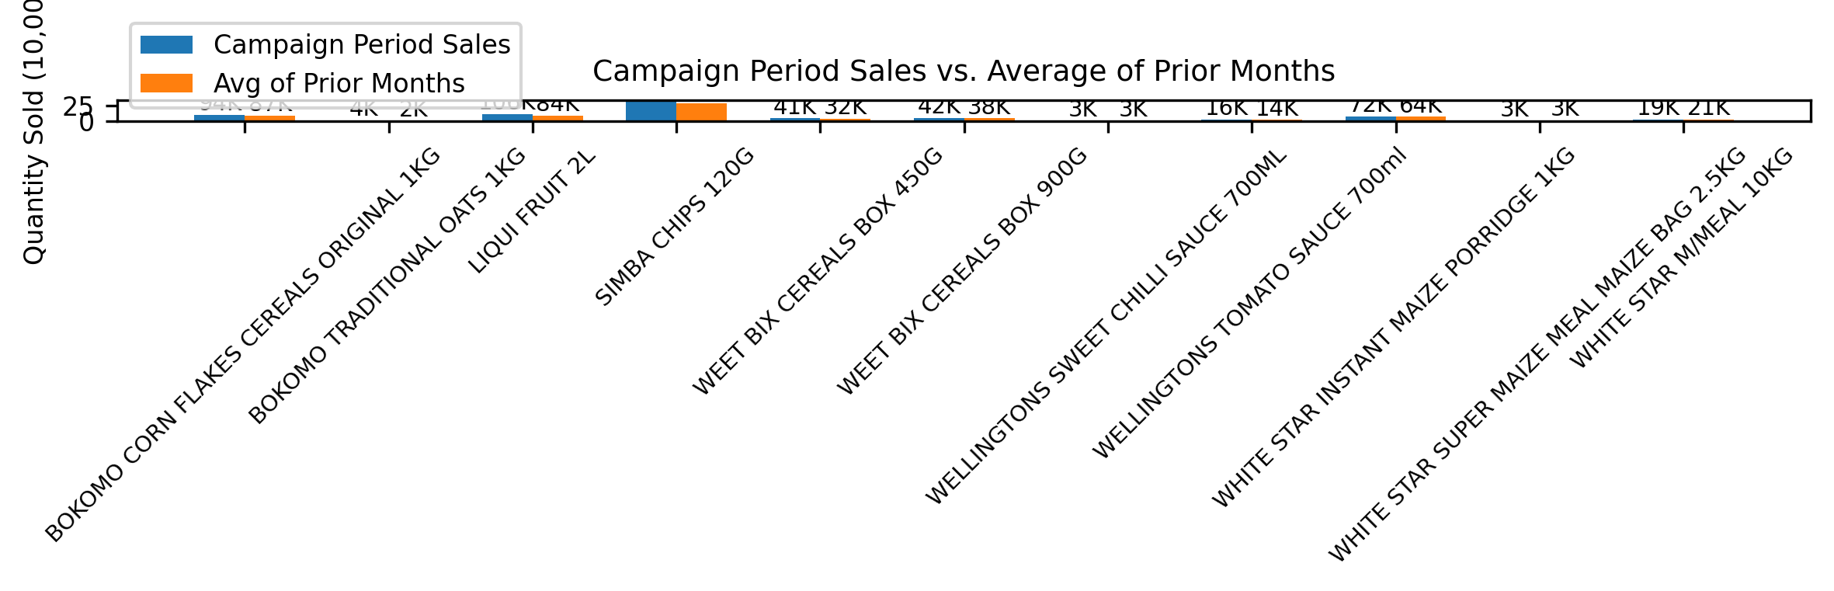
Observations: The chart compares each product's sales during the campaign period to the average of the two prior periods. 9 out of 11 products achieved higher sales during the campaign than their prior average, indicating a generally positive campaign impact. The highest campaign period sales were for SIMBA CHIPS 120G (304K units), while the highest average prior sales were for SIMBA CHIPS 120G (279K units).
Interpretation: Products with campaign sales above their prior average (e.g., BOKOMO CORN FLAKES CEREALS ORIGINAL 1KG, BOKOMO TRADITIONAL OATS 1KG, LIQUI FRUIT 2L, SIMBA CHIPS 120G, WEET BIX CEREALS BOX 450G, WEET BIX CEREALS BOX 900G, WELLINGTONS SWEET CHILLI SAUCE 700ML, WELLINGTONS TOMATO SAUCE 700ml, WHITE STAR INSTANT MAIZE PORRIDGE 1KG) likely benefited from campaign activities, showing strong consumer response or effective promotional strategies. Products with lower campaign sales than their prior average (e.g., WHITE STAR SUPER MAIZE MEAL MAIZE BAG 2.5KG, WHITE STAR M/MEAL 10KG) may require further analysis to identify causes, such as market saturation, competitive pressure, or insufficient campaign support.
Opportunities: Replicate successful tactics from top-performing products across the portfolio. Investigate underperforming products for potential improvements in marketing, distribution, or product offering. Consider reallocating resources to products with the highest campaign responsiveness for future campaigns.

Sales Increase During Campaign vs. Avg of Prior Months
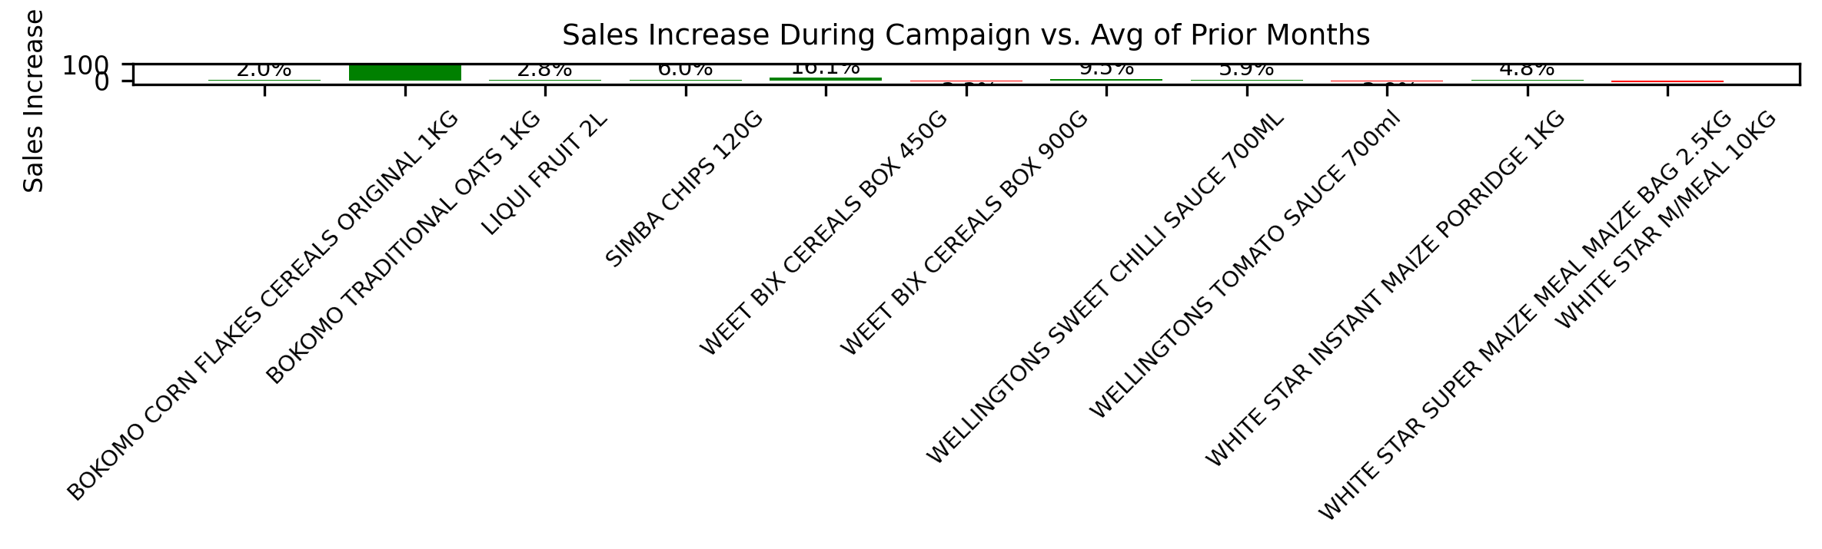
Observations: This chart shows the percentage increase or decrease in sales for each product during the campaign compared to the average of prior months. 8 products experienced sales growth, while 3 saw a decline. The strongest growth was observed for BOKOMO TRADITIONAL OATS 1KG (+92.0%), while the largest decline was for WHITE STAR M/MEAL 10KG (-9.3%).
Interpretation: Green bars highlight products with positive momentum, suggesting effective campaign execution or increased market demand. Red bars indicate products that lost ground, which may signal issues such as increased competition, shifting consumer preferences, or campaign misalignment. The average sales increase across all products was 11.1%.
Opportunities: Double down on growth products by expanding promotional efforts or distribution. For declining products, conduct root cause analysis (e.g., pricing, placement, competitor actions) and test corrective actions in future campaigns. Use these insights to inform product portfolio decisions and optimize future marketing investments.

Summary
The data indicates a generally positive trend in sales performance during the campaign period, with the majority of products experiencing growth. Stakeholders should focus on sustaining the momentum for top-performing products while investigating the causes behind declining products to inform targeted interventions. These actionable insights can guide strategic planning and resource allocation for future campaigns.

