**Henri Alvarez**

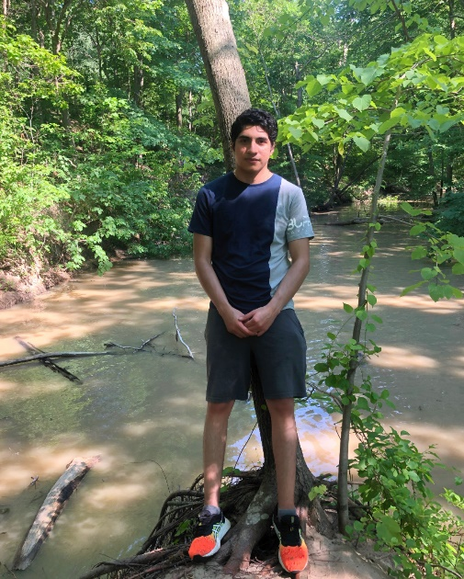

Hello, my name is Henri Alvarez. Here are a few interesting points about me.

**Value/Beliefs**

I value honesty and morale above all. I believe anyone can make an impact on the world.

**Interests**

A few of my interests include chess, drawing, and coding.

**Career goal**

My goal is to bring individuals together through technology.

**Expectations**

I hope to learn how to better organize code through classes, objects, modules, etc.