Results from land use model LUISA-BEES

Sarah Mubareka

August 25,2020

Table of Contents

# Introduction

The land use model LUISA-BEES (“Land Use Integrated Sustainability Assessment - BioEconomy and Ecosystem Services”) is a dedicated land use model to assess the biomass availability and uses for the EU bioeconomy from the forest and agriculture sectors.

This report summarises the results of a scenario that is based on the [2030 Climate and Energy package](https://ec.europa.eu/clima/policies/strategies/2030_en) reference scenario. The purpose of doing this is to assess the land availability for the energy crops that are foreseen in this scenario. Furthermore, the model was configured to encourage tree plantations on any available non-productive land, where trees could suitably grow.

The results are land use maps at 1-hectare resolution, showing a plausible pattern for land use supposing that energy crops foreseen in the C&E scenario are to be planted somewhere in Europe. The tree plantations are also mapped and quantified in view of the application of the 2020 Biodiversity Strategy.

##Scenario assumptions *describe scenario assumptions here*

#EU-level results The EU-level results are presented in this section. ##Land use map Basic land use statistics for the EU. 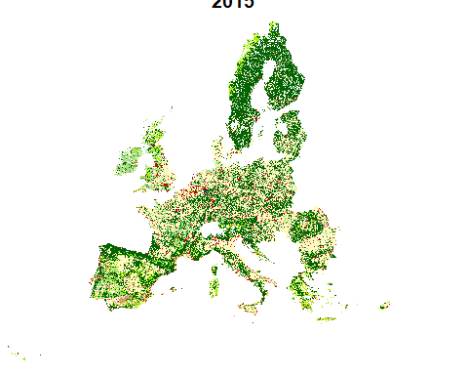

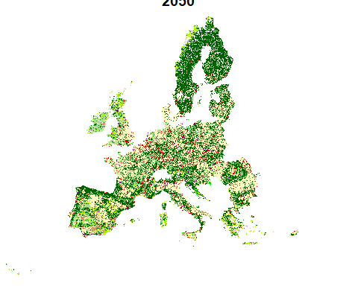

#Land use composition evolution ##2020-2050 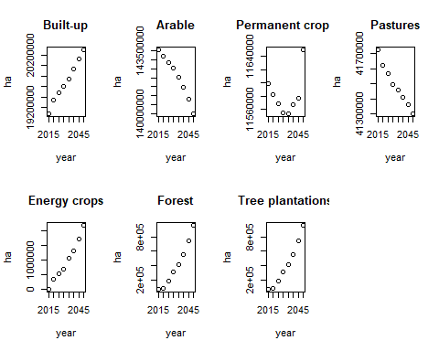

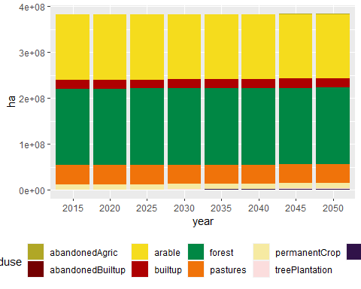

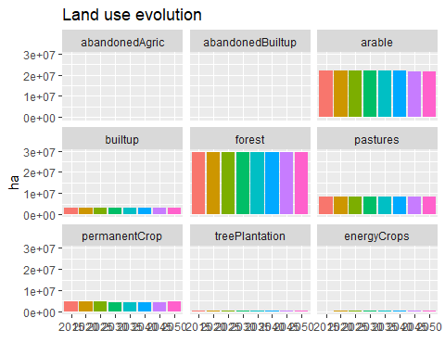

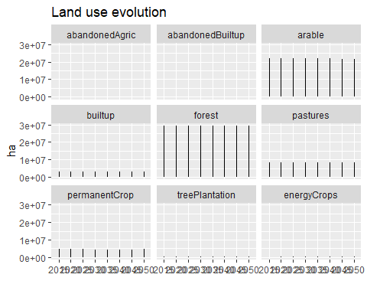

#GHG EMissions LULUCF 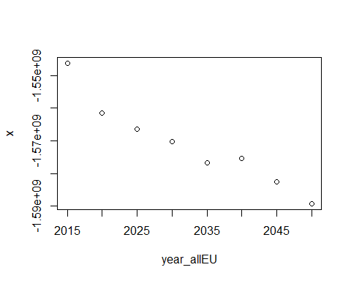

# Land use map  
![](generatereports_files/figure-docx/unnamed-chunk-10-1.png)<!-- -->![](generatereports_files/figure-docx/unnamed-chunk-10-2.png)<!-- -->![](generatereports_files/figure-docx/unnamed-chunk-10-3.png)<!-- -->![](generatereports_files/figure-docx/unnamed-chunk-10-4.png)<!-- -->  
##Sankey diagrams for land use change flows, 2015-2050

## PhantomJS not found. You can install it with webshot::install_phantomjs(). If it is installed, please make sure the phantomjs executable can be found via the PATH variable.

<!--html_preserve--><div id="htmlwidget-6cfbf0c4d7a5775fcf71" style="width:900px;height:900px;" class="chordNetwork html-widget"></div>  
<script type="application/json" data-for="htmlwidget-6cfbf0c4d7a5775fcf71">{"x":{"matrix":[[15420350,6758,0,0,0,0,0,0,0,0,35328,0,0,0,0,0],[540,2559776,0,0,0,0,0,0,0,0,0,177324,0,0,0,0],[14437,47505,143555412,200088,56021,0,0,4218,0,0,0,0,711,0,0,0],[4371,7586,0,11167988,21812,0,0,0,59963,0,0,0,0,0,0,0],[116644,633850,0,130886,41390907,0,0,0,0,1128,0,0,0,0,0,273],[7640,9430,0,79546,107123,158193538,0,0,0,0,0,0,0,0,0,0],[92045,83174,0,10169,20435,0,8797637,0,0,0,0,0,0,0,202425,0],[0,0,0,0,0,0,0,0,0,0,0,0,0,0,0,0],[0,0,0,0,0,0,0,0,0,0,0,0,0,0,0,0],[0,0,0,0,0,0,0,0,0,0,0,0,0,0,0,0],[0,0,0,0,0,0,0,0,0,0,0,0,0,0,0,0],[0,0,0,0,0,0,0,0,0,0,0,0,0,0,0,0],[0,0,0,0,0,0,0,0,0,0,0,0,0,0,0,0],[74891,837,0,10638,128407,0,0,0,0,0,0,0,0,23774775,0,66623],[0,0,0,0,0,0,0,0,0,0,0,0,0,0,0,0],[0,0,0,0,0,0,0,0,0,0,0,0,0,0,0,0]],"options":{"width":900,"height":900,"use_ticks":0,"initial_opacity":0.8,"colour_scale":["#FF0000","#FF00FF","#FFDD89","#cc0099","#00FF89","#006600","#00FF99","#FFDD89","#00FF00","#FF0000","#FF0000","#FF00FF","#FFDD89","#CC9900","#00FF00","#666600"],"padding":0.1,"font_size":14,"font_family":"sans-serif","labels":["urban","industry","arable","permCrops","pastures","forestMature","woodland","abanArab","abanPC","abanPast","abanUrban","abanIndustry","necr","shva","forestYoung","plantations"],"label_distance":100}},"evals":[],"jsHooks":[]}</script><!--/html_preserve-->

## URBAN INDUSTRIAL ARABLE PERMANENTC PASTURES FORESTSMAT TRANSWOODL

## 1 15420350 6758 0 0 0 0 0

## 2 540 2559776 0 0 0 0 0

## 3 14437 47505 143555412 200088 56021 0 0

## 4 4371 7586 0 11167988 21812 0 0

## 5 116644 633850 0 130886 41390907 0 0

## 6 7640 9430 0 79546 107123 158193538 0

## 7 92045 83174 0 10169 20435 0 8797637

## 8 0 0 0 0 0 0 0

## 9 0 0 0 0 0 0 0

## 10 0 0 0 0 0 0 0

## 11 0 0 0 0 0 0 0

## 12 0 0 0 0 0 0 0

## 13 0 0 0 0 0 0 0

## 14 74891 837 0 10638 128407 0 0

## 15 0 0 0 0 0 0 0

## 16 0 0 0 0 0 0 0

## ABANARABLE ABANPERMAN ABANPASTUR ABANURBAN ABANINDUST NEWENERGYC SHVA

## 1 0 0 0 35328 0 0 0

## 2 0 0 0 0 177324 0 0

## 3 4218 0 0 0 0 711 0

## 4 0 59963 0 0 0 0 0

## 5 0 0 1128 0 0 0 0

## 6 0 0 0 0 0 0 0

## 7 0 0 0 0 0 0 0

## 8 0 0 0 0 0 0 0

## 9 0 0 0 0 0 0 0

## 10 0 0 0 0 0 0 0

## 11 0 0 0 0 0 0 0

## 12 0 0 0 0 0 0 0

## 13 0 0 0 0 0 0 0

## 14 0 0 0 0 0 0 23774775

## 15 0 0 0 0 0 0 0

## 16 0 0 0 0 0 0 0

## FORESTSYOU TREEPLANTA

## 1 0 0

## 2 0 0

## 3 0 0

## 4 0 0

## 5 0 273

## 6 0 0

## 7 202425 0

## 8 0 0

## 9 0 0

## 10 0 0

## 11 0 0

## 12 0 0

## 13 0 0

## 14 0 66623

## 15 0 0

## 16 0 0

<!-- #Investigate Amar's observation that land are changes drastically between 2 runs -->  
<!-- #Amar (CAPRI modeller) noticed differences between the land use area sums for xTab and (correctly) questioned how this could be. The base map had changed between the three runs (v0 on JRC box: orignal CLC; v1 on JRC box: forest corrected by polygon - i.e. MMU of CLC respected; Vx on my PC was run with a pixel-based correction of CLC). -->  
<!-- ```{r,echo=FALSE} -->  
<!-- #loop through folders to get xTab2050 data and make Sankeys -->  
<!-- filename<-"P2015_xTabMT.dbf" -->  
<!-- #marchdatadir<-"D:/landuse/luisetta_outmarch312020" -->  
<!-- maydatadir<-"D:/landuse/LUISA-BEES_outmay162020" -->  
<!-- augdatadir<-"D:/landuse/LUISA-BEES_outaug232020" -->  
<!-- listMay<- list.dirs(maydatadir, recursive=FALSE) -->  
<!-- listAug<- list.dirs(augdatadir, recursive=FALSE) -->  
<!-- allruns<-list() -->  
<!-- for (i in seq_along(list)) { -->  
<!-- listMay[i] -->  
<!-- listAug[i] -->  
<!-- xTabMay<-read.dbf(paste0(listMay[i],"/",filename)) -->  
<!-- xTabAug<-read.dbf(paste0(listAug[i],"/",filename)) -->  
<!-- may<-(sum(xTabMay[,])) -->  
<!-- aug<-(sum(xTabAug[,])) -->  
<!-- diff<-aug-may -->  
<!-- allruns[[i]] <- diff -->  
<!-- } -->  
<!-- diffs = do.call(rbind,allruns) -->  
<!-- diffs<-as.data.frame(diffs) -->  
<!-- diffs$country<-countries -->  
<!-- print(diffs) -->  
  
  
<!-- ``` -->  
  
#loop through folders to get xTab2050 data and make Sankeys

## Warning: It looks like Source/Target is not zero-indexed. This is required in

## JavaScript and so your plot may not render.

## Warning: It looks like Source/Target is not zero-indexed. This is required in

## JavaScript and so your plot may not render.

## Warning: It looks like Source/Target is not zero-indexed. This is required in

## JavaScript and so your plot may not render.

## Warning: It looks like Source/Target is not zero-indexed. This is required in

## JavaScript and so your plot may not render.

## Warning: It looks like Source/Target is not zero-indexed. This is required in

## JavaScript and so your plot may not render.

## Warning: It looks like Source/Target is not zero-indexed. This is required in

## JavaScript and so your plot may not render.

## Warning: It looks like Source/Target is not zero-indexed. This is required in

## JavaScript and so your plot may not render.

## Warning: It looks like Source/Target is not zero-indexed. This is required in

## JavaScript and so your plot may not render.

## Warning: It looks like Source/Target is not zero-indexed. This is required in

## JavaScript and so your plot may not render.

## Warning: It looks like Source/Target is not zero-indexed. This is required in

## JavaScript and so your plot may not render.

## Warning: It looks like Source/Target is not zero-indexed. This is required in

## JavaScript and so your plot may not render.

## Warning: It looks like Source/Target is not zero-indexed. This is required in

## JavaScript and so your plot may not render.

## Warning: It looks like Source/Target is not zero-indexed. This is required in

## JavaScript and so your plot may not render.

## Warning: It looks like Source/Target is not zero-indexed. This is required in

## JavaScript and so your plot may not render.

## Warning: It looks like Source/Target is not zero-indexed. This is required in

## JavaScript and so your plot may not render.

## Warning: It looks like Source/Target is not zero-indexed. This is required in

## JavaScript and so your plot may not render.

## Warning: It looks like Source/Target is not zero-indexed. This is required in

## JavaScript and so your plot may not render.

## Warning: It looks like Source/Target is not zero-indexed. This is required in

## JavaScript and so your plot may not render.

## Warning: It looks like Source/Target is not zero-indexed. This is required in

## JavaScript and so your plot may not render.

## Warning: It looks like Source/Target is not zero-indexed. This is required in

## JavaScript and so your plot may not render.

## Warning: It looks like Source/Target is not zero-indexed. This is required in

## JavaScript and so your plot may not render.

## Warning: It looks like Source/Target is not zero-indexed. This is required in

## JavaScript and so your plot may not render.

## Warning: It looks like Source/Target is not zero-indexed. This is required in

## JavaScript and so your plot may not render.

## Warning: It looks like Source/Target is not zero-indexed. This is required in

## JavaScript and so your plot may not render.

## Warning: It looks like Source/Target is not zero-indexed. This is required in

## JavaScript and so your plot may not render.

## Warning: It looks like Source/Target is not zero-indexed. This is required in

## JavaScript and so your plot may not render.

## Warning: It looks like Source/Target is not zero-indexed. This is required in

## JavaScript and so your plot may not render.

```