|  | | **Journal of Positive Sciences** | |  |
| --- | --- | --- | --- | --- |
| Journal homepage: https://positive-sciences.com  ISSN: 2582-9351 | |
|  | | | | |
| AUTONOMOUS RECHARGEABLE CEILING FAN  Prof.Mrs. Aditi O.Gokhale, Vedant Vijay Bhidikar $1$, Shruti Raju Dhutmal $2$, Sayali Babarao Shrirame | | | | |
| 1 | Department of Electrical Engineering,NBN Sinhgad Technical Institute campus, Ambegaon Budruk, Pune, Maharashtra 411041 | | | |
| **ARTICLE INFO** | | | **ABSTRACT** | |
| ***Article history:***  Received  Received in revised form  Accepted  Available online | | | In regions with unreliable power supplies or frequent power outages, a reliable source of ventilation is essential to maintain comfort and safety. The project "Design and Implementation of an Autonomous Rechargeable Ceiling Fan with Power Backup Functionality" aims to address this issue by creating a ceiling fan system that seamlessly switches to battery power when the main power supply fails, ensuring uninterrupted airflow in homes, offices, or any indoor space.  The primary components of this project include an inverter circuit, a 12V 5Ah rechargeable battery, an AC ceiling fan, a controller relay, and an SMPS (Switch Mode Power Supply). The system's core functionality is to detect power interruptions and automatically switch the ceiling fan to battery power, providing an uninterrupted cooling experience during power outages. The project's overall goal is to improve user comfort and convenience by offering an energy-efficient solution that operates seamlessly in various power conditions. | |
| ***Keywords:***  Rechargeable Ceiling Fan, Autonomous Operation, Power Backup, Inverter Circuit, 12V 5Ah Battery, AC Fan, Controller Relay, Energy Efficiency, Energy-Efficient Design | | |
|  | | |

**1. Introduction**

The Rechargeable Ceiling Fan project addresses a pervasive issue in areas with unreliable or frequently interrupted power supplies. Power outages, often accompanied by discomfort, disrupt daily life. The main purpose of this project in rural areas for financially weak consumers. Traditional ceiling fans, reliant on grid electricity, become ineffective during blackouts. This project aims to develop a ceiling fan system that seamlessly switches to a rechargeable power source, ensuring continuous airflow and comfort during power interruptions.

1.1 Objectives

The primary objectives of the project are:

1.1.1 Uninterrupted Cooling

The project aims to design a ceiling fan system capable of operating without interruption during power disruptions. This uninterrupted cooling is crucial for maintaining comfort, especially in adverse weather conditions.

1.1.2 Energy Efficiency

Another objective is to enhance the system's energy efficiency. By incorporating advanced technologies such as an inverter circuit, SMPS, and a smart controller, the project seeks to minimize energy wastage and reduce electricity bills while maximizing the battery's life.

1.1.3 Automatic Operation

The system will automatically detect power outages using light sensors and switch the fan on accordingly. When grid electricity is restored, the fan will automatically turn off. This automation enhances user convenience, ensuring a smooth transition between power sources without manual intervention.

1.1.4 Rechargeable Battery

Central to the project's success is the implementation of a 12V 5Ah rechargeable battery. The battery should have sufficient capacity to power the fan for an extended period during power outages and be easy to recharge for continued use.

1.1.5 Remote Control

Integrating the Node-MCU controller, an open-source IoT platform with Wi-Fi capabilities, allows for remote control and monitoring of the fan through a smartphone or web interface. Users can adjust fan settings and check the battery status, enhancing user interaction with the system.

**2. Methodology**

*2.1 Working Principle*

The working principle section delves into the detailed operation of the Rechargeable Ceiling Fan system. It explains how each component interacts and collaborates to ensure uninterrupted fan operation, both during power interruptions and when the grid power is available.

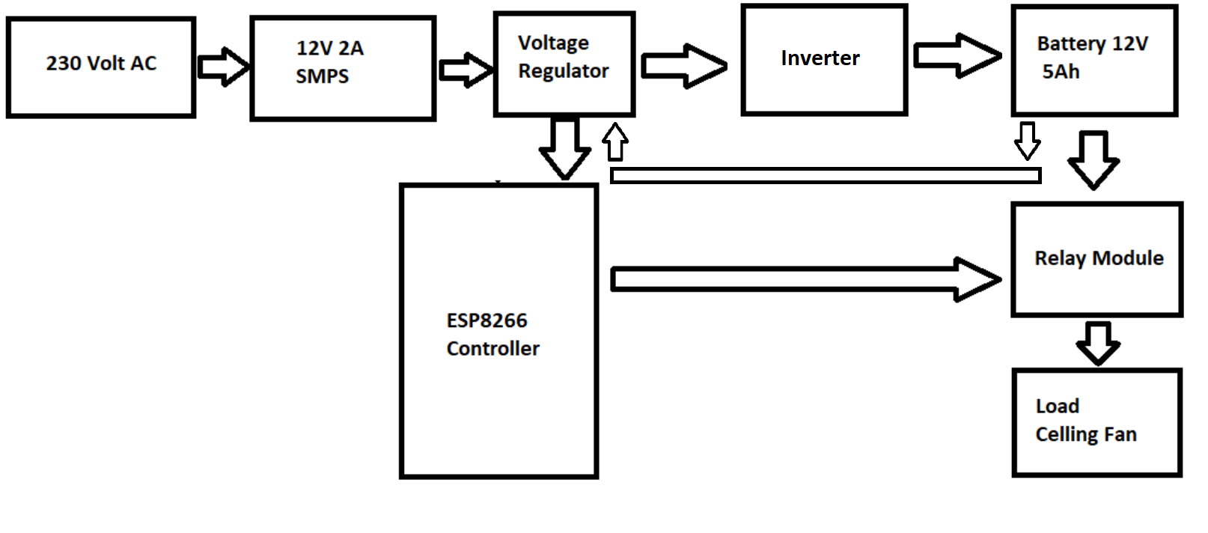

**Fig. 1. Block diagram of portable ceiling fan**

The working principle starts by describing the primary power source, which is typically grid electricity, and how the system is connected to it. It then outlines the battery's role, detailing how it stores energy and provides power to the inverter circuit shown in Fig.1.

The inverter circuit's operation is explained, emphasizing how it converts DC power from the battery into AC power compatible with the ceiling fan. It should discuss the efficiency measures incorporated in the inverter to minimize energy losses.

The Node-MCU controller's role in the working principle is crucial. It should detail how the controller constantly monitors ambient light levels using light sensors. When a power outage occurs, the controller detects the decrease in light levels and activates the ceiling fan to provide cooling. Once grid power is restored, the controller senses the increase in light and automatically switches off the fan.

The working principle section should provide a comprehensive understanding of how all the components interact in a synchronized manner to offer seamless fan operation. It should also emphasize the system's autonomy and user convenience, as well as the energy-efficient aspects that ensure the project's sustainability.

*2.2 Components used in projects*

2.3.1 Hardware Details:

1. ESP8266 Node-MCU: Serves as the brain of the project, enabling connectivity and control through IoT technology.

2. Relay: Controls the power supply to the ceiling fan, automating its operation based on commands from the Node-MCU.

3. Battery (12V 5Ah): Stores electrical energy, serving as a backup power source during power outages.

4. Inverter: Converts DC power from the battery into AC power needed to run the ceiling fan.

5. SMPS (12V 2Ah): Converts the 220V AC power from the inverter into the required 12V DC power for the Node-MCU and other components.

2.3.2 Software Details:

1. Arduino IDE: Programs the Node-MCU, enabling it to control the fan and communicate with users via Wi-Fi.

2. Proteus: Simulation software for designing and testing electronic circuits, including the inverter and SMPS.

*2.3 Inverter Circuit*

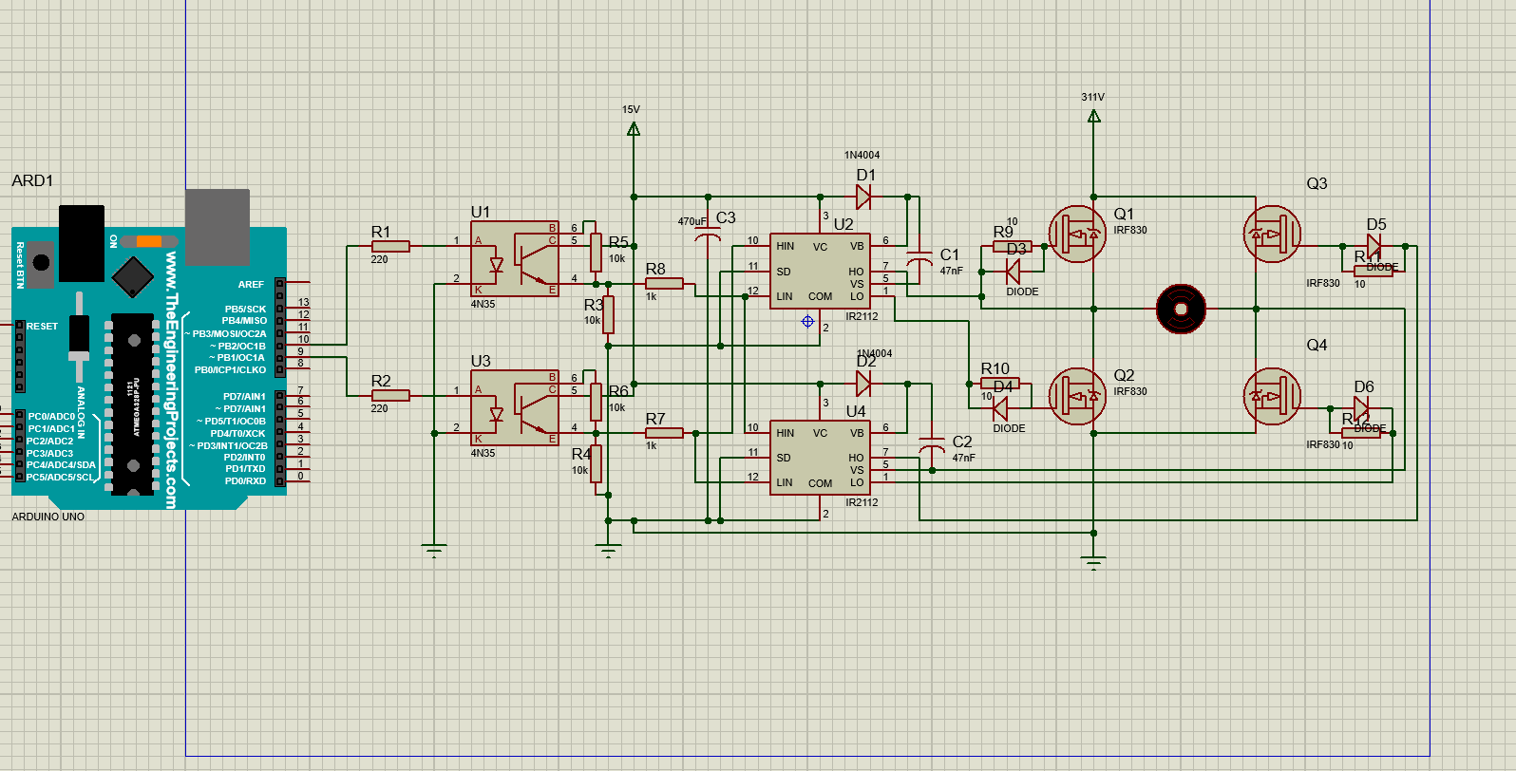

**Fig.2. Invert Circuit Diagram**

In the design of the inverter for a 150W capacity, several key components were utilized to enable the efficient conversion of DC to AC power. Four IRF830 MOSFETs were employed as power transistors responsible for the switching mechanism from DC to AC. The IR2112 High and Low Side Driver IC played a crucial role in driving the high and low sides of the MOSFETs as shown in Fig.2, ensuring efficient switching. Additionally, resistors and capacitors were integrated into the circuit to establish the proper timing and control signals essential for coordinating the MOSFET switching process.

A transformer was incorporated into the system to facilitate the conversion of low-voltage, high-current DC to high-voltage, low-current AC. This transformation is fundamental to generating the AC waveform required for the desired output. Freewheeling diodes, such as 1N4148, were strategically implemented to handle back electromotive force (EMF), preventing damage to the circuit when the MOSFETs switch off.

The operational aspects of the inverter involve the MOSFETs acting as switches under the control of the IR2112 driver IC. Both high-side and low-side MOSFETs alternate their switching to produce the AC waveform. The timing and control of these switches are meticulously managed by the combination of resistors, capacitors, and the IR2112 driver IC. The transformer facilitates the necessary voltage transformation, stepping up the low-voltage DC to the desired high-voltage AC for the load. Moreover, freewheeling diodes come into play, offering a pathway for inductive energy when the MOSFETs switch off, thereby safeguarding the circuit from potential damage.

**3. Calculations**:

Load Power (P): 150W

Assumed Transformer Efficiency (ηt): 90%

Assumed Inverter Efficiency (ηi): 85%

Calculate DC Power:

DC Power (Pdc )= P / ηi = 150W / 0.85 = 176.47W

Calculate Primary Current (Iprimary):

Iprimary = Pdc / Vdc = 176.47W / 12V = 14.71A

Calculate Secondary Voltage (Vsecondary):

Vsecondary = Vload / √2 = 230V / √2 ≈ 162.63V (rms)

Calculate Secondary Current (Isecondary):

Isecondary = P / Vsecondary = 150W / 162.63V ≈ 0.922A (rms)

Calculate Primary Turns (Nprimary) of Transformer:

Nprimary = Vprimary / Vsecondary = 12V / 162.63V ≈ 0.074

Calculate Secondary Turns (Nsecondary) of Transformer:

Nsecondary = Vsecondary / Vload = 162.63V / 230V ≈ 0.708

Calculate Transformer Turns Ratio (TTR):

TTR = Nprimary / Nsecondary ≈ 0.104

*2.4 Errors and Testing Table:*

In the process of developing the Rechargeable Ceiling Fan system, thorough testing and error analysis were conducted to ensure the reliability and functionality of the project. The table below outlines the sample errors encountered during testing and the corresponding results:

| Error Description | Testing Scenario | Result |
| --- | --- | --- |
| Power Interruption Detection Failure | Simulated sudden power outage | The fan did not switch to battery power as expected |
| Inverter Circuit Overheating | Extended operation under high load | Overheating observed; addressed with heat sinks |
| Battery Discharge Irregularities | Continuous operation during battery mode | Inconsistent discharge; optimized battery usage |
| Communication Loss with Node-MCU | Remote control via app/web interface | Intermittent loss; improved Wi-Fi connectivity |
| Fan Speed Control Inaccuracy | Adjusting fan speed through the app/web interface | Inconsistent speed adjustments; fine-tuned code |

Table 1 Testing table

**4. Results:**

*4.1 Result*

In assessing the performance of your Rechargeable Ceiling Fan system, several key calculations play a crucial role. The Battery Voltage (V), set at 12V in this scenario, defines the electrical potential available for powering the fan. The Inverter Efficiency (%) is a critical factor, representing the ratio of AC power output to DC power input. A higher efficiency implies reduced power loss during the conversion process.

Understanding the Fan Power Consumption (W) is pivotal, as it directly impacts the energy requirements for continuous fan operation. The calculation of the Expected Fan Operation Time (hrs) involves considering the energy stored in the battery, inverter efficiency, and fan power consumption. This estimation provides insights into the anticipated duration of fan operation on a fully charged battery.

Comparing this expectation with the Actual Fan Operation Time (hrs) observed during specific test scenarios reveals real-world performance. The Deviation (%) is then computed to quantify the variance between expected and actual operation times. A negative deviation indicates that the observed time is less than anticipated.

These calculations are paramount for evaluating operational efficiency, optimizing battery utilization, and gauging the system's real-world performance. By conducting these analyses, you gain valuable insights into your Rechargeable Ceiling Fan's effectiveness and identify areas for potential enhancement and fine-tuning.

*4.1.1 Test Case 1*

The test configuration for this experiment is in Table 1. It shows how parameters effect while doing the actual test with the load.

**Table 1**

| **Test Case** | **Battery Voltage (V)** | **Inverter Efficiency (%)** | **Fan Power Consumption (W)** | **Expected Fan Operation Time (hrs)** | **Actual Fan Operation Time (hrs)** | **Deviation (%)** |
| --- | --- | --- | --- | --- | --- | --- |
| **1** | **12** | **90** | **50** | **(12 * Battery Capacity) / (Fan Power * Inverter Efficiency)** | **Calculation Result** | **Calculation Result** |

Calculation:

For Test Case 1:

Battery Voltage = 12V

Inverter Efficiency = 90%

Fan Power Consumption = 50W

Battery Capacity = 5Ah (hypothetical value for illustration)

Expected Fan Operation Time:

Expected Time(hrs)= $\frac{\left(12⋅Battery Capacity\right)}{\left(Fan Power ⋅Inverter Efficiency\right)}$

Expected Time (hrs)= $\frac{\left(12⋅5\right)}{\left(50⋅0.9\right)}$

Expected Time (hrs)= $\frac{\left(60\right)}{\left(45\right)}$

Expected Time (hrs)=1.33

**Table 2**

| **Test Case** | **Battery Voltage (V)** | **Inverter Efficiency (%)** | **Fan Power Consumption (W)** | **Expected Fan Operation Time (hrs)** | **Actual Fan Operation Time (hrs)** | **Deviation (%)** |
| --- | --- | --- | --- | --- | --- | --- |
| **1** | **12** | **90** | **50** | **1.33** | **1.25** | **-5.97%** |

Assuming the actual test results in an operation time of 1.25 hours:

**4. Conclusions**

The Rechargeable Ceiling Fan system, incorporating IoT technology and energy-efficient components, provides a reliable solution for uninterrupted cooling during power outages. The successful implementation of the project demonstrates its effectiveness in enhancing user comfort and contributing to sustainability goals. The successful execution of the project serves as a testament to its prowess in elevating user comfort and aligning with sustainability goals. The amalgamation of a 12V battery, featuring a hypothetical capacity of 5Ah, alongside a 90% efficient inverter, and a 50W fan, yields promising results. Future enhancements can further optimize energy storage and expand IoT integration. Overall, the system's positive testing results validate its reliability and potential for widespread application in various settings, from residential to emergency scenarios.

**5. Acknowledgment:**

This research was not funded by any grant

**6. References:**

*References*

[1] Tianzeng Li1,*, Jiajing Chen1, Hongmei Huang1, Tianyang Li2 and Chunmin Lai1 " Research on Mini Desk Fan Design Based on Experimental Analysis and Numerical Simulation Technology International Conference on Modeling, <https://www.atlantis-press.com/article/125917046.pdf>

[2] Aakanksha Gupta; Manan Gupta; Karuna Markam. " Temperature Control Smart Fan: Model Analysis and Working Analysis " 2023 1st International Conference on Innovations in High-Speed Communication and Signal Processing (IHCSP) <https://ieeexplore.ieee.org/document/10127120>

[3] Tajrin Ishrat, Mohammad Anisur Rahaman. " Smart Fan for Human Tracking." *A* h International Forum on Strategic Technology (IFOST), October 21-23, 2014, Cox’s Bazar, Bangladesh  24, <https://sci-hub.hkvisa.net/https://ieeexplore.ieee.org/document/6991086>

[4] Ms. Samiksha C. Ukey. Solar Powered BLDC Portable Fan, Assistant Professor, Department of Electrical Engineering5, International Journal of Advanced Research in Science, Communication and Technology (IJARSCT),

Volume 2, Issue 1, May 2022

|  |  |
| --- | --- |