**UTAW - Super Weapons - Ballista**

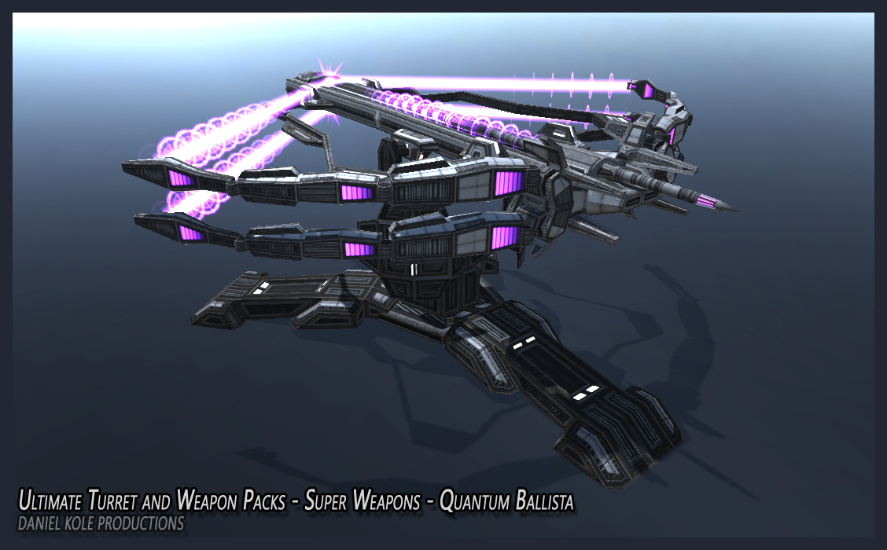

**FOR UNITY3D DOCUMENTATION**

**RELEASE VERSION 1.0**

***CREATED BY: DANIEL KOLE***

*Copywrite 2016 - Daniel Kole Productions*

***UTAW - Super Weapons - Ballista - Overview:***

Requires Unity 5.4.1 or higher.

*The* ***Ballista - Super Weapons - UTAW*** *is a large, bow-like weapon system for delivering bolts of plasma to explode on the battlefield. Textures are 2048x2048 PBR-Metallic Setup.*

***FEATURE LIST:***

*- FULLY-FUNCTIONING BALLISTA WEAPON SYSTEM*

*- TARGETING SYSTEM INCLUDED (C# SCRIPTS)*

*- 2 MODES FOR BOW*

*- PBR ENABLED MATERIALS*

***Ballista – Super Weapons - UTAW - Usage and Version History:***

***Usage and Installation:***

To use this package:

- Start a new project and import the Ballista – Super Weapons - UTAW Asset Package into the project.

- Open the ***ballistaDemoScene.unity*** scene located in the DKP/SuperWeaponBallista/Demo/Scenes folder. This scene shows off the Ballista Auto-Targeting Target Boxes.

***Version History:***

***Version 1.0 -***

**- First Release Version of Ballista – Super Weapon - UTAW.**

**- Includes a demo scene.**