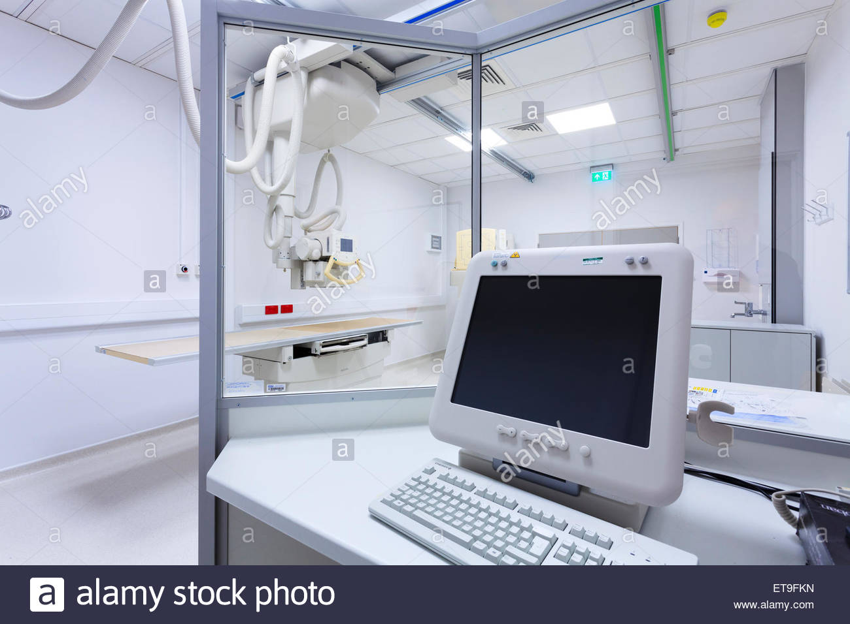

**Title:** X-Ray room

**Description:**

You are in a Bright white room with white walls and blue floors.

There is a computer with a glass screen around it.

There is a wooden bed where patients can lie during the x ray procedure. There are no windows in this room. The key is behind an item which is the answer to the following riddle:

I have cities, but no houses. I have mountains, but no trees. I have water, but no fish. What am I?

**Items**: Cabinet, computer, map, glasses, desk, instruments, machines

**Solving the puzzle – User only has 3 maximum attempts otherwise puzzle is solved**

1. Inspect map -> new item: key
2. Inspect the cabinet -> you solved the puzzle

**Wrong outcomes**

1. If user inspects any other items than cabinet or map, we say nothing.

…………………………………………………………………………………………………………………………………………..

Rydych chi mewn ystafell wyn llachar gyda waliau gwyn a lloriau glas.

Mae cyfrifiadur gyda sgrin wydr o'i gwmpas.

Mae gwely pren lle gall cleifion gysgu yn ystod y weithdrefn pelydr x. Nid oes ffenestri yn yr ystafell hon.

Datryswch y dychymyg canlynol i ddod o hyd i leoliad yr allwedd i'r cypyrddau dan glo.

……………………………………………………………………………………………………………………………………………

Aim: combine key with cabinet. (to get medicine)

Rydych chi mewn ystafell wyn llachar gyda waliau gwyn a lloriau glas.

Mae cyfrifiadur gyda sgrin wydr o'i gwmpas.

Mae gwely pren lle gall cleifion gysgu yn ystod y weithdrefn pelydr x. Nid oes ffenestri yn yr ystafell hon.

Datryswch y dychymyg canlynol i ddod o hyd i leoliad yr allwedd i'r cypyrddau dan glo.