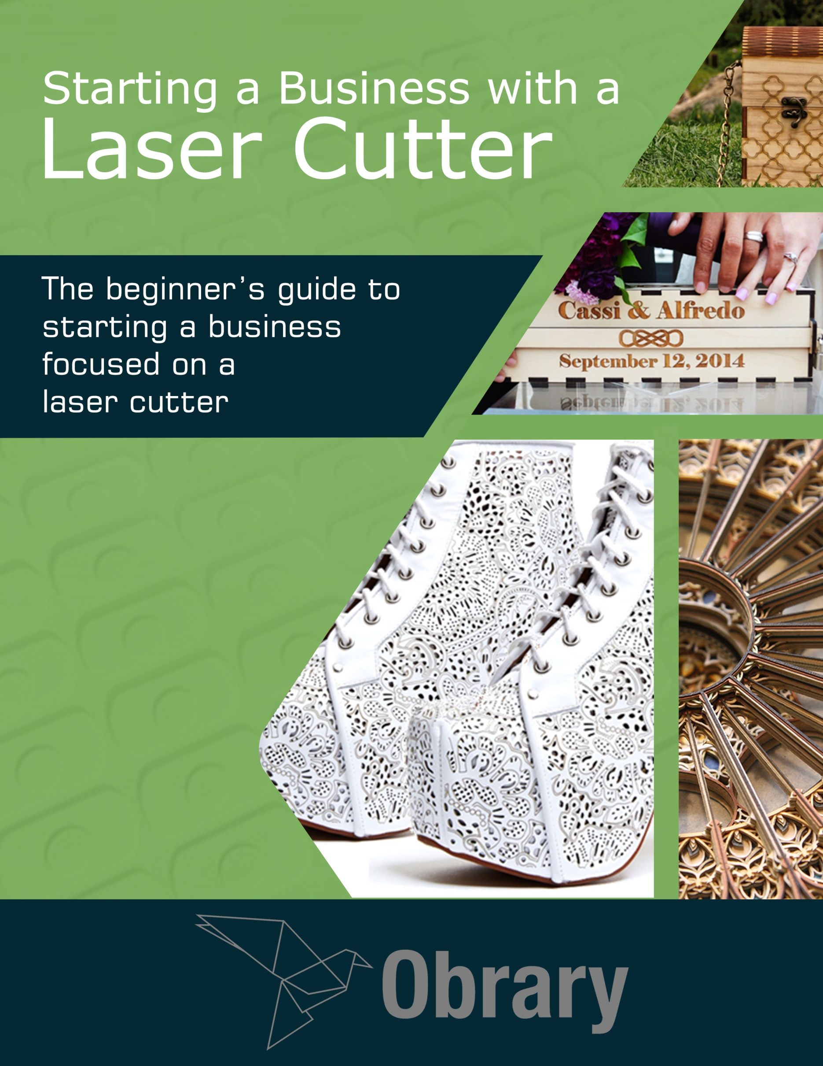

Contents

Introduction 1

Products and Services to Sell 2

Creating Your Company’s Brand 8

Creating Your Company 13

Creating an Online Presence 16

Shipping 19

Additional Resources 22

About Obrary 23

## Version

This document was last updated September 4, 2016.

## License

This eBook is distributed under the Creative Commons BY-SA license.



# Introduction

A laser cutter is a fantastic tool. It can cut, engrave and mark all kinds of materials. Building a business around your laser cutter is possible. Many people have done exactly that. These companies can be found distributed across the world. As shipping is a significant cost, these companies tend to be more local. In other words, they make a great local, small or family run business.

This eBook will walk you through many of the things that you need to think about in creating your company and building the business.

# Products and Services to Sell

The revenue stream for your Laser Cutter business will fall under two big umbrellas, products and services. Products are those products that are defined by you, marketed to your audience and sold to customers. Services are less defined than products. Here are some further details.

## Products

The first thing to note about products is the difference between a finished product and a kit. You can sell kits that require finishing and complex assembly to makers and do-it-yourselfers. But finished products will appeal to broader set of customers. And you’ll be able to charge more for a finished product than for a kit.

Focusing on a theme or set of related products can help your business be successful. This can be a couple of different reasons like:

* Focusing on a certain type of product can help contribute to your company’s brand. More on brand later.
* Your quality will improve as you’ll learn how to optimize your process.

Here are some laser product ideas to kickstart your product brainstorming:

### Art

The precision of the laser can produce some visually compelling wall art.

### City maps

A popular trend in laser products these days

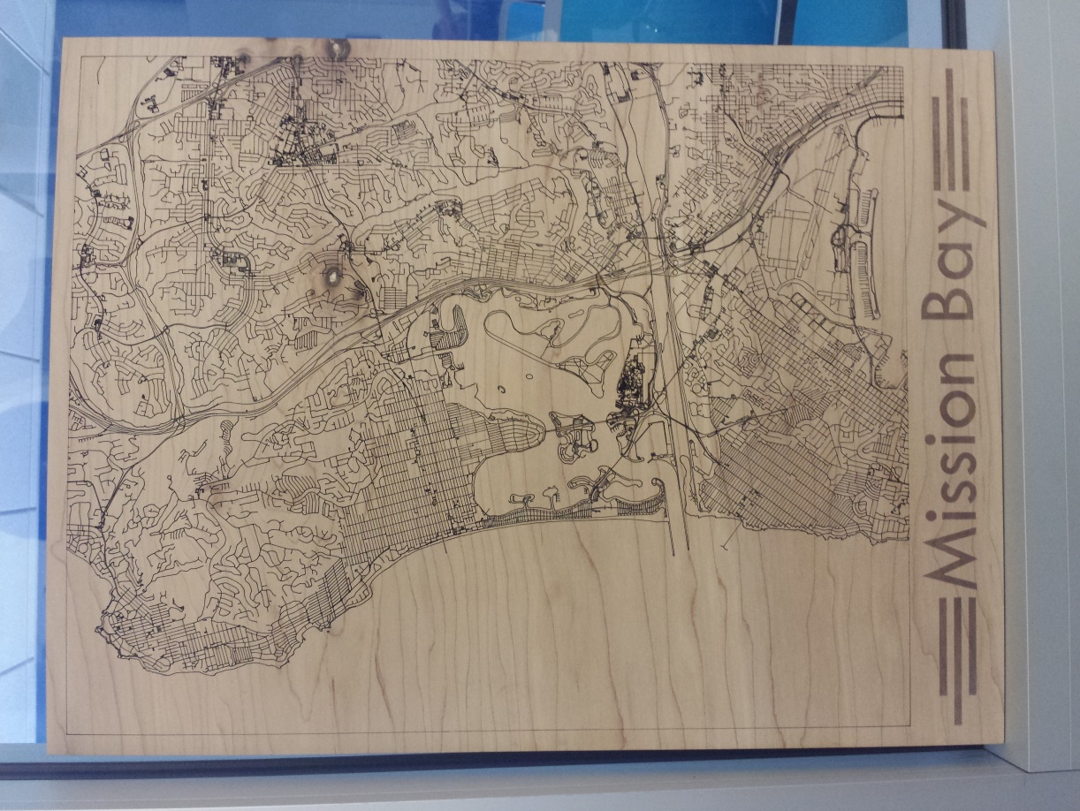

Map of a San Diego Neighborhood

### Company Marketing

Branding elements for companies.

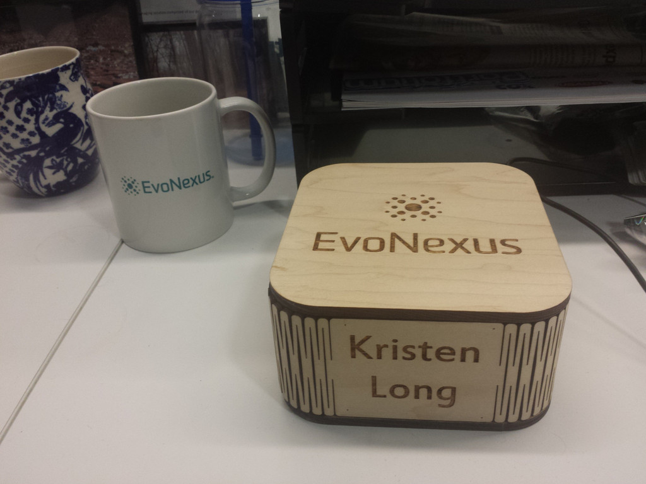

Branded Business Card Box

### Custom Products

Custom products as defined by the customer

### Fan paraphernalia

Fans of movies, books and other popular pop-culture will enjoy related products.

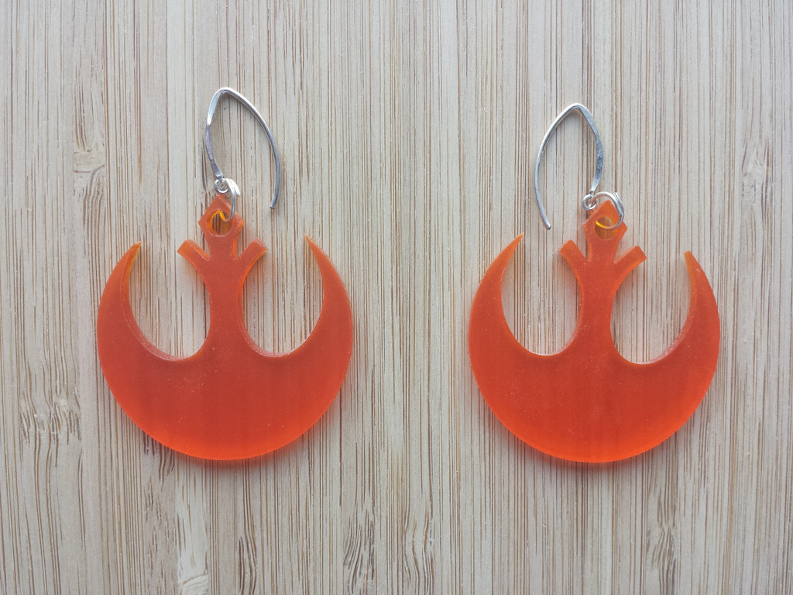

Star Wars inspired earrings

### Glassware

Engraved bottles and glasses.

### Jewelry

Earrings, charms, pendants, etc.

### Pets

Tags, collars, urns and memorials.

### Photo Engraving

Family memories on marble, glass or wood.

### Signage

Create custom signs in wood and acrylic

### Weapons

Gun and knife owners and collectors enjoy having customized weapons.

### Weddings

Weddings are high-dollar events that are highly personalized. Wedding products include bridesmaid gifts, groomsman gifts, invitations, Wedding Ceremony Wine Box, photo albums, guest logs and more.

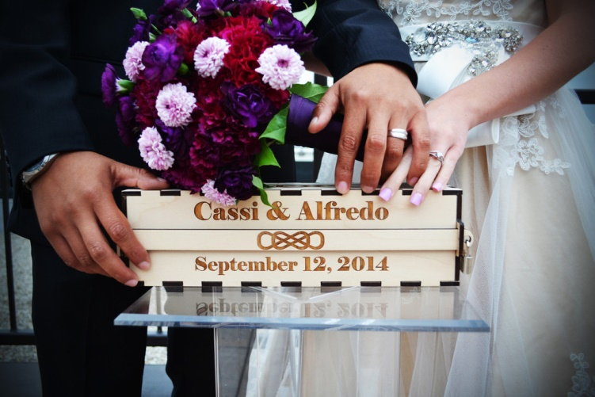

Wedding Ceremony Wine Box

## Product Design Library

At Obrary, we have a library of product designs that are great products for your business to add to your product portfolio. The designs are all open designs. You can download and use them for free even as a part of your business. You can see them at <http://obrary.com/lasers>.

## Pre-made products

There are many companies out there that supply pre-made, ‘blank’ products for the purpose of companies like yours turning them into customized and personalized products.

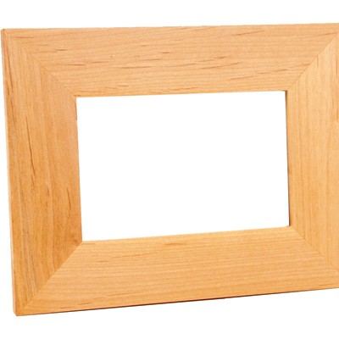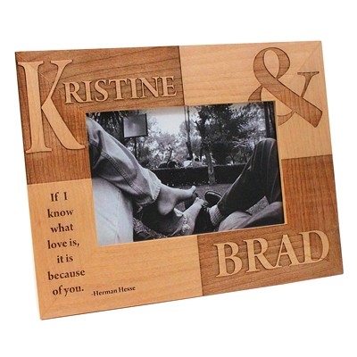

Blank and Personalized Picture Frame

Here are some places to source such products:

* LaserBits – <http://laserbits.com>
* LaserGifts - <http://lasernation.com/>
* LaserSketch - <http://www.lasersketch.com/catalog/index-1.htm>
* Wholesale Cutting Boards - <http://www.wholesalecuttingboards.com/>
* Alibaba - <http://www.alibaba.com/showroom/laser-engraving-blanks.html>

## Services

Services include charging for your time and expertise. A common laser service is design work. This includes designing a custom product from scratch. It also includes converting images to formats that the laser can engrave with high quality.

## Other Tools

Many of your customers are going to want products and services that beyond that provided with a laser cutter. In other words, you should consider expanding your toolset to be able to provide more complete products. For example, imagine a product that is milled on the CNC router and then personalized. Adding more tools will increase the complexity and quality of the products that you can make.

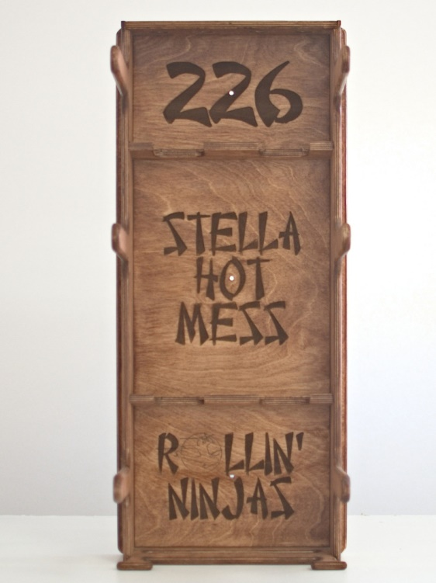

Milled on the CNC and engraved on the laser  
Product design - <http://obrary.com/products/roller-derby-gear-rack>

# Creating Your Company’s Brand

Here’s a definition of Brand from Donna Antonucci:

Brand is a known identity of a company in terms of what products and services they offer but also the essence of what the company stands for in terms of service and other emotional, non-tangible consumer concerns. To brand something is when a company or person makes descriptive and evocative communications, subtle and overt statements that describe what the company stands for. For example, is the brand the most economical, does it stands for superior service, is it an environmental responsible provider of x,y,z service or product. Each communication is deliberate in evoking emotion in the receiver to leave him/her with an essence of what the company or person stands for.

Here are some of the tasks you need to take to establish your brand.

## Naming Your Company

Having a name for your company is an important part of your brand. Here’s some benefits to putting a name to your company even if you haven’t created yet:

### Internal

For you (if you are a one person company) or for your team, putting a name down gives your idea an identity. It’s now real. It almost like you can now reach out and touch it. It keeps you focused. You’re no longer brainstorming random ideas. You’re executing on building your now named product/company.

### External

Putting a name behind something gives it street cred. Everyone has ideas. But by naming yours, it makes it more real. You no longer have to use the phrase that you came up with to explain the idea like “engraving photos and other memorable events into marble and stone using high powered lasers”. You can just say “StoneMemories”.

### Basic Rules

Here are some basic rules for naming your company:

1. It must be easy to say
2. Shorter is better
3. People must be able to easily spell it correctly.  
   This rule is broken by many companies these days. It is an easy pit to fall into as you try to find an available name domain. For example if WorldsBestLaserCompany.com was taken, you might be tempted to name your company WorldzBestLazerrCompany.com.  
   Just think a few years down the road. Do you really want to spell out your company name every time you tell people about it or share your email?
4. The .com domain must be available (whether freely available or available for purchase). Having a domain other than .com diminishes the perception of the company. LaserStudio.com has more impact than LaserStudio.org. Here’s an interesting blog post by Paul Graham that supports the you-must-have-the-.com position, <http://paulgraham.com/name.html>.
5. If the name is going to be descriptive, it must speak to your value proposition or differentiation.

### Local Rules

You will also need to factor in any government regulations pertaining to company’s names that are in place to ensure a new company does not infringe upon the right of an existing business. You’ll be able to find these rules at your local government’s website.

## Domain

Today, a company’s domain name is an essential part of its brand. Your domain is the web address that people go to to learn more about your company. Usually, you want your domain to match your company name.

Your domain is also used to get branded email. Its worth the money to pay for email hosting to get an email address with your domain and stop using [MrBeerDrinker@aol.com](mailto:MrBeerDrinker@aol.com) for your company email.

Today, its very hard to find a domain that isn’t owned by someone. They exist, but usually they are not desirable. Many owned domains are actually not in use. They are ‘parked.’ It’s pretty easy to spot a parked domain. The website usually looks very generic and some even have for sale signs on them.

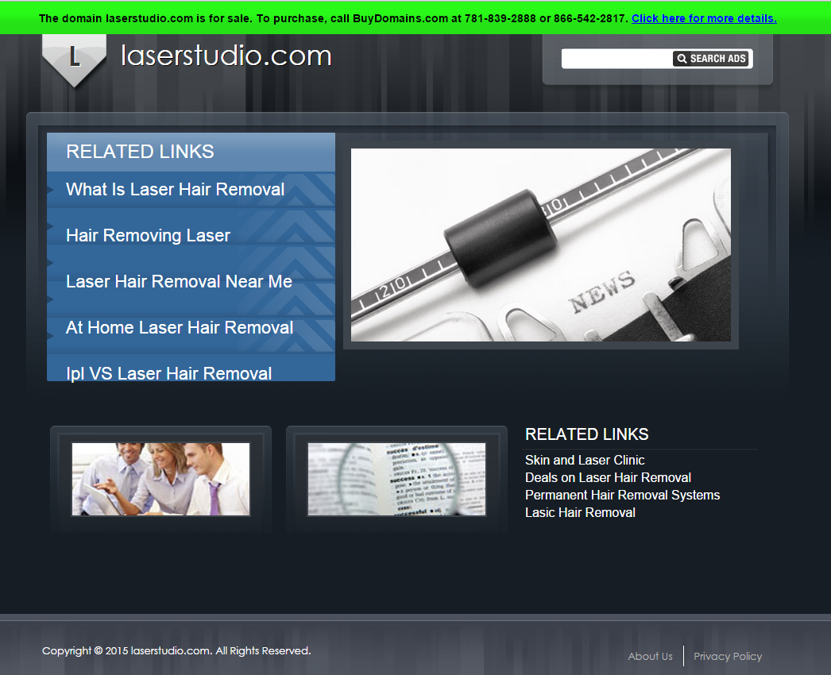

Parked Domain

Buying an owned domain is a common occurrence, so it’s a pretty simple process. And prices can be reasonable. It can also get expensive if you are going after a very desirable domain.

You can check the availability of a domain at many sites including GoDaddy. Here’s a name generator that checks for domain availability from Shopify, <http://www.shopify.com/tools/business-name-generator>.

## Logo

A logo is a great visual way to establish your brand. It will appear on your website, business cards, marketing materials and maybe even your products. Many of our products get the Obrary label added to them. So you should think about what your logo says about your company. If you want people to treat your company seriously, its best to have a serious logo.

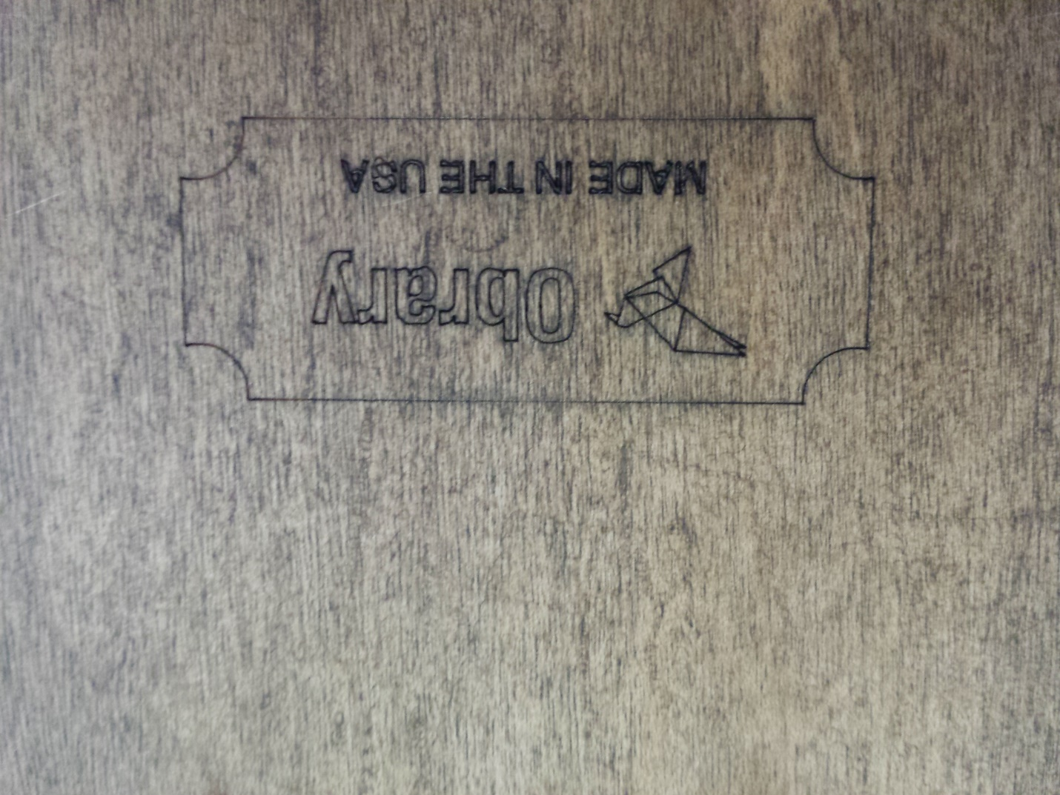

The Obrary label on a product

Here are some ways that you can get your logo created:

* Do It Yourself
* Crowd-Sourcing
* Hire a Designer

### Do It Yourself

There are tools out there that help you design your own logo including:

* Hipster Logo Generator – <http://www.hipsterlogogenerator.com/>. Completely free
* GraphicSprings Logo Creator - <https://www.graphicsprings.com/>
* Logoshi - <https://www.logoshi.com/>
* Logaster - <https://www.logaster.com/>
* Withoomph - <http://withoomph.com/>

### Crowd Sourcing

If you or your friends’ network can’t create your logo, there are some low cost options that bring together designers from across the planet including:

* 99Designs – <http://99designs.com/>. A marketplace of designers from around the world that compete to create your logo.
* DesignCrowd – <http://www.designcrowd.com/>. similar to 99Designs.
* Upwork. - <https://www.upwork.com/o/profiles/browse/?q=logo%20designers>
* CrowdSpring - <http://www.crowdspring.com/>
* Fiverr - <https://uk.fiverr.com/>. Not known for high quality.

### Hire a Designer

To find a designer, do a web search for ‘<your city> logo designer’.

# Creating Your Company

To get your business started, you are going to need to register the business with the appropriate government entities. The rules vary by location and are subject to change. So instead of trying to put all this information in this eBook, here are links to the appropriate government websites.



## Country Specific Sites

Here are the websites for starting a business in a number of countries:

* Australia - <http://www.business.gov.au/business-topics/starting-a-business/Pages/default.aspx>
* Canada - <http://www.canadabusiness.ca/eng/page/2856/>
* United Kingdom - <https://www.gov.uk/set-up-business-uk/overview>

## United States

In the United States, businesses are established at the state level, not the federal level. Each state has its own set of rules and regulations that businesses must follow to create the legal entity that is the company and run its operations with respect to taxes and other filing requirements.

Here’s a link to the guide from each state on starting a business in that state. Some of them are handy PDF files that you can download and get all of the information in one package. Other states offer the information on a website.

* Alabama - <http://www.madeinalabama.com/assets/2013/02/2012_Alabama_Answers.pdf>
* Alaska - <https://www.commerce.alaska.gov/web/Portals/5/pub/EstablishingABusiness.pdf>
* Arizona - <http://www.azcc.gov/Divisions/Corporations/Ten-Steps-to-Starting-a-Business-in-Arizona.pdf>
* Arkansas - <http://www.dfa.arkansas.gov/offices/policyAndLegal/Documents/starting_a-new_business.pdf>
* California - <http://business.ca.gov/StartaBusiness.aspx>
* Colorado - <https://www.colorado.gov/apps/jboss/cbe/start-business.xhtml>
* Connecticut - <http://www.ct.gov/drs/lib/drs/publications/pubsip/2015/ip_2015(12).pdf>
* Delaware - <http://delaware.gov/topics/startasmallbusiness.shtml>
* Florida - <http://dos.myflorida.com/library-archives/research/florida-information/business/starting-a-business-in-florida/>
* Georgia - <http://www.georgia.org/small-business/>
* Hawaii - <http://cca.hawaii.gov/bac/steps-to-starting-a-business/>
* Idaho - <http://business.idaho.gov/StartingaBusiness.aspx>
* Illinois - <https://www.illinois.gov/dceo/SmallBizAssistance/BeginHere/Documents/Starting%20Your%20Business%20In%20IL%202014.pdf>
* Indiana - <http://www.in.gov/sos/business/2428.htm>
* Iowa - <http://www.iowa.gov/For_Businesses/Starting%20a%20Business>
* Kansas - <http://www.kansas.gov/businesscenter/>
* Kentucky - <http://onestop.ky.gov/start/Pages/default.aspx>
* Louisiana - <http://www.sos.la.gov/BusinessServices/StartABusiness/Pages/default.aspx>
* Maine - <http://www.maine.gov/portal/business/starting.html>
* Maryland - <http://business.maryland.gov/start>
* Massachusetts - <http://www.mass.gov/portal/business/start-business/new-business-steps.html>
* Michigan - <http://www.sbdcmichigan.org/wp-content/uploads/2014/01/Guide-to-Starting-and-Operating-a-Small-Business-2014v2.pdf>
* Minnesota - <http://mn.gov/deed/images/GuideToStartingABusinessInMinnesota2014.pdf>
* Mississippi - <http://www.mssbdc.org/i-want-to-start-a-business>
* Missouri - <http://s1.sos.mo.gov/business/outreach/starting_steps>
* Montana - <http://sos.mt.gov/Business/Startup/>
* Nebraska - <http://www.revenue.nebraska.gov/business/bus_regist.html>
* Nevada - <https://www.nvsilverflume.gov/checklist>
* New Hampshire - <http://www.nheconomy.com/business-services/starting-a-business-in-nh.aspx>
* New Jersey - <http://www.nj.gov/njbusiness/starting/>
* New Mexico - <http://www.newmexico.gov/business/Starting_A_Business.aspx>
* New York - <http://www.ny.gov/services/start-business-new-york-state>
* North Carolina - <http://www.thrivenc.com/businessservices/start-a-new-business>
* North Dakota - <http://www.nd.gov/businessreg/>
* Ohio - <http://business.ohio.gov/starting/>
* Oklahoma - <https://www.sos.ok.gov/business/infoSB.aspx>
* Oregon - <http://sos.oregon.gov/business/Pages/starting-business.aspx>
* Pennsylvania - <http://www.revenue.pa.gov/formsandpublications/formsforbusinesses/documents/rev-588.pdf>
* Rhode Island - <https://www.ri.gov/SOS/quickstart/>
* South Carolina - <http://www.sc.gov/business/Pages/STARTINGABUSINESS.aspx>
* South Dakota - <http://sd.gov/business.aspx>
* Tennessee - <http://www.tn.gov/ecd/topic/how-to-start-a-business>
* Texas - <https://texaswideopenforbusiness.com/start-business>
* Utah - <http://www.utah.gov/business/starting.html>
* Vermont - <http://www.vermont.gov/portal/business/index.php?id=87>
* Virginia - <http://www.bos.virginia.gov/starting.shtml>
* Washington - <http://business.wa.gov/start-your-business-0>
* West Virginia - <http://www.business4wv.com/b4wvpublic/default.aspx?pagename=startbusiness>
* Wisconsin - <https://www.revenue.wi.gov/businesses/new-business/index.html>
* Wyoming - <http://soswy.state.wy.us/Business/StartABusiness.aspx>

# Creating an Online Presence

There are many options for you to help you create an online presence. Most companies will use more than one of them, so that have multiple channels of business revenue. Diversification of revenue streams across channels can minimize the risk of a single channel failing (for whatever reason).

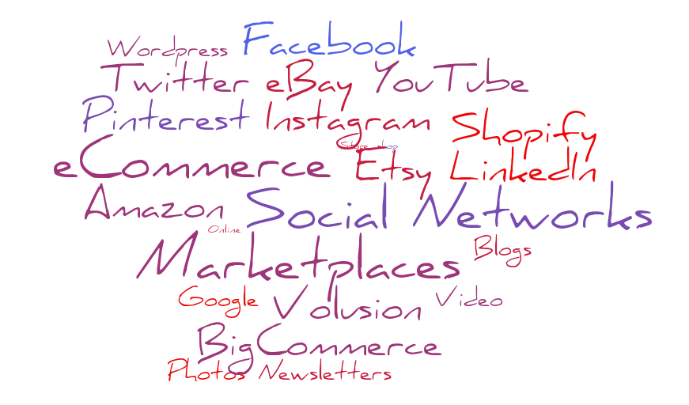

## eCommerce Platforms

In an eCommerce platform, you will create your own online store. You have a lot of control over the user experience. You are also responsible for generating traffic to the site. The top 3 eCommerce platforms as rated by [eCommerce-Platforms.com](http://ecommerce-platforms.com/comparison-chart) are:

* Shopify - <http://www.shopify.com/free-trial>
* Volusion - <http://www.volusion.com/>
* BigCommerce - <https://www.bigcommerce.com/>

## Marketplaces

Putting your products on a marketplace is a good way to start getting customers quickly. This is because these marketplaces already have an established online presence. They have customers buying products today some of whom are probably searching for products like yours. Here are some marketplaces to get started with.

* Amazon - [http://services.amazon.com/content/sell-on-amazon.htm](http://services.amazon.com/content/sell-on-amazon.htm/ref=footer_soa). Set up your own store within the top online retailer.
* Amazon Handmade - <http://services.amazon.com/handmade/handmade.htm>. Amazon’s competitor to Etsy.
* eBay - <http://pages.ebay.com/sellerinformation/learn-to-sell-online/how-to-sell.html>. Once known for auctions, and now a retailer.
* Etsy - <https://www.etsy.com/sell/>. The largest online marketplace for handmade and vintage items.

## Social Networks

Most businesses will benefit from creating and maintaining a company presence on social networks. There are too many social networks for a small company to manage a presence on them all. So to get started, Facebook and Twitter are highly trafficked social networks that will give you the most traffic After that, Instagram and Pinterest are very photo based – which works well for a product based company

## Content

The content you put on your site includes your product descriptions and product photography. They are used to convert visitors to your website into purchasers of your products.

### Product descriptions

Not everyone will read your product descriptions. But many people do read them completely along with the search engines which use text to index your content. Here are some things to think about when writing your product descriptions.

* Know who your ideal customer is. Talk to them in language they would use.
* Talk about the benefits of your products to your customers.
* Minimize the use of superlatives and exclamation points.
* Use positive customer reviews and let them brag about you.
* If your product has been professional reviewed or highlighted by a professional publication, be sure to include that.

### Product Photos

While not everyone will read your product descriptions, everyone will look at your product photos. The quality of your photography will have a direct impact on your conversion. The better your make your products look in the photos, the more units you will sell.

Here is a detailed article from Shopify that explains how to shoot a white background, product photo with minimal equipment and expense, The Ultimate DIY Guide to Beautiful Product Photography - <http://www.shopify.ca/blog/12206313-the-ultimate-diy-guide-to-beautiful-product-photography>

There are many of photo editing tools available for you. Here are the free tools:

* Fotor - <http://www.fotor.com/>. Cloud based editor. So there is no download – just access it from within your browser.
* GIMP - <http://www.gimp.org/>. For free software, GIMP has a lot of capabilities. As such, there is quite a bit of a learning curve. It is a download. There are versions for Windows, Mac and Linux.
* Photo Editor - <https://www.aviary.com/>. Mobile app.
* Photoshop Express - <http://www.photoshop.com/products/photoshopexpress>. Mobile app. Versions for Android, iPhone and Windows Phone.
* PicMonkey - <http://www.picmonkey.com/>. Another cloud based editor.
* Pixlr Express - <https://pixlr.com/express/>. Cloud based editor.

# Shipping

If you are running an online store and selling products to customers outside of your local area, you are going to need to ship products. Here are some things to think about when it comes to shipping your products to your customers.

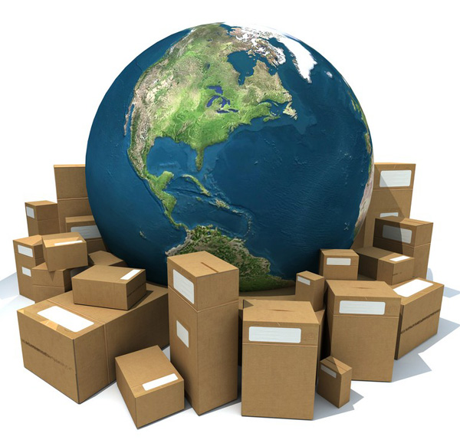

## Who Pays

The first thing is who will pay for shipping. One of the reasons that stores offer free shipping is that customers love free shipping. It is proven that offering free shipping will increase sales. But the costs will eat into your profits.

You can also offer free shipping for transactions over a certain dollar amount. This can be a great motivator for your customers to add more items to their cart in order to meet the minimum requirement.

The other option is to have the customer pay a shipping fee on top of the price of the product. That fee can be the fee that you get charged by the shipping company which will vary by the size of the package and the distance of the shipping. Or it can be a flat fee per product as some of your shipping options are flat rate priced.

And, of course, your shipping strategy can be a combination of the above based on your product mix.

## Calculating Shipping Fee

In your online store, you’ll need to decide if you are going to calculate shipping cost in advance or when a customer places the order. Some of this decision will depend on what shipping cost tools your platforms have.

There are tools in the ecommerce platform and add-on apps to the ecommerce platforms that can calculate shipping costs for you. But these tools are not perfect. Most of them work well enough if your shipping is not complex. In other words, if there is not much variance in the size and weight of your products. But if you are shipping a variety of products that have a different package dimensions and weights, these tools fall short.

The core of the problem is that the carriers have shifted their pricing models to be a function of the package’s weight and the package’s height, width and length. The online shipping cost tools have not caught up yet. So if you are shipping large packages that vary widely by product, you are going to need to hack together a solution that is most accurate for you.

And if you have more than one online channel, say your own ecommerce platform and Etsy, each channel will probably have different ways to calculate shipping cost. So your total price to a customer for a given product can vary by channel.

## Shipping Options

Here are some shipping companies that are available:

* Australia Post
  + Shipping Guide - <http://auspost.com.au/parcels-mail/downloadable-post-guides.html>
  + Shipping Cost Calculator - <http://auspost.com.au/parcels-mail/downloadable-post-guides.html>
* Canada Post
  + Shipping Guide - <https://www.canadapost.ca/web/en/pages/parcelsbus/default.page>
  + Shipping Cost Calculator - <https://www.canadapost.ca/cpotools/apps/far/business/findARate>
* FedEx
  + Shipping Guide - <http://www.fedex.com/us/service-guide/index.html>
  + Shipping Cost Calculator - <http://www.fedex.com/us/service-guide/index.html>
* United Kingdom Royal Mail
  + Shipping Guide - <http://www.royalmail.com/business-service>
  + Shipping Cost Calculator - <http://www.royalmail.com/price-finder>
* United Parcel Service (UPS)
  + Shipping Guide - <http://www.ups.com/content/us/en/shipping/time/service/index.html>
  + Shipping Cost Calculator - <http://www.ups.com/content/us/en/shipping/time/service/index.html>
* United States Postal Service (USPS)
  + Shipping Guide - <http://pe.usps.com/text/dmm100/intro.htm>
  + Shipping Cost Calculator - <http://postcalc.usps.gov/>

## Packaging and Your Brand

Your packaging is the first impression your customer is going to have of your physical product. Products delivered in a nice looking package are seen as having higher quality. In today’s world of ecommerce where shipping packages to a customer is now very common, the bar has been raised quite a bit on the quality of the packaging. It has become a part of your brand. Opening a package has now become an experience.

So think about your packaging and ways to improve the quality.

* Are your boxes sized to fit your products?
* Do you have branding on your packages?
* Can you improve the quality of the packaging? Think a fabric pouch with a drawstring to hold small pieces instead of a zip-lock bag.

Here are some companies that sell packaging products:

* Uline - <http://www.uline.com/>
* CoPak - <http://www.copakusa.com/>
* Global Industrial - <http://www.globalindustrial.com/t/packaging>
* PaperMart - <http://www.papermart.com/product-packaging/>
* Clearbags - <http://www.clearbags.com/>
* eSupplyStore - <http://www.esupplystore.com/>
* Fast-Pak - <http://www.fast-pack.com/>
* Value Mailers - [Value Mailers](http://www.valuemailers.com/)

# Additional Resources

Here are some links to the other eBooks in our Laser Cutter series:

* Laser Cutter 101 eBook - <http://info.obrary.com/laser-cutter-101>
* Laser Cutter Advanced Techniques eBook - <http://info.obrary.com/laser-cutter-advanced-techniques>

# About Obrary

Obrary is a technology company based in San Diego, California. Obrary is focused on software that automates the digital manufacturing process.

You can visit Obrary on the web at <http://obrary.com>.

## Free, Open Designs

Obrary provides a free library of open designs for products that are made on the laser cutter. See the products at <http://obrary.com/laser>.

