Liu Weihao

A0232935A

## Introduction

The goal of this control system is to control the temperature of wafer. I discretize the bake-plate to 5 zone. Because the state-space model has been given, I decide to use state feedback and state observer to control the temperature.

In the MATLAB file, I designed a LQR controller and use all of system state as it’s feedback. Because we can’t measure the wafer temperature, I design a state observer to estimate the wafer temperature and use it as the controller’s input.

## LQR controller design

LQR (Linear–quadratic regulator) is a state feedback controller provided by optimal control. In MATLAB, we can use the function “K = lqr (A, B, Q, R)” to calculate the feedback matrix.

Because there’s no limit on input signal, and we hope the wafer temperature can arrive steady-state temperature as soon as possible, the Eigenvalue of R can be very small. Besides, the Q value should be much bigger than R. The code is as below.

(At first time, I set all the eigenvalues of Q to be 100, but the temperature in T6 is rising much more slowly than in T7~T10, so I add it to 400)

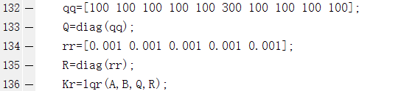

## State observer design

As the instructions on the assignment, we can’t measure the wafer temperature directly, but the LQR controller need all the temperatures as it’s feedback. So, we must design a state observer to estimate the wafer temperature according to the other data we can measure (the plate temperature) and use the output of this part as the LQR controller’s input.

The design of this part refers to the book “Feedback control of dynamic systems / Gene Franklin, J. David Powell, Abbas Emami-Naeini” and some other books, articles, etc. The observer can be expressed by the following formula.



: the temperature of the plate,

: the output of the observe.

So, the state of the original system can be expressed as: .

## The stable state of this system

The wafer needs to arrive 110℃ when it stable, so we need to calculate the plate’s steady-state temperature and the references input signal. When system arrives stable state, the state equation is as follow.



 is the stable state of this control system. By solving this equation, we get the value of and .

Because  , the last 5 column of the matrix  and  is zero. And the last 5 column of the matrix  is 110. We can divide the matrix  into four part:  .. Then, we can get  :



And we can calculate the matrix : 

## Results

The initial temperature:

Plate:114.5833,114.5833,114.5833,114.5833,114.6880

Wafer:25,25,25,25,25

I give the input signal a constrain 0≤u≤10,000. According to the simulation results, the wafer temperature will steady at 110℃ after 100s. The non-uniformity is less than 0.95℃.

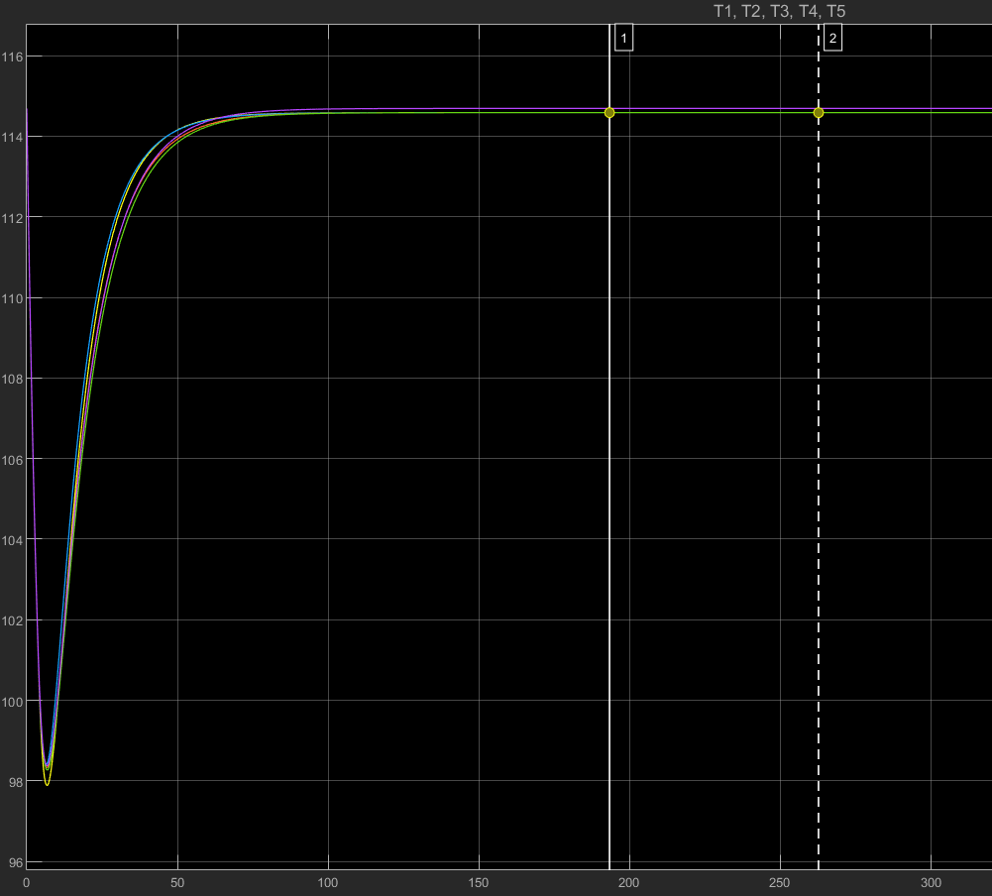

Figure 1 Bake-plate temperature

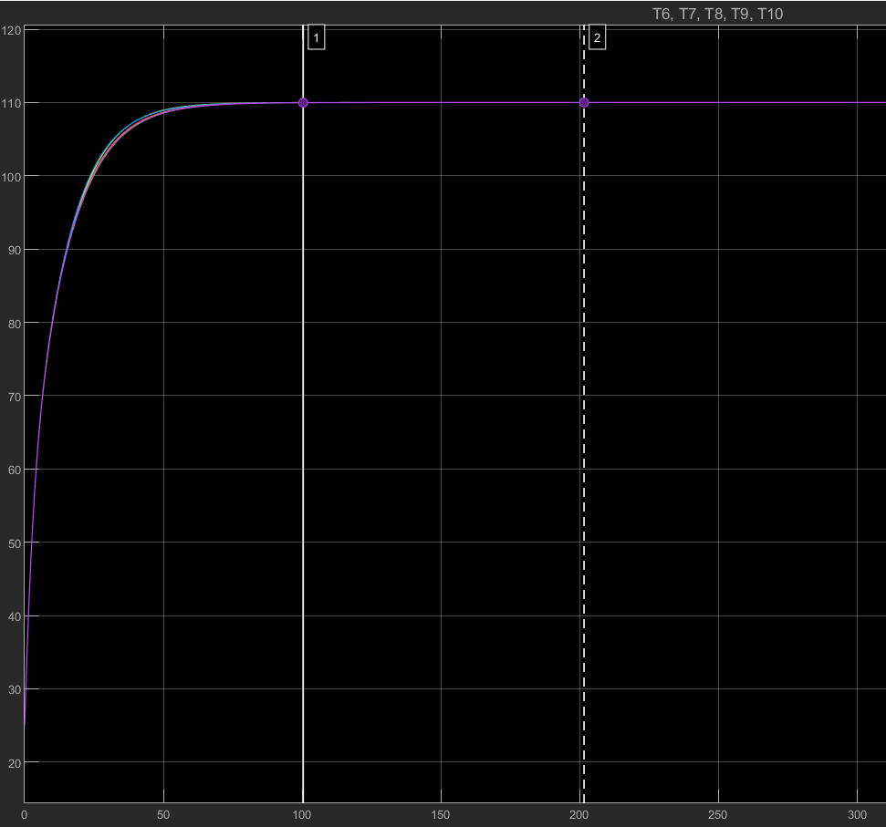

Figure 2 wafer temperature

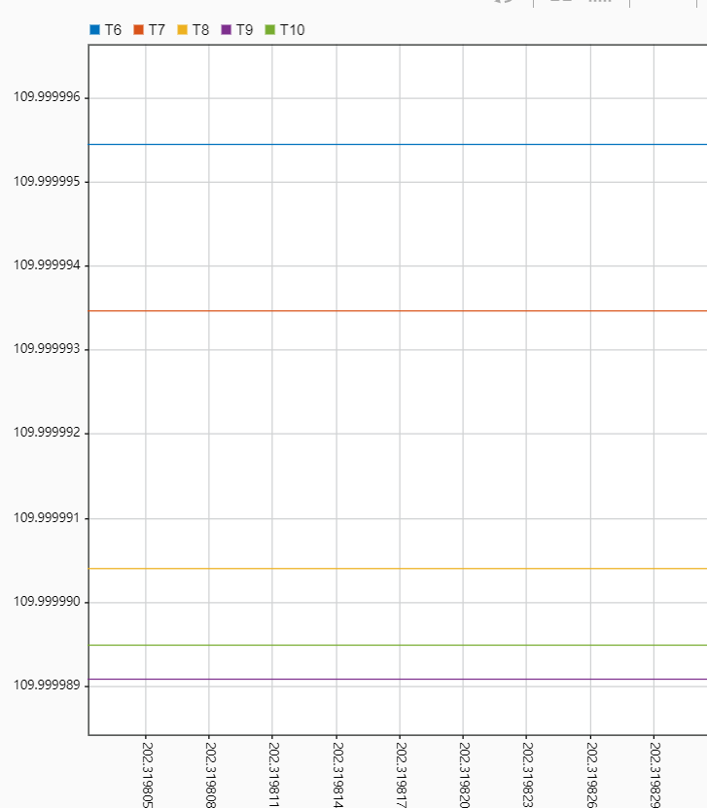

Figure 3 Steady-state temperature of the wafer

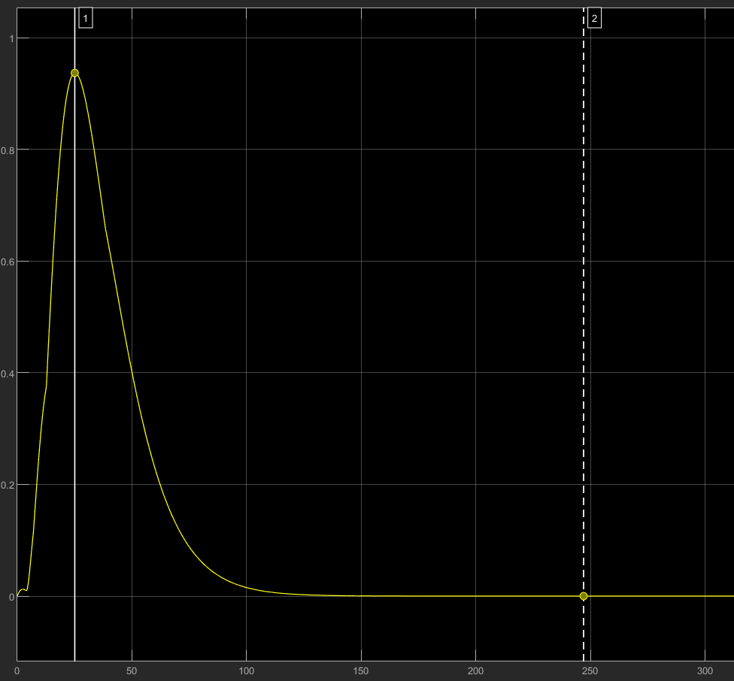

Figure 4 non-uniformity

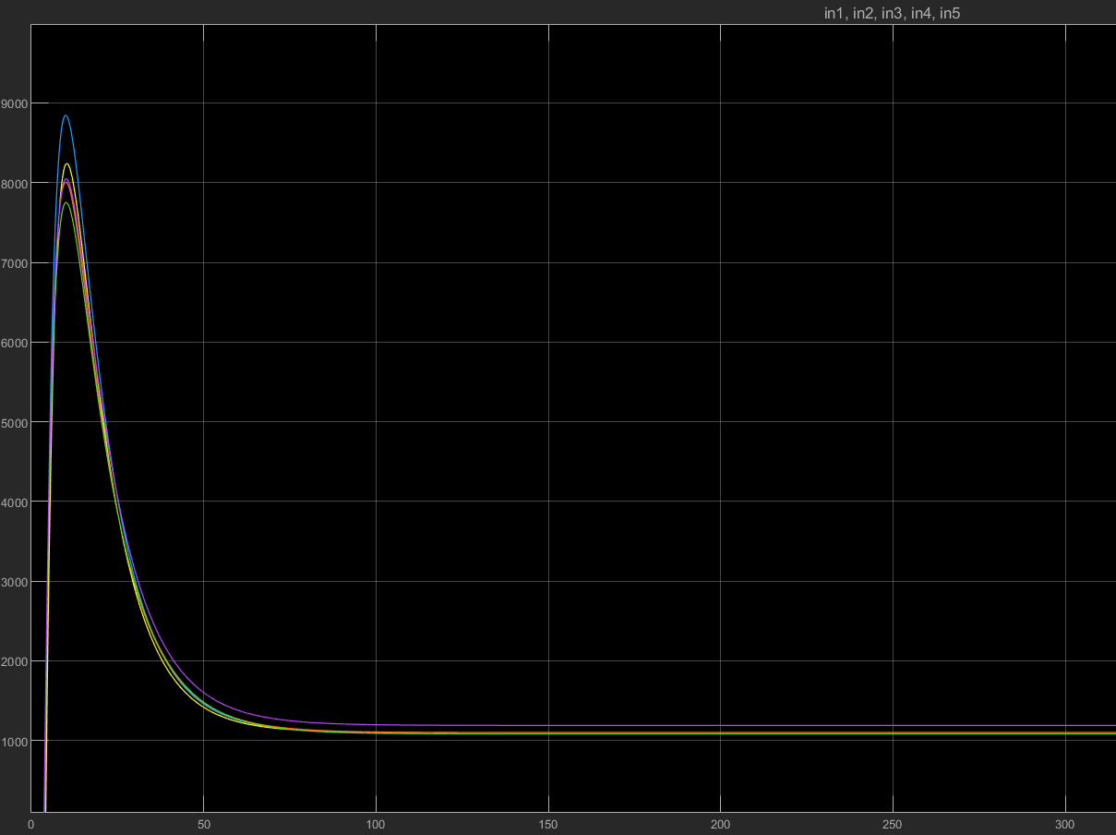

Figure 5 input signal