**EE5104 CA1**

**Fu Yuming**

**A0224710U**

*(a) Write down the continuous-time algorithm for an adaptive controller for the given plant which meets the following specifications.*

plant:



reference model:



control law:

,



adaptive law:



*(b) Using any programming language, run simulations to show the performance of your adaptive controller when the reference signal r(t) is a square wave of an appropriately chosen period.*

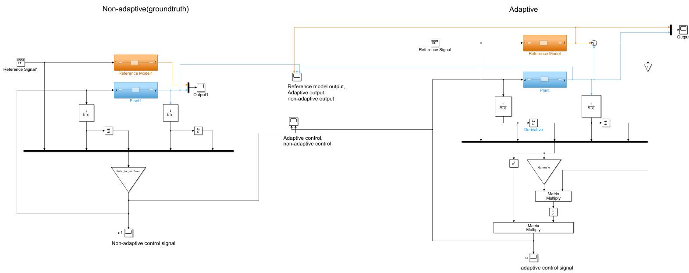

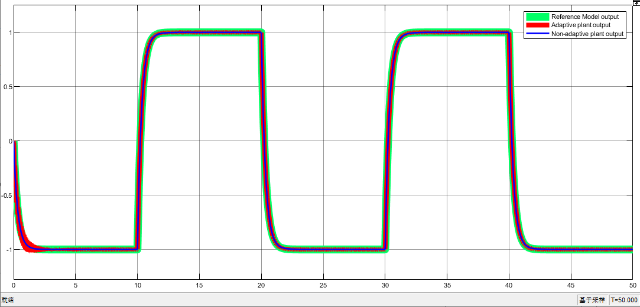

Fig.1(a) **Reference model output**、**Adaptive plant output**、**Non-adaptive plant output**

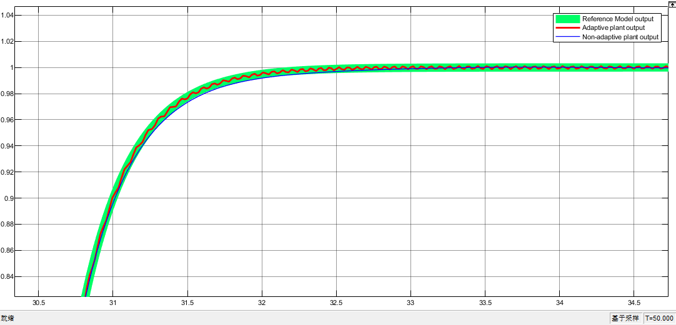

Fig.1(b) zoom in

*Show also some representative plots of the adapted controller gains, comparing these with the exact controller gains.*

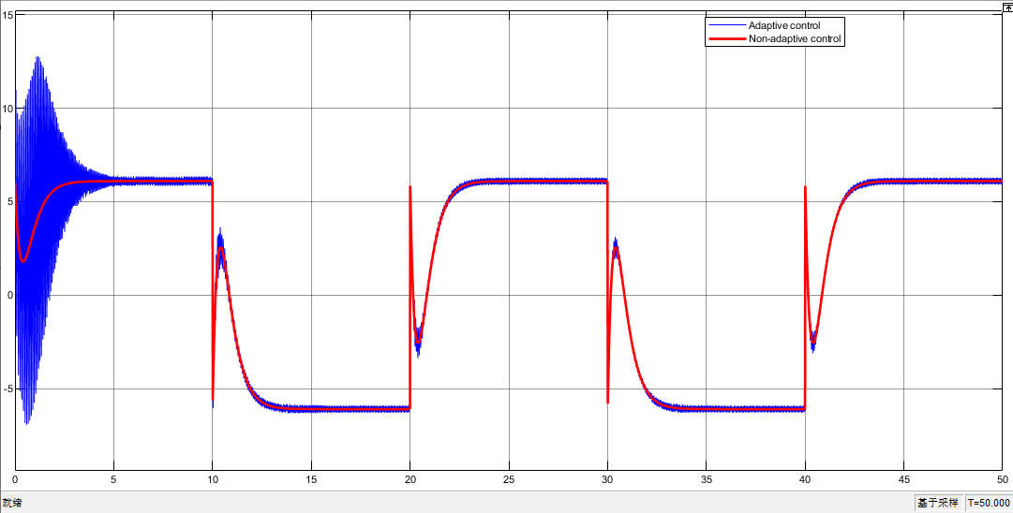

Fig.1(c) **Adaptive controller signal(blue)** 、**non-adaptive controller signal**

*(c) Investigate the effects of different choices of the observer polynomial (denoted as T(p) in the class notes), and different choices of the adaptation gains (denoted as Γ in the class notes)*





**summary:**

① Different Γ Fig.1(a)~Fig.1(c)

When Γ is relatively small, the control signal and output oscillation frequency is slow, tracking error (adaptive plant output - reference model output) is large, but after several periods it can track well. If Γ is too small, in Fig.1(b) it is difficult to track.

When Γ is relatively large, the control signal and output oscillation frequency is high, tracking error (adaptive plant output - reference model output) is small, it can track quickly.

② different T(p) Fig.2(a)~Fig.2(e)

If η and wn are at acceptable range, big/small η and wn doesn't influence result much (adaptive plant output - reference model output). But control signal, adaptive control signal(blue) oscillate heavily

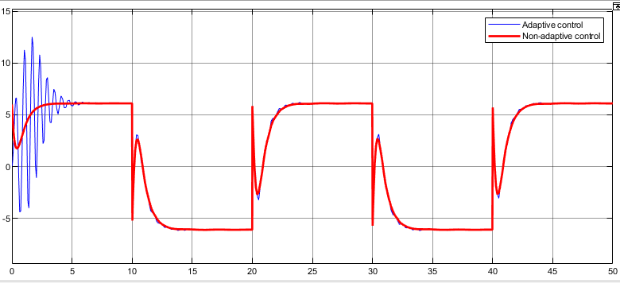

control signal u(t)

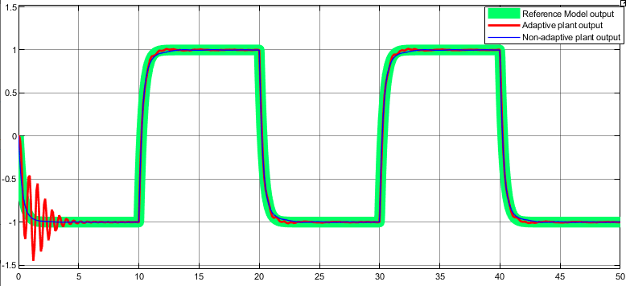

output y(t)

Fig.1(a)  control signal u(t) ; output y(t)

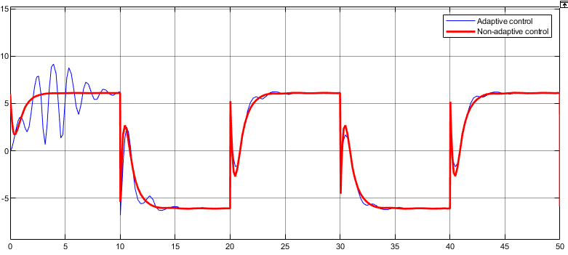

control signal u(t)

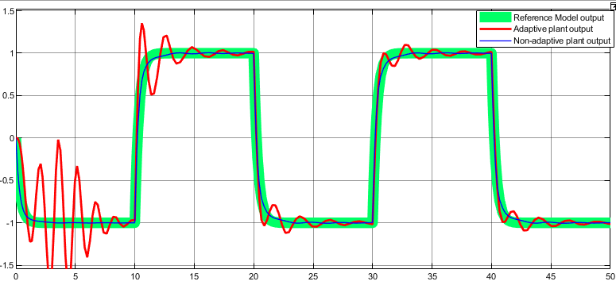

output y(t)

Fig.1(b)  control signal u(t) ; output y(t)



control signal u(t)



output y(t)

Fig.1(c)  control signal u(t) ; output y(t)

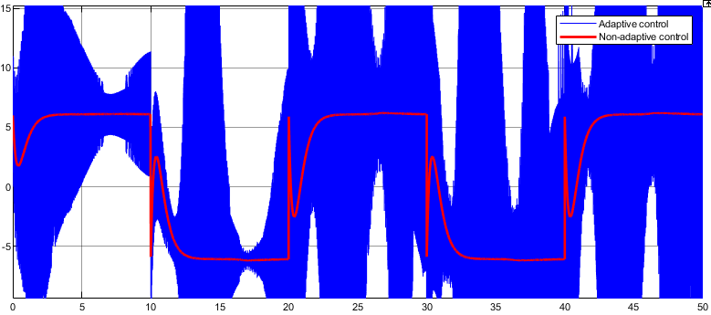

control signal u(t)

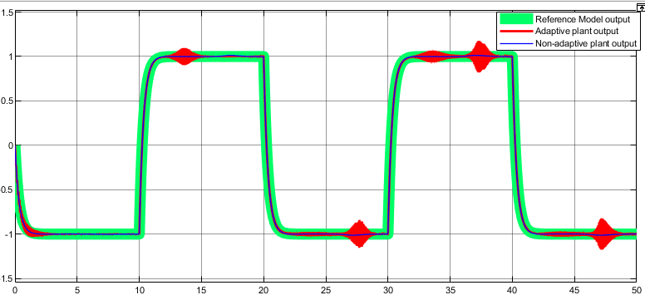

output y(t)

Fig.2(a)  control signal u(t) ; output y(t)

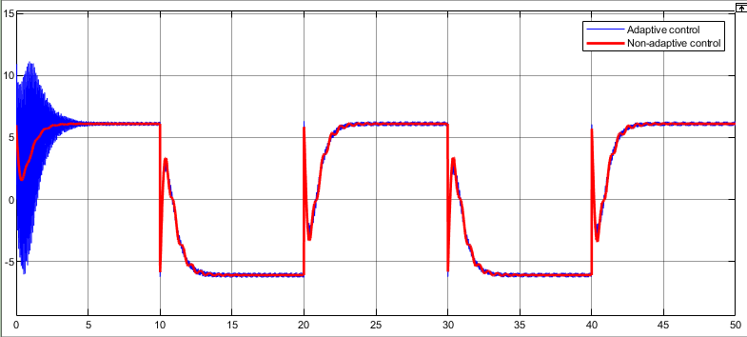

control signal u(t)

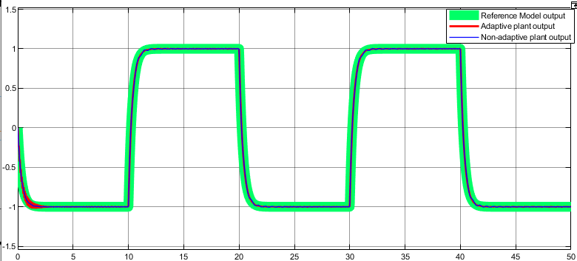

output y(t)

Fig.2(b)  control signal u(t) ; output y(t)

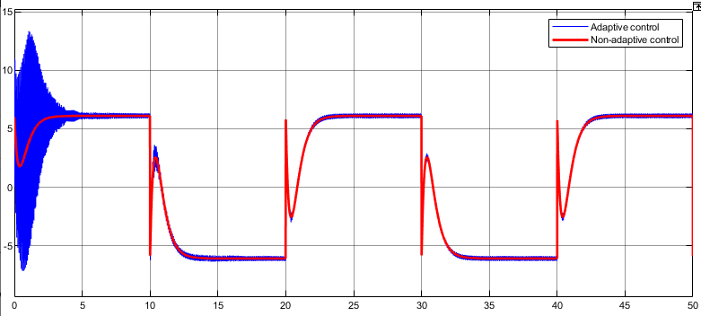

control signal u(t)

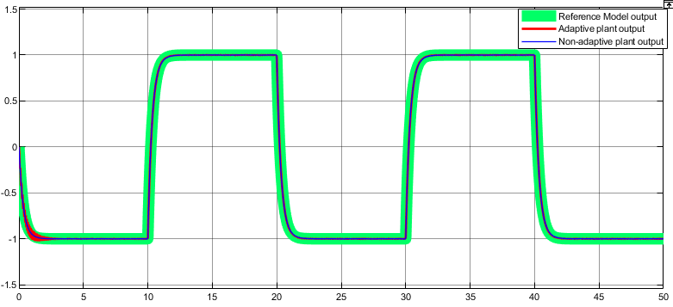

output y(t)

Fig.2(c)  control signal u(t) ; output y(t)

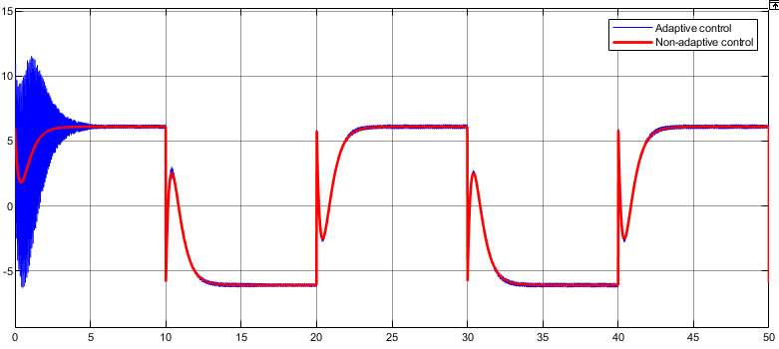

control signal u(t)

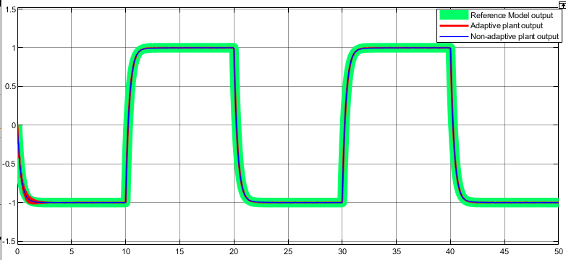

output y(t)

Fig.2(d)  control signal u(t) ; output y(t)

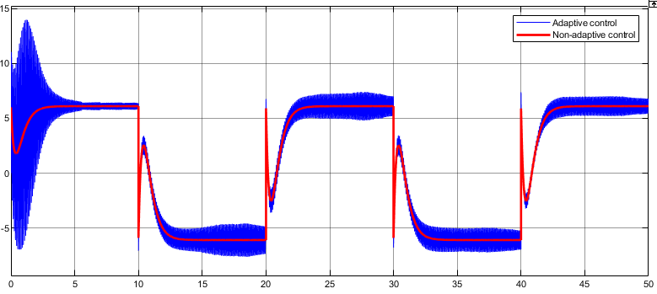

control signal u(t)

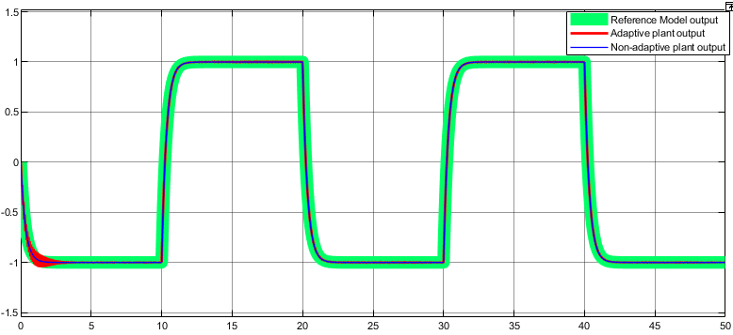

output y(t)

Fig.2(e)  control signal u(t) ; output y(t)

*(d) For a particular choice of T(p) and Γ which you consider best in some sense, investigate the specific case where the reference signal is the single sinusoid: r(t)=10sin(0.5t)*

*Discuss the simulation results you observe for this specific case, noting especially the output tracking error and the adapted controller gains.*

**summary:**

sine wave is easier to track than square wave because it doesn't have abrupt change of function value.

Tracking error is guranteed to converge to 0. But for adapted controller gain (parameter error is bounded but will not gurantee to be 0)

