**EE5104 CA3**

**Fu Yuming**

**A0224710U**

**1、Calibration**

|  |  |
| --- | --- |
| Potientiometer Output  (in volts) | Angular Position  (in degrees) |
| -5 | -180 |
| -4 | -144 |
| -3 | -108 |
| -2 | -72 |
| -1 | -36 |
| 0 | 0 |
| 1 | 36 |
| 2 | 72 |
| 3 | 108 |
| 4 | 144 |
| 5 | 180 |

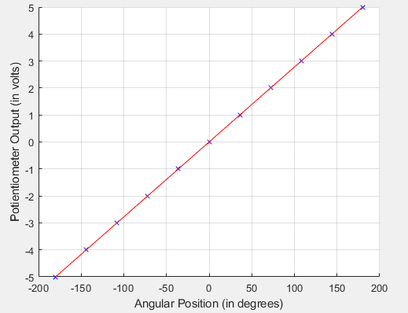

Results for the calibration of the potientiometer 

|  |  |  |  |
| --- | --- | --- | --- |
| Input Voltage (volts) | Tachogenerator Output (volts) | Angular Velocity (rpm) | Angular Velocity (rad/sec) |
| -5 | -4.03 | -301 | -31.52 |
| -4 | -3.17 | -237 | -24.82 |
| -3 | -2.3 | -172 | -18.01 |
| -2 | -1.45 | -108 | -11.31 |
| -1 | -0.6 | -45 | -4.71 |
| 0 | 0 | 0 | 0 |
| 1 | 0.62 | 48 | 5.03 |
| 2 | 1.48 | 111 | 11.62 |
| 3 | 2.33 | 175 | 18.33 |
| 4 | 3.2 | 239 | 25.03 |
| 5 | 4.06 | 303 | 31.73 |

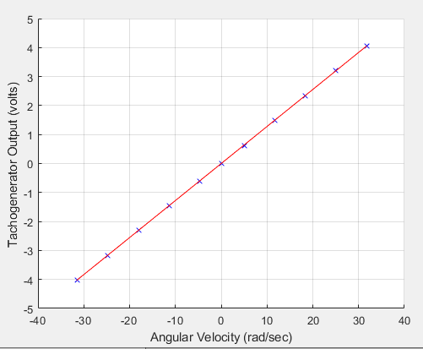

Results for the calibration of the tachogenerator 

**2、Adaptive control with all state-variables measurable**

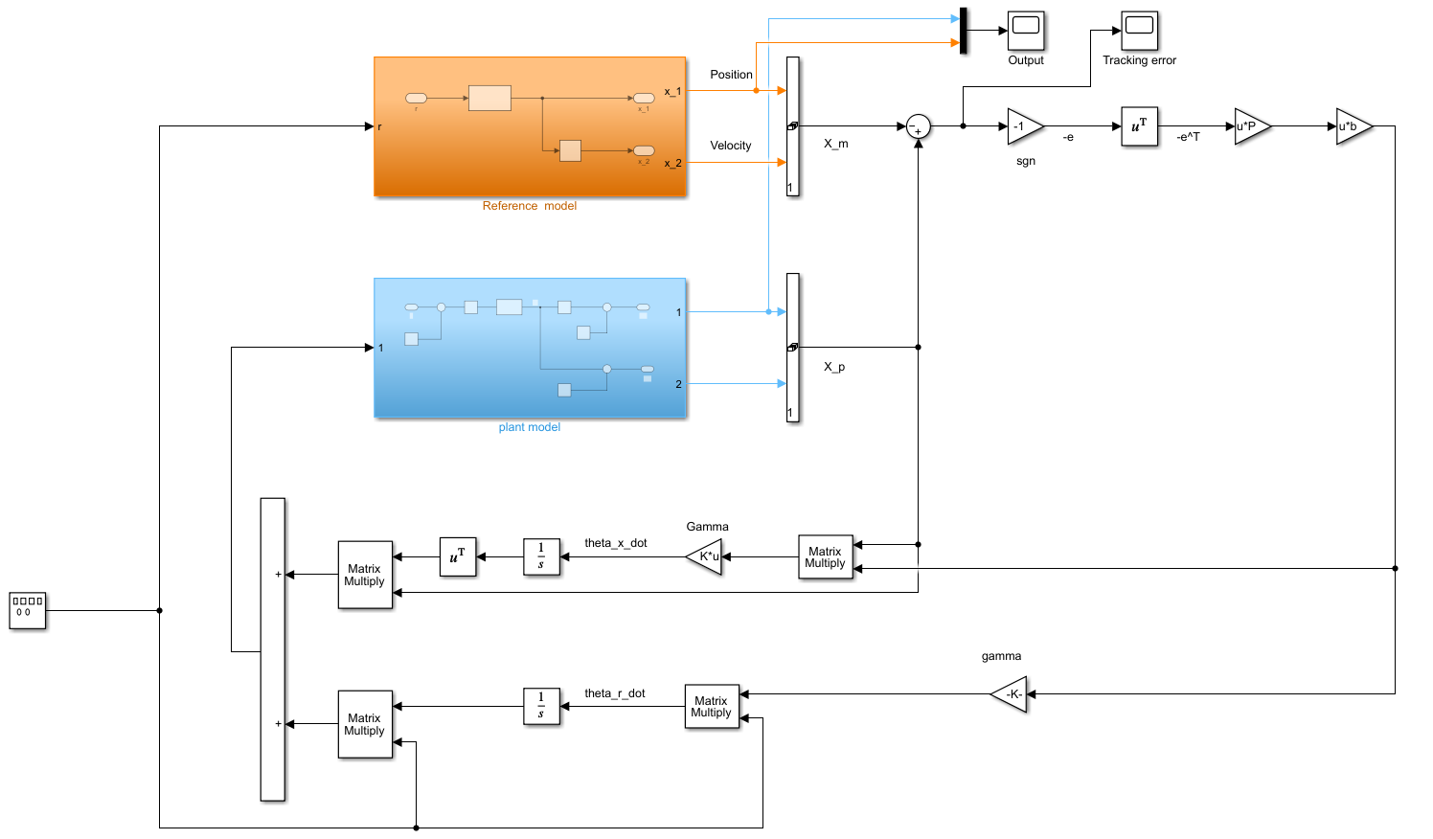

Fig.1(a) Adaptive controller

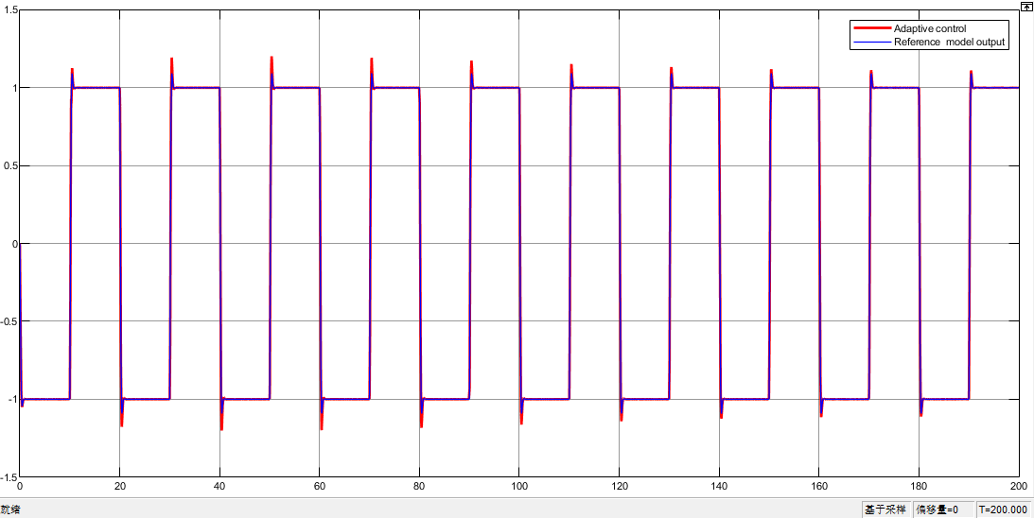

Fig.1(b) Adaptive control plant output/Reference model output

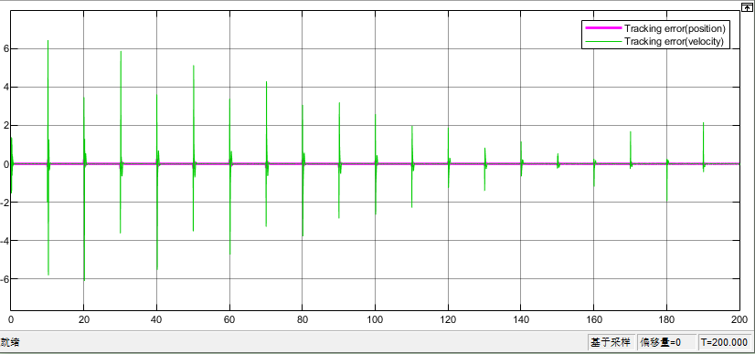

Fig.1(c) Tracking error

Here is the adaptive controller result without any noise

**2.1 Various choice of reference model state matrix **

reference model transfer function



reference model state space





assume natural frequence  is fixed, we only change damp factor 

**Summary:** when the damp factor become bigger, the step response converges faster and the overshoot is smaller, the adapticve control(position) output also converges faster in each square wave activation .

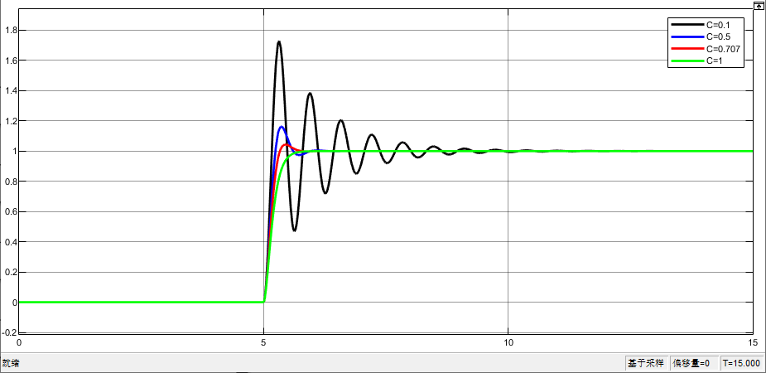

Fig.2(a) reference model, step response for different damp factor(0.1,0.5,0.707,1)

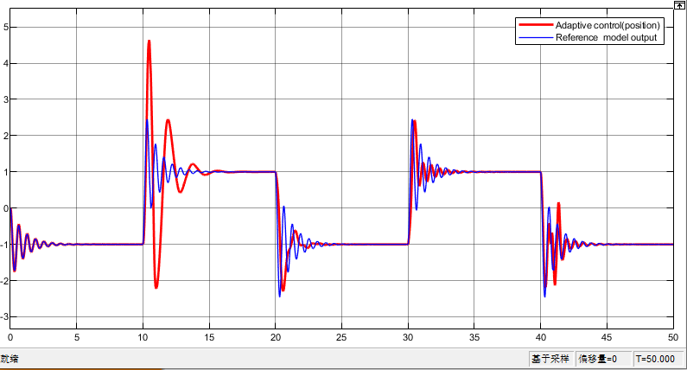

Fig.2(b)  (zoom in)

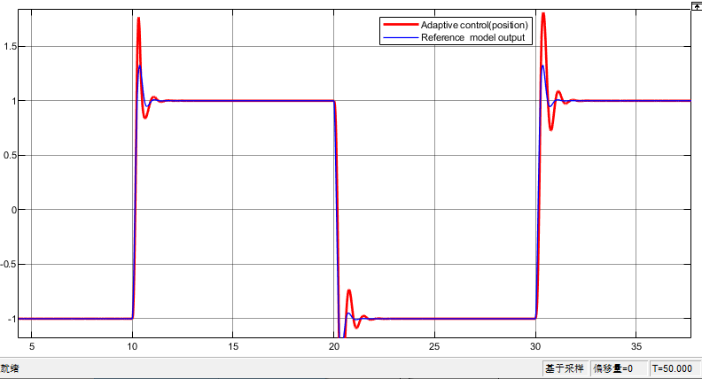

Fig.2(c)  (zoom in)

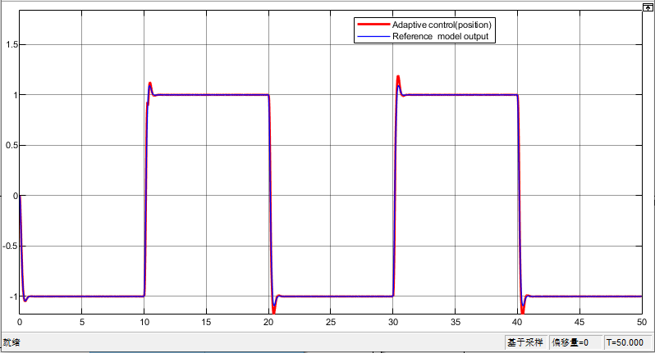

Fig.2(c)  (zoom in)

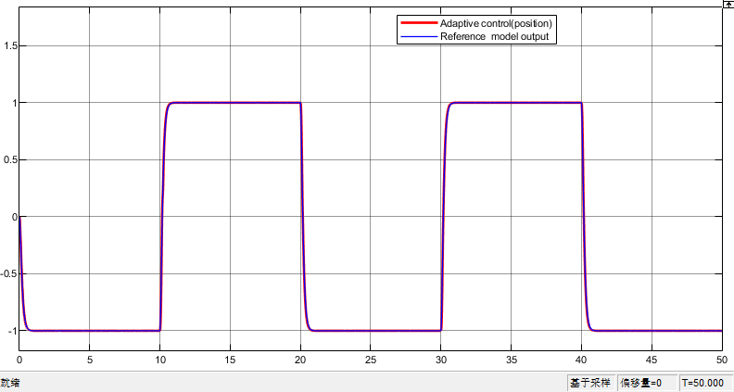

Fig.2(c)  (zoom in)

**2.2 Various reference command signal **

**Summary:** When the reference command signal is sine wave, the tracking error(adaptive control outpout - reference model output) converges to zero fastest.When the reference command signal is rawtooth wave, the tracking error(adaptive control outpout - reference model output) converges to zero slowest. Because compared with square wave and rawtooth wave, the sine wave is smooth and continuous and doesn’t have sudden jump. Thus even if damp factor  is small, the reference model output itself converges quickly and also for adaptive control output.

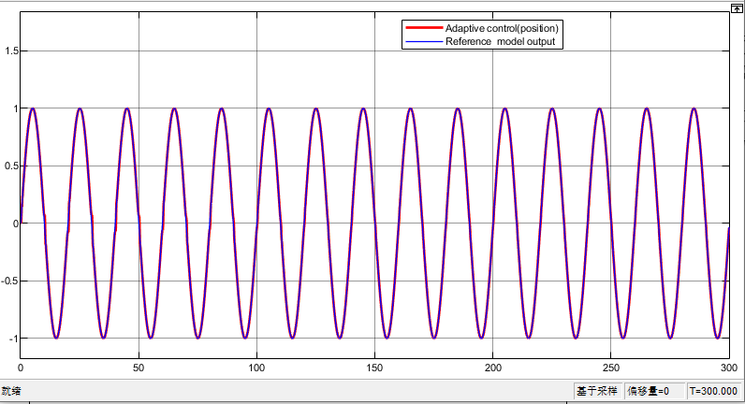

Fig.3(a)  reference signal = Sine wave (peroid=20s)

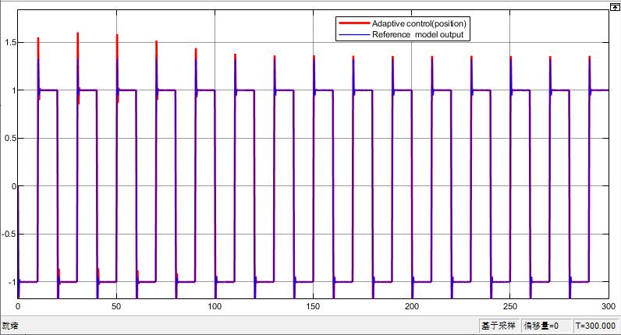

Fig.3  reference signal = Square wave (peroid=20s)

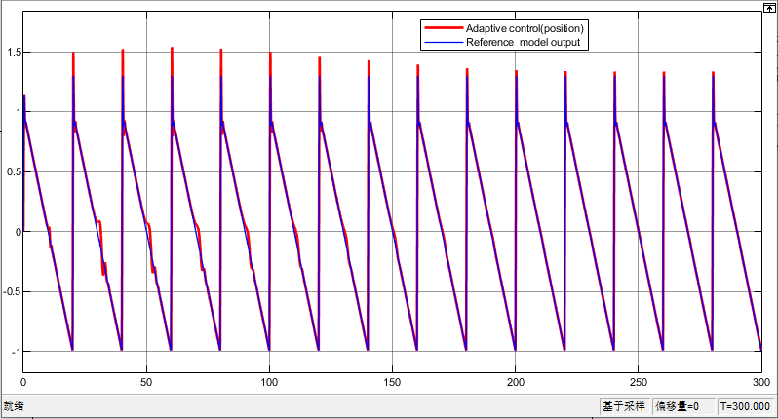

Fig.3  reference signal = sawtooth (peroid=20s)

**2.3 Different choices of design parameters**

**Summary:** A proper  are strongly influencing the speed of tracking error converging to 0.

At first, we choose  , , , Lyapunov .

When is larger(Fig.4(a~d)), changed to,,, Lyapunov , the performanceof plant model can’t track the reference model anymore or the tracking error convergence is too slow.

When is smaller(Fig.4(e)), changed to,,, Lyapunov ,

the tracking error convergence becomes slower, because at first in adaptive law, the e(t) is very large but  is too small leading to e(t) convergence speed is small.

Similarly, when Lyapunov maxtrix Q is too small, the tracking error convergence is slower due to Q affect the result of P, which also affect 

**Analysisi :**  ,  at each step, if is too large, it will let  difficult to approximate . For example, last step e(t)>0, because very big, letting >>0, and thus in the next step e(t)<<0, again because very big letting <<0. The result is that the tracking error oscilate. We can see in the picture(zoom in).

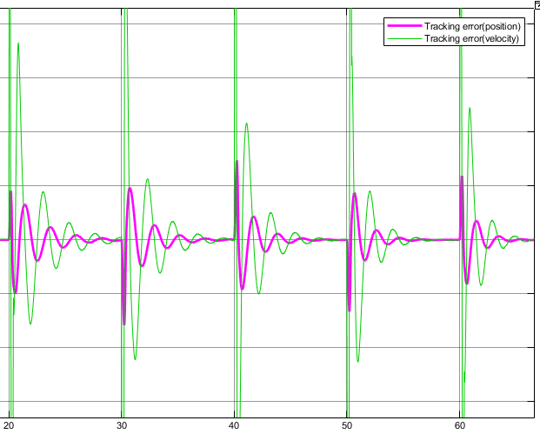

Fig.4 tracking error (position,zoom in) , , , Lyapunov 

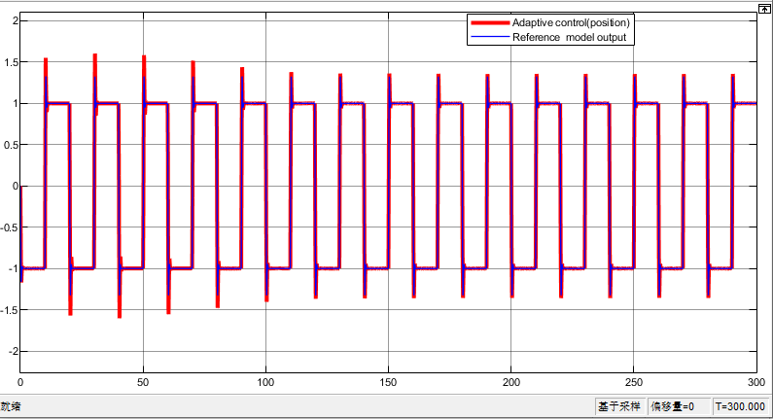

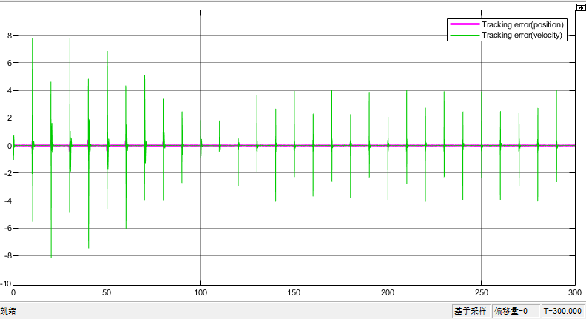

Fig.4(a)  , , , Lyapunov 

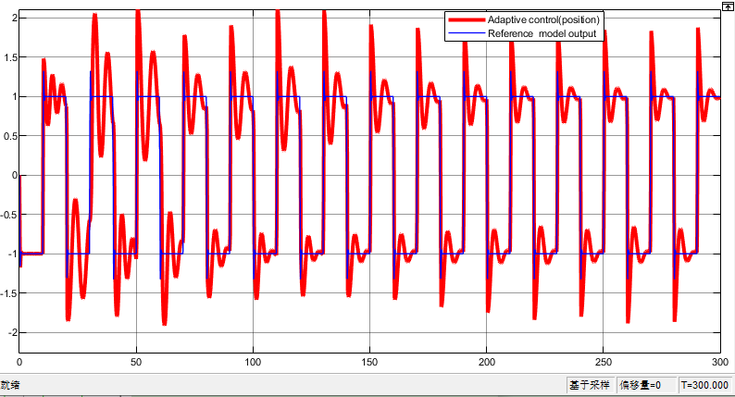

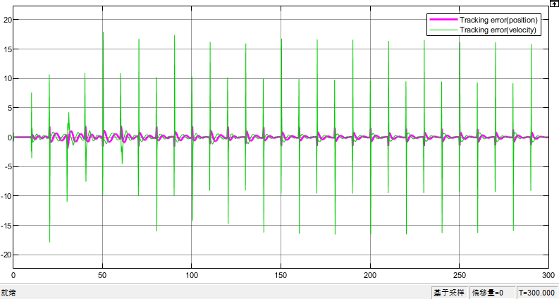

Fig.4(b)  , , , Lyapunov 

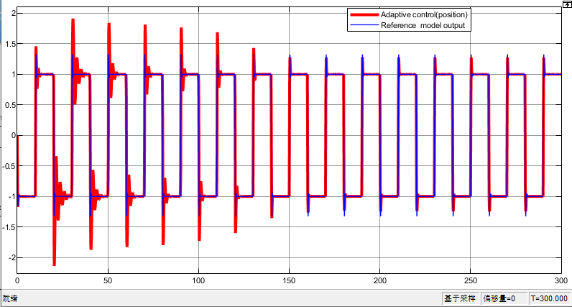

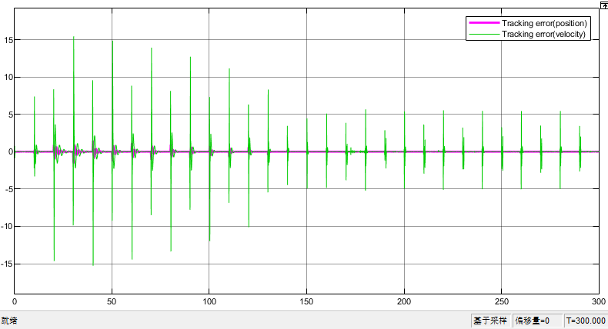

Fig.4(c)  , , , Lyapunov 

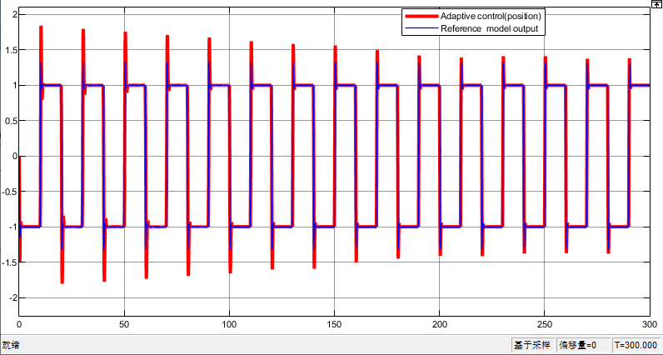

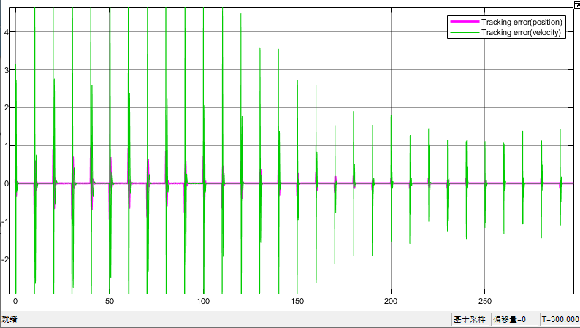

Fig.4(d)  , , , Lyapunov 

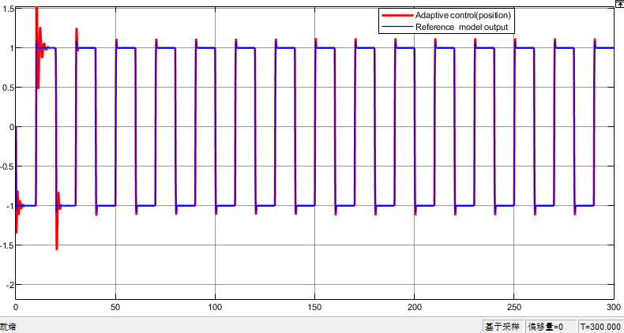

Fig.4(e)  , , , Lyapunov 

**2.4 Effect of realistic noise**

**Summary:** When sensor noisea and measurement noise exist, if the noise level is at acceptable range(not too big), the adaptive controller will track the reference model and the performance is acceptable. If the noise is too big (Fig5(d)), the adaotiv econtroller will fail to track. Because each step, the adaptive law  ,  will be heavily polluted because of polluted e(t).

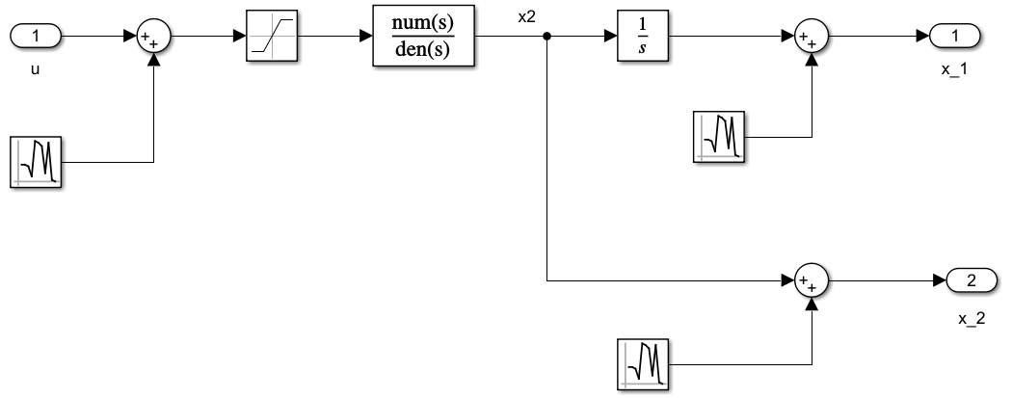

Fig.5 plant model

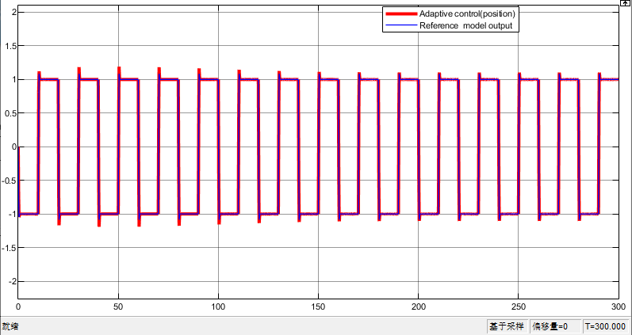

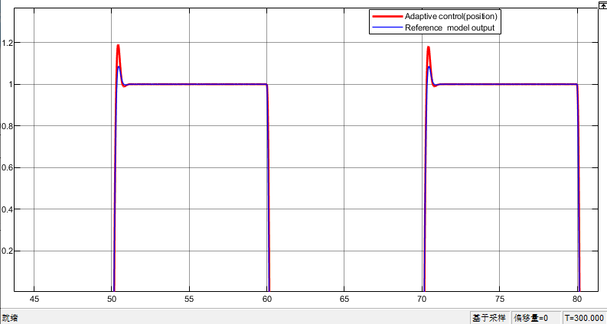

Fig.5(a)  no noise

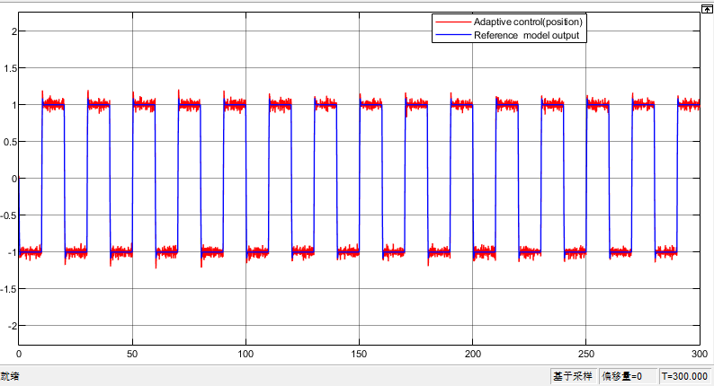

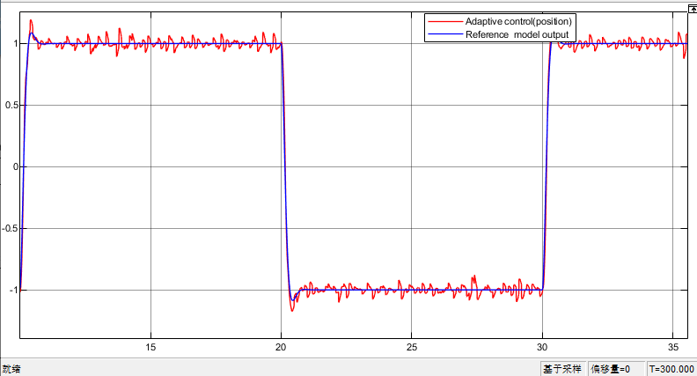

Fig.5(b)  , gaussian random noise, mean=0, variance=0.001

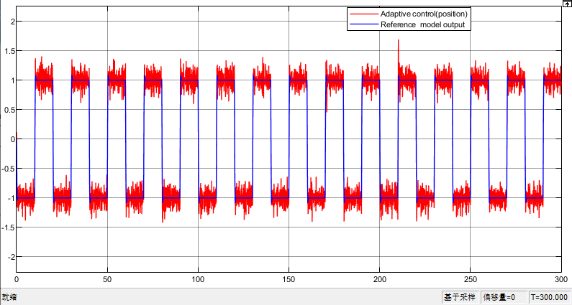

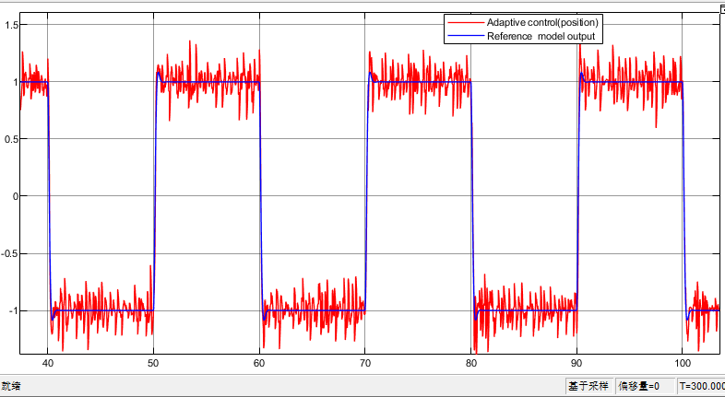

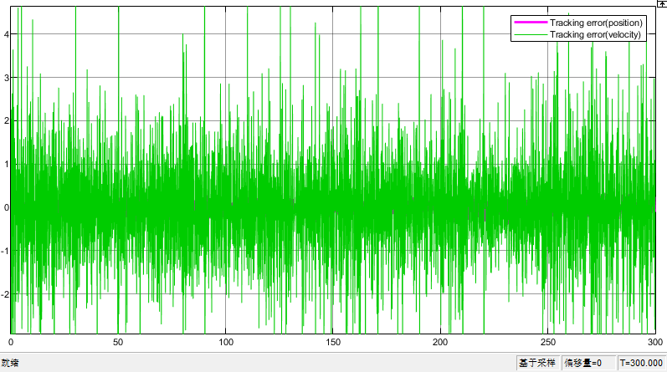

Fig.5(c)  , gaussian random noise, mean=0, variance=0.01

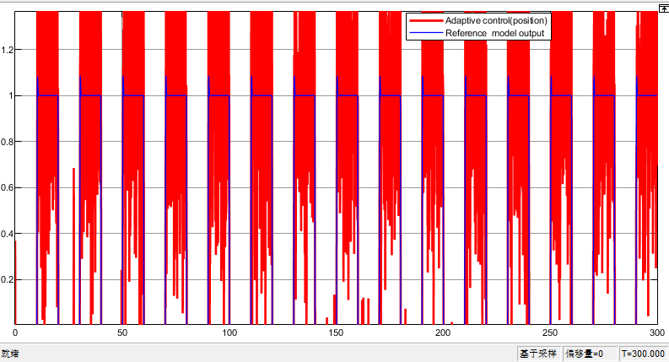

Fig.5(d)  , gaussian random noise, mean=0, variance=0.1